**1. During a routine inspection, a technician discovered that software that was installed on a computer was secretly collecting data about websites that were visited by users of the computer. Which type of threat is affecting this computer?**

DoS attack​  
identity theft  
**spyware\***  
zero-day attack

**2. Which term refers to a network that provides secure access to the corporate offices by suppliers, customers and collaborators?**

Internet  
intranet  
**extranet\***  
extendednet

**3. A large corporation has modified its network to allow users to access network resources from their personal laptops and smart phones. Which networking trend does this describe?**

cloud computing  
online collaboration  
**bring your own device\***  
video conferencing

**4. What is an ISP?**

It is a standards body that develops cabling and wiring standards for networking.  
It is a protocol that establishes how computers within a local network communicate.  
**It is an organization that enables individuals and businesses to connect to the Internet.\***  
It is a networking device that combines the functionality of several different networking devices in one.

**5. Match the requirements of a reliable network with the supporting network architecture. (Not all options are used.)**

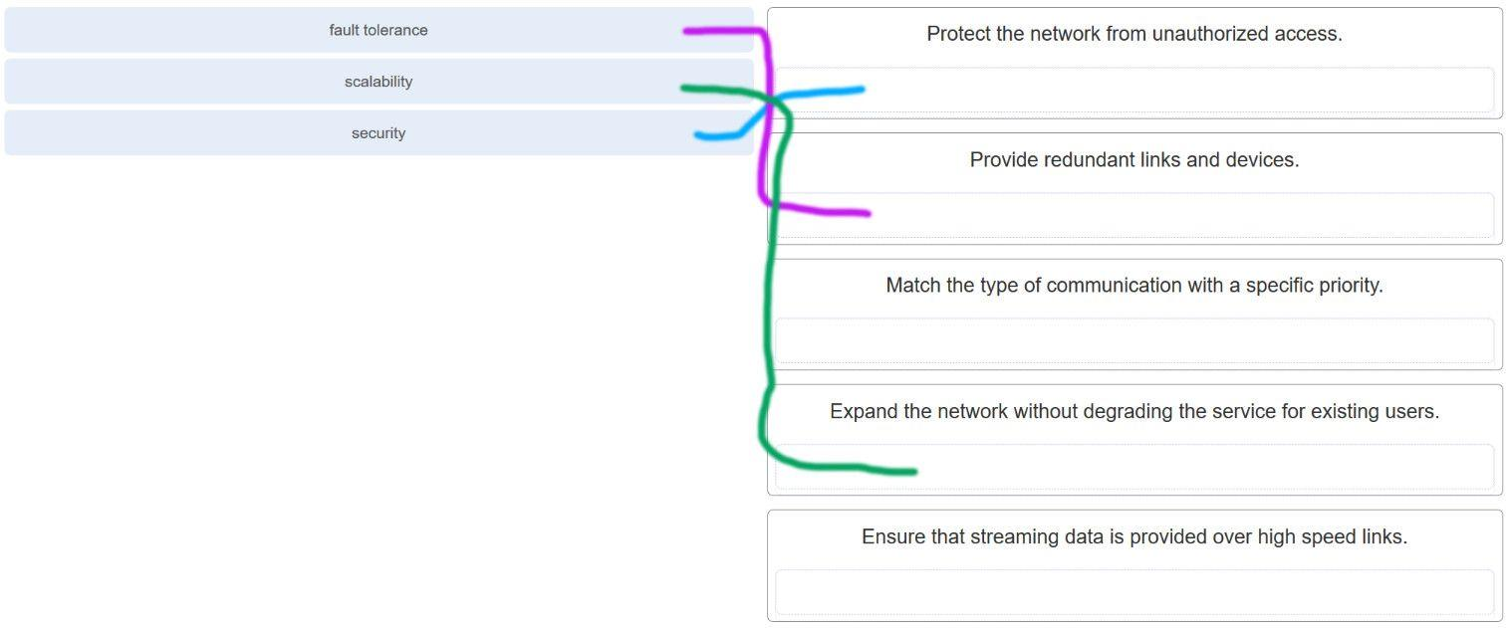

CCNA 1 v7.0 Modules 1 – 3 Exam Answers p5

**6. An employee at a branch office is creating a quote for a customer. In order to do this, the employee needs to access confidential pricing information from internal servers at the Head Office. What type of network would the employee access?**

**an intranet\***  
the Internet  
an extranet  
a local area network

**7. Which statement describes the use of powerline networking technology?**

New “smart” electrical cabling is used to extend an existing home LAN.  
A home LAN is installed without the use of physical cabling.  
**A device connects to an existing home LAN using an adapter and an existing electrical outlet.\***  
Wireless access points use powerline adapters to distribute data through the home LAN.

**8. A networking technician is working on the wireless network at a medical clinic. The technician accidentally sets up the wireless network so that patients can see the medical records data of other patients. Which of the four network characteristics has been violated in this situation?**

fault tolerance  
scalability  
**security\***  
Quality of Service (QoS)  
reliability

**Explanation:** Network security includes protecting the confidentiality of data that is on the network. In this case, because confidential data has been made available to unauthorized users, the security characteristic of the network has failed.

**9. Match each characteristic to its corresponding Internet connectivity type. (Not all options are used.)**

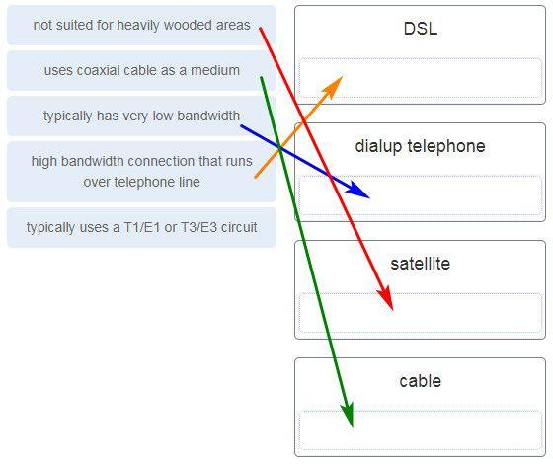

CCNA 1 v7.0 Modules 1 – 3 Exam Answers p9

**Explanation:** DSL is an always-on, high bandwidth connection that runs over telephone lines. Cable uses the same coaxial cable that carries television signals into the home to provide Internet access. Dialup telephone is much slower than either DSL or cable, but is the least expensive option for home users because it can use any telephone line and a simple modem. Satellite requires a clear line of sight and is affected by trees and other obstructions. None of these typical home options use dedicated leased lines such as T1/E1 and T3/E3.

**10. What two criteria are used to help select a network medium from various network media? (Choose two.)**

the types of data that need to be prioritized  
the cost of the end devices utilized in the network  
**the distance the selected medium can successfully carry a signal\***  
the number of intermediate devices installed in the network  
**the environment where the selected medium is to be installed\***

**11. What type of network traffic requires QoS?**

email  
on-line purchasing  
**video conferencing\***  
wiki

**12. A user is implementing security on a small office network. Which two actions would provide the minimum security requirements for this network? (Choose two.)**

**implementing a firewall\***  
installing a wireless network  
**installing antivirus software\***  
implementing an intrusion detection system  
adding a dedicated intrusion prevention device

**Explanation:** Technically complex security measures such as intrusion prevention and intrusion prevention systems are usually associated with business networks rather than home networks. Installing antivirus software, antimalware software, and implementing a firewall will usually be the minimum requirements for home networks. Installing a home wireless network will not improve network security, and will require further security actions to be taken.

router configuration mode

**14. Which interface allows remote management of a Layer 2 switch?**

the AUX interface  
the console port interface  
**the switch virtual interface\***  
the first Ethernet port interface

**Explanation:** In a Layer 2 switch, there is a switch virtual interface (SVI) that provides a means for remotely managing the device.

**15. What function does pressing the Tab key have when entering a command in IOS?**

It aborts the current command and returns to configuration mode.  
It exits configuration mode and returns to user EXEC mode.  
It moves the cursor to the beginning of the next line.  
**It completes the remainder of a partially typed word in a command.\***

**Explanation:** Pressing the Tab key after a command has been partially typed will cause the IOS to complete the rest of the command.

**16. While trying to solve a network issue, a technician made multiple changes to the current router configuration file. The changes did not solve the problem and were not saved. What action can the technician take to discard the changes and work with the file in NVRAM?**

**Issue the reload command without saving the running configuration.\***  
Delete the vlan.dat file and reboot the device.  
Close and reopen the terminal emulation software.  
Issue the copy startup-config running-config command.

**Explanation:** The technician does not want to make any mistakes trying to remove all the changes that were done to the running configuration file. The solution is to reboot the router without saving the running configuration. The copy startup-config running-config command does not overwrite the running configuration file with the configuration file stored in NVRAM, but rather it just has an additive effect.

**17. An administrator uses the Ctrl-Shift-6 key combination on a switch after issuing the ping command. What is the purpose of using these keystrokes?**

to restart the ping process  
**to interrupt the ping process\***  
to exit to a different configuration mode  
to allow the user to complete the command

**18. Refer to the exhibit.**

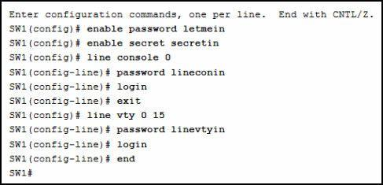

CCNA 1 v7.0 Modules 1 – 3 Exam Answers p18

**A network administrator is configuring access control to switch SW1. If the administrator uses a console connection to connect to the switch, which password is needed to access user EXEC mode?**

letmein  
secretin  
**lineconin\***  
linevtyin

**Explanation:** Telnet accesses a network device through the virtual interface configured with the line VTY command. The password configured under this is required to access the user EXEC mode. The password configured under the line console 0 command is required to gain entry through the console port, and the enable and enable secret passwords are used to allow entry into the privileged EXEC mode.

**19. A technician configures a switch with these commands:**

SwitchA(config)# interface vlan 1

SwitchA(config-if)# ip address 192.168.1.1 255.255.255.0

SwitchA(config-if)# no shutdown

**What is the technician configuring?**

Telnet access  
**SVI\***  
password encryption  
physical switchport access

**Explanation:** For a switch to have an IP address, a switch virtual interface must be configured. This allows the switch to be managed remotely over the network.

**20. Which command or key combination allows a user to return to the previous level in the command hierarchy?**

end  
**exit\***  
Ctrl-Z  
Ctrl-C

**Explanation:** End and CTRL-Z return the user to the privileged EXEC mode. Ctrl-C ends a command in process. The exit command returns the user to the previous level.

**21. What are two characteristics of RAM on a Cisco device? (Choose two.)**

RAM provides nonvolatile storage.  
**The configuration that is actively running on the device is stored in RAM.\***  
**The contents of RAM are lost during a power cycle.\***  
RAM is a component in Cisco switches but not in Cisco routers.  
RAM is able to store multiple versions of IOS and configuration files.

**22. Which two host names follow the guidelines for naming conventions on Cisco IOS devices? (Choose two.)**

Branch2!  
**RM-3-Switch-2A4\***  
Floor(15)  
HO Floor 17  
**SwBranch799\***

**Explanation:** Some guidelines for naming conventions are that names should:  
Start with a letter  
Contain no spaces  
End with a letter or digit  
Use only letters, digits, and dashes  
Be less than 64 characters in length

**23. How is SSH different from Telnet?**

SSH makes connections over the network, whereas Telnet is for out-of-band access.  
**SSH provides security to remote sessions by encrypting messages and using user authentication. Telnet is considered insecure and sends messages in plaintext.\***  
SSH requires the use of the PuTTY terminal emulation program. Tera Term must be used to connect to devices through the use of Telnet.  
SSH must be configured over an active network connection, whereas Telnet is used to connect to a device from a console connection.

**Explanation:** SSH is the preferred protocol for connecting to a device operating system over the network because it is much more secure than Telnet. Both SSH and Telnet are used to connect to devices over the network, and so are both used in-band. PuTTY and Terra Term can be used to make both SSH and Telnet connections.

**25. What are three characteristics of an SVI? (Choose three.)**

It is designed as a security protocol to protect switch ports.  
**It is not associated with any physical interface on a switch.\***  
It is a special interface that allows connectivity by different types of media.  
It is required to allow connectivity by any device at any location.  
**It provides a means to remotely manage a switch.\***  
**It is associated with VLAN1 by default.\***

**Explanation:** Switches have one or more switch virtual interfaces (SVIs). SVIs are created in software since there is no physical hardware associated with them. Virtual interfaces provide a means to remotely manage a switch over a network that is using IP. Each switch comes with one SVI appearing in the default configuration “out-of-the-box.” The default SVI interface is VLAN1.

**26. What command is used to verify the condition of the switch interfaces, including the status of the interfaces and a configured IP address?**

ipconfig  
ping  
traceroute  
**show ip interface brief\***

**Explanation:** The show ip interface brief command is used to display a brief synopsis of the condition of the device interfaces. The ipconfig command is used to verify TCP/IP properties on a host. The ping command is used to verify Layer 3 connectivity. The traceroute command is used to trace the network path from source to destination.

**28. Match the definitions to their respective CLI hot keys and shortcuts. (Not all options are used.)**

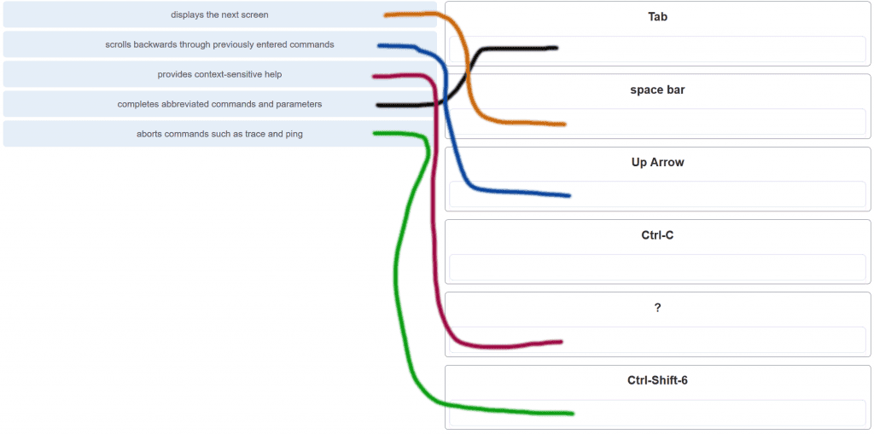

CCNA 1 v7.0 Modules 1 – 3 Exam Answers p28

**29. In the show running-config command, which part of the syntax is represented by running-config?**

the command  
**a keyword\***  
a variable  
a prompt

**Explanation:** The first part of the syntax, show, is the command, and the second part of the syntax, running-config, is the keyword. The keyword specifies what should be displayed as the output of the show command.

**30. After making configuration changes on a Cisco switch, a network administrator issues a copy running-config startup-config command. What is the result of issuing this command?**

The new configuration will be stored in flash memory.  
**The new configuration will be loaded if the switch is restarted.\***  
The current IOS file will be replaced with the newly configured file.  
The configuration changes will be removed and the original configuration will be restored.

**31. What command will prevent all unencrypted passwords from displaying in plain text in a configuration file?**

(config)# enable password secret  
(config)# enable secret Secret_Password  
(config-line)# password secret  
**(config)# service password-encryption\***  
(config)# enable secret Encrypted_Password

**32. A network administrator enters the service password-encryption command into the configuration mode of a router. What does this command accomplish?**

This command encrypts passwords as they are transmitted across serial WAN links.  
**This command prevents someone from viewing the running configuration passwords.\***  
This command enables a strong encryption algorithm for the enable secret password command.  
This command automatically encrypts passwords in configuration files that are currently stored in NVRAM.  
This command provides an exclusive encrypted password for external service personnel who are required to do router maintenance.

**Explanation:** The startup-config and running-config files display most passwords in plaintext. Use the service password-encryption global config command to encrypt all plaintext passwords in these files.

**33. What method can be used by two computers to ensure that packets are not dropped because too much data is being sent too quickly?**

encapsulation  
**flow control\***  
access method  
response timeout

**Explanation:** In order for two computers to be able to communicate effectively, there must be a mechanism that allows both the source and destination to set the timing of the transmission and receipt of data. Flow control allows for this by ensuring that data is not sent too fast for it to be received properly.

**34. Which statement accurately describes a TCP/IP encapsulation process when a PC is sending data to the network?**

Data is sent from the internet layer to the network access layer.  
Packets are sent from the network access layer to the transport layer.  
**Segments are sent from the transport layer to the internet layer.\***  
Frames are sent from the network access layer to the internet layer.

**Explanation:** When the data is traveling from the PC to the network, the transport layer sends segments to the internet layer. The internet layer sends packets to the network access layer, which creates frames and then converts the frames to bits. The bits are released to the network media.

**35. What three application layer protocols are part of the TCP/IP protocol suite? (Choose three.)**

ARP  
**DHCP\***  
**DNS\***  
**FTP\***  
NAT  
PPP

**Explanation:** DNS, DHCP, and FTP are all application layer protocols in the TCP/IP protocol suite. ARP and PPP are network access layer protocols, and NAT is an internet layer protocol in the TCP/IP protocol suite.

**36. Match the description to the organization. (Not all options are used.)**

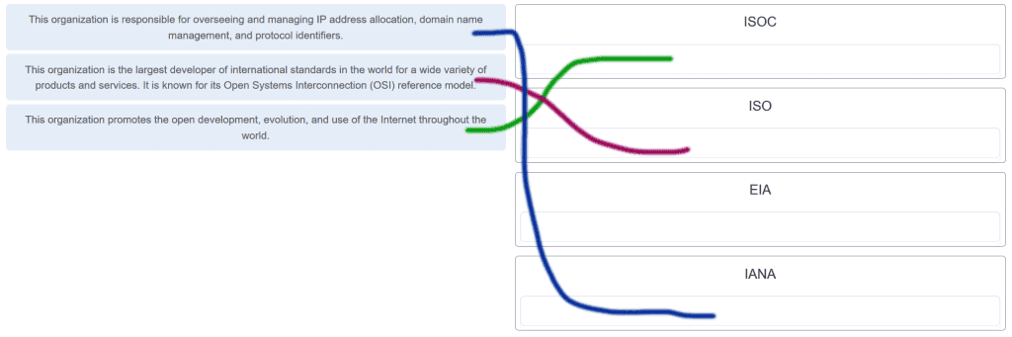

CCNA 1 v7.0 Modules 1 – 3 Exam Answers p36

**37. Which name is assigned to the transport layer PDU?**

bits  
data  
frame  
packet  
**segment\***

**Explanation:** Application data is passed down the protocol stack on its way to be transmitted across the network media. During the process, various protocols add information to it at each level. At each stage of the process, a PDU (protocol data unit) has a different name to reflect its new functions. The PDUs are named according to the protocols of the TCP/IP suite:  
Data – The general term for the PDU used at the application layer.  
Segment – transport layer PDU  
Packet – network layer PDU  
Frame – data link layer PDU  
Bits – A physical layer PDU used when physically transmitting data over the medium

**38. When IPv4 addressing is manually configured on a web server, which property of the IPv4 configuration identifies the network and host portion for an IPv4 address?**

DNS server address  
**subnet mask\***  
default gateway  
DHCP server address

**Explanation:** There are several components that need to be entered when configuring IPv4 for an end device:  
IPv4 address – uniquely identifies an end device on the network  
Subnet mask – determines the network address portion and host portion for an IPv4 address  
Default gateway – the IP address of the router interface used for communicating with hosts in another network  
DNS server address – the IP address of the Domain Name System (DNS) server  
DHCP server address (if DHCP is used) is not configured manually on end devices. It will be provided by a DHCP server when an end device requests an IP address.

**39. What process involves placing one PDU inside of another PDU?**

**Encapsulation\***  
encoding  
segmentation  
flow control

**Explanation:** When a message is placed inside of another message, this is known as encapsulation. On networks, encapsulation takes place when one protocol data unit is carried inside of the data field of the next lower protocol data unit.

**40. What layer is responsible for routing messages through an internetwork in the TCP/IP model?**

**Internet\***  
transport  
network access  
session

**Explanation:** The TCP/IP model consists of four layers: application, transport, internet, and network access. Of these four layers, it is the internet layer that is responsible for routing messages. The session layer is not part of the TCP/IP model but is rather part of the OSI model.

**41. For the TCP/IP protocol suite, what is the correct order of events when a Telnet message is being prepared to be sent over the network?**

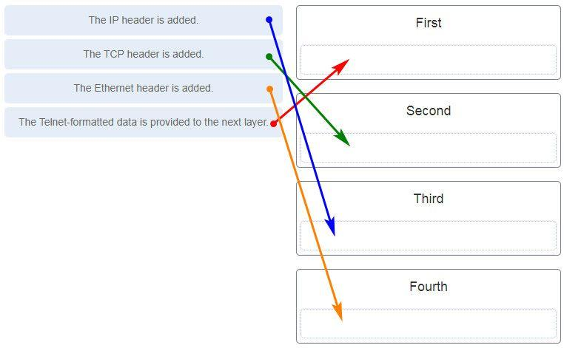

CCNA 1 v7.0 Modules 1 – 3 Exam Answers p41

**42. Which PDU format is used when bits are received from the network medium by the NIC of a host?**

file  
**frame\***  
packet  
segment

**Explanation:** When received at the physical layer of a host, the bits are formatted into a frame at the data link layer. A packet is the PDU at the network layer. A segment is the PDU at the transport layer. A file is a data structure that may be used at the application layer.

**43. Refer to the exhibit.**

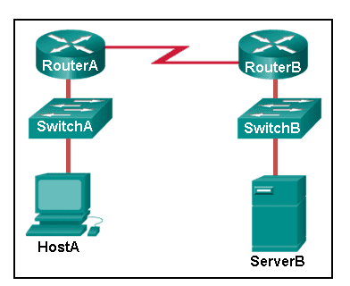

CCNA 1 v7.0 Modules 1 – 3 Exam Answers p43

**ServerB is attempting to contact HostA. Which two statements correctly identify the addressing that ServerB will generate in the process? (Choose two.)**

ServerB will generate a packet with the destination IP address of RouterB.  
ServerB will generate a frame with the destination MAC address of SwitchB.  
ServerB will generate a packet with the destination IP address of RouterA.  
**ServerB will generate a frame with the destination MAC address of RouterB.\***  
**ServerB will generate a packet with the destination IP address of HostA.\***  
ServerB will generate a frame with the destination MAC address of RouterA.

**44. Which method allows a computer to react accordingly when it requests data from a server and the server takes too long to respond?**

encapsulation  
flow control  
access method  
**response timeout\***

**45. A web client is receiving a response for a web page from a web server. From the perspective of the client, what is the correct order of the protocol stack that is used to decode the received transmission?**

**Ethernet, IP, TCP, HTTP\***  
HTTP, TCP, IP, Ethernet  
Ethernet, TCP, IP, HTTP  
HTTP, Ethernet, IP, TCP

**Explanation:**  
1. HTTP governs the way that a web server and client interact.  
2. TCP manages individual conversations between web servers and clients.  
3. IP is responsible for delivery across the best path to the destination.  
4. Ethernet takes the packet from IP and formats it for transmission.

**46. Which two OSI model layers have the same functionality as a single layer of the TCP/IP model? (Choose two.)**

**data link\***  
network  
**physical\***  
session  
transport

**47. At which layer of the OSI model would a logical address be added during encapsulation?**

physical layer  
data link layer  
**network layer\***  
transport layer

**48. What is a characteristic of multicast messages?**

**They are sent to a select group of hosts.\***  
They are sent to all hosts on a network.  
They must be acknowledged.  
They are sent to a single destination.

**Explanation:** Multicast is a one-to-many type of communication. Multicast messages are addressed to a specific multicast group.

**49. Which statement is correct about network protocols?**

Network protocols define the type of hardware that is used and how it is mounted in racks.  
**They define how messages are exchanged between the source and the destination.\***  
They all function in the network access layer of TCP/IP.  
They are only required for exchange of messages between devices on remote networks.

**50. What is an advantage of network devices using open standard protocols?**

Network communications is confined to data transfers between devices from the same vendor.  
**A client host and a server running different operating systems can successfully exchange data.\***  
Internet access can be controlled by a single ISP in each market.  
Competition and innovation are limited to specific types of products.

**51. Which device performs the function of determining the path that messages should take through internetworks?**

**a router\***  
a firewall  
a web server  
a DSL modem

**Explanation:** A router is used to determine the path that the messages should take through the network. A firewall is used to filter incoming and outgoing traffic. A DSL modem is used to provide Internet connection for a home or an organization.

**52. Open the PT Activity.**

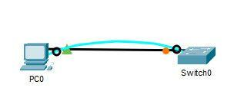

CCNA 1 v7.0 Modules 1 – 3 Exam Answers p52

**Perform the tasks in the activity instructions and then answer the question.  
What is the IP address of the switch virtual interface (SVI) on Switch0?**

**192.168.5.10\***  
192.168.10.5  
192.168.10.1  
192.168.5.0

**Explanation:** After the enable command is issued, the show running-configuration command or the show ip interfaces brief command will display the IP address of the switch virtual interface (SVI).

**53. Why would a Layer 2 switch need an IP address?**

to enable the switch to send broadcast frames to attached PCs  
to enable the switch to function as a default gateway  
**to enable the switch to be managed remotely\***  
to enable the switch to receive frames from attached PCs

**Explanation:** A switch, as a Layer 2 device, does not need an IP address to transmit frames to attached devices. However, when a switch is accessed remotely through the network, it must have a Layer 3 address. The IP address must be applied to a virtual interface rather than to a physical interface. Routers, not switches, function as default gateways.

**54. Refer to the exhibit.**

CCNA 1 v7.0 Modules 1 – 3 Exam Answers p54

CCNA 1 v7.0 Modules 1 – 3 Exam Answers p54

**An administrator is trying to configure the switch but receives the error message that is displayed in the exhibit. What is the problem?**

The entire command, configure terminal, must be used.  
The administrator is already in global configuration mode.  
**The administrator must first enter privileged EXEC mode before issuing the command.\***  
The administrator must connect via the console port to access global configuration mode.

**Explanation:** In order to enter global configuration mode, the command configure terminal, or a shortened version such as config t, must be entered from privileged EXEC mode. In this scenario the administrator is in user EXEC mode, as indicated by the > symbol after the hostname. The administrator would need to use the enable command to move into privileged EXEC mode before entering the configure terminal command.

**55. What term describes a network owned by one organization that provides safe and secure access to individuals who work for a different organization?**

**Extranet\***  
cloud  
BYOD  
quality of service

**56. What term describes storing personal files on servers over the internet to provide access anywhere, anytime, and on any device?**

**Cloud\***  
BYOD  
quality of service  
converged network

**57. What term describes a network where one computer can be both client and server?**

**peer-to-peer\***  
cloud  
BYOD  
quality of service

**58. What term describes a type of network used by people who work from home or from a small remote office?**

**SOHO network\***  
BYOD  
quality of service  
converged network

**59. What term describes a computing model where server software runs on dedicated computers?**

**client/server\***  
internet  
intranet  
extranet

**60. What term describes a type of network used by people who work from home or from a small remote office?**

**SOHO network\***  
internet  
intranet  
extranet

**61. What term describes a technology that allows devices to connect to the LAN using an electrical outlet?**

**powerline networking\***  
internet  
intranet  
extranet

**62. What term describes a policy that allows network devices to manage the flow of data to give priority to voice and video?**

**quality of service\***  
internet  
intranet  
extranet

**63. What term describes a private collection of LANs and WANs that belongs to an organization?**

**Intranet\***  
internet  
extranet  
peer-to-peer

**64. What term describes the ability to use personal devices across a business or campus network?**

**BYOD\***  
internet  
intranet  
extranet

**65. At which OSI layer is a source IP address added to a PDU during the encapsulation process?**

**network layer\***  
data link layer  
transport layer  
application layer

**66. At which OSI layer is a destination port number added to a PDU during the encapsulation process?**

**transport layer\***  
data link layer  
network layer  
application layer

**67. At which OSI layer is data added to a PDU during the encapsulation process?**

**application layer\***  
data link layer  
network layer  
transport layer

**68. At which OSI layer is a source IP address added to a PDU during the encapsulation process?**

**network layer\***  
data link layer  
application layer  
presentation layer

**69. At which OSI layer is data added to a PDU during the encapsulation process?**

**application layer\***  
transport layer  
network layer  
presentation layer

**70. At which OSI layer is a destination IP address added to a PDU during the encapsulation process?**

**network layer\***  
application layer  
transport layer  
presentation layer

**71. At which OSI layer is a source MAC address added to a PDU during the encapsulation process?**

**data link layer\***  
application layer  
transport layer  
presentation layer

**72. At which OSI layer is a source port number added to a PDU during the encapsulation process?**

**transport layer\***  
application layer  
network layer  
presentation layer

**73. At which OSI layer is a destination MAC address added to a PDU during the encapsulation process?**

**data link layer\***  
transport layer  
application layer  
network layer

**74. At which OSI layer is a source port number added to a PDU during the encapsulation process?**

**transport layer\***  
network layer  
application layer  
data link layer

**Modules 1 – 3: Basic Network Connectivity and Communications Exam Answers (Additional)**

**1. During a routine inspection, a technician discovered that software that was installed on a computer was secretly collecting data about websites that were visited by users of the computer. Which type of threat is affecting this computer?**

DoS attack​  
identity theft  
**spyware\***  
zero-day attack

**2. Which term refers to a network that provides secure access to the corporate offices by suppliers, customers and collaborators?**

Internet  
intranet  
**extranet\***  
extendednet

**3. A large corporation has modified its network to allow users to access network resources from their personal laptops and smart phones. Which networking trend does this describe?**

loud computing  
online collaboration  
**bring your own device\***  
video conferencing

**4. What is an ISP?**

It is a standards body that develops cabling and wiring standards for networking.  
It is a protocol that establishes how computers within a local network communicate.  
**It is an organization that enables individuals and businesses to connect to the Internet.\***  
It is a networking device that combines the functionality of several different networking devices in one.

**5. In which scenario would the use of a WISP be recommended?**

an Internet cafe in a city  
**a farm in a rural area without wired broadband access\***  
any home with multiple wireless devices  
an apartment in a building with cable access to the Internet

**6. What characteristic of a network enables it to quickly grow to support new users and applications without impacting the performance of the service being delivered to existing users?**

reliability  
**scalability\***  
quality of service  
accessibility

**7. A college is building a new dormitory on its campus. Workers are digging in the ground to install a new water pipe for the dormitory. A worker accidentally damages a fiber optic cable that connects two of the existing dormitories to the campus data center. Although the cable has been cut, students in the dormitories only experience a very short interruption of network services. What characteristic of the network is shown here?**

quality of service (QoS)  
scalability  
security  
**fault tolerance\***  
integrity

**8. What are two characteristics of a scalable network? (Choose two.)**

easily overloaded with increased traffic  
**grows in size without impacting existing users\***  
is not as reliable as a small network  
**suitable for modular devices that allow for expansion\***  
offers limited number of applications

**9. Which device performs the function of determining the path that messages should take through internetworks?**

**a router\***  
a firewall  
a web server  
a DSL modem

**10. Which two Internet connection options do not require that physical cables be run to the building? (Choose two.)**

DSL  
**Celular\***  
**Satellite\***  
dialup  
dedicated leased line

**11. What type of network must a home user access in order to do online shopping?**

an intranet  
**the Internet\***  
an extranet  
a local area network

**12. How does BYOD change the way in which businesses implement networks?​**

BYOD requires organizations to purchase laptops rather than desktops.  
BYOD users are responsible for their own network security, thus reducing the need for organizational security policies.  
BYOD devices are more expensive than devices that are purchased by an organization.  
**BYOD provides flexibility in where and how users can access network resources.\***

**13. An employee wants to access the network of the organization remotely, in the safest possible way. What network feature would allow an employee to gain secure remote access to a company network?**

ACL  
IPS  
**VPN\***  
BYOD

**14. What is the Internet?**

It is a network based on Ethernet technology.  
It provides network access for mobile devices.  
**It provides connections through interconnected global networks.\***  
It is a private network for an organization with LAN and WAN connections.

**15. What are two functions of end devices on a network? (Choose two.)**

**They originate the data that flows through the network.\***  
They direct data over alternate paths in the event of link failures.  
They filter the flow of data to enhance security.  
**They are the interface between humans and the communication network.\***  
They provide the channel over which the network message travels.

**16. Which statement is true about the running configuration file in a Cisco IOS device?**

**It affects the operation of the device immediately when modified.\***  
It is stored in NVRAM.  
It should be deleted using the erase running-config command.  
It is automatically saved when the router reboots.

**17. Which two statements are true regarding the user EXEC mode? (Choose two.)**

All router commands are available.  
Global configuration mode can be accessed by entering the enable command.  
**The device prompt for this mode ends with the “>” symbol.\***  
Interfaces and routing protocols can be configured.  
**Only some aspects of the router configuration can be viewed.\***

**18. Which type of access is secured on a Cisco router or switch with the enable secret command?**

virtual terminal  
**privileged EXEC\***  
AUX port  
console line

**19. What is the default SVI on a Cisco switch?**

**VLAN1\***  
VLAN99  
VLAN100  
VLAN999

**20. When a hostname is configured through the Cisco CLI, which three naming conventions are part of the guidelines? (Choose three.)**

**the hostname should be fewer than 64 characters in length\***  
the hostname should be written in all lower case characters  
**the hostname should contain no spaces\***  
the hostname should end with a special character  
**the hostname should begin with a letter\***

**21. What is the function of the shell in an OS?**

It interacts with the device hardware.  
**It interfaces between the users and the kernel.\***  
It provides dedicated firewall services.  
It provides the intrusion protection services for the device.

**22. A router with a valid operating system contains a configuration file stored in NVRAM. The configuration file has an enable secret password but no console password. When the router boots up, which mode will display?**

global configuration mode  
setup mode  
privileged EXEC mode  
**user EXEC mode\***

**23. An administrator has just changed the IP address of an interface on an IOS device. What else must be done in order to apply those changes to the device?**

Copy the running configuration to the startup configuration file.  
Copy the information in the startup configuration file to the running configuration.  
Reload the device and type yes when prompted to save the configuration.  
**Nothing must be done. Changes to the configuration on an IOS device take effect as soon as the command is typed correctly and the Enter key has been pressed.\***

**24. Which memory location on a Cisco router or switch will lose all content when the device is restarted?**

ROM  
flash  
NVRAM  
**RAM\***

**25. Why would a technician enter the command copy startup-config running-config?**

to remove all configurations from the switch  
to save an active configuration to NVRAM  
**to copy an existing configuration into RAM\***  
to make a changed configuration the new startup configuration

**26. Which functionality is provided by DHCP?**

**automatic assignment of an IP address to each host\***  
remote switch management  
translation of IP addresses to domain names  
end-to-end connectivity test

**27. Which two functions are provided to users by the context-sensitive help feature of the Cisco IOS CLI? (Choose two.)**

providing an error message when a wrong command is submitted  
**displaying a list of all available commands within the current mode\***  
allowing the user to complete the remainder of an abbreviated command with the TAB key  
**determining which option, keyword, or argument is available for the entered command\***  
selecting the best command to accomplish a task

**28. Which memory location on a Cisco router or switch stores the startup configuration file?**

RAM  
ROM  
**NVRAM\***  
flash

**29. To what subnet does the IP address 10.1.100.50 belong if a subnet mask of 255.255.0.0 is used?**

**10.1.0.0\***  
10.0.0.0  
10.1.100.32  
10.1.100.0

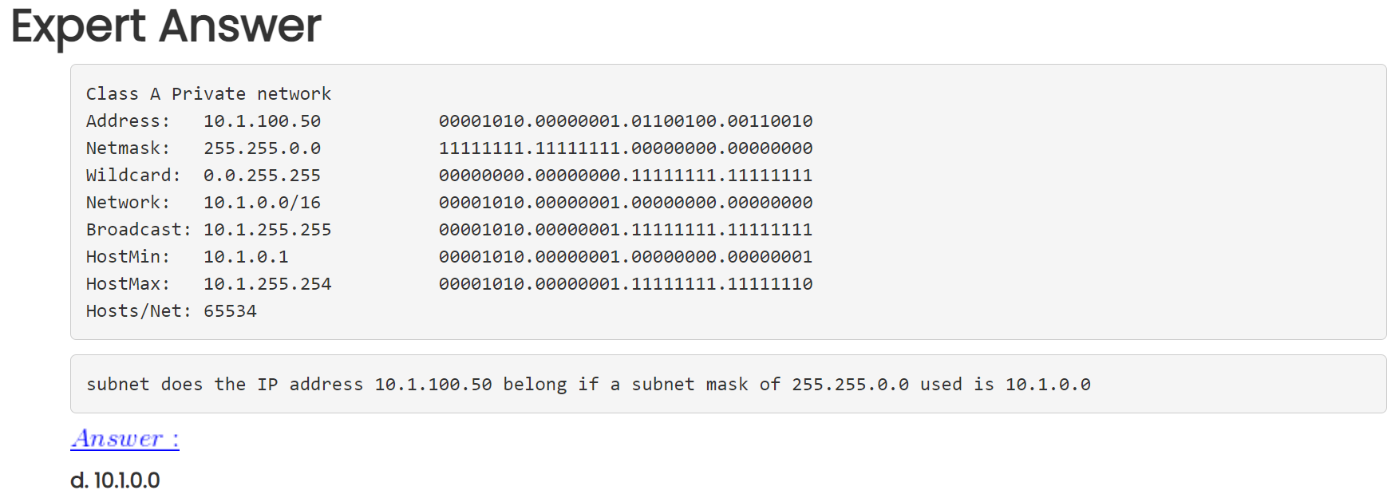

**30. Which three acronyms/initialisms represent standards organizations? (Choose three.)**

**IANA\***  
TCP/IP  
**IEEE\***  
**IETF\***  
OSI  
MAC

**31. What type of communication will send a message to all devices on a local area network?**

**Broadcast\***  
multicast  
unicast  
allcast

**32. In computer communication, what is the purpose of message encoding?**

**to convert information to the appropriate form for transmission\***  
to interpret information  
to break large messages into smaller frames  
to negotiate correct timing for successful communication

**33. Which message delivery option is used when all devices need to receive the same message simultaneously?**

duplex  
unicast  
multicast  
**broadcast\***

**34. What are two benefits of using a layered network model? (Choose two.)**

**It assists in protocol design.\***  
It speeds up packet delivery.  
It prevents designers from creating their own model.  
**It prevents technology in one layer from affecting other layers.\***  
It ensures a device at one layer can function at the next higher layer.

**35. What is the purpose of protocols in data communications?**

specifying the bandwidth of the channel or medium for each type of communication  
specifying the device operating systems that will support the communication  
**providing the rules required for a specific type of communication to occur\***  
dictating the content of the message sent during communication

**36. Which logical address is used for delivery of data to a remote network?**

destination MAC address  
**destination IP address\***  
destination port number  
source MAC address  
source IP address

**37. What is the general term that is used to describe a piece of data at any layer of a networking model?**

frame  
packet  
**protocol data unit\***  
segment

**38. Which two protocols function at the internet layer? (Choose two.)**

POP  
BOOTP  
**ICMP\***  
**IP\***  
PPP

**39. Which layer of the OSI model defines services to segment and reassemble data for individual communications between end devices?**

application  
presentation  
session  
**transport\***  
network

**40. Which type of communication will send a message to a group of host destinations simultaneously?**

broadcast  
**multicast\***  
unicast  
anycast

**41. What process is used to receive transmitted data and convert it into a readable message?**

access control  
**decoding\***  
encapsulation  
flow control

**42. What is done to an IP packet before it is transmitted over the physical medium?**

It is tagged with information guaranteeing reliable delivery.  
It is segmented into smaller individual pieces.  
It is encapsulated into a TCP segment.  
**It is encapsulated in a Layer 2 frame.\***

**43. What process is used to place one message inside another message for transfer from the source to the destination?**

access control  
decoding  
**encapsulation\***  
flow control

**44. A web client is sending a request for a webpage to a web server. From the perspective of the client, what is the correct order of the protocol stack that is used to prepare the request for transmission?**

HTTP, IP, TCP, Ethernet  
**HTTP, TCP, IP, Ethernet\***  
Ethernet, TCP, IP, HTTP  
Ethernet, IP, TCP, HTTP

**1. What is the purpose of the OSI physical layer?**

controlling access to media  
**transmitting bits across the local media\***  
performing error detection on received frames  
exchanging frames between nodes over physical network media

**2. Why are two strands of fiber used for a single fiber optic connection?**

The two strands allow the data to travel for longer distances without degrading.  
They prevent crosstalk from causing interference on the connection.  
They increase the speed at which the data can travel.  
**They allow for full-duplex connectivity.\***

**3. Which characteristic describes crosstalk?**

the distortion of the network signal from fluorescent lighting  
**the distortion of the transmitted messages from signals carried in adjacent wires\***  
the weakening of the network signal over long cable lengths  
the loss of wireless signal over excessive distance from the access point

**4. Which procedure is used to reduce the effect of crosstalk in copper cables?**

requiring proper grounding connections  
**twisting opposing circuit wire pairs together\***  
wrapping the bundle of wires with metallic shielding  
designing a cable infrastructure to avoid crosstalk interference  
avoiding sharp bends during installation

**5. Match the situation with the appropriate use of network media.**

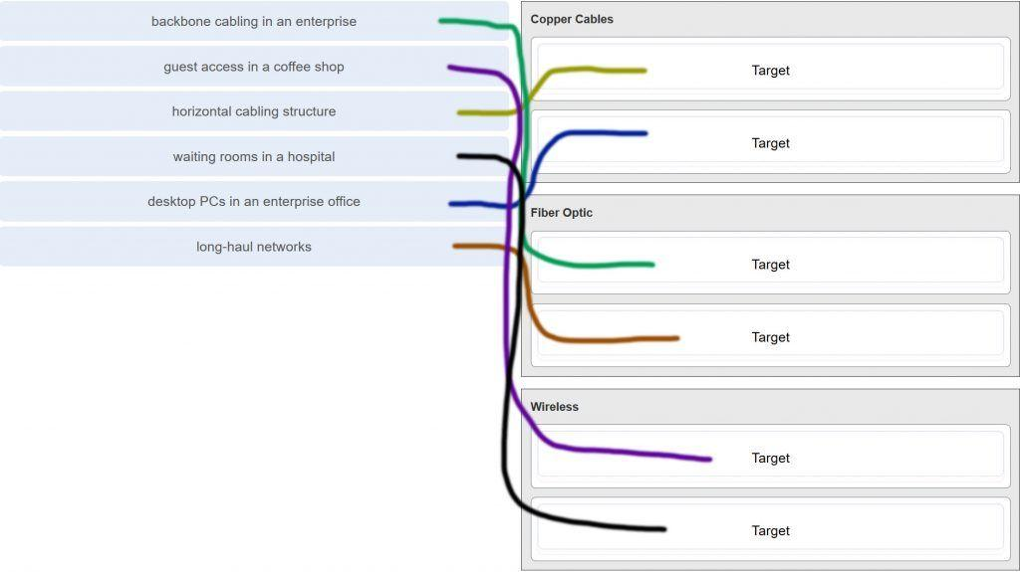

CCNA 1 v7.0 Modules 4 – 7 Exam Answers p5

**6. A network administrator is measuring the transfer of bits across the company backbone for a mission critical financial application. The administrator notices that the network throughput appears lower than the bandwidth expected. Which three factors could influence the differences in throughput? (Choose three.)**

**the amount of traffic that is currently crossing the network\***  
the sophistication of the encapsulation method applied to the data  
**the type of traffic that is crossing the network\***  
**the latency that is created by the number of network devices that the data is crossing\***  
the bandwidth of the WAN connection to the Internet  
the reliability of the gigabit Ethernet infrastructure of the backbone

**7. What are two characteristics of fiber-optic cable? (Choose two.)**

**It is not affected by EMI or RFI.\***  
Each pair of cables is wrapped in metallic foil.  
It combines the technique of cancellation, shielding, and twisting to protect data.  
It typically contains 4 pairs of fiber-optic wires.  
**It is more expensive than UTP cabling is.\***

**8. What is a primary role of the Physical layer in transmitting data on the network?**

**create the signals that represent the bits in each frame on to the media\***  
provide physical addressing to the devices  
determine the path packets take through the network  
control data access to the media

**Explanation:** The OSI physical layer provides the means to transport the bits that make up a frame across the network media. This layer accepts a complete frame from the data link layer and encodes it as a series of signals that are transmitted to the local media.

**9. With the use of unshielded twisted-pair copper wire in a network, what causes crosstalk within the cable pairs?**

**the magnetic field around the adjacent pairs of wire\***  
the use of braided wire to shield the adjacent wire pairs  
the reflection of the electrical wave back from the far end of the cable  
the collision caused by two nodes trying to use the media simultaneously

**Explanation:** Crosstalk is a type of noise, or interference that occurs when signal transmission on one wire interferes with another wire. When current flows through a wire a magnetic field is produced. The produced magnetic field will interface the signal carried in the adjacent wire.

**10. Refer to the graphic.**

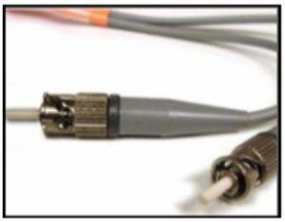

CCNA 1 v7.0 Modules 4 – 7 Exam Answers p10

**What type of cabling is shown?**

STP  
UTP  
coax  
**fiber\***

**Explanation:** Network cabling include different types of cables:  
UTP cable consists of four pairs of color-coded wires that have been twisted together and then encased in a flexible plastic sheath.  
STP cable uses four pairs of wires, each wrapped in a foil shield, which are then wrapped in an overall metallic braid or foil.  
Coaxial cable uses a copper conductor and a layer of flexible plastic insulation surrounds the copper conductor.  
Fiber cable is a flexible, extremely thin, transparent strand of glass surrounded by plastic insulation.

**11. In addition to the cable length, what two factors could interfere with the communication carried over UTP cables? (Choose two.)**

**Crosstalk\***  
bandwidth  
size of the network  
signal modulation technique  
**electromagnetic interference\***

**Explanation:** Copper media is widely used in network communications. However, copper media is limited by distance and signal interference. Data is transmitted on copper cables as electrical pulses. The electrical pulses are susceptible to interference from two sources:  
Electromagnetic interference (EMI) or radio frequency interference (RFI) – EMI and RFI signals can distort and corrupt the data signals being carried by copper media.  
Crosstalk – Crosstalk is a disturbance caused by the electric or magnetic fields of a signal on one wire interfering with the signal in an adjacent wire.

**12. Refer to the graphic.**

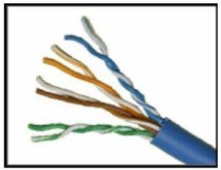

CCNA 1 v7.0 Modules 4 – 7 Exam Answers p12

**What type of cabling is shown?**

STP  
**UTP\***  
coax  
fiber

**13. Which two devices commonly affect wireless networks? (Choose two.)**

Blu-ray players  
home theaters  
**cordless phones\***  
**microwaves\***  
incandescent light bulbs  
external hard drives

**Explanation:** Radio Frequency Interference (RFI) is the interference that is caused by radio transmitters and other devices that are transmitting in the same frequency.

**14. Which two statements describe the services provided by the data link layer? (Choose two.)**

It defines the end-to-end delivery addressing scheme.  
It maintains the path between the source and destination devices during the data transmission.  
**It manages the access of frames to the network media.\***  
It provides reliable delivery through link establishment and flow control.  
It ensures that application data will be transmitted according to the prioritization.  
**It packages various Layer 3 PDUs into a frame format that is compatible with the network interface.\***

**Explanation:** The data link layer is divided into two sub layers, namely Logical Link Control (LLC) and Media Access Control (MAC). LLC forms a frame from the network layer PDU into a format that conforms to the requirements of the network interface and media. A network layer PDU might be for IPv4 or IPv6. The MAC sub layer defines the media access processes performed by the hardware. It manages the frame access to the network media according to the physical signaling requirements (copper cable, fiber optic, wireless, etc.)

**15. What is the function of the CRC value that is found in the FCS field of a frame?**

**to verify the integrity of the received frame\***  
to verify the physical address in the frame  
to verify the logical address in the frame  
to compute the checksum header for the data field in the frame

**16. What is contained in the trailer of a data-link frame?**

logical address  
physical address  
data  
**error detection\***

**17. Which statement describes a characteristic of the frame header fields of the data link layer?**

They all include the flow control and logical connection fields.  
Ethernet frame header fields contain Layer 3 source and destination addresses.  
**They vary depending on protocols.\***  
They include information on user applications.

**Explanation:** All data link layer protocols encapsulate the Layer 3 PDU within the data field of the frame. However, the structure of the frame and the fields that are contained in the header vary according to the protocol. Different data link layer protocols may use different fields, like priority/quality of service, logical connection control, physical link control, flow control, and congestion control.

**18. A network team is comparing physical WAN topologies for connecting remote sites to a headquarters building. Which topology provides high availability and connects some, but not all, remote sites?**

mesh  
**partial mesh\***  
hub and spoke  
point-to-point

**Explanation:** Partial mesh topologies provide high availability by interconnecting multiple remote sites, but do not require a connection between all remote sites. A mesh topology requires point-to-point links with every system being connected to every other system. A point-to-point topology is where each device is connected to one other device. A hub and spoke uses a central device in a star topology that connects to other point-to-point devices.

**19. Which two fields or features does Ethernet examine to determine if a received frame is passed to the data link layer or discarded by the NIC? (Choose two.)**

auto-MDIX  
CEF  
**Frame Check Sequence\***  
**minimum frame size\***  
source MAC address

**20. Which media communication type does not require media arbitration in the data link layer?**

deterministic  
half-duplex  
**full-duplex\***  
controlled access

**Explanation:** Half-duplex communication occurs when both devices can both transmit and receive on the medium but cannot do so simultaneously. Full-duplex communication occurs when both devices can transmit and receive on the medium at the same time and therefore does not require media arbitration. Half-duplex communication is typically contention-based, whereas controlled (deterministic) access is applied in technologies where devices take turns to access the medium.

**21. Which statement describes an extended star topology?**

**End devices connect to a central intermediate device, which in turn connects to other central intermediate devices.\***  
End devices are connected together by a bus and each bus connects to a central intermediate device.  
Each end system is connected to its respective neighbor via an intermediate device.  
All end and intermediate devices are connected in a chain to each other.

**Explanation:** In an extended star topology, central intermediate devices interconnect other star topologies.

**22. What is a characteristic of the LLC sublayer?**

It provides the logical addressing required that identifies the device.  
It provides delimitation of data according to the physical signaling requirements of the medium.  
**It places information in the frame allowing multiple Layer 3 protocols to use the same network interface and media.\***  
It defines software processes that provide services to the physical layer.

**23. What are three ways that media access control is used in networking? (Choose three.)**

**Ethernet utilizes CSMA/CD.\***  
**Media access control provides placement of data frames onto the media.\***  
Contention-based access is also known as deterministic.  
802.11 utilizes CSMA/CD.  
**Data link layer protocols define the rules for access to different media.\***  
Networks with controlled access have reduced performance due to data collisions.

**24. During the encapsulation process, what occurs at the data link layer for a PC connected to an Ethernet network?**

An IP address is added.  
The logical address is added.  
**The physical address is added.\***  
The process port number is added.

**Explanation:** The Ethernet frame includes the source and destination physical address. The trailer includes a CRC value in the Frame Check Sequence field to allow the receiving device to determine if the frame has been changed (has errors) during the transmission.

**25. What three items are contained in an Ethernet header and trailer? (Choose three.)**

source IP address  
**source MAC address\***  
destination IP address  
**destination MAC address\***  
**error-checking information\***

**Explanation:** Layer 2 headers contain the following:  
Frame start and stop indicator flags at the beginning and end of a frame  
Addressing – for Ethernet networks this part of the header contains source and destination MAC addresses  
Type field to indicate what Layer 3 protocol is being used  
Error detection to determine if the frame arrived without error

**26. What type of communication rule would best describe CSMA/CD?**

**access method\***  
flow control  
message encapsulation  
message encoding

**Explanation:** Carrier sense multiple access collision detection (CSMA/CD) is the access method used with Ethernet. The access method rule of communication dictates how a network device is able to place a signal on the carrier. CSMA/CD dictates those rules on an Ethernet network and CSMA/CA dictates those rules on an 802.11 wireless LAN.

**27. Which three basic parts are common to all frame types supported by the data link layer? (Choose three.)**

**header\***  
type field  
MTU size  
**Data\***  
**Tráiler\***  
CRC value

**Explanation:** The data link protocol is responsible for NIC-to-NIC communications within the same network. Although there are many different data link layer protocols that describe data link layer frames, each frame type has three basic parts:  
Header  
Data  
Trailer

**28. Which statement is true about the CSMA/CD access method that is used in Ethernet?**

When a device hears a carrier signal and transmits, a collision cannot occur.  
A jamming signal causes only devices that caused the collision to execute a backoff algorithm.  
**All network devices must listen before transmitting.\***  
Devices involved in a collision get priority to transmit after the backoff period.

**29. What is the auto-MDIX feature on a switch?**

the automatic configuration of an interface for 10/100/1000 Mb/s operation  
**the automatic configuration of an interface for a straight-through or a crossover Ethernet cable connection\***  
the automatic configuration of full-duplex operation over a single Ethernet copper or optical cable  
the ability to turn a switch interface on or off accordingly if an active connection is detected

**Explanation:** The auto-MDIX enables a switch to use a crossover or a straight-through Ethernet cable to connect to a device regardless of the device on the other end of the connection.

**30. Refer to the exhibit.**

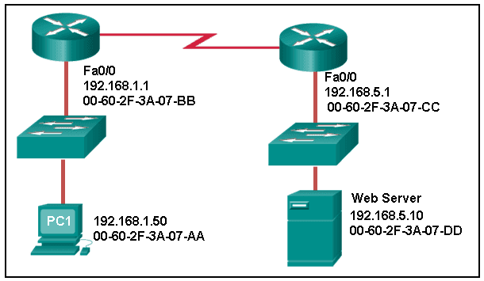

CCNA 1 v7.0 Modules 4 – 7 Exam Answers p30

**What is the destination MAC address of the Ethernet frame as it leaves the web server if the final destination is PC1?**

00-60-2F-3A-07-AA  
00-60-2F-3A-07-BB  
**00-60-2F-3A-07-CC\***  
00-60-2F-3A-07-DD

**Explanation:** The destination MAC address is used for local delivery of Ethernet frames. The MAC (Layer 2) address changes at each network segment along the path. As the frame leaves the web server, it will be delivered by using the MAC address of the default gateway.

**31. A Layer 2 switch is used to switch incoming frames from a 1000BASE-T port to a port connected to a 100Base-T network. Which method of memory buffering would work best for this task?**

port-based buffering  
level 1 cache buffering  
**shared memory buffering\***  
fixed configuration buffering

**32. What are two examples of the cut-through switching method? (Choose two.)**

store-and-forward switching  
**fast-forward switching\***  
CRC switching  
**fragment-free switching\***  
QOS switching

**33. Which frame forwarding method receives the entire frame and performs a CRC check to detect errors before forwarding the frame?**

cut-through switching  
**store-and-forward switching\***  
fragment-free switching  
fast-forward switching

**Explanation:** Fast-forward and fragment-free switching are variations of cut-through switching, which begins to forward the frame before the entire frame is received.

**34. What is the purpose of the FCS field in a frame?**

to obtain the MAC address of the sending node  
to verify the logical address of the sending node  
to compute the CRC header for the data field  
**to determine if errors occurred in the transmission and reception\***

**Explanation:** The FCS field in a frame is used to detect any errors in the transmission and receipt of a frame. This is done by comparing the CRC value within the frame against a computed CRC value of the frame. If the two values do not match, then the frame is discarded.

**35. Which switching method has the lowest level of latency?**

cut-through  
store-and-forward  
fragment-free  
**fast-forward\***

**Explanation:** Fast-forward switching begins to forward a frame after reading the destination MAC address, resulting in the lowest latency. Fragment-free reads the first 64 bytes before forwarding. Store-and-forward has the highest latency because it reads the entire frame before beginning to forward it. Both fragment-free and fast-forward are types of cut-through switching.

**36. A network administrator is connecting two modern switches using a straight-through cable. The switches are new and have never been configured. Which three statements are correct about the final result of the connection? (Choose three.)**

**The link between the switches will work at the fastest speed that is supported by both switches.\***  
**The link between switches will work as full-duplex.\***  
If both switches support different speeds, they will each work at their own fastest speed.  
**The auto-MDIX feature will configure the interfaces eliminating the need for a crossover cable.\***  
The connection will not be possible unless the administrator changes the cable to a crossover cable.  
The duplex capability has to be manually configured because it cannot be negotiated.

**Explanation:** Modern switches can negotiate to work in full-duplex mode if both switches are capable. They will negotiate to work using the fastest possible speed and the auto-MDIX feature is enabled by default, so a cable change is not needed.

**37. Which advantage does the store-and-forward switching method have compared with the cut-through switching method?**

collision detecting  
**frame error checking\***  
faster frame forwarding  
frame forwarding using IPv4 Layer 3 and 4 information

**Explanation:** A switch using the store-and-forward switching method performs an error check on an incoming frame by comparing the FCS value against its own FCS calculations after the entire frame is received. In comparison, a switch using the cut-through switching method makes quick forwarding decisions and starts the forwarding process without waiting for the entire frame to be received. Thus a switch using cut-through switching may send invalid frames to the network. The performance of store-and-forward switching is slower compared to cut-through switching performance. Collision detection is monitored by the sending device. Store-and-forward switching does not use IPv4 Layer 3 and 4 information for its forwarding decisions.

**38. When the store-and-forward method of switching is in use, what part of the Ethernet frame is used to perform an error check?**

**CRC in the tráiler\***  
source MAC address in the header  
destination MAC address in the header  
protocol type in the header

**39. Which switching method uses the CRC value in a frame?**

cut-through  
fast-forward  
fragment-free  
**store-and-forward\***

**Explanation:** When the store-and-forward switching method is used, the switch receives the complete frame before forwarding it on to the destination. The cyclic redundancy check (CRC) part of the trailer is used to determine if the frame has been modified during transit.​​ In contrast, a cut-through switch forwards the frame once the destination Layer 2 address is read. Two types of cut-through switching methods are fast-forward and fragment-free.

**40. What are two actions performed by a Cisco switch? (Choose two.)**

building a routing table that is based on the first IP address in the frame header  
**using the source MAC addresses of frames to build and maintain a MAC address table\***  
forwarding frames with unknown destination IP addresses to the default gateway  
**utilizing the MAC address table to forward frames via the destination MAC address\***  
examining the destination MAC address to add new entries to the MAC address table

**Explanation:** Important actions that a switch performs are as follows:  
When a frame comes in, the switch examines the Layer 2 source address to build and maintain the Layer 2 MAC address table.  
It examines the Layer 2 destination address to determine how to forward the frame. When the destination address is in the MAC address table, then the frame is sent out a particular port. When the address is unknown, the frame is sent to all ports that have devices connected to that network.

**41. Which two statements describe features or functions of the logical link control sublayer in Ethernet standards? (Choose two.)**

**Logical link control is implemented in software.\***  
Logical link control is specified in the IEEE 802.3 standard.  
The LLC sublayer adds a header and a trailer to the data.  
**The data link layer uses LLC to communicate with the upper layers of the protocol suite.\***  
The LLC sublayer is responsible for the placement and retrieval of frames on and off the media.

**Explanation:** Logical link control is implemented in software and enables the data link layer to communicate with the upper layers of the protocol suite. Logical link control is specified in the IEEE 802.2 standard. IEEE 802.3 is a suite of standards that define the different Ethernet types. The MAC (Media Access Control) sublayer is responsible for the placement and retrieval of frames on and off the media. The MAC sublayer is also responsible for adding a header and a trailer to the network layer protocol data unit (PDU).

**42. What is the auto-MDIX feature?**

**It enables a device to automatically configure an interface to use a straight-through or a crossover cable.\***  
It enables a device to automatically configure the duplex settings of a segment.  
It enables a device to automatically configure the speed of its interface.  
It enables a switch to dynamically select the forwarding method.

**43. What is one advantage of using the cut-through switching method instead of the store-and-forward switching method?**

has a positive impact on bandwidth by dropping most of the invalid frames  
makes a fast forwarding decision based on the source MAC address of the frame  
**has a lower latency appropriate for high-performance computing applications​\***  
provides the flexibility to support any mix of Ethernet speeds

**Explanation:** Cut-through switching provides lower latency switching for high-performance computing (HPC) applications. Cut-through switching allows more invalid frames to cross the network than store-and-forward switching. The cut-through switching method can make a forwarding decision as soon as it looks up the destination MAC address of the frame.

**44. Which is a multicast MAC address?**

FF-FF-FF-FF-FF-FF  
5C-26-0A-4B-19-3E  
**01-00-5E-00-00-03\***  
00-26-0F-4B-00-3E

**45. Refer to the exhibit.**

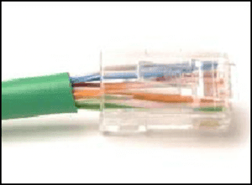

CCNA 1 v7.0 Modules 4 – 7 Exam Answers p45

**What is wrong with the displayed termination?**

The woven copper braid should not have been removed.  
The wrong type of connector is being used.  
**The untwisted length of each wire is too long.\***  
The wires are too thick for the connector that is used.

**Explanation:** When a cable to an RJ-45 connector is terminated, it is important to ensure that the untwisted wires are not too long and that the flexible plastic sheath surrounding the wires is crimped down and not the bare wires. None of the colored wires should be visible from the bottom of the jack.

**46. Refer to the exhibit.**

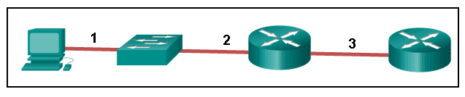

CCNA 1 v7.0 Modules 4 – 7 Exam Answers p46

**The PC is connected to the console port of the switch. All the other connections are made through FastEthernet links. Which types of UTP cables can be used to connect the devices?​**

1 – rollover, 2 – crossover, 3 – straight-through  
**1 – rollover, 2 – straight-through, 3 – crossover\***  
1 – crossover, 2 – straight-through, 3 – rollover  
1 – crossover, 2 – rollover, 3 – straight-through

**Explanation:** A straight-through cable is commonly used to interconnect a host to a switch and a switch to a router. A crossover cable is used to interconnect similar devices together like switch to a switch, a host to a host, or a router to a router. If a switch has the MDIX capability, a crossover could be used to connect the switch to the router; however, that option is not available. A rollover cable is used to connect to a router or switch console port.

**47. Open the PT Activity. Perform the tasks in the activity instructions and then answer the question.  
Which port does Switch0 use to send frames to the host with the IPv4 address 10.1.1.5?**

Fa0/1  
Fa0/5  
Fa0/9  
**Fa0/11\***

**Explanation:** Issuing the command ipconfig /all from the PC0 command prompt displays the IPv4 address and MAC address. When the IPv4 address 10.1.1.5 is pinged from PC0, the switch stores the source MAC address (from PC0) along with the port to which PC0 is connected. When the destination reply is received, the switch takes the destination MAC address and compares to MAC addresses stored in the MAC address table. Issuing the show mac-address-table on the PC0 Terminal application displays two dynamic MAC address entries. The MAC address and port entry that does not belong to PC0 must be the MAC address and port of the destination with the IPv4 address 10.1.1.5.

**48. What does the term “attenuation” mean in data communication?**

**loss of signal strength as distance increases\***  
time for a signal to reach its destination  
leakage of signals from one cable pair to another  
strengthening of a signal by a networking device

**Explanation:** Data is transmitted on copper cables as electrical pulses. A detector in the network interface of a destination device must receive a signal that can be successfully decoded to match the signal sent. However, the farther the signal travels, the more it deteriorates. This is referred to as signal attenuation.

**49. What makes fiber preferable to copper cabling for interconnecting buildings? (Choose three.)**

**greater distances per cable run\***  
lower installation cost  
**limited susceptibility to EMI/RFI\***  
durable connections  
**greater bandwidth potential\***  
easily terminated

**Explanation:** Optical fiber cable transmits data over longer distances and at higher bandwidths than any other networking media. Unlike copper wires, fiber-optic cable can transmit signals with less attenuation and is completely immune to EMI and RFI.

**50. What OSI physical layer term describes the process by which one wave modifies another wave?**

**Modulation\***  
IEEE  
EIA/TIA  
air

**51. What OSI physical layer term describes the capacity at which a medium can carry data?**

**Bandwidth\***  
IEEE  
EIA/TIA  
air

**52. What OSI physical layer term describes the capacity at which a medium can carry data?**

**Bandwidth\***  
throughput  
latency  
goodput

**53. What OSI physical layer term describes the measure of the transfer of bits across a medium over a given period of time?**

**Throughput\***  
bandwidth  
latency  
goodput

**54. What OSI physical layer term describes the amount of time, including delays, for data to travel from one point to another?**

**Latency\***  
bandwidth  
throughput  
goodput

**55. What OSI physical layer term describes the amount of time, including delays, for data to travel from one point to another?**

**Latency\***  
fiber-optic cable  
air  
copper cable

**56. What OSI physical layer term describes the measure of usable data transferred over a given period of time?**

**Goodput\***  
fiber-optic cable  
air  
copper cable

**57. What OSI physical layer term describes the physical medium which uses electrical pulses?**

**copper cable\***  
fiber-optic cable  
air  
goodput

**58. What OSI physical layer term describes the physical medium that uses the propagation of light?**

**fiber-optic cable\***  
goodput  
latency  
throughput

**59. What OSI physical layer term describes the physical medium for microwave transmissions?**

**Air\***  
goodput  
latency  
throughput

**60. Which two functions are performed at the MAC sublayer of the OSI data link layer? (Choose two.)**

**Implements a trailer to detect transmission errors.\***  
**Controls the NIC responsible for sending and receiving data on the physical medium.\***  
Places information in the frame that identifies which network layer protocol is being used for the frame.  
Adds Layer 2 control information to network protocol data.  
Enables IPv4 and IPv6 to utilize the same network interface and media.

**61. Which two functions are performed at the LLC sublayer of the OSI data link layer? (Choose two.)**

**Enables IPv4 and IPv6 to utilize the same network interface and media.\***  
**Places information in the frame that identifies which network layer protocol is being used for the frame.\***  
Integrates various physical technologies.  
Implements a process to delimit fields within a Layer 2 frame.  
Controls the NIC responsible for sending and receiving data on the physical medium.

**62. Which two functions are performed at the MAC sublayer of the OSI data link layer? (Choose two.)**

**Provides a mechanism to allow multiple devices to communicate over a shared medium.\***  
**Controls the NIC responsible for sending and receiving data on the physical medium.\***  
Places information in the frame that identifies which network layer protocol is being used for the frame.  
Adds Layer 2 control information to network protocol data.  
Communicates between the networking software at the upper layers and the device hardware at the lower layers.

**63. Which two functions are performed at the MAC sublayer of the OSI data link layer? (Choose two.)**

**Controls the NIC responsible for sending and receiving data on the physical medium.\***  
**Integrates various physical technologies.\***  
Communicates between the networking software at the upper layers and the device hardware at the lower layers.  
Adds Layer 2 control information to network protocol data.  
Places information in the frame that identifies which network layer protocol is being used for the frame.

**64. Which two functions are performed at the LLC sublayer of the OSI data link layer? (Choose two.)**

**Adds Layer 2 control information to network protocol data.\***  
**Places information in the frame that identifies which network layer protocol is being used for the frame.\***  
Performs data encapsulation.  
Controls the NIC responsible for sending and receiving data on the physical medium.  
Integrates various physical technologies.

**65. Which two functions are performed at the MAC sublayer of the OSI data link layer? (Choose two.)**

**Provides synchronization between source and target nodes.\***  
**Integrates various physical technologies.\***  
Communicates between the networking software at the upper layers and the device hardware at the lower layers.  
Adds Layer 2 control information to network protocol data.  
Enables IPv4 and IPv6 to utilize the same network interface and media.

**66. Which two functions are performed at the LLC sublayer of the OSI data link layer? (Choose two.)**

**Adds Layer 2 control information to network protocol data.\***  
**Enables IPv4 and IPv6 to utilize the same network interface and media.\***  
Provides data link layer addressing.  
Implements a trailer to detect transmission errors.  
Provides synchronization between source and target nodes.

**67. Which two functions are performed at the MAC sublayer of the OSI data link layer? (Choose two.)**

**Implements a trailer to detect transmission errors.\***  
**Provides synchronization between source and target nodes.\***  
Places information in the frame that identifies which network layer protocol is being used for the frame.  
Enables IPv4 and IPv6 to utilize the same network interface and media.  
Adds Layer 2 control information to network protocol data.

**68. Which two functions are performed at the LLC sublayer of the OSI data link layer? (Choose two.)**

**Enables IPv4 and IPv6 to utilize the same network interface and media.\***  
**Adds Layer 2 control information to network protocol data.\***  
Integrates various physical technologies.  
Implements a trailer to detect transmission errors.  
Provides synchronization between source and target nodes.

**69. Which two functions are performed at the MAC sublayer of the OSI data link layer? (Choose two.)**

**Provides a mechanism to allow multiple devices to communicate over a shared medium.\***  
**Controls the NIC responsible for sending and receiving data on the physical medium.\***  
Places information in the frame that identifies which network layer protocol is being used for the frame.  
Adds Layer 2 control information to network protocol data.  
Enables IPv4 and IPv6 to utilize the same network interface and media.

**70. What action will occur if a switch receives a frame and does have the source MAC address in the MAC table?**

**The switch refreshes the timer on that entry.\***  
The switch shares the MAC address table entry with any connected switches.  
The switch does not forward the frame.  
The switch sends the frame to a connected router because the destination MAC address is not local.

**71. What action will occur if a switch receives a frame with the destination MAC address FF:FF:FF:FF:FF:FF?**

**The switch forwards it out all ports except the ingress port.\***  
The switch shares the MAC address table entry with any connected switches.  
The switch does not forward the frame.  
The switch sends the frame to a connected router because the destination MAC address is not local.

**72. What action will occur if a host receives a frame with a destination MAC address it does not recognize?**

**The host will discard the frame.\***  
The host sends the frame to the switch to update the MAC address table.  
The host forwards the frame to the router.  
The host forwards the frame to all other hosts.

**73. What action will occur if a switch receives a frame with the destination MAC address 01:00:5E:00:00:D9?**

**The switch forwards it out all ports except the ingress port.\***  
The switch does not forward the frame.  
The switch sends the frame to a connected router because the destination MAC address is not local.  
The switch shares the MAC address table entry with any connected switches.

**74. What action will occur if a host receives a frame with a destination MAC address of FF:FF:FF:FF:FF:FF?**

**The host will process the frame.\***  
The host forwards the frame to the router.  
The host sends the frame to the switch to update the MAC address table.  
The host forwards the frame to all other hosts.

**75. What action will occur if a switch receives a frame and does have the source MAC address in the MAC table?**

**The switch refreshes the timer on that entry.\***  
The switch adds it to its MAC address table associated with the port number.  
The switch forwards the frame to the associated port.  
The switch sends the frame to a connected router because the destination MAC address is not local.

**76. What action will occur if a host receives a frame with a destination MAC address of FF:FF:FF:FF:FF:FF?**

**The host will process the frame.\***  
The host returns the frame to the switch.  
The host replies to the switch with its own IP address.  
The host forwards the frame to all other hosts.

**77. What action will occur if a switch receives a frame and does have the source MAC address in the MAC table?**

**The switch refreshes the timer on that entry.\***  
The switch shares the MAC address table entry with any connected switches.  
The switch does not forward the frame.  
The switch adds it to its MAC address table associated with the port number.

**78. What action will occur if a host receives a frame with a destination MAC address it does not recognize?**

**The host will discard the frame.\***  
The host replies to the switch with its own IP address.  
The host forwards the frame to all other hosts.  
The host returns the frame to the switch.

**79. What action will occur if a switch receives a frame with the destination MAC address FF:FF:FF:FF:FF:FF?**

**The switch forwards it out all ports except the ingress port.\***  
The switch refreshes the timer on that entry.  
The switch does not forward the frame.  
The switch sends the frame to a connected router because the destination MAC address is not local.

**Modules 4 – 7: Ethernet Concepts Exam Answers (Additional)**

**1. What is the purpose of the OSI physical layer?**

controlling access to media  
**transmitting bits across the local media\***  
performing error detection on received frames  
exchanging frames between nodes over physical network media

**2. Why are two strands of fiber used for a single fiber optic connection?**

The two strands allow the data to travel for longer distances without degrading.  
They prevent crosstalk from causing interference on the connection.  
They increase the speed at which the data can travel.  
**They allow for full-duplex connectivity.\***

**3. Which characteristic describes crosstalk?**

the distortion of the network signal from fluorescent lighting  
**the distortion of the transmitted messages from signals carried in adjacent wires\***  
the weakening of the network signal over long cable lengths  
the loss of wireless signal over excessive distance from the access point

**4. Which procedure is used to reduce the effect of crosstalk in copper cables?**

requiring proper grounding connections  
**twisting opposing circuit wire pairs together\***  
wrapping the bundle of wires with metallic shielding  
designing a cable infrastructure to avoid crosstalk interference  
avoiding sharp bends during installation

**5. Which type of UTP cable is used to connect a PC to a switch port?**

console  
rollover  
crossover  
**straight-through\***

**6. What is the definition of bandwidth?**

the measure of the transfer of bits across the media over a given period of time  
the speed at which bits travel on the network  
**the amount of data that can flow from one place to another in a given amount of time\***  
the measure of usable data transferred over a given period of time

**7. Which statement correctly describes frame encoding?**

It uses the characteristic of one wave to modify another wave.  
It transmits data signals along with a clock signal which occurs at evenly spaced time durations.  
It generates the electrical, optical, or wireless signals that represent the binary numbers of the frame.  
**It converts bits into a predefined code in order to provide a predictable pattern to help distinguish data bits from control bits.\***

**8. What is a characteristic of UTP cabling?**

**Cancellation\***  
cladding  
immunity to electrical hazards  
woven copper braid or metallic foil

**9. A wireless LAN is being deployed inside the new one room office that is occupied by the park ranger. The office is located at the highest part of the national park. After network testing is complete, the technicians report that the wireless LAN signal is occasionally affected by some type of interference. What are two possible causes of the signal distortion? (Choose two.)**

**the microwave oven\***  
the large number of trees that surround the office  
**the cellular phones that are used by the employees\***  
the elevated location where the wireless LAN was installed  
the number of wireless devices that are used in the wireless LAN

**10. What is indicated by the term throughput?**

the guaranteed data transfer rate offered by an ISP  
the capacity of a particular medium to carry data  
the measure of the usable data transferred across the media  
**the measure of the bits transferred across the media over a given period of time\***  
the time it takes for a message to get from sender to receiver

**11. What is one advantage of using fiber optic cabling rather than copper cabling?**

It is usually cheaper than copper cabling.  
It is able to be installed around sharp bends.  
It is easier to terminate and install than copper cabling.  
**It is able to carry signals much farther than copper cabling.\***

**12. Which standards organization oversees development of wireless LAN standards?**

IANA  
**IEEE\***  
ISO  
TIA

**13. A network administrator is designing a new network infrastructure that includes both wired and wireless connectivity. Under which situation would a wireless connection be recommended?**

The end-user device only has an Ethernet NIC.  
The end-user device requires a dedicated connection because of performance requirements.  
**The end-user device needs mobility when connecting to the network.\***  
The end-user device area has a high concentration of RFI.

**14. A network administrator is troubleshooting connectivity issues on a server. Using a tester, the administrator notices that the signals generated by the server NIC are distorted and not usable. In which layer of the OSI model is the error categorized?**

presentation layer  
network layer  
**physical layer\***  
data link layer

**15. What type of cable is used to connect a workstation serial port to a Cisco router console port?**

crossover  
**rollover\***  
straight-through  
coaxial

**16. What is the binary representation for the decimal number 173?**

10100111  
10100101  
**10101101\***  
10110101

**17. Given the binary address of 11101100 00010001 00001100 00001010, which address does this represent in dotted decimal format?**

234.17.10.9  
234.16.12.10  
236.17.12.6  
**236.17.12.10\***

**18. How many binary bits exist within an IPv6 address?**

32  
48  
64  
128*  
256

**19. What is the binary equivalent of the decimal number 232?**

**11101000\***  
11000110  
10011000  
11110010

**20. Which two statements are correct about IPv4 and IPv6 addresses? (Choose two.)**

**IPv6 addresses are represented by hexadecimal numbers.\***  
IPv4 addresses are represented by hexadecimal numbers.  
IPv6 addresses are 32 bits in length.  
**IPv4 addresses are 32 bits in length.\***  
IPv4 addresses are 128 bits in length.  
IPv6 addresses are 64 bits in length.

**21. Which IPv4 address format was created for ease of use by people and is expressed as 201.192.1.14?**

binary  
**dotted decimal\***  
hexadecimal  
ASCII

**22. What is the dotted decimal representation of the IPv4 address 11001011.00000000.01110001.11010011?**

192.0.2.199  
198.51.100.201  
**203.0.113.211\***  
209.165.201.223

**23. What is the decimal equivalent of the binary number 10010101?**

**149\***  
157  
168  
192

**24. What is the decimal equivalent of the hex number 0x3F?**

**63\***  
77  
87  
93

**25. What is the dotted decimal representation of the IPv4 address which is represented as the binary string 00001010.01100100.00010101.00000001?**

**10.100.21.1\***  
10.10.20.1  
100.10.11.1  
100.21.10.1

**26. What is the decimal equivalent of 0xC9?**

185  
200  
**201\***  
199

**27. Which is a valid hexadecimal number?**

**F\***  
g  
h  
j

**28. What is the binary representation of 0xCA?**

10111010  
11010101  
**11001010\***  
11011010

**29. How many bits are in an IPv4 address?**

**32\***  
64  
128  
256

**30. What identifier is used at the data link layer to uniquely identify an Ethernet device?**

IP address  
**MAC address\***  
sequence number  
TCP port number  
UDP port number

**31. Which two engineering organizations define open standards and protocols that apply to the data link layer? (Choose two.)**

**International Organization for Standardization (ISO)\***  
Internet Assigned Numbers Authority (IANA)  
**International Telecommunication Union (ITU)\***  
Electronic Industries Alliance (EIA)  
Internet Society (ISOC)

**32. Which layer of the OSI model is responsible for specifying the encapsulation method used for specific types of media?**

application  
transport  
**data link\***  
physical

**33. What is true concerning physical and logical topologies?**

The logical topology is always the same as the physical topology.  
Physical topologies are concerned with how a network transfers frames.  
Physical topologies display the IP addressing scheme of each network.  
**Logical topologies refer to how a network transfers data between devices.\***

**34. What type of physical topology can be created by connecting all Ethernet cables to a central device?**

bus  
ring  
**star\***  
mesh

**35. A technician has been asked to develop a physical topology for a network that provides a high level of redundancy. Which physical topology requires that every node is attached to every other node on the network?**

bus  
hierarchical  
**mesh\***  
ring  
star

**36. Which statement describes the half-duplex mode of data transmission?**

Data that is transmitted over the network can only flow in one direction.  
**Data that is transmitted over the network flows in one direction at a time.\***  
Data that is transmitted over the network flows in one direction to many different destinations simultaneously.  
Data that is transmitted over the network flows in both directions at the same time.

**37. Which is a function of the Logical Link Control (LLC) sublayer?**

to define the media access processes that are performed by the hardware  
to provide data link layer addressing  
**to identify which network layer protocol is being used\***  
to accept segments and package them into data units that are called packets

**38. Which data link layer media access control method does Ethernet use?**

**CSMA/CD\***  
determinism  
turn taking  
token passing

**39. What are the two sublayers of the OSI model data link layer? (Choose two.)**

internet  
physical  
**LLC\***  
transport  
**MAC\***  
network access

**40. What method is used to manage contention-based access on a wireless network?**

CSMA/CD  
priority ordering  
**CSMA/CA\***  
token passing

**41. What are two services performed by the data link layer of the OSI model? (Choose two.)**

It encrypts data packets.  
It determines the path to forward packets.  
**It accepts Layer 3 packets and encapsulates them into frames.\***  
**It provides media access control and performs error detection.\***  
It monitors the Layer 2 communication by building a MAC address table.

**42. What does a router do after de-encapsulating a received frame?**

**determines the best path\***  
de-encapsulates the frame  
re-encapsulates the packet into a new frame  
forwards the new frame onto the network medium

**43. What attribute of a NIC would place it at the data link layer of the OSI model?**

attached Ethernet cable  
IP address  
**MAC address\***  
RJ-45 port  
TCP/IP protocol stack

**44. Although CSMA/CD is still a feature of Ethernet, why is it no longer necessary?**

the virtually unlimited availability of IPv6 addresses  
the use of CSMA/CA  
**the use of full-duplex capable Layer 2 switches\***  
the development of half-duplex switch operation  
the use of Gigabit Ethernet speeds

**45. Which network device makes forwarding decisions based on the destination MAC address that is contained in the frame?**

repeater  
hub  
**switch\***  
router

**46. Which network device has the primary function to send data to a specific destination based on the information found in the MAC address table?**

hub  
router  
**switch\***  
modem

**47. Which function or operation is performed by the LLC sublayer?**

It performs data encapsulation.  
**It communicates with upper protocol layers.\***  
It is responsible for media access control.  
It adds a header and trailer to a packet to form an OSI Layer 2 PDU.

**48. Which statement is true about MAC addresses?**

MAC addresses are implemented by software.  
A NIC only needs a MAC address if connected to a WAN.  
**The first three bytes are used by the vendor assigned OUI.\***  
The ISO is responsible for MAC addresses regulations.

**49. What happens to runt frames received by a Cisco Ethernet switch?**

**The frame is dropped.\***  
The frame is returned to the originating network device.  
The frame is broadcast to all other devices on the same network.  
The frame is sent to the default gateway.

**50. What are the two sizes (minimum and maximum) of an Ethernet frame? (Choose two.)**

56 bytes  
**64 bytes\***  
128 bytes  
1024 bytes  
**1518 bytes\***

**51. What addressing information is recorded by a switch to build its MAC address table?**

the destination Layer 3 address of incoming packets  
the destination Layer 2 address of outgoing frames  
the source Layer 3 address of outgoing packets  
**the source Layer 2 address of incoming frames\***

**52. Which two characteristics describe Ethernet technology? (Choose two.)**

**It is supported by IEEE 802.3 standards.\***  
It is supported by IEEE 802.5 standards.  
It typically uses an average of 16 Mb/s for data transfer rates.  
**It uses the CSMA/CD access control method.\***  
It uses a ring topology.

**53. What statement describes a characteristic of MAC addresses?**

**They must be globally unique.\***  
They are only routable within the private network.  
They are added as part of a Layer 3 PDU.  
They have a 32-bit binary value.

**54. What is the special value assigned to the first 24 bits of a multicast MAC address?**

01-5E-00  
FF-00-5E  
FF-FF-FF  
**01-00-5E\***

**55. What will a host on an Ethernet network do if it receives a frame with a destination MAC address that does not match its own MAC address?**

**It will discard the frame.\***  
It will forward the frame to the next host.  
It will remove the frame from the media.  
It will strip off the data-link frame to check the destination IP address.

**56. What is auto-MDIX?**

a type of Cisco switch  
an Ethernet connector type  
a type of port on a Cisco switch  
**a feature that detects Ethernet cable typ​e\***

**57. Which two functions or operations are performed by the MAC sublayer? (Choose two.)**

**It is responsible for Media Access Control.\***  
It performs the function of NIC driver software.  
**It adds a header and trailer to form an OSI Layer 2 PDU.\***  
It handles communication between upper and lower layers.  
It adds control information to network protocol layer data.

**58. What type of address is 01-00-5E-0A-00-02?**

an address that reaches every host inside a local subnet  
an address that reaches one specific host  
an address that reaches every host in the network  
**an address that reaches a specific group of hosts\***

[**HOME**](https://www.ccnaexam.net/)

[**CCNA 1 V7.0**](https://www.ccnaexam.net/category/ccna-1-v7-0)

CCNA 1 V7 Modules 8 – 10 Free Exam Answers

[**CCNA 1 V7.0**](https://www.ccnaexam.net/category/ccna-1-v7-0)

**CCNA 1 v7 Modules 8 – 10 Free Exam Answers**

[**CCNAv7**](https://www.ccnaexam.net/author/ccnav7)**December 30, 2019**

**CCNA 1 v7 Modules 8 – 10: Communicating Between Networks Exam Answers**

**1. Which information is used by routers to forward a data packet toward its destination?**

source IP address  
**destination IP address\***  
source data-link address  
destination data-link address

**2. A computer has to send a packet to a destination host in the same LAN. How will the packet be sent?**

The packet will be sent to the default gateway first, and then, depending on the response from the gateway, it may be sent to the destination host.  
**The packet will be sent directly to the destination host.\***  
The packet will first be sent to the default gateway, and then from the default gateway it will be sent directly to the destination host.  
The packet will be sent only to the default gateway.

**3. A router receives a packet from the Gigabit 0/0 interface and determines that the packet needs to be forwarded out the Gigabit 0/1 interface. What**

will the router do next?  
route the packet out the Gigabit 0/1 interface  
**create a new Layer 2 Ethernet frame to be sent to the destination\***  
look into the ARP cache to determine the destination IP address  
look into the routing table to determine if the destination network is in the routing table

**4. Which IPv4 address can a host use to ping the loopback interface?**

126.0.0.1  
127.0.0.0  
126.0.0.0  
**127.0.0.1\***

**5. A computer can access devices on the same network but cannot access devices on other networks. What is the probable cause of this problem?**

The cable is not connected properly to the NIC.  
The computer has an invalid IP address.  
The computer has an incorrect subnet mask.  
**The computer has an invalid default gateway address.\***

**6. Which statement describes a feature of the IP protocol?**

IP encapsulation is modified based on network media.  
IP relies on Layer 2 protocols for transmission error control.  
MAC addresses are used during the IP packet encapsulation.  
**IP relies on upper layer services to handle situations of missing or out-of-order packets.\***

**Explanation:** IP protocol is a connection-less protocol, considered unreliable in terms of end-to-end delivery. It does not provide error control in the cases where receiving packets are out-of-order or in cases of missing packets. It relies on upper layer services, such as TCP, to resolve these issues.

**7. Why is NAT not needed in IPv6?​**

Because IPv6 has integrated security, there is no need to hide the IPv6 addresses of internal networks.​  
**Any host or user can get a public IPv6 network address because the number of available IPv6 addresses is extremely large.​\***  
The problems that are induced by NAT applications are solved because the IPv6 header improves packet handling by intermediate routers.​  
The end-to-end connectivity problems that are caused by NAT are solved because the number of routes increases with the number of nodes that are connected to the Internet.

**8. Which parameter does the router use to choose the path to the destination when there are multiple routes available?**

**the lower metric value that is associated with the destination network\***  
the lower gateway IP address to get to the destination network  
the higher metric value that is associated with the destination network  
the higher gateway IP address to get to the destination network

**9. What are two services provided by the OSI network layer? (Choose two.)**

performing error detection  
**routing packets toward the destination\***  
**encapsulating PDUs from the transport layer\***  
placement of frames on the media  
collision detection

**Explanation:** The OSI network layer provides several services to allow communication between devices:  
addressing  
encapsulation  
routing  
de-encapsulation  
Error detection, placing frames on the media, and collision detection are all functions of the data ink layer.

**10. Within a production network, what is the purpose of configuring a switch with a default gateway address?**

Hosts that are connected to the switch can use the switch default gateway address to forward packets to a remote destination.  
A switch must have a default gateway to be accessible by Telnet and SSH.  
**The default gateway address is used to forward packets originating from the switch to remote networks.\***  
It provides a next-hop address for all traffic that flows through the switch.

**Explanation:** A default gateway address allows a switch to forward packets that originate on the switch to remote networks. A default gateway address on a switch does not provide Layer 3 routing for PCs that are connected on that switch. A switch can still be accessible from Telnet as long as the source of the Telnet connection is on the local network.

**11. What is a basic characteristic of the IP protocol?**

**Connectionless\***  
media dependent  
user data segmentation  
reliable end-to-end delivery

**Explanation:** Internet Protocol (IP) is a network layer protocol that does not require initial exchange of control information to establish an end-to-end connection before packets are forwarded. Thus, IP is connectionless and does not provide reliable end-to-end delivery by itself. IP is media independent. User data segmentation is a service provided at the transport layer.

**12. Which field in the IPv4 header is used to prevent a packet from traversing a network endlessly?**

**Time-to-Live\***  
Sequence Number  
Acknowledgment Number  
Differentiated Services

**Explanation:** The value of the Time-to-Live (TTL) field in the IPv4 header is used to limit the lifetime of a packet. The sending host sets the initial TTL value; which is decreased by one each time the packet is processed by a router. If the TTL field decrements to zero, the router discards the packet and sends an Internet Control Message Protocol (ICMP) Time Exceeded message to the source IP address. The Differentiated Services (DS) field is used to determine the priority of each packet. Sequence Number and Acknowledgment Number are two fields in the TCP header.

**13. What is one advantage that the IPv6 simplified header offers over IPv4?**

smaller-sized header  
little requirement for processing checksums  
smaller-sized source and destination IP addresses  
**efficient packet handling\***

**Explanation:** The IPv6 simplified header offers several advantages over IPv4:  
Better routing efficiency and efficient packet handling for performance and forwarding-rate scalability  
No requirement for processing checksums  
Simplified and more efficient extension header mechanisms (as opposed to the IPv4 Options field)  
A Flow Label field for per-flow processing with no need to open the transport inner packet to identify the various traffic flows

**14. What IPv4 header field identifies the upper layer protocol carried in the packet?**

**Protocol\***  
Identification  
Version  
Differentiated Services

**Explanation:** It is the Protocol field in the IP header that identifies the upper-layer protocol the packet is carrying. The Version field identifies the IP version. The Differential Services field is used for setting packet priority. The Identification field is used to reorder fragmented packets.

**15. Refer to the exhibit. Match the packets with their destination IP address to the exiting interfaces on the router. (Not all targets are used.)**

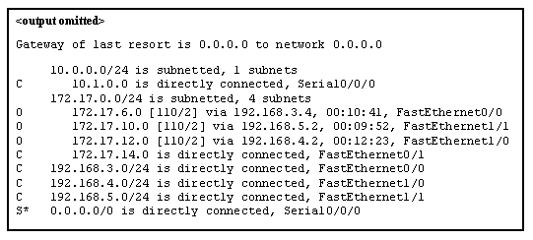

CCNA 1 v7.0 Modules 8 – 10 Exam Answers p15-1

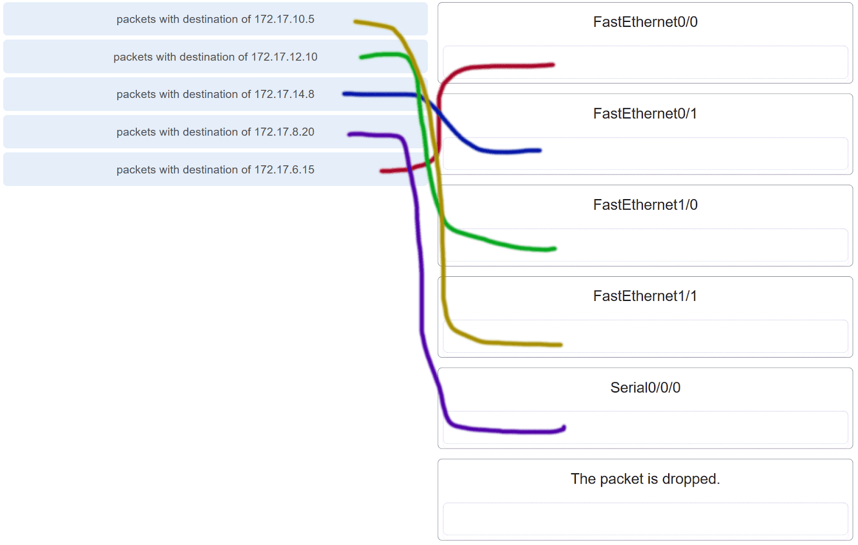

CCNA 1 v7.0 Modules 8 – 10 Exam Answers p15-2

**Explanation:** Packets with a destination of 172.17.6.15 are forwarded through Fa0/0. Packets with a destination of 172.17.10.5 are forwarded through Fa1/1. Packets with a destination of 172.17.12.10 are forwarded through Fa1/0. Packets with a destination of 172.17.14.8 are forwarded through Fa0/1. Because network 172.17.8.0 has no entry in the routing table, it will take the gateway of last resort, which means that packets with a destination of 172.17.8.20 are forwarded through Serial0/0/0. Because a gateway of last resort exists, no packets will be dropped.

**16. What information does the loopback test provide?**

**The TCP/IP stack on the device is working correctly.\***  
The device has end-to-end connectivity.  
DHCP is working correctly.  
The Ethernet cable is working correctly.  
The device has the correct IP address on the network.

**17. What routing table entry has a next hop address associated with a destination network?**

directly-connected routes  
local routes  
**remote routes\***  
C and L source routes

**18. How do hosts ensure that their packets are directed to the correct network destination?**

**They have to keep their own local routing table that contains a route to the loopback interface, a local network route, and a remote default route.​\***  
They always direct their packets to the default gateway, which will be responsible for the packet delivery.  
They search in their own local routing table for a route to the network destination address and pass this information to the default gateway.  
They send a query packet to the default gateway asking for the best route.

**19. When transporting data from real-time applications, such as streaming audio and video, which field in the IPv6 header can be used to inform the routers and switches to maintain the same path for the packets in the same conversation?**

Next Header  
**Flow Label\***  
Traffic Class  
Differentiated Services

**Explanation:** The Flow Label in IPv6 header is a 20-bit field that provides a special service for real-time applications. This field can be used to inform routers and switches to maintain the same path for the packet flow so that packets will not be reordered.

**20. What statement describes the function of the Address Resolution Protocol?**

ARP is used to discover the IP address of any host on a different network.  
ARP is used to discover the IP address of any host on the local network.  
ARP is used to discover the MAC address of any host on a different network.  
**ARP is used to discover the MAC address of any host on the local network.\***

**21. Under which two circumstances will a switch flood a frame out of every port except the port that the frame was received on? (Choose two.)**

**The frame has the broadcast address as the destination address.\***  
**The destination address is unknown to the switch.\***  
The source address in the frame header is the broadcast address.  
The source address in the frame is a multicast address.  
The destination address in the frame is a known unicast address.

**Explanation:** A switch will flood a frame out of every port, except the one that the frame was received from, under two circumstances. Either the frame has the broadcast address as the destination address, or the destination address is unknown to the switch.

**22. Which statement describes the treatment of ARP requests on the local link?**

They must be forwarded by all routers on the local network.  
**They are received and processed by every device on the local network.\***  
They are dropped by all switches on the local network.  
They are received and processed only by the target device.

**Explanation:** One of the negative issues with ARP requests is that they are sent as a broadcast. This means all devices on the local link must receive and process the request.

**23. Which destination address is used in an ARP request frame?**

0.0.0.0  
255.255.255.255  
**FFFF.FFFF.FFFF\***  
AAAA.AAAA.AAAA  
the physical address of the destination host

**Explanation:** The purpose of an ARP request is to find the MAC address of the destination host on an Ethernet LAN. The ARP process sends a Layer 2 broadcast to all devices on the Ethernet LAN. The frame contains the IP address of the destination and the broadcast MAC address, FFFF.FFFF.FFFF. The host with the IP address that matches the IP address in the ARP request will reply with a unicast frame that includes the MAC address of the host. Thus the original sending host will obtain the destination IP and MAC address pair to continue the encapsulation process for data transmission.

**24. A network technician issues the arp -d * command on a PC after the router that is connected to the LAN is reconfigured. What is the result after this command is issued?**

**The ARP cache is cleared.\***  
The current content of the ARP cache is displayed.  
The detailed information of the ARP cache is displayed.  
The ARP cache is synchronized with the router interface.

**Explanation:** Issuing the arp –d * command on a PC will clear the ARP cache content. This is helpful when a network technician wants to ensure the cache is populated with updated information.

**25. Refer to the exhibit.**

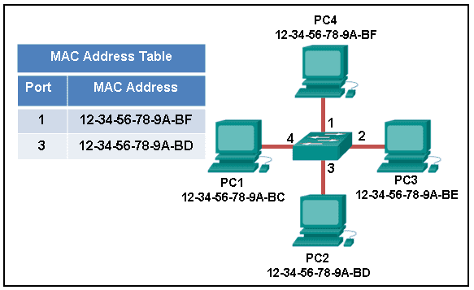

CCNA 1 v7.0 Modules 8 – 10 Exam Answers p25

**The exhibit shows a small switched network and the contents of the MAC address table of the switch. PC1 has sent a frame addressed to PC3. What will the switch do with the frame?**

The switch will discard the frame.  
The switch will forward the frame only to port 2.  
**The switch will forward the frame to all ports except port 4.\***  
The switch will forward the frame to all ports.  
The switch will forward the frame only to ports 1 and 3.

**Explanation:** The MAC address of PC3 is not present in the MAC table of the switch. Because the switch does not know where to send the frame that is addressed to PC3, it will forward the frame to all the switch ports, except for port 4, which is the incoming port.

**26. Which two types of IPv6 messages are used in place of ARP for address resolution?**

anycast  
broadcast  
echo reply  
echo request  
**neighbor solicitation\***  
**neighbor advertisement\***

**Explanation:** IPv6 does not use ARP. Instead, ICMPv6 neighbor discovery is used by sending neighbor solicitation and neighbor advertisement messages.

**27. What is the aim of an ARP spoofing attack?**

to flood the network with ARP reply broadcasts  
to fill switch MAC address tables with bogus addresses  
**to associate IP addresses to the wrong MAC address\***  
to overwhelm network hosts with ARP requests

**28. Refer to the exhibit.**

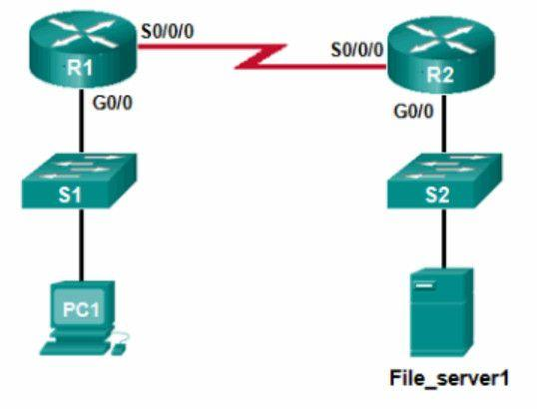

CCNA 1 v7.0 Modules 8 – 10 Exam Answers p28

**PC1 attempts to connect to File_server1 and sends an ARP request to obtain a destination MAC address. Which MAC address will PC1 receive in the ARP reply?**

the MAC address of S1  
**the MAC address of the G0/0 interface on R1\***  
the MAC address of the G0/0 interface on R2  
the MAC address of S2  
the MAC address of File_server1

**29. Where are IPv4 address to Layer 2 Ethernet address mappings maintained on a host computer?**

neighbor table  
**ARP cache\***  
routing table  
MAC address table

**30. What important information is examined in the Ethernet frame header by a Layer 2 device in order to forward the data onward?**

source MAC address  
source IP address  
**destination MAC address\***  
Ethernet type  
destination IP address

**Explanation:** The Layer 2 device, such as a switch, uses the destination MAC address to determine which path (interface or port) should be used to send the data onward to the destination device.

**31. Match the commands to the correct actions. (Not all options are used.)**

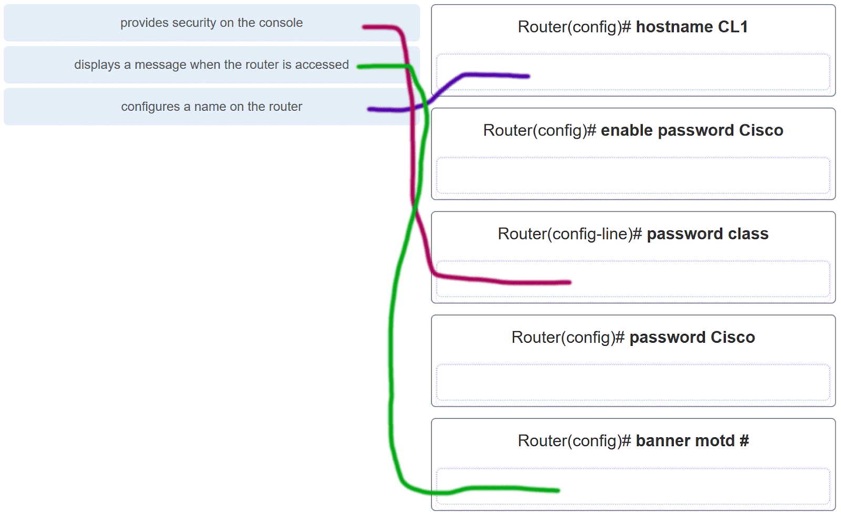

CCNA 1 v7.0 Modules 8 – 10 Exam Answers p31

**32. A new network administrator has been asked to enter a banner message on a Cisco device. What is the fastest way a network administrator could test whether the banner is properly configured?**

Reboot the device.  
Enter CTRL-Z at the privileged mode prompt.  
Exit global configuration mode.  
Power cycle the device.  
**Exit privileged EXEC mode and press Enter.\***

**Explanation:** While at the privileged mode prompt such as Router#, type exit,press Enter, and the banner message appears. Power cycling a network device that has had the banner motd command issued will also display the banner message, but this is not a quick way to test the configuration.

**33. A network administrator requires access to manage routers and switches locally and remotely. Match the description to the access method. (Not all options are used.)**

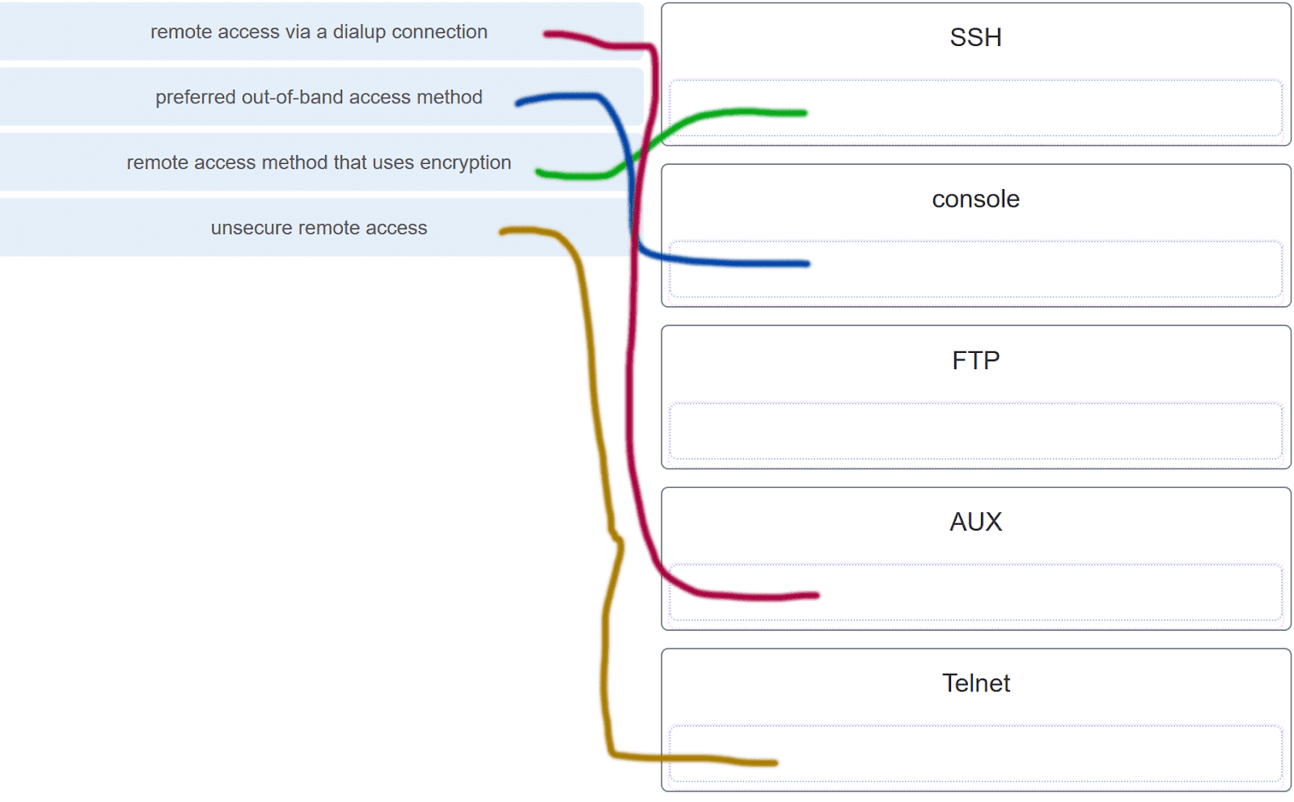

CCNA 1 v7.0 Modules 8 – 10 Exam Answers p33

**Explanation:** Both the console and AUX ports can be used to directly connect to a Cisco network device for management purposes. However, it is more common to use the console port. The AUX port is more often used for remote access via a dial up connection. SSH and Telnet are both remote access methods that depend on an active network connection. SSH uses a stronger password authentication than Telnet uses and also uses encryption on transmitted data.

**34. Match the phases to the functions during the boot up process of a Cisco router. (Not all options are used.)**

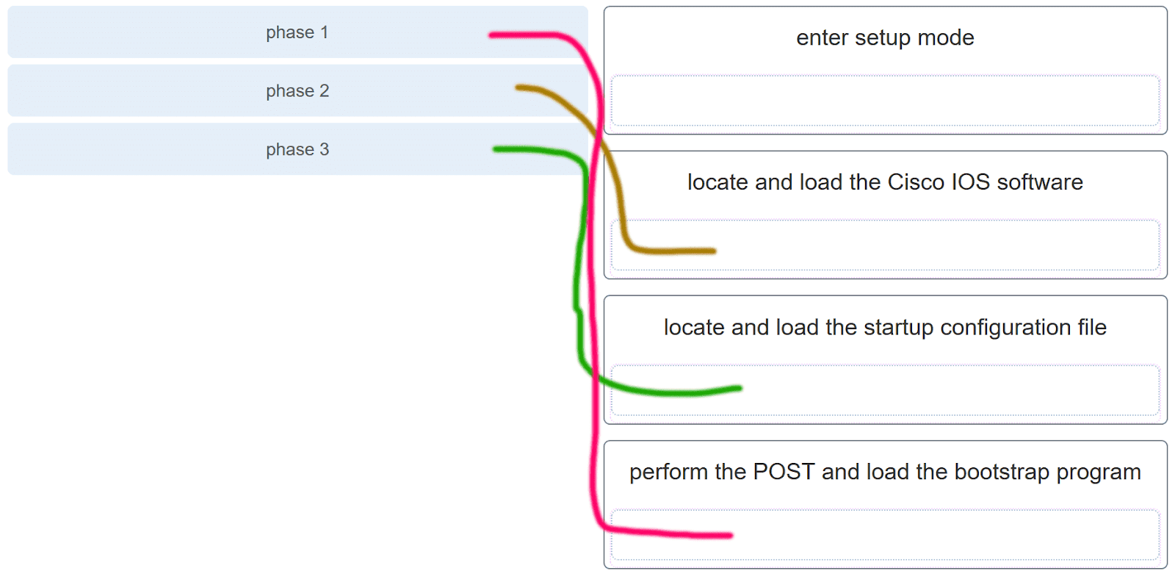

CCNA 1 v7.0 Modules 8 – 10 Exam Answers p34

**Explanation:** There are three major phases to the bootup process of a Cisco router:  
1. Perform the POST and load the bootstrap program.  
2. Locate and load the Cisco IOS software.  
3. Locate and load the startup configuration file  
If a startup configuration file cannot be located, the router will enter setup mode by displaying the setup mode prompt.

**35. Match the command with the device mode at which the command is entered. (Not all options are used.)**

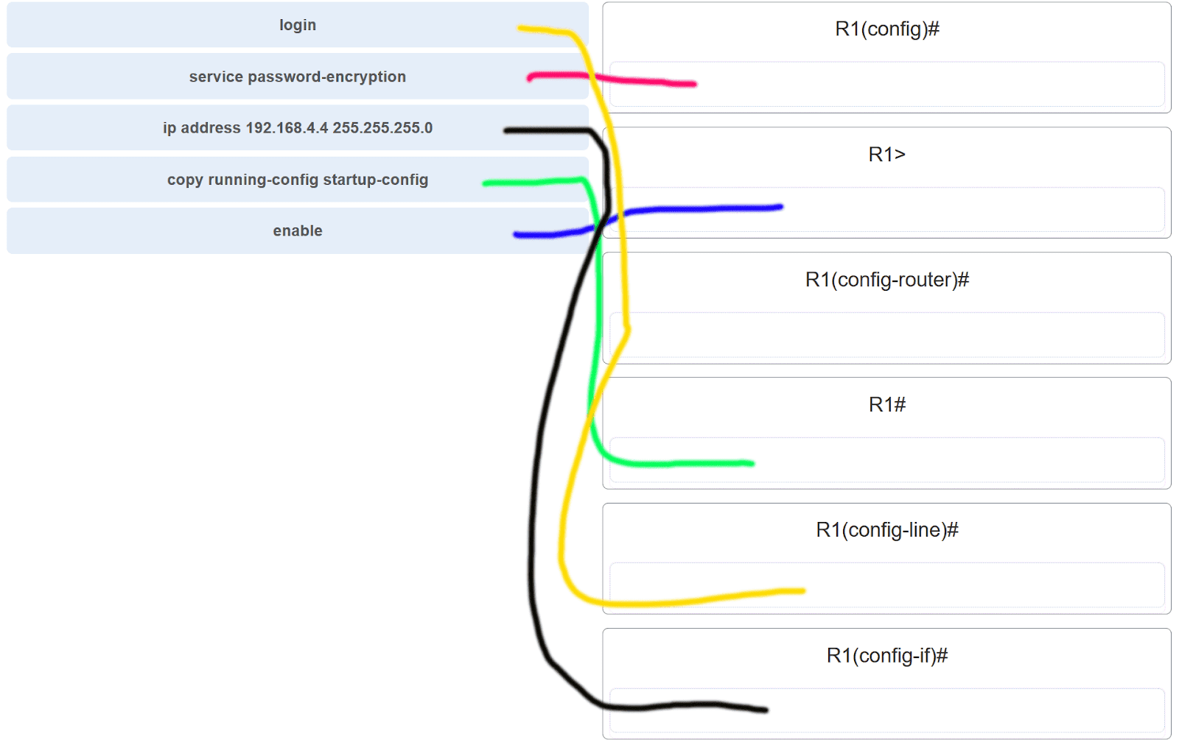

CCNA 1 v7.0 Modules 8 – 10 Exam Answers p35

**Explanation:** The enable command is entered in R1> mode. The login command is entered in R1(config-line)# mode. The copy running-config startup-config command is entered in R1# mode. The ip address 192.168.4.4 255.255.255.0 command is entered in R1(config-if)# mode. The service password-encryption command is entered in global configuration mode.

**36. What are two functions of NVRAM? (Choose two.)**

to store the routing table  
**to retain contents when power is removed\***  
**to store the startup configuration file\***  
to contain the running configuration file  
to store the ARP table

**Explanation:** NVRAM is permanent memory storage, so the startup configuration file is preserved even if the router loses power.

**37. A router boots and enters setup mode. What is the reason for this?**

The IOS image is corrupt.  
Cisco IOS is missing from flash memory.  
**The configuration file is missing from NVRAM.\***  
The POST process has detected hardware failure.

**38. The global configuration command ip default-gateway 172.16.100.1 is applied to a switch. What is the effect of this command?**

The switch will have a management interface with the address 172.16.100.1.  
**The switch can be remotely managed from a host on another network.\***  
The switch can communicate with other hosts on the 172.16.100.0 network.  
The switch is limited to sending and receiving frames to and from the gateway 172.16.100.1.

**Explanation:** A default gateway address is typically configured on all devices to allow them to communicate beyond just their local network.In a switch this is achieved using the command ip default-gateway .

**39. What happens when the transport input ssh command is entered on the switch vty lines?**

The SSH client on the switch is enabled.  
**Communication between the switch and remote users is encrypted.\***  
The switch requires a username/password combination for remote access.  
The switch requires remote connections via a proprietary client software.

**Explanation:** The transport input ssh command when entered on the switch vty (virtual terminal lines) will encrypt all inbound controlled telnet connections.

**40. Refer to the exhibit.**

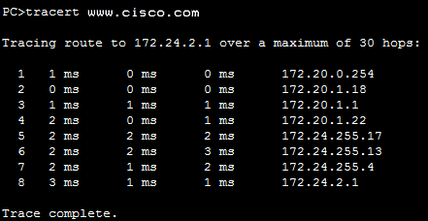

CCNA 1 v7.0 Modules 8 – 10 Exam Answers p40

**A user PC has successfully transmitted packets to www.cisco.com. Which IP address does the user PC target in order to forward its data off the local network?**

172.24.255.17  
172.24.1.22  
**172.20.0.254\***  
172.24.255.4  
172.20.1.18

**41. Match the configuration mode with the command that is available in that mode. (Not all options are used.)**

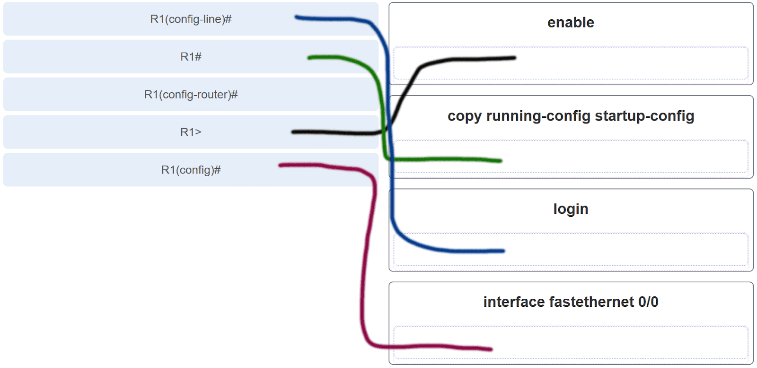

CCNA 1 v7.0 Modules 8 – 10 Exam Answers p41

**Explanation:** The enable command is entered at the R1> prompt. The login command is entered at the R1(config-line)# prompt. The copy running-config startup-config command is entered at the R1# prompt. The interface fastethernet 0/0 command is entered at the R1(config)# prompt.

**42. Which three commands are used to set up secure access to a router through a connection to the console interface? (Choose three.)**

interface fastethernet 0/0  
line vty 0 4  
**line console 0\***  
enable secret cisco  
**login\***  
**password cisco\***

**Explanation:** The three commands needed to password protect the console port are as follows:  
line console 0  
password cisco  
login  
The interface fastethernet 0/0 command is commonly used to access the configuration mode used to apply specific parameters such as the IP address to the Fa0/0 port. The line vty 0 4 command is used to access the configuration mode for Telnet. The0and 4 parameters specify ports 0 through 4, or a maximum of five simultaneous Telnet connections. The enable secret command is used to apply a password used on the router to access the privileged mode.

**43. Refer to the exhibit.**

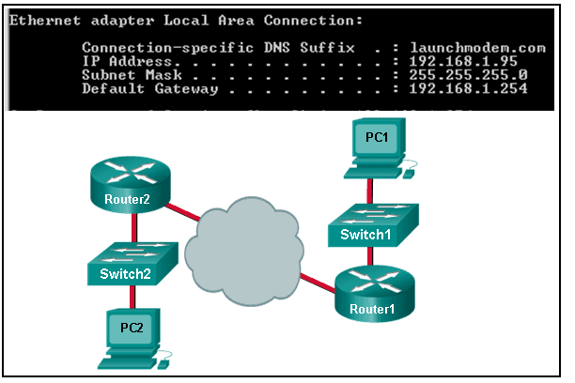

CCNA 1 v7.0 Modules 8 – 10 Exam Answers p43

**Consider the IP address configuration shown from PC1. What is a description of the default gateway address?**

It is the IP address of the Router1 interface that connects the company to the Internet.  
**It is the IP address of the Router1 interface that connects the PC1 LAN to Router1.\***  
It is the IP address of Switch1 that connects PC1 to other devices on the same LAN.  
It is the IP address of the ISP network device located in the cloud.

**44. Which two functions are primary functions of a router? (Choose two.)**

**packet forwarding\***  
microsegmentation  
domain name resolution  
**path selection\***  
flow control

**Explanation:** A router accepts a packet and accesses its routing table to determine the appropriate exit interface based on the destination address. The router then forwards the packet out of that interface.

**45. What is the effect of using the Router# copy running-config startup-config command on a router?**

The contents of ROM will change.  
The contents of RAM will change.  
**The contents of NVRAM will change.\***  
The contents of flash will change.

**Explanation:** The command copy running-config startup-config copies the running-configuration file from RAM into NVRAM and saves it as the startup-configuration file. Since NVRAM is none-volatile memory it will be able to retain the configuration details when the router is powered off.

**46. What will happen if the default gateway address is incorrectly configured on a host?**

The host cannot communicate with other hosts in the local network.  
The switch will not forward packets initiated by the host.  
The host will have to use ARP to determine the correct address of the default gateway.  
**The host cannot communicate with hosts in other networks.\***  
A ping from the host to 127.0.0.1 would not be successful.

**Explanation:** When a host needs to send a message to another host located on the same network, it can forward the message directly. However, when a host needs to send a message to a remote network, it must use the router, also known as the default gateway. This is because the data link frame address of the remote destination host cannot be used directly. Instead, the IP packet has to be sent to the router (default gateway) and the router will forward the packet toward its destination. Therefore, if the default gateway is incorrectly configured, the host can communicate with other hosts on the same network, but not with hosts on remote networks.

**47. What are two potential network problems that can result from ARP operation? (Choose two.)**

Manually configuring static ARP associations could facilitate ARP poisoning or MAC address spoofing.  
**On large networks with low bandwidth, multiple ARP broadcasts could cause data communication delays.\***  
Network attackers could manipulate MAC address and IP address mappings in ARP messages with the intent of intercepting network traffic.*  
Large numbers of ARP request broadcasts could cause the host MAC address table to overflow and prevent the host from communicating on the network.  
Multiple ARP replies result in the switch MAC address table containing entries that match the MAC addresses of hosts that are connected to the relevant switch port.

**Explanation:** Large numbers of ARP broadcast messages could cause momentary data communications delays. Network attackers could manipulate MAC address and IP address mappings in ARP messages with the intent to intercept network traffic. ARP requests and replies cause entries to be made into the ARP table, not the MAC address table. ARP table overflows are very unlikely. Manually configuring static ARP associations is a way to prevent, not facilitate, ARP poisoning and MAC address spoofing. Multiple ARP replies resulting in the switch MAC address table containing entries that match the MAC addresses of connected nodes and are associated with the relevant switch port are required for normal switch frame forwarding operations. It is not an ARP caused network problem.

**48. Open the PT activity. Perform the tasks in the activity instructions and then answer the question.  
Which interfaces in each router are active and operational?**

R1: G0/0 and S0/0/0  
R2: G0/0 and S0/0/0

R1: G0/1 and S0/0/1  
R2: G0/0 and S0/0/1

**R1: G0/0 and S0/0/0**  
**R2: G0/1 and S0/0/0\*\***

R1: G0/0 and S0/0/1  
R2: G0/1 and S0/0/1

**Explanation:** The command to use for this activity is show ip interface brief in each router. The active and operational interfaces are represented by the value “up” in the “Status” and “Protocol” columns. The interfaces in R1 with these characteristics are G0/0 and S0/0/0. In R2 they are G0/1 and S0/0/0.

**49. Which term describes a field in the IPv4 packet header used to identify the next level protocol?**

**Protocol\***  
destination IPv4 address  
source IPv4 address  
TTL

**50. Which term describes a field in the IPv4 packet header that contains an 8-bit binary value used to determine the priority of each packet?**

**differentiated services\***  
destination IPv4 address  
source IPv4 address  
protocol

**51. Which term describes a field in the IPv4 packet header that contains a 32-bit binary value associated with an interface on the sending device?**

**source IPv4 address\***  
destination IPv4 address  
protocol  
TTL

**52. Which term describes a field in the IPv4 packet header used to detect corruption in the IPv4 header?**

**header checksum\***  
source IPv4 address  
protocol  
TTL

**53.**

RTR1(config)# interface gi0/1

RTR1(config-if)# description Connects to the Marketing LAN

RTR1(config-if)# ip address 10.27.15.17 255.255.255.0

RTR1(config-if)# no shutdown

RTR1(config-if)# interface gi0/0

RTR1(config-if)# description Connects to the Payroll LAN

RTR1(config-if)# ip address 10.27.14.148 255.255.255.0

RTR1(config-if)# no shutdown

RTR1(config-if)# interface s0/0/0

RTR1(config-if)# description Connects to the ISP

RTR1(config-if)# ip address 10.14.15.254 255.255.255.0

RTR1(config-if)# no shutdown

RTR1(config-if)# interface s0/0/1

RTR1(config-if)# description Connects to the Head Office WAN

RTR1(config-if)# ip address 203.0.113.39 255.255.255.0

RTR1(config-if)# no shutdown

RTR1(config-if)# end

**Refer to the exhibit. A network administrator is connecting a new host to the Payroll LAN. The host needs to communicate with remote networks. What IP address would be configured as the default gateway on the new host?**

**10.27.14.148\***  
10.27.14.1  
10.14.15.254  
203.0.113.39  
10.27.15.17

**54. Which term describes a field in the IPv4 packet header that contains a unicast, multicast, or broadcast address?**

**destination IPv4 address\***  
protocol  
TTL  
header checksum

**55. Which term describes a field in the IPv4 packet header used to limit the lifetime of a packet?**

**TTL\***  
source IPv4 address  
protocol  
header checksum

**56. Which term describes a field in the IPv4 packet header that contains a 4-bit binary value set to 0100?**

**Versión\***  
source IPv4 address  
protocol  
TTL

**57. Which term describes a field in the IPv4 packet header used to identify the next level protocol?**

**Protocol\***  
version  
differentiated services  
header checksum

**58. Which term describes a field in the IPv4 packet header that contains a 4-bit binary value set to 0100?**

**Versión\***  
differentiated services  
header checksum  
TTL

**59. What property of ARP causes cached IP-to-MAC mappings to remain in memory longer?**

**Entries in an ARP table are time-stamped and are purged after the timeout expires.\***  
A static IP-to-MAC address entry can be entered manually into an ARP table.  
The type field 0x806 appears in the header of the Ethernet frame.  
The port-to-MAC address table on a switch has the same entries as the ARP table on the switch.

**60. What property of ARP allows MAC addresses of frequently used servers to be fixed in the ARP table?**

**A static IP-to-MAC address entry can be entered manually into an ARP table.\***  
Entries in an ARP table are time-stamped and are purged after the timeout expires.  
The type field 0x806 appears in the header of the Ethernet frame.  
The port-to-MAC address table on a switch has the same entries as the ARP table on the switch.

**61. What property of ARP allows MAC addresses of frequently used servers to be fixed in the ARP table?**

**A static IP-to-MAC address entry can be entered manually into an ARP table.\***  
The destination MAC address FF-FF-FF-FF-FF-FF appears in the header of the Ethernet frame.  
The source MAC address appears in the header of the Ethernet frame.  
The port-to-MAC address table on a switch has the same entries as the ARP table on the switch.

**62. What property of ARP allows hosts on a LAN to send traffic to remote networks?**

**Local hosts learn the MAC address of the default gateway.\***  
The destination MAC address FF-FF-FF-FF-FF-FF appears in the header of the Ethernet frame.  
The source MAC address appears in the header of the Ethernet frame.  
The port-to-MAC address table on a switch has the same entries as the ARP table on the switch.

**63.**

Floor(config)# interface gi0/1

Floor(config-if)# description Connects to the Registrar LAN

Floor(config-if)# ip address 192.168.235.234 255.255.255.0

Floor(config-if)# no shutdown

Floor(config-if)# interface gi0/0

Floor(config-if)# description Connects to the Manager LAN

Floor(config-if)# ip address 192.168.234.114 255.255.255.0

Floor(config-if)# no shutdown

Floor(config-if)# interface s0/0/0

Floor(config-if)# description Connects to the ISP

Floor(config-if)# ip address 10.234.235.254 255.255.255.0

Floor(config-if)# no shutdown

Floor(config-if)# interface s0/0/1

Floor(config-if)# description Connects to the Head Office WAN

Floor(config-if)# ip address 203.0.113.3 255.255.255.0

Floor(config-if)# no shutdown

Floor(config-if)# end

**Refer to the exhibit. A network administrator is connecting a new host to the Registrar LAN. The host needs to communicate with remote networks. What IP address would be configured as the default gateway on the new host?**

**192.168.235.234\***  
192.168.235.1  
10.234.235.254  
203.0.113.3  
192.168.234.114

**64. What property of ARP forces all Ethernet NICs to process an ARP request?**

**The destination MAC address FF-FF-FF-FF-FF-FF appears in the header of the Ethernet frame.\***  
The source MAC address appears in the header of the Ethernet frame.  
The type field 0x806 appears in the header of the Ethernet frame.  
ARP replies are broadcast on the network when a host receives an ARP request.

**65. What property of ARP causes a reply only to the source sending an ARP request?**

**The source MAC address appears in the header of the Ethernet frame.\***  
The destination MAC address FF-FF-FF-FF-FF-FF appears in the header of the Ethernet frame.  
The type field 0x806 appears in the header of the Ethernet frame.  
ARP replies are broadcast on the network when a host receives an ARP request.

**66. What property of ARP causes the request to be flooded out all ports of a switch except for the port receiving the ARP request?**

**The destination MAC address FF-FF-FF-FF-FF-FF appears in the header of the Ethernet frame.\***  
The type field 0x806 appears in the header of the Ethernet frame.  
Entries in an ARP table are time-stamped and are purged after the timeout expires.  
ARP replies are broadcast on the network when a host receives an ARP request.

**67. What property of ARP causes the NICs receiving an ARP request to pass the data portion of the Ethernet frame to the ARP process?**

**The type field 0x806 appears in the header of the Ethernet frame.\***  
The destination MAC address FF-FF-FF-FF-FF-FF appears in the header of the Ethernet frame.  
Entries in an ARP table are time-stamped and are purged after the timeout expires.  
ARP replies are broadcast on the network when a host receives an ARP request.

**68. What property of ARP causes the NICs receiving an ARP request to pass the data portion of the Ethernet frame to the ARP process?**

**The type field 0x806 appears in the header of the Ethernet frame.\***  
The destination MAC address FF-FF-FF-FF-FF-FF appears in the header of the Ethernet frame.  
Entries in an ARP table are time-stamped and are purged after the timeout expires.  
The port-to-MAC address table on a switch has the same entries as the ARP table on the switch.

**69.**

Main(config)# interface gi0/1

Main(config-if)# description Connects to the Service LAN

Main(config-if)# ip address 172.29.157.156 255.255.255.0

Main(config-if)# no shutdown

Main(config-if)# interface gi0/0

Main(config-if)# description Connects to the Engineering LAN

Main(config-if)# ip address 172.29.156.36 255.255.255.0

Main(config-if)# no shutdown

Main(config-if)# interface s0/0/0

Main(config-if)# description Connects to the ISP

Main(config-if)# ip address 10.156.157.254 255.255.255.0

Main(config-if)# no shutdown

Main(config-if)# interface s0/0/1

Main(config-if)# description Connects to the Head Office WAN

Main(config-if)# ip address 198.51.100.177 255.255.255.0

Main(config-if)# no shutdown

Main(config-if)# end

**Refer to the exhibit. A network administrator is connecting a new host to the Service LAN. The host needs to communicate with remote networks. What IP address would be configured as the default gateway on the new host?**

**172.29.157.156\***  
172.29.157.1  
10.156.157.254  
198.51.100.177  
172.29.156.36

**70.**

BldgA(config)# interface gi0/1

BldgA(config-if)# description Connects to the Medical LAN

BldgA(config-if)# ip address 192.168.191.189 255.255.255.0

BldgA(config-if)# no shutdown

BldgA(config-if)# interface gi0/0

BldgA(config-if)# description Connects to the Client LAN

BldgA(config-if)# ip address 192.168.190.70 255.255.255.0

BldgA(config-if)# no shutdown

BldgA(config-if)# interface s0/0/0

BldgA(config-if)# description Connects to the ISP

BldgA(config-if)# ip address 10.190.191.254 255.255.255.0

BldgA(config-if)# no shutdown

BldgA(config-if)# interface s0/0/1

BldgA(config-if)# description Connects to the Head Office WAN

BldgA(config-if)# ip address 198.51.100.213 255.255.255.0

BldgA(config-if)# no shutdown

BldgA(config-if)# end

**Refer to the exhibit. A network administrator is connecting a new host to the Medical LAN. The host needs to communicate with remote networks. What IP address would be configured as the default gateway on the new host?**

**192.168.191.189\***  
192.168.191.1  
10.190.191.254  
198.51.100.213  
192.168.190.70

**71.**

Floor(config)# interface gi0/1

Floor(config-if)# description Connects to the Registrar LAN

Floor(config-if)# ip address 192.168.225.223 255.255.255.0

Floor(config-if)# no shutdown

Floor(config-if)# interface gi0/0

Floor(config-if)# description Connects to the Manager LAN

Floor(config-if)# ip address 192.168.224.103 255.255.255.0

Floor(config-if)# no shutdown

Floor(config-if)# interface s0/0/0

Floor(config-if)# description Connects to the ISP

Floor(config-if)# ip address 10.224.225.254 255.255.255.0

Floor(config-if)# no shutdown

Floor(config-if)# interface s0/0/1

Floor(config-if)# description Connects to the Head Office WAN

Floor(config-if)# ip address 203.0.113.246 255.255.255.0

Floor(config-if)# no shutdown

Floor(config-if)# end

**Refer to the exhibit. A network administrator is connecting a new host to the Registrar LAN. The host needs to communicate with remote networks. What IP address would be configured as the default gateway on the new host?**

**192.168.225.223\***  
192.168.225.1  
10.224.225.254  
203.0.113.246  
192.168.224.103

**72.**

Floor(config)# interface gi0/1

Floor(config-if)# description Connects to the Registrar LAN

Floor(config-if)# ip address 10.118.63.65 255.255.255.0

Floor(config-if)# no shutdown

Floor(config-if)# interface gi0/0

Floor(config-if)# description Connects to the Manager LAN

Floor(config-if)# ip address 10.118.62.196 255.255.255.0

Floor(config-if)# no shutdown

Floor(config-if)# interface s0/0/0

Floor(config-if)# description Connects to the ISP

Floor(config-if)# ip address 10.62.63.254 255.255.255.0

Floor(config-if)# no shutdown

Floor(config-if)# interface s0/0/1

Floor(config-if)# description Connects to the Head Office WAN

Floor(config-if)# ip address 209.165.200.87 255.255.255.0

Floor(config-if)# no shutdown

Floor(config-if)# end

**Refer to the exhibit. A network administrator is connecting a new host to the Manager LAN. The host needs to communicate with remote networks. What IP address would be configured as the default gateway on the new host?**

**10.118.62.196\***  
10.118.62.1  
10.62.63.254  
209.165.200.87  
10.118.63.65

**73.**

HQ(config)# interface gi0/1

HQ(config-if)# description Connects to the Branch LAN

HQ(config-if)# ip address 172.19.99.99 255.255.255.0

HQ(config-if)# no shutdown

HQ(config-if)# interface gi0/0

HQ(config-if)# description Connects to the Store LAN

HQ(config-if)# ip address 172.19.98.230 255.255.255.0

HQ(config-if)# no shutdown

HQ(config-if)# interface s0/0/0

HQ(config-if)# description Connects to the ISP

HQ(config-if)# ip address 10.98.99.254 255.255.255.0

HQ(config-if)# no shutdown

HQ(config-if)# interface s0/0/1

HQ(config-if)# description Connects to the Head Office WAN

HQ(config-if)# ip address 209.165.200.120 255.255.255.0

HQ(config-if)# no shutdown

HQ(config-if)# end

**Refer to the exhibit. A network administrator is connecting a new host to the Store LAN. The host needs to communicate with remote networks. What IP address would be configured as the default gateway on the new host?**

**172.19.98.230\***  
172.19.98.1  
10.98.99.254  
209.165.200.120  
172.19.99.99

**74.**

HQ(config)# interface gi0/1

HQ(config-if)# description Connects to the Branch LAN

HQ(config-if)# ip address 172.20.133.132 255.255.255.0

HQ(config-if)# no shutdown

HQ(config-if)# interface gi0/0

HQ(config-if)# description Connects to the Store LAN

HQ(config-if)# ip address 172.20.132.13 255.255.255.0

HQ(config-if)# no shutdown

HQ(config-if)# interface s0/0/0

HQ(config-if)# description Connects to the ISP

HQ(config-if)# ip address 10.132.133.254 255.255.255.0

HQ(config-if)# no shutdown

HQ(config-if)# interface s0/0/1

HQ(config-if)# description Connects to the Head Office WAN

HQ(config-if)# ip address 198.51.100.156 255.255.255.0

HQ(config-if)# no shutdown

HQ(config-if)# end

**Refer to the exhibit. A network administrator is connecting a new host to the Store LAN. The host needs to communicate with remote networks. What IP address would be configured as the default gateway on the new host?**

**172.20.132.13\***  
172.20.132.1  
10.132.133.254  
198.51.100.156  
172.20.133.132

**75.**

Main(config)# interface gi0/1

Main(config-if)# description Connects to the Service LAN

Main(config-if)# ip address 192.168.167.166 255.255.255.0

Main(config-if)# no shutdown

Main(config-if)# interface gi0/0

Main(config-if)# description Connects to the Engineering LAN

Main(config-if)# ip address 192.168.166.46 255.255.255.0

Main(config-if)# no shutdown

Main(config-if)# interface s0/0/0

Main(config-if)# description Connects to the ISP

Main(config-if)# ip address 10.166.167.254 255.255.255.0

Main(config-if)# no shutdown

Main(config-if)# interface s0/0/1

Main(config-if)# description Connects to the Head Office WAN

Main(config-if)# ip address 198.51.100.189 255.255.255.0

Main(config-if)# no shutdown

Main(config-if)# end

**Refer to the exhibit. A network administrator is connecting a new host to the Service LAN. The host needs to communicate with remote networks. What IP address would be configured as the default gateway on the new host?**

**192.168.167.166\***  
192.168.167.1  
10.166.167.254  
198.51.100.189  
192.168.166.46

**76.**

BldgA(config)# interface gi0/1

BldgA(config-if)# description Connects to the Medical LAN

BldgA(config-if)# ip address 192.168.201.200 255.255.255.0

BldgA(config-if)# no shutdown

BldgA(config-if)# interface gi0/0

BldgA(config-if)# description Connects to the Client LAN

BldgA(config-if)# ip address 192.168.200.80 255.255.255.0

BldgA(config-if)# no shutdown

BldgA(config-if)# interface s0/0/0

BldgA(config-if)# description Connects to the ISP

BldgA(config-if)# ip address 10.200.201.254 255.255.255.0

BldgA(config-if)# no shutdown

BldgA(config-if)# interface s0/0/1

BldgA(config-if)# description Connects to the Head Office WAN

BldgA(config-if)# ip address 203.0.113.222 255.255.255.0

BldgA(config-if)# no shutdown

BldgA(config-if)# end

**Refer to the exhibit. A network administrator is connecting a new host to the Medical LAN. The host needs to communicate with remote networks. What IP address would be configured as the default gateway on the new host?**

**192.168.201.200\***  
192.168.201.1  
10.200.201.254  
203.0.113.222  
192.168.200.80

**77. Open the PT activity. Perform the tasks in the activity instructions and then answer the question.**

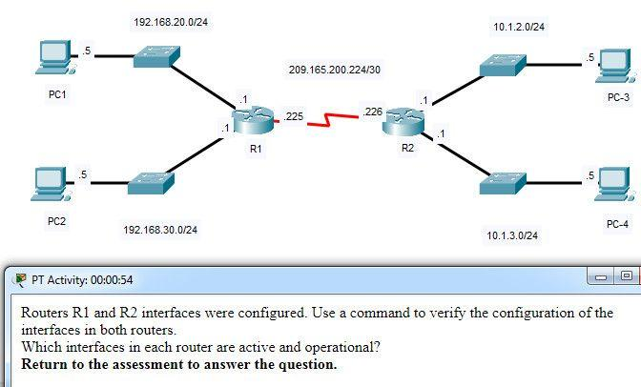

CCNA 1 v7.0 Modules 8 – 10 Exam Answers p77

**Which interfaces in each router are active and operational?**

R1: G0/0 and S0/0/1  
R2: G0/1 and S0/0/1

**R1: G0/1 and S0/0/1**  
**R2: G0/0 and S0/0/1\*\***

R1: G0/0 and S0/0/0  
R2: G0/1 and S0/0/0

R1: G0/0 and S0/0/0  
R2: G0/0 and S0/0/0

**CCNA1 v7 – ITN – Modules 8 – 10: Communicating Between Networks Exam Answers (Additional)**

**1. Which information is used by routers to forward a data packet toward its destination?**

source IP address  
**destination IP address\***  
source data-link address  
destination data-link address

**2. A computer has to send a packet to a destination host in the same LAN. How will the packet be sent?**

The packet will be sent to the default gateway first, and then, depending on the response from the gateway, it may be sent to the destination host.  
**The packet will be sent directly to the destination host.\***  
The packet will first be sent to the default gateway, and then from the default gateway it will be sent directly to the destination host.  
The packet will be sent only to the default gateway.

**3. A router receives a packet from the Gigabit 0/0 interface and determines that the packet needs to be forwarded out the Gigabit 0/1 interface. What will the router do next?**

route the packet out the Gigabit 0/1 interface  
**create a new Layer 2 Ethernet frame to be sent to the destination\***  
look into the ARP cache to determine the destination IP address  
look into the routing table to determine if the destination network is in the routing table

**4. Which IPv4 address can a host use to ping the loopback interface?**

126.0.0.1  
127.0.0.0  
126.0.0.0  
**127.0.0.1\***

**5. When a connectionless protocol is in use at a lower layer of the OSI model, how is missing data detected and retransmitted if necessary?**

Connectionless acknowledgements are used to request retransmission.  
**Upper-layer connection-oriented protocols keep track of the data received and can request retransmission from the upper-level protocols on the sending host.\***  
Network layer IP protocols manage the communication sessions if connection-oriented transport services are not available.  
The best-effort delivery process guarantees that all packets that are sent are received.

**6. What was the reason for the creation and implementation of IPv6?**

to make reading a 32-bit address easier  
**to relieve IPv4 address depletion\***  
to provide more address space in the Internet Names Registry  
to allow NAT support for private addressing

**7. Which statement accurately describes a characteristic of IPv4?**

All IPv4 addresses are assignable to hosts.​  
**IPv4 has a 32-bit address space.​\***  
An IPv4 header has fewer fields than an IPv6 header has.​  
IPv4 natively supports IPsec.​

**8. Which field in an IPv4 packet header will typically stay the same during its transmission?**

Flag  
Time-to-Live  
Packet Length  
**Destination Address\***

**9. When a router receives a packet, what information must be examined in order for the packet to be forwarded to a remote destination?**

destination MAC address  
source IP address  
**destination IP address\***  
source MAC address

**10. Which field in an IPv6 packet is used by the router to determine if a packet has expired and should be dropped?**

TTL  
**Hop Limit\***  
Address Unreachable  
No Route to Destination

**11. Which command can be used on a Windows host to display the routing table?**

netstat –s  
show ip route  
**netstat –r\***  
tracert

**12. What information is added during encapsulation at OSI Layer 3?**

source and destination MAC  
source and destination application protocol  
source and destination port number  
**source and destination IP address\***

**13. How does the network layer use the MTU value?**

The network layer depends on the higher level layers to determine the MTU.  
The network layer depends on the data link layer to set the MTU, and adjusts the speed of transmission to accommodate it.  
**The MTU is passed to the network layer by the data link layer.\***  
To increase speed of delivery, the network layer ignores the MTU.

**14. Which characteristic describes an IPv6 enhancement over IPv4?​**

IPv6 addresses are based on 128-bit flat addressing as opposed to IPv4 which is based on 32-bit hierarchical addressing.  
**The IPv6 header is simpler than the IPv4 header is, which improves packet handling.\***  
Both IPv4 and IPv6 support authentication, but only IPv6 supports privacy capabilities.  
The IPv6 address space is four times bigger than the IPv4 address space.​

**15. When an IP packet is sent to a host on a remote network, what information is provided by ARP?**

the IP address of the destination host  
the IP address of the default gateway  
**the MAC address of the router interface closest to the sending host\***  
the MAC address of the switch port that connects to the sending host

**16. How does the ARP process use an IP address?**

to determine the MAC address of the remote destination host  
**to determine the MAC address of a device on the same network\***  
to determine the amount of time a packet takes when traveling from source to destination  
to determine the network number based on the number of bits in the IP address

**17. The ARP table in a switch maps which two types of address together?**

**Layer 3 address to a Layer 2 address\***  
Layer 3 address to a Layer 4 address  
Layer 4 address to a Layer 2 address  
Layer 2 address to a Layer 4 address

**18. What is one function of the ARP protocol?**

obtaining an IPv4 address automatically  
mapping a domain name to its IP address  
**resolving an IPv4 address to a MAC address\***  
maintaining a table of domain names with their resolved IP addresses

**19. Which router component holds the routing table, ARP cache, and running configuration file?**

**RAM\***  
Flash  
NVRAM  
ROM

**20. What type of information is contained in an ARP table?**

switch ports associated with destination MAC addresses  
domain name to IP address mappings  
routes to reach destination networks  
**IP address to MAC address mappings\***

**21. A PC is configured to obtain an IP address automatically from network 192.168.1.0/24. The network administrator issues the arp –a command and notices an entry of 192.168.1.255 ff-ff-ff-ff-ff-ff. Which statement describes this entry?**

**This is a static map entry.\***  
This is a dynamic map entry.  
This entry refers to the PC itself.  
This entry maps to the default gateway.

**22. A cybersecurity analyst believes an attacker is spoofing the MAC address of the default gateway to perform a man-in-the-middle attack. Which command should the analyst use to view the MAC address a host is using to reach the default gateway?**

ipconfig /all  
route print  
netstat -r  
**arp –a\***

**23. What is a function of ARP?**

resolving MAC addresses to IPv4 addresses  
resolving port addresses to MAC addresses  
resolving MAC addresses to port addresses  
**resolving IPv4 addresses to MAC addresses\***

**24. What is the purpose of ARP in an IPv4 network?**

to forward data onward based on the destination IP address  
**to obtain a specific MAC address when an IP address is known\***  
to forward data onward based on the destination MAC address.  
to build the MAC address table in a switch from the information that is gathered

**25. Which action is taken by a Layer 2 switch when it receives a Layer 2 broadcast frame?**

It drops the frame.  
**It sends the frame to all ports except the port on which it received the frame.\***  
It sends the frame to all ports that are registered to forward broadcasts.  
It sends the frame to all ports.

**26. Which destination address is used in an ARP request frame?**

0.0.0.0  
255.255.255.255  
**FFFF.FFFF.FFFF\***  
127.0.0.1  
01-00-5E-00-AA-23

**27. What addresses are mapped by ARP?**

**destination MAC address to a destination IPv4 address\***  
destination IPv4 address to the source MAC address  
destination IPv4 address to the destination host name  
destination MAC address to the source IPv4 address

**28. What will a Layer 2 switch do when the destination MAC address of a received frame is not in the MAC table?**

It initiates an ARP request.  
It broadcasts the frame out of all ports on the switch.  
It notifies the sending host that the frame cannot be delivered.  
**It forwards the frame out of all ports except for the port at which the frame was received.\***

**29. Which two ICMPv6 messages are used during the Ethernet MAC address resolution process? (Choose two.)**

router solicitation  
router advertisement  
**neighbor solicitation\***  
**neighbor advertisement\***  
echo request

**30. A router boots and enters setup mode. What is the reason for this?**

The IOS image is corrupt.  
Cisco IOS is missing from flash memory.  
**The configuration file is missing from NVRAM.\***  
The POST process has detected hardware failure.

**31. Which command is used to encrypt all passwords in a router configuration file?**

Router_A (config) # enable secret  
**Router_A (config) # service password-encryption\***  
Router_A (config) # enable password  
Router_A (config) # encrypt password

**32. Company policy requires using the most secure method to safeguard access to the privileged exec and configuration mode on the routers. The privileged exec password is trustknow1. Which of the following router commands achieves the goal of providing the highest level of security?**

secret password trustknow1  
enable password trustknow1  
service password-encryption  
**enable secret trustknow1\***

**33. What will be the response from the router after the command, “router(config)# hostname portsmouth” is entered?**

portsmouth#  
**portsmouth(config)#\***  
invalid input detected  
router(config-host)#  
hostname = portsmouth  
portsmouth#  
? command not recognized  
router(config)#

**34. An administrator is configuring a new router to permit out-of-band management access. Which set of commands will allow the required login using a password of cisco?**

Router(config)# line vty 0 4  
Router(config-line)# password manage  
Router(config-line)# exit  
Router(config)# enable password cisco

Router(config)# line vty 0 4  
Router(config-line)# password cisco  
Router(config-line)# login

**Router(config)# line console 0**  
**Router(config-line)# password cisco**  
**Router(config-line)# login\*\*\***

Router(config)# line console 0  
Router(config-line)# password cisco  
Router(config-line)# exit  
Router(config)# service password-encryption

**35. Which command can be used on a Cisco router to display all interfaces, the IPv4 address assigned, and the current status?**

**show ip interface brief\***  
ping  
show ip route  
show interface fa0/1

**36. Which CLI mode allows users to access all device commands, such as those used for configuration, management, and troubleshooting?**

user EXEC mode  
**privileged EXEC mode\***  
global configuration mode  
interface configuration mode

**37. What is the purpose of the startup configuration file on a Cisco router?**

to facilitate the basic operation of the hardware components of a device  
**to contain the commands that are used to initially configure a router on startup\***  
to contain the configuration commands that the router IOS is currently using  
to provide a limited backup version of the IOS, in case the router cannot load the full featured IOS

**38. Which characteristic describes the default gateway of a host computer?**

**the logical address of the router interface on the same network as the host computer\***  
the physical address of the switch interface connected to the host computer  
the physical address of the router interface on the same network as the host computer  
the logical address assigned to the switch interface connected to the router

**39. What is the purpose of the banner motd command?**

It configures a message that will identify printed documents to LAN users.  
It is a way that routers communicate the status of their links with one another.  
It provides an easy way of communicating with any user attached to a router’s LANs.  
**It provides a way to make announcements to those who log in to a router.\***

**40. A technician is configuring a router to allow for all forms of management access. As part of each different type of access, the technician is trying to type the command login. Which configuration mode should be entered to do this task?**

user executive mode  
global configuration mode  
**any line configuration mode\***  
privileged EXEC mode

**41. What is stored in the NVRAM of a Cisco router?**

the Cisco IOS  
the running configuration  
the bootup instructions  
**the startup configuration\***

**42. Which statement regarding the service password-encryption command is true?**

It is configured in privileged EXEC mode.  
It encrypts only line mode passwords.  
**As soon as the service password-encryption command is entered, all currently set passwords formerly displayed in plain text are encrypted.\***  
To see the passwords encrypted by the service password-encryption command in plain text, issue the no service password-encryption command.

**. What is the prefix length notation for the subnet mask 255.255.255.224?**

/25  
/26  
**/27\***  
/28

**Explanation:** The binary format for 255.255.255.224 is 11111111.11111111.11111111.11100000. The prefix length is the number of consecutive 1s in the subnet mask. Therefore, the prefix length is /27.

**2. How many valid host addresses are available on an IPv4 subnet that is configured with a /26 mask?**

254  
190  
192  
**62\***  
64

**3. Which subnet mask would be used if 5 host bits are available?**

255.255.255.0  
255.255.255.128  
**255.255.255.224​\***  
255.255.255.240

**4. A network administrator subnets the 192.168.10.0/24 network into subnets with /26 masks. How many equal-sized subnets are created?**

1  
2  
**4\***  
8  
16  
64

**5. Match the subnetwork to a host address that would be included within the subnetwork. (Not all options are used.)**

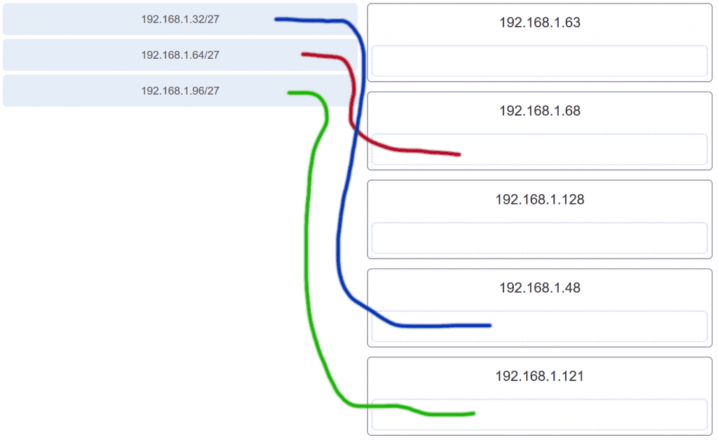

**6. An administrator wants to create four subnetworks from the network address 192.168.1.0/24. What is the network address and subnet mask of the second useable subnet?**

**subnetwork 192.168.1.64**  
**subnet mask 255.255.255.192\*\***

subnetwork 192.168.1.32  
subnet mask 255.255.255.240

subnetwork 192.168.1.64  
subnet mask 255.255.255.240

subnetwork 192.168.1.128  
subnet mask 255.255.255.192

subnetwork 192.168.1.8  
subnet mask 255.255.255.224

**7. How many bits must be borrowed from the host portion of an address to accommodate a router with five connected networks?**

two  
**three\***  
four  
five

**Explanation:** Each network that is directly connected to an interface on a router requires its own subnet. The formula 2n, where n is the number of bits borrowed, is used to calculate the available number of subnets when borrowing a specific number of bits.

**8. How many host addresses are available on the 192.168.10.128/26 network?**

30  
32  
60  
**62\***  
64

**Explanation:** A /26 prefix gives 6 host bits, which provides a total of 64 addresses, because 26 = 64. Subtracting the network and broadcast addresses leaves 62 usable host addresses.

**9. How many host addresses are available on the network 172.16.128.0 with a subnet mask of 255.255.252.0?**

510  
512  
**1022\***  
1024  
2046  
2048

**Explanation:** A mask of 255.255.252.0 is equal to a prefix of /22. A /22 prefix provides 22 bits for the network portion and leaves 10 bits for the host portion. The 10 bits in the host portion will provide 1022 usable IP addresses (210 – 2 = 1022).

**10. Match each IPv4 address to the appropriate address category. (Not all options are used.)**

**11. What three blocks of addresses are defined by RFC 1918 for private network use? (Choose three.)**

**10.0.0.0/8\***  
**172.16.0.0/12\***  
**192.168.0.0/16\***  
100.64.0.0/14  
169.254.0.0/16  
239.0.0.0/8

**Explanation:** RFC 1918, Address Allocation for Private Internets, defines three blocks of IPv4 address for private networks that should not be routable on the public Internet.  
10.0.0.0/8  
172.16.0.0/12  
192.168.0.0/16

**12. Refer to the exhibit.**

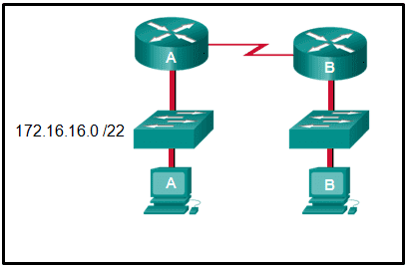

**An administrator must send a message to everyone on the router A network. What is the broadcast address for network 172.16.16.0/22?**

172.16.16.255  
172.16.20.255  
**172.16.19.255\***  
172.16.23.255  
172.16.255.255

**Explanation:** The 172.16.16.0/22 network has 22 bits in the network portion and 10 bits in the host portion. Converting the network address to binary yields a subnet mask of 255.255.252.0. The range of addresses in this network will end with the last address available before 172.16.20.0. Valid host addresses for this network range from 172.16.16.1-172.16.19.254, making 172.16.19.255 the broadcast address.

**13. A site administrator has been told that a particular network at the site must accommodate 126 hosts. Which subnet mask would be used that contains the required number of host bits?**

255.255.255.0  
**255.255.255.128\***  
255.255.255.224  
255.255.255.240

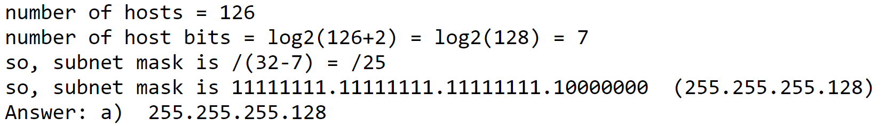

**Explanation:** The subnet mask of 255.255.255.0 has 8 host bits. The mask of 255.255.255.128 results in 7 host bits. The mask of 255.255.255.224 has 5 host bits. Finally, 255.255.255.240 represents 4 host bits.

**14. Refer to the exhibit.**

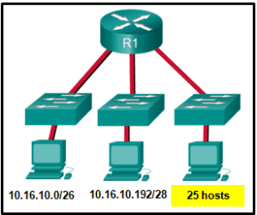

**Considering the addresses already used and having to remain within the 10.16.10.0/24 network range, which subnet address could be assigned to the network containing 25 hosts?**

10.16.10.160/26  
10.16.10.128/28  
**10.16.10.64/27\***  
10.16.10.224/26  
10.16.10.240/27  
10.16.10.240/28

**Explanation:** Addresses 10.16.10.0 through 10.16.10.63 are taken for the leftmost network. Addresses 10.16.10.192 through 10.16.10.207 are used by the center network.The address space from 208-255 assumes a /28 mask, which does not allow enough host bits to accommodate 25 host addresses.The address ranges that are available include 10.16.10.64/26 and10.16.10.128/26. To accommodate 25 hosts, 5 host bits are needed, so a /27 mask is necessary. Four possible /27 subnets could be created from the available addresses between 10.16.10.64 and 10.16.10.191:  
10.16.10.64/27  
10.16.10.96/27  
10.16.10.128/27  
10.16.10.160/27

**15. What is the usable number of host IP addresses on a network that has a /26 mask?**

256  
254  
64  
**62\***  
32  
16

**Explanation:** A /26 mask is the same as 255.255.255.192. The mask leaves 6 host bits. With 6 host bits, 64 IP addresses are possible. One address represents the subnet number and one address represents the broadcast address, which means that 62 addresses can then be used to assign to network devices.

**16. Which address prefix range is reserved for IPv4 multicast?**

240.0.0.0 – 254.255.255.255  
**224.0.0.0 – 239.255.255.255\***  
169.254.0.0 – 169.254.255.255  
127.0.0.0 – 127.255.255.255

**17. Refer to the exhibit.**

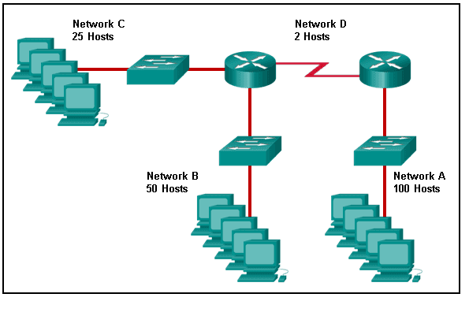

**Match the network with the correct IP address and prefix that will satisfy the usable host addressing requirements for each network.**

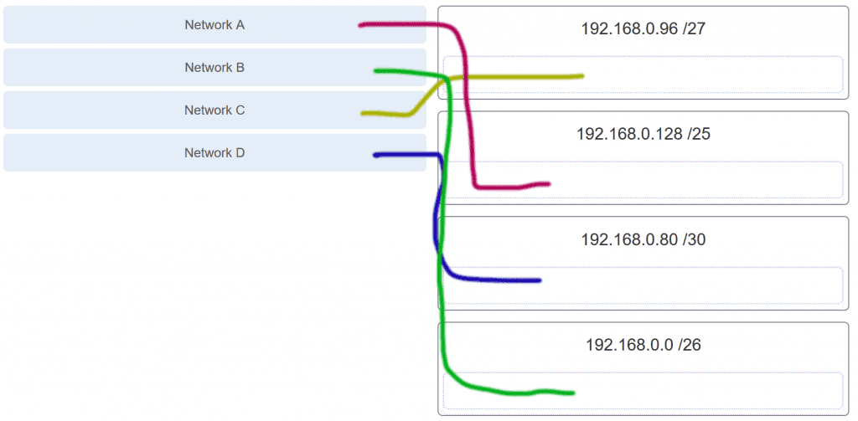

**Explanation:** Network A needs to use 192.168.0.128 /25, which yields 128 host addresses.  
Network B needs to use 192.168.0.0 /26, which yields 64 host addresses.  
Network C needs to use 192.168.0.96 /27, which yields 32 host addresses.  
Network D needs to use 192.168.0.80/30, which yields 4 host addresses.

**18. A high school in New York (school A) is using videoconferencing technology to establish student interactions with another high school (school B) in Russia. The videoconferencing is conducted between two end devices through the Internet. The network administrator of school A configures the end device with the IP address 209.165.201.10. The administrator sends a request for the IP address for the end device in school B and the response is 192.168.25.10. Neither school is using a VPN. The administrator knows immediately that this IP will not work. Why?**

This is a loopback address.  
This is a link-local address.  
**This is a private IP address.\***  
There is an IP address conflict.

**19. Which three addresses are valid public addresses? (Choose three.)**

**198.133.219.17\***  
192.168.1.245  
10.15.250.5  
**128.107.12.117\***  
172.31.1.25  
**64.104.78.227\***

**Explanation:** The ranges of private IPv4 addresses are as folllows:  
10.0.0.0 – 10.255.255.255  
172.16.0.0 – 172.31.255.255  
192.168.0.0 – 192.168.255.255

**20. A message is sent to all hosts on a remote network. Which type of message is it?**

limited broadcast  
multicast  
**directed broadcast\***  
unicast

**Explanation:** A directed broadcast is a message sent to all hosts on a specific network. It is useful for sending a broadcast to all hosts on a nonlocal network. A multicast message is a message sent to a selected group of hosts that are part of a subscribing multicast group. A limited broadcast is used for a communication that is limited to the hosts on the local network. A unicast message is a message sent from one host to another.

**21. A company has a network address of 192.168.1.64 with a subnet mask of 255.255.255.192. The company wants to create two subnetworks that would contain 10 hosts and 18 hosts respectively. Which two networks would achieve that? (Choose two.)**

192.168.1.16/28  
**192.168.1.64/27\***  
192.168.1.128/27  
**192.168.1.96/28\***  
192.168.1.192/28

**22. Which address is a valid IPv6 link-local unicast address?**

FEC8:1::FFFF  
FD80::1:1234  
**FE80::1:4545:6578:ABC1\***  
FE0A::100:7788:998F  
FC90:5678:4251:FFFF

**Explanation:** IPv6 LLAs are in the fe80::/10 range. The /10 indicates that the first 10 bits are 1111 1110 10xx xxxx. The first hextet has a range of 1111 1110 1000 0000 (fe80) to 1111 1110 1011 1111 (febf).

**23. Which of these addresses is the shortest abbreviation for the IP address:  
3FFE:1044:0000:0000:00AB:0000:0000:0057?**

3FFE:1044::AB::57  
3FFE:1044::00AB::0057  
**3FFE:1044:0:0:AB::57\***  
3FFE:1044:0:0:00AB::0057  
3FFE:1044:0000:0000:00AB::57  
3FFE:1044:0000:0000:00AB::0057

**Explanation:** The rules for reducing the notation of IPv6 addresses are:  
1. Omit any leading 0s (zeros) in any hextet.  
2. Replace any single, contiguous string of one or more 16-bit hextets consisting of all zeros with a double colon (::) .  
3. The double colon (::) can only be used once within an address.

**24. A network administrator has received the IPv6 prefix 2001:DB8::/48 for subnetting. Assuming the administrator does not subnet into the interface ID portion of the address space, how many subnets can the administrator create from the /48 prefix?**

16  
256  
4096  
**65536\***

**Explanation:** With a network prefix of 48, there will be 16 bits available for subnetting because the interface ID starts at bit 64. Sixteen bits will yield 65536 subnets.

**25. Given IPv6 address prefix 2001:db8::/48, what will be the last subnet that is created if the subnet prefix is changed to /52?**

2001:db8:0:f00::/52  
2001:db8:0:8000::/52  
2001:db8:0:f::/52  
**2001:db8:0:f000::/52\***

**Explanation:** Prefix 2001:db8::/48 has 48 network bits. If we subnet to a /52, we are moving the network boundary four bits to the right and creating 16 subnets. The first subnet is 2001:db8::/52 the last subnet is 2001:db8:0:f000::/52.

**26. Consider the following range of addresses:**

2001:0DB8:BC15:00A0:0000::  
2001:0DB8:BC15:00A1:0000::  
2001:0DB8:BC15:00A2:0000::  
…  
2001:0DB8:BC15:00AF:0000::  
The prefix-length for the range of addresses is   **/60** .

**Explanation:** All the addresses have the part 2001:0DB8:BC15:00A in common. Each number or letter in the address represents 4 bits, so the prefix-length is /60.

**27. What type of IPv6 address is FE80::1?**

loopback  
**link-local\***  
multicast  
global unicast

**28. Refer to the exhibit.**

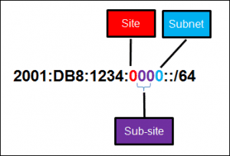

**A company is deploying an IPv6 addressing scheme for its network. The company design document indicates that the subnet portion of the IPv6 addresses is used for the new hierarchical network design, with the site subsection to represent multiple geographical sites of the company, the sub-site section to represent multiple campuses at each site, and the subnet section to indicate each network segment separated by routers. With such a scheme, what is the maximum number of subnets achieved per sub-site?**

0  
4  
**16\***  
256

**Explanation:** Because only one hexadecimal character is used to represent the subnet, that one character can represent 16 different values 0 through F.

**29. What is used in the EUI-64 process to create an IPv6 interface ID on an IPv6 enabled interface?**

**the MAC address of the IPv6 enabled interface\***  
a randomly generated 64-bit hexadecimal address  
an IPv6 address that is provided by a DHCPv6 server  
an IPv4 address that is configured on the interface

**Explanation:** The EUI-64 process uses the MAC address of an interface to construct an interface ID (IID). Because the MAC address is only 48 bits in length, 16 additional bits (FF:FE) must be added to the MAC address to create the full 64-bit interface ID.

**30. What is the prefix for the host address 2001:DB8:BC15:A:12AB::1/64?**

2001:DB8:BC15  
**2001:DB8:BC15:A\***  
2001:DB8:BC15:A:1  
2001:DB8:BC15:A:12

**31. An IPv6 enabled device sends a data packet with the destination address of FF02::1. What is the target of this packet?​**

the one IPv6 device on the link that has been uniquely configured with this address  
**all IPv6 enabled devices on the local link​ or network\***  
only IPv6 DHCP servers​  
only IPv6 configured routers

**32. Match the IPv6 address with the IPv6 address type. (Not all options are used.)**

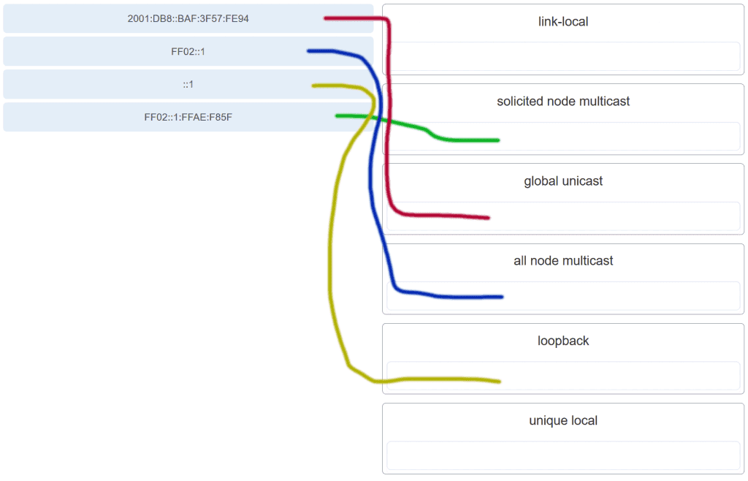

**Explanation:** FF02::1:FFAE:F85F is a solicited node multicast address.  
2001:DB8::BAF:3F57:FE94 is a global unicast address.  
FF02::1 is the all node multicast address. Packets sent to this address will be received by all IPv6 hosts on the local link.  
::1 is the IPv6 loopback address.  
There are no examples of link local or unique local addresses provided.

**33. Which IPv6 prefix is reserved for communication between devices on the same link?**

FC00::/7  
2001::/32  
**FE80::/10\***  
FDFF::/7

**Explanation:** IPv6 link-local unicast addresses are in the FE80::/10 prefix range and are not routable. They are used only for communications between devices on the same link.

**34. Which type of IPv6 address refers to any unicast address that is assigned to multiple hosts?**

unique local  
global unicast  
link-local  
**anycast\***

**35. What are two types of IPv6 unicast addresses? (Choose two.)**

multicast  
**loopback\***  
**link-local\***  
anycast  
broadcast

**Explanation:** Multicast, anycast, and unicast are types of IPv6 addresses. There is no broadcast address in IPv6. Loopback and link-local are specific types of unicast addresses.

**36. Which service provides dynamic global IPv6 addressing to end devices without using a server that keeps a record of available IPv6 addresses?**

stateful DHCPv6  
**SLAAC\***  
static IPv6 addressing  
stateless DHCPv6

**Explanation:** Using stateless address autoconfiguration (SLAAC), a PC can solicit a router and receive the prefix length of the network. From this information the PC can then create its own IPv6 global unicast address.

**37. Which protocol supports Stateless Address Autoconfiguration (SLAAC) for dynamic assignment of IPv6 addresses to a host?**

ARPv6  
DHCPv6  
**ICMPv6\***  
UDP

**Explanation:** SLAAC uses ICMPv6 messages when dynamically assigning an IPv6 address to a host. DHCPv6 is an alternate method of assigning an IPv6 addresses to a host. ARPv6 does not exist. Neighbor Discovery Protocol (NDP) provides the functionality of ARP for IPv6 networks. UDP is the transport layer protocol used by DHCPv6.

**38. Three methods allow IPv6 and IPv4 to co-exist. Match each method with its description. (Not all options are used.)**

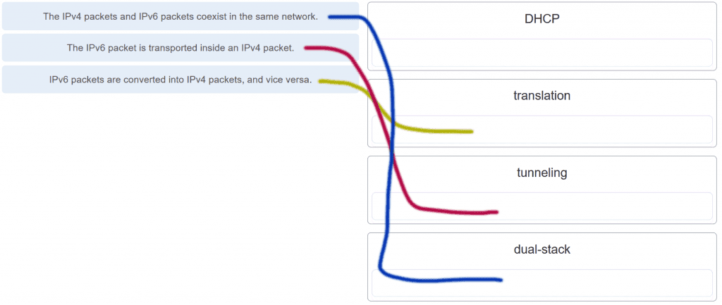

**39. A technician uses the ping 127.0.0.1 command. What is the technician testing?**

**the TCP/IP stack on a network host\***  
connectivity between two adjacent Cisco devices  
connectivity between a PC and the default gateway  
connectivity between two PCs on the same network  
physical connectivity of a particular PC and the network

**40. Refer to the exhibit.**

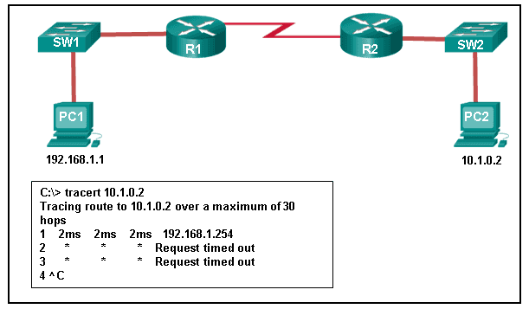

**An administrator is trying to troubleshoot connectivity between PC1 and PC2 and uses the tracert command from PC1 to do it. Based on the displayed output, where should the administrator begin troubleshooting?**

PC2  
**R1\***  
SW2  
R2  
SW1

**41. Which protocol is used by the traceroute command to send and receive echo-requests and echo-replies?**

SNMP  
**ICMP\***  
Telnet  
TCP

**Explanation:** Traceroute uses the ICMP (Internet Control Message Protocol) to send and receive echo-request and echo-reply messages.

**42. Which ICMPv6 message is sent when the IPv6 hop limit field of a packet is decremented to zero and the packet cannot be forwarded?**

network unreachable  
**time exceded\***  
protocol unreachable  
port unreachable

**43. A user executes a traceroute over IPv6. At what point would a router in the path to the destination device drop the packet?**

when the value of the Hop Limit field reaches 255  
**when the value of the Hop Limit field reaches zero\***  
when the router receives an ICMP time exceeded message  
when the target host responds with an ICMP echo reply message

**44. What is the purpose of ICMP messages?**

to inform routers about network topology changes  
to ensure the delivery of an IP packet  
**to provide feedback of IP packet transmissions\***  
to monitor the process of a domain name to IP address resolution

**Explanation:** The purpose of ICMP messages is to provide feedback about issues that are related to the processing of IP packets.

**45. What source IP address does a router use by default when the traceroute command is issued?**

the highest configured IP address on the router  
a loopback IP address  
**the IP address of the outbound interface\***  
the lowest configured IP address on the router

**Explanation:** When sending an echo request message, a router will use the IP address of the exit interface as the source IP address. This default behavior can be changed by using an extended ping and specifying a specific source IP address.

**46. Match each description with an appropriate IP address. (Not all options are used.)**

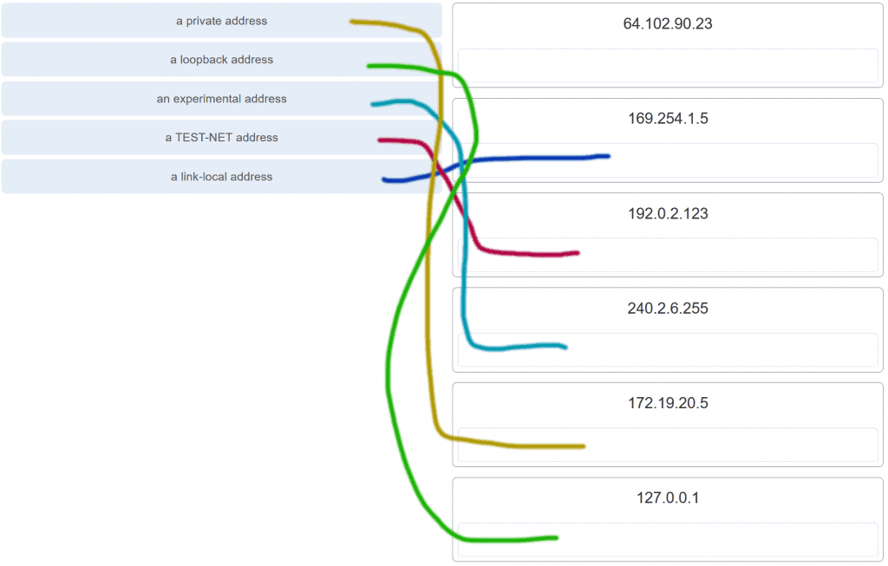

**Explanation:** Link-Local addresses are assigned automatically by the OS environment and are located in the block 169.254.0.0/16. The private addresses ranges are 10.0.0.0/8, 172.16.0.0/12, and 192.168.0.0/16. TEST-NET addresses belong to the range 192.0.2.0/24. The addresses in the block 240.0.0.0 to 255.255.255.254 are reserved as experimental addresses. Loopback addresses belong to the block 127.0.0.0/8.

**47. A user issues a ping 192.135.250.103 command and receives a response that includes a code of 1. What does this code represent?**

**host unreachable\***  
protocol unreachable  
port unreachable  
network unreachable

**48. Which subnet would include the address 192.168.1.96 as a usable host address?**

**192.168.1.64/26\***  
192.168.1.32/27  
192.168.1.32/28  
192.168.1.64/29

**Explanation:** For the subnet of 192.168.1.64/26, there are 6 bits for host addresses, yielding 64 possible addresses. However, the first and last subnets are the network and broadcast addresses for this subnet. Therefore, the range of host addresses for this subnet is 192.168.1.65 to 192.168.1.126. The other subnets do not contain the address 192.168.1.96 as a valid host address.

**49. Open the PT Activity. Perform the tasks in the activity instructions and then answer the question.**

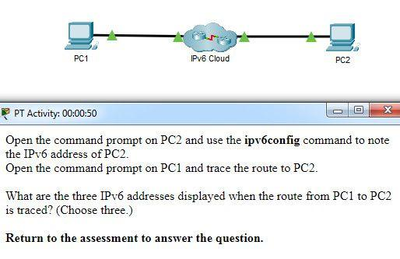

**What are the three IPv6 addresses displayed when the route from PC1 to PC2 is traced? (Choose three.)**

**2001:DB8:1:1::1\***  
2001:DB8:1:1::A  
2001:DB8:1:2::2  
**2001:DB8:1:2::1\***  
2001:DB8:1:3::1  
**2001:DB8:1:3::2\***  
2001:DB8:1:4::1

**Explanation:** Using the ipv6config command on PC2 displays the IPv6 address of PC2, which is 2001:DB8:1:4::A. The IPV6 link-local address, FE80::260:70FF:FE34:6930, is not used in route tracing. Using the tracert 2001:DB8:1:4::A command on PC1 displays four addresses: 2001:DB8:1:1::1, 2001:DB8:1:2::1 , 2001:DB8:1:3::2, and 2001:DB8:1:4::A.

**50. A host is transmitting a broadcast. Which host or hosts will receive it?**

**all hosts in the same subnet\***  
a specially defined group of hosts  
the closest neighbor on the same network  
all hosts on the Internet

**51. A host is transmitting a unicast. Which host or hosts will receive it?**

**one specific host\***  
a specially defined group of hosts  
all hosts on the Internet  
the closest neighbor on the same network

**52. A user issues a ping 2001:db8:FACE:39::10 command and receives a response that includes a code of 3. What does this code represent?**

**address unreachable\***  
network unreachable  
host unreachable  
protocol unreachable

**53. A host is transmitting a multicast. Which host or hosts will receive it?**

**a specially defined group of hosts\***  
one specific host  
all hosts with the same IP address  
the closest neighbor on the same network

**54. A host is transmitting a multicast. Which host or hosts will receive it?**

**a specially defined group of hosts\***  
one specific host  
directly connected network devices  
the closest neighbor on the same network

**55. A host is transmitting a multicast. Which host or hosts will receive it?**

**a specially defined group of hosts\***  
one specific host  
all hosts with the same IP address  
all hosts on the Internet

**56. A host is transmitting a multicast. Which host or hosts will receive it?**

**a specially defined group of hosts\***  
one specific host  
directly connected network devices  
all hosts on the Internet

**57. A host is transmitting a multicast. Which host or hosts will receive it?**

**a specially defined group of hosts\***  
all hosts in the same subnet  
directly connected network devices  
the closest neighbor on the same network

**58. A host is transmitting a broadcast. Which host or hosts will receive it?**

**all hosts in the same subnet\***  
one specific host  
the closest neighbor on the same network  
directly connected network devices

**59. A host is transmitting a broadcast. Which host or hosts will receive it?**

**all hosts in the same subnet\***  
one specific host  
all hosts on the Internet  
directly connected network devices

**60. Which is the compressed format of the IPv6 address 2001:0db8:0000:0000:0000:a0b0:0008:0001?**

**2001:db8::a0b0:8:1\***  
2001:db8::ab8:1:0:1000  
2001:db80:0:1::80:1  
2001:db80:::1::80:1

**61. Which is the compressed format of the IPv6 address fe80:09ea:0000:2200:0000:0000:0fe0:0290?**

**fe80:9ea:0:2200::fe0:290\***  
fe80:9:20::b000:290  
fe80:9ea0::2020:0:bf:e0:9290  
fe80:9ea0::2020::bf:e0:9290

**62. Which is the compressed format of the IPv6 address 2002:0042:0010:c400:0000:0000:0000:0909?**

**2002:42:10:c400::909\***  
200:420:110:c4b::910:0:90  
2002:4200::25:1090:0:99  
2002:42::25:1090:0:99

**63. Which is the compressed format of the IPv6 address 2001:0db8:0000:0000:0ab8:0001:0000:1000?**

**2001:db8::ab8:1:0:1000\***  
2001:db8::a0b0:8:1  
2001:db8:1::ab8:0:1  
2001:db8:0:1::8:1

**64. Which is the compressed format of the IPv6 address 2002:0420:00c4:1008:0025:0190:0000:0990?**

**2002:420:c4:1008:25:190::990\***  
2002:42:10:c400::909  
2002:4200::25:1090:0:99  
2002:42::25:1090:0:99

**65. Which is the compressed format of the IPv6 address 2001:0db8:0000:0000:0000:a0b0:0008:0001?**

**2001:db8::a0b0:8:1\***  
2001:db8:1::ab8:0:1  
2001:db8::ab8:1:0:1000  
2001:db8:0:1::8:1

**66. Which is the compressed format of the IPv6 address fe80:0000:0000:0000:0220:0b3f:f0e0:0029?**

**fe80::220:b3f:f0e0:29\***  
fe80:9ea:0:2200::fe0:290  
fe80:9ea0::2020:0:bf:e0:9290  
fe80:9ea0::2020::bf:e0:9290

**67. Which is the compressed format of the IPv6 address 2001:0db8:0000:0000:0000:a0b0:0008:0001?**

**2001:db8::a0b0:8:1\***  
2001:db8::ab8:1:0:1000  
2001:db80:0:1::80:1  
2001:db8:0:1::8:1

**68. Which is the compressed format of the IPv6 address 2002:0042:0010:c400:0000:0000:0000:0909?**

**2002:42:10:c400::909\***  
2002:4200::25:1090:0:99  
2002:420:c4:1008:25:190::990  
2002:42::25:1090:0:99

**69. Which is the compressed format of the IPv6 address fe80:09ea:0000:2200:0000:0000:0fe0:0290?**

**fe80:9ea:0:2200::fe0:290\***  
fe80:9ea0::2020:0:bf:e0:9290  
fe80::220:b3f:f0e0:29  
fe80::0220:0b3f:f0e0:0029

**70. A user issues a ping 2001:db8:FACE:39::10 command and receives a response that includes a code of 2 . What does this code represent?**

**beyond scope of the source address\***  
communication with the destination administratively prohibited  
address unreachable  
no route to destination

**71. A user issues a ping 192.135.250.103 command and receives a response that includes a code of 1. What does this code represent?**

**host unreachable\***  
beyond scope of the source address  
address unreachable  
communication with the destination administratively prohibited

**72. A user issues a ping fe80:65ab:dcc1::100 command and receives a response that includes a code of 3. What does this code represent?**

**address unreachable\***  
communication with the destination administratively prohibited  
beyond scope of the source address  
no route to destination

**73. A user issues a ping 10.10.14.67 command and receives a response that includes a code of 0. What does this code represent?**

**network unreachable\***  
protocol unreachable  
port unreachable  
host unreachable

**74. A user issues a ping fe80:65ab:dcc1::100 command and receives a response that includes a code of 4. What does this code represent?**

**port unreachable\***  
host unreachable  
protocol unreachable  
network unreachable

**75. A user issues a ping 198.133.219.8 command and receives a response that includes a code of 0. What does this code represent?**

**network unreachable\***  
protocol unreachable  
port unreachable  
host unreachable

**76. A user issues a ping 2001:db8:3040:114::88 command and receives a response that includes a code of 4. What does this code represent?**

**port unreachable\***  
host unreachable  
protocol unreachable  
network unreachable

**77. A user issues a ping 2001:db8:FACE:39::10 command and receives a response that includes a code of 2. What does this code represent?**

**beyond scope of the source address\***  
host unreachable  
protocol unreachable  
network unreachable

**Modules 11 – 13: IP Addressing Exam Answers (Additional)**

**1. What is the prefix length notation for the subnet mask 255.255.255.224?**

/25  
/26  
**/27\***  
/28

**2. How many valid host addresses are available on an IPv4 subnet that is configured with a /26 mask?**

254  
190  
192  
**62\***  
64

**3. Which subnet mask would be used if 5 host bits are available?**

255.255.255.0  
255.255.255.128  
**255.255.255.224​\***  
255.255.255.240

**4. A network administrator subnets the 192.168.10.0/24 network into subnets with /26 masks. How many equal-sized subnets are created?**

1  
2  
**4\***  
8  
16  
64

**5. What subnet mask is represented by the slash notation /20?**

255.255.255.248  
255.255.224.0  
**255.255.240.0\***  
255.255.255.0  
255.255.255.192

**6. Which statement is true about variable-length subnet masking?**

Each subnet is the same size.  
**The size of each subnet may be different, depending on requirements.\***  
Subnets may only be subnetted one additional time.  
Bits are returned, rather than borrowed, to create additional subnets.

**7. Why does a Layer 3 device perform the ANDing process on a destination IP address and subnet mask?**

to identify the broadcast address of the destination network  
to identify the host address of the destination host  
to identify faulty frames  
**to identify the network address of the destination network\***

**8. How many usable IP addresses are available on the 192.168.1.0/27 network?**

256  
254  
62  
**30\***  
16  
32

**9. Which subnet mask would be used if exactly 4 host bits are available?**

255.255.255.224  
255.255.255.128  
**255.255.255.240\***  
255.255.255.248

**10. Which two parts are components of an IPv4 address? (Choose two.)**

subnet portion  
**network portion\***  
logical portion  
**host portion\***  
physical portion  
broadcast portion

**11. If a network device has a mask of /26, how many IP addresses are available for hosts on this network?**

64  
30  
**62\***  
32  
16  
14

**12. What does the IP address 172.17.4.250/24 represent?**

network address  
multicast address  
**host address\***  
broadcast address

**13. If a network device has a mask of /28, how many IP addresses are available for hosts on this network?**

256  
254  
62  
32  
16  
**14\***

**14. What is the purpose of the subnet mask in conjunction with an IP address?**

to uniquely identify a host on a network  
to identify whether the address is public or private  
**to determine the subnet to which the host belongs\***  
to mask the IP address to outsiders

**15. A network administrator is variably subnetting a network. The smallest subnet has a mask of 255.255.255.224. How many usable host addresses will this subnet provide?​**

2  
6  
14  
**30\***  
62

**16. What is indicated by a successful ping to the ::1 IPv6 address?**

The host is cabled properly.  
The default gateway address is correctly configured.  
All hosts on the local link are available.  
The link-local address is correctly configured.  
**IP is properly installed on the host.\***

**17. What is the most compressed representation of the IPv6 address 2001:0000:0000:abcd:0000:0000:0000:0001?**

2001:0:abcd::1  
**2001:0:0:abcd::1\***  
2001::abcd::1  
2001:0000:abcd::1  
2001::abcd:0:1

**18. What is the purpose of the command ping ::1?**

**It tests the internal configuration of an IPv6 host.\***  
It tests the broadcast capability of all hosts on the subnet.  
It tests the multicast connectivity to all hosts on the subnet.  
It tests the reachability of the default gateway for the network.

**19. At a minimum, which address is required on IPv6-enabled interfaces?**

**link-local\***  
unique local  
site local  
global unicast

**20. What is the interface ID of the IPv6 address 2001:DB8::1000:A9CD:47FF:FE57:FE94/64?**

FE94  
FE57:FE94  
47FF:FE57:FE94  
**A9CD:47FF:FE57:FE94\***  
1000:A9CD:47FF:FE57:FE94

**21. What are three parts of an IPv6 global unicast address? (Choose three.)**

an interface ID that is used to identify the local network for a particular host  
a global routing prefix that is used to identify the network portion of the address that has been provided by an ISP*  
**a subnet ID that is used to identify networks inside of the local enterprise site\***  
a global routing prefix that is used to identify the portion of the network address provided by a local administrator  
**an interface ID that is used to identify the local host on the network\***

**22. What is the valid most compressed format possible of the IPv6 address 2001:0DB8:0000:AB00:0000:0000:0000:1234?**

**2001:DB8:0:AB00::1234\***  
2001:DB8:0:AB::1234  
2001:DB8::AB00::1234  
2001:DB8:0:AB:0:1234

**23. What is the prefix associated with the IPv6 address 2001:CA48:D15:EA:CC44::1/64?**

2001::/64  
2001:CA48::/64​  
**2001:CA48:D15:EA::/64​\***  
2001:CA48:D15:EA:CC44::/64​

**24. What type of address is automatically assigned to an interface when IPv6 is enabled on that interface?**

global unicast  
**link-local\***  
loopback  
unique local

**25. Which IPv6 network prefix is only intended for local links and can not be routed?**

2001::/3  
FC00::/7  
**FE80::/10\***  
FEC0::/10

**26. Your organization is issued the IPv6 prefix of 2001:0000:130F::/48 by your service provider. With this prefix, how many bits are available for your organization to create subnetworks if interface ID bits are not borrowed?**

8  
**16\***  
80  
128

**27. What is the subnet address for the IPv6 address 2001:D12:AA04:B5::1/64?**

2001::/64  
2001:D12::/64​  
2001:D12:AA04::/64​  
**2001:D12:AA04:B5::/64​\***

**28. Which type of IPv6 address is not routable and used only for communication on a single subnet?**

global unicast address  
**link-local address\***  
loopback address  
unique local address  
unspecified address

**29. Which address type is not supported in IPv6?**

private  
multicast  
unicast  
**broadcast\***

**30. What is the minimum configuration for a router interface that is participating in IPv6 routing?**

**to have only a link-local IPv6 address\***  
to have both an IPv4 and an IPv6 address  
to have a self-generated loopback address  
to have both a link-local and a global unicast IPv6 address  
to have only an automatically generated multicast IPv6 address

**31. A user calls to report that a PC cannot access the internet. The network technician asks the user to issue the command ping 127.0.0.1 in a command prompt window. The user reports that the result is four positive replies. What conclusion can be drawn based on this connectivity test?**

The PC can access the network. The problem exists beyond the local network.  
The IP address obtained from the DHCP server is correct.  
The PC can access the Internet. However, the web browser may not work.  
**The TCP/IP implementation is functional.\***

**32. Which command can be used to test connectivity between two devices using echo request and echo reply messages?**

netstat  
traceroute  
ICMP  
**Ping\***

**33. What field content is used by ICMPv6 to determine that a packet has expired?**

TTL field  
CRC field  
**Hop Limit field\***  
Time Exceeded field

**34. Which protocol provides feedback from the destination host to the source host about errors in packet delivery?**

ARP  
BOOTP  
DNS  
**ICMP\***

**35. Which utility uses the Internet Control Messaging Protocol (ICMP)?**

RIP  
DNS  
**Ping\***  
NTP

**36. A network administrator can successfully ping the server at www.cisco.com, but cannot ping the company web server located at an ISP in another city. Which tool or command would help identify the specific router where the packet was lost or delayed?**

ipconfig  
netstat  
telnet  
**traceroute\***

**37. Which protocol is used by IPv4 and IPv6 to provide error messaging?**

**ICMP\***  
NDP  
ARP  
DHCP

**38. What message is sent by a host to check the uniqueness of an IPv6 address before using that address?**

**neighbor solicitation\***  
ARP request  
echo request  
router solicitation

**39. A technician is troubleshooting a network where it is suspected that a defective node in the network path is causing packets to be dropped. The technician only has the IP address of the end point device and does not have any details of the intermediate devices. What command can the technician use to identify the faulty node?**

**Tracert\***  
ping  
ipconfig /flushdns  
ipconfig /displaydns

**40. A user who is unable to connect to the file server contacts the help desk. The helpdesk technician asks the user to ping the IP address of the default gateway that is configured on the workstation. What is the purpose for this ping command?**

to obtain a dynamic IP address from the server  
to request that gateway forward the connection request to the file server  
**to test that the host has the capability to reach hosts on other networks\***  
to resolve the domain name of the file server to its IP address

**41. What is a function of the tracert command that differs from the ping command when they are used on a workstation?**

The tracert command reaches the destination faster.  
**The tracert command shows the information of routers in the path.\***  
The tracert command sends one ICMP message to each hop in the path.  
The tracert command is used to test the connectivity between two devices.

**42. Which ICMP message is used by the traceroute utility during the process of finding the path between two end hosts?**

redirect  
ping  
**time exceeded\***  
destination unreachable

**43. Which two things can be determined by using the ping command? (Choose two.)**

the number of routers between the source and destination device  
the IP address of the router nearest the destination device  
**the average time it takes a packet to reach the destination and for the response to return to the source\***  
**the destination device is reachable through the network\***  
the average time it takes each router in the path between source and destination to respond

**44. Which statement describes a characteristic of the traceroute utility?**

It sends four Echo Request messages.  
It utilizes the ICMP Source Quench messages.  
It is primarily used to test connectivity between two hosts.  
**It identifies the routers in the path from a source host to a destination host.\***

**. Which action is performed by a client when establishing communication with a server via the use of UDP at the transport layer?**

The client sets the window size for the session.  
The client sends an ISN to the server to start the 3-way handshake.  
**The client randomly selects a source port number.\***  
The client sends a synchronization segment to begin the session.

**2. Which transport layer feature is used to guarantee session establishment?**

UDP ACK flag  
**TCP 3-way handshake\***  
UDP sequence number  
TCP port number

**3. What is the complete range of TCP and UDP well-known ports?**

0 to 255  
**0 to 1023\***  
256 – 1023  
1024 – 49151

**4. What is a socket?**

the combination of the source and destination IP address and source and destination Ethernet address  
**the combination of a source IP address and port number or a destination IP address and port number\***  
the combination of the source and destination sequence and acknowledgment numbers  
the combination of the source and destination sequence numbers and port numbers

**5. A PC is downloading a large file from a server. The TCP window is 1000 bytes. The server is sending the file using 100-byte segments. How many segments will the server send before it requires an acknowledgment from the PC?**

1 segment  
**10 segments\***  
100 segments  
1000 segments

**6. Which factor determines TCP window size?**

the amount of data to be transmitted  
the number of services included in the TCP segment  
**the amount of data the destination can process at one time\***  
the amount of data the source is capable of sending at one time

**Explanation:**Window is the number of bytes that the sender will send prior to expecting an acknowledgement from the destination device. The initial window is agreed upon during the session startup via the three-way handshake between source and destination. It is determined by how much data the destination device of a TCP session is able to accept and process at one time.

**7. What does a client do when it has UDP datagrams to send?**

**It just sends the datagrams.\***  
It queries the server to see if it is ready to receive data.  
It sends a simplified three-way handshake to the server.  
It sends to the server a segment with the SYN flag set to synchronize the conversation.

**Explanation:** When a client has UDP datagrams to send, it just sends the datagrams.

**8. Which three fields are used in a UDP segment header? (Choose three.)**

Window Size  
**Length\***  
**Source Port\***  
Acknowledgment Number  
**Checksum\***  
Sequence Number

**Explanation:** A UDP header consists of only the Source Port, Destination Port, Length, and Checksum fields. Sequence Number, Acknowledgment Number, and Window Size are TCP header fields.

**9. What are two roles of the transport layer in data communication on a network? (Choose two.)**

identifying the proper application for each communication stream  
**tracking the individual communication between applications on the source and destination hosts\***  
providing frame delimiting to identify bits making up a frame  
performing a cyclic redundancy check on the frame for errors  
providing the interface between applications and the underlying network over which messages are transmitted

**Explanation:** The transport layer has several responsibilities. The primary responsibilities include the following:  
Tracking the individual communication streams between applications on the source and destination hosts  
Segmenting data at the source and reassembling the data at the destination  
Identifying the proper application for each communication stream through the use of port numbers

**10. What information is used by TCP to reassemble and reorder received segments?**

port numbers  
**sequence numbers\***  
acknowledgment numbers  
fragment numbers

**11. What important information is added to the TCP/IP transport layer header to ensure communication and connectivity with a remote network device?**

timing and synchronization  
**destination and source port numbers\***  
destination and source physical addresses  
destination and source logical network addresses

**12. Which two characteristics are associated with UDP sessions? (Choose two.)**

**Destination devices receive traffic with minimal delay.\***  
Transmitted data segments are tracked.  
Destination devices reassemble messages and pass them to an application.  
**Received data is unacknowledged.\***  
Unacknowledged data packets are retransmitted.

**Explanation:**  
**TCP:**  
Provides tracking of transmitted data segments  
Destination devices will acknowledge received data.  
Source devices will retransmit unacknowledged data.  
**UDP:**  
Destination devices will not acknowledge received data  
Headers use very little overhead and cause minimal delay.​

**13. A client application needs to terminate a TCP communication session with a server. Place the termination process steps in the order that they will occur. (Not all options are used.)**

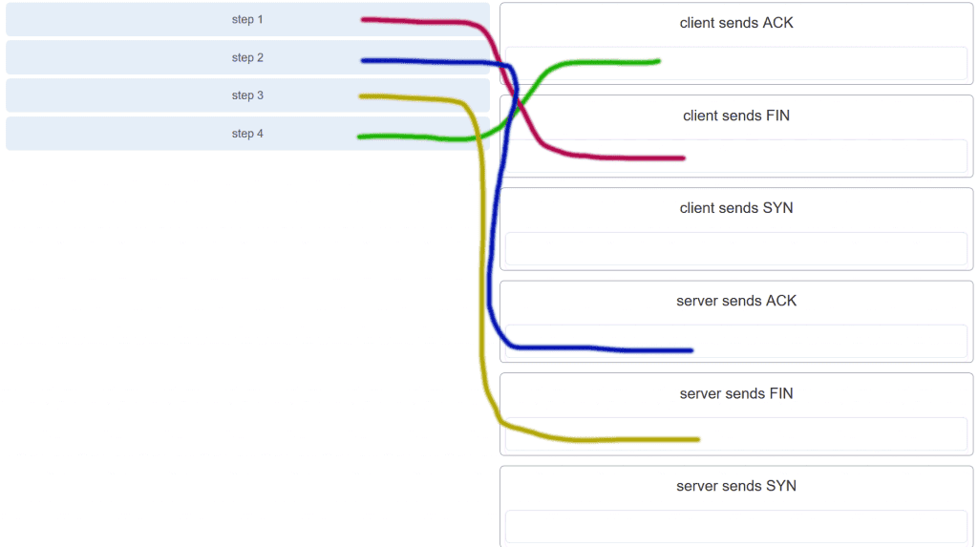

CCNA 1 v7.0 Modules 14 – 15 Exam Answers p13

**14. Which flag in the TCP header is used in response to a received FIN in order to terminate connectivity between two network devices?**

FIN  
**ACK\***  
SYN  
RST

**15. Which protocol or service uses UDP for a client-to-server communication and TCP for server-to-server communication?**

HTTP  
FTP  
**DNS\***  
SMTP

**Explanation:** Some applications may use both TCP and UDP. DNS uses UDP when clients send requests to a DNS server, and TCP when two DNS serves directly communicate.

**16. What is a characteristic of UDP?**

UDP datagrams take the same path and arrive in the correct order at the destination.​  
Applications that use UDP are always considered unreliable.​  
**UDP reassembles the received datagrams in the order they were received.\***  
UDP only passes data to the network when the destination is ready to receive the data.

**Explanation:** UDP has no way to reorder the datagrams into their transmission order, so UDP simply reassembles the data in the order it was received and forwards it to the application.​

**17. What kind of port must be requested from IANA in order to be used with a specific application?**

**registered port\***  
private port  
dynamic port  
source port

**Explanation:** Registered ports (numbers 1024 to 49151) are assigned by IANA to a requesting entity to use with specific processes or applications. These processes are primarily individual applications that a user has chosen to install, rather than common applications that would receive a well-known port number. For example, Cisco has registered port 1985 for its Hot Standby Routing Protocol (HSRP) process.​

**18. Which three application layer protocols use TCP? (Choose three.)**

**SMTP\***  
**FTP\***  
SNMP  
**HTTP\***  
TFTP  
DHCP

**Explanation:** Some protocols require the reliable data transport that is provided by TCP. In addition, these protocols do not have real time communication requirements and can tolerate some data loss while minimizing protocol overhead. Examples of these protocols are SMTP, FTP, and HTTP.

**19. Which three statements characterize UDP? (Choose three.)**

**UDP provides basic connectionless transport layer functions.\***  
UDP provides connection-oriented, fast transport of data at Layer 3.  
**UDP relies on application layer protocols for error detection.\***  
**UDP is a low overhead protocol that does not provide sequencing or flow control mechanisms.\***  
UDP relies on IP for error detection and recovery.  
UDP provides sophisticated flow control mechanisms.

**20. Which two fields are included in the TCP header but not in the UDP header? (Choose two.)**

**Window\***  
checksum  
source port  
destination port  
**sequence number\***

**Explanation:** The sequence number and window fields are included in the TCP header but not in the UDP header.

**21. Which field in the TCP header indicates the status of the three-way handshake process?**

window  
reserved  
checksum  
**control bits\***

**Explanation:** The value in the control bits field of theTCP header indicates the progress and status of the connection.

**22. Why does HTTP use TCP as the transport layer protocol?**

to ensure the fastest possible download speed  
because HTTP is a best-effort protocol  
because transmission errors can be tolerated easily  
**because HTTP requires reliable delivery\***

**23. Which two types of applications are best suited for UDP? (Choose two.)**

applications that need data flow control  
applications that require reliable delivery  
**applications that handle reliability themselves\***  
applications that need the reordering of segments  
**applications that can tolerate some data loss, but require little or no delay\***

**24. How are port numbers used in the TCP/IP encapsulation process?**

Source port numbers and destination port numbers are not necessary when UDP is the transport layer protocol being used for the communication.  
Source port and destination port numbers are randomly generated.  
**If multiple conversations occur that are using the same service, the source port number is used to track the separate conversations.\***  
Destination port numbers are assigned automatically and cannot be changed.

**Explanation:** Both UDP and TCP use port numbers to provide a unique identifier for each conversation. Source port numbers are randomly generated and are used to track different conversations. Destination port numbers identify specific services by using either a default port number for the service or a port number that is assigned manually by a system administrator.

**25. In what two situations would UDP be better than TCP as the preferred transport protocol? (Choose two.)**

when applications need to guarantee that a packet arrives intact, in sequence, and unduplicated  
**when a faster delivery mechanism is needed\***  
when delivery overhead is not an issue  
**when applications do not need to guarantee delivery of the data\***  
when destination port numbers are dynamic

**Explanation:** UDP is a very simple transport layer protocol that does not guarantee delivery. Devices on both ends of the conversation are not required to keep track of the conversation. UDP is used as the transport protocol for applications that need a speedy, best-effort delivery.

**26. What are three responsibilities of the transport layer? (Choose three.)**

**meeting the reliability requirements of applications, if any\***  
**multiplexing multiple communication streams from many users or applications on the same network\***  
**identifying the applications and services on the client and server that should handle transmitted data\***  
directing packets towards the destination network  
formatting data into a compatible form for receipt by the destination devices  
conducting error detection of the contents in frames

**27. Which three statements describe a DHCP Discover message? (Choose three.)**

The source MAC address is 48 ones (FF-FF-FF-FF-FF-FF).  
**The destination IP address is 255.255.255.255.\***  
The message comes from a server offering an IP address.  
**The message comes from a client seeking an IP address.\***  
**All hosts receive the message, but only a DHCP server replies.\***  
Only the DHCP server receives the message.

**Explanation:** When a host configured to use DHCP powers up on a network it sends a DHCPDISCOVER message. FF-FF-FF-FF-FF-FF is the L2 broadcast address. A DHCP server replies with a unicast DHCPOFFER message back to the host.

**28. Which two protocols may devices use in the application process that sends email? (Choose two.)**

HTTP  
**SMTP\***  
POP  
IMAP  
**DNS\***  
POP3

**29. What is true about the Server Message Block protocol?**

Different SMB message types have a different format.  
**Clients establish a long term connection to servers.\***  
SMB messages cannot authenticate a session.  
SMB uses the FTP protocol for communication.

**Explanation:** The Server Message Block protocol is a protocol for file, printer, and directory sharing. Clients establish a long term connection to servers and when the connection is active, the resources can be accessed. Every SMB message has the same format. The use of SMB differs from FTP mainly in the length of the sessions. SMB messages can authenticate sessions.

**30. What is the function of the HTTP GET message?**

**to request an HTML page from a web server\***  
to send error information from a web server to a web client  
to upload content to a web server from a web client  
to retrieve client email from an email server using TCP port 110

**31. Which OSI layer provides the interface between the applications used to communicate and the underlying network over which messages are transmitted?**

**Application\***  
presentation  
session  
transport

**32. Which networking model is being used when an author uploads one chapter document to a file server of a book publisher?**

peer-to-peer  
master-slave  
**client/server\***  
point-to-point

**Explanation:** In the client/server network model, a network device assumes the role of server in order to provide a particular service such as file transfer and storage. In the client/server network model, a dedicated server does not have to be used, but if one is present, the network model being used is the client/server model. In contrast, a peer-to-peer network does not have a dedicated server.

**33. What do the client/server and peer-to-peer network models have in common?**

Both models have dedicated servers.  
**Both models support devices in server and client roles.\***  
Both models require the use of TCP/IP-based protocols.  
Both models are used only in the wired network environment.

**Explanation:** In both the client/server and peer-to-peer network models, clients and servers exist. In peer-to-peer networks, no dedicated server exists, but a device can assume the server role to provide information to a device serving in the client role.

**34. In what networking model would eDonkey, eMule, BitTorrent, Bitcoin, and LionShare be used?**

**peer-to-peer\***  
client-based  
master-slave  
point-to-point

**Explanation:** In a peer-to-peer networking model, data is exchanged between two network devices without the use of a dedicated server. Peer-to-peer applications such as Shareaz, eDonkey, and Bitcoin allow one network device to assume the role of server, while one or more other network devices assume the role of client using the peer-to-peer application.

**35. What is a common protocol that is used with peer-to-peer applications such as WireShare, Bearshare, and Shareaza?**

Ethernet  
**Gnutella\***  
POP  
SMTP

**36. What is a key characteristic of the peer-to-peer networking model?**

wireless networking  
social networking without the Internet  
network printing using a print server  
**resource sharing without a dedicated server\***

**Explanation:** The peer-to-peer (P2P) networking model allows data, printer, and resource sharing without a dedicated server.​​

**37. The application layer of the TCP/IP model performs the functions of what three layers of the OSI model? (Choose three.)**

physical  
**session\***  
network  
**presentation\***  
data link  
transport  
**application\***

**Explanation:** The network access layer of the TCP/IP model performs the same functions as the physical and data link layers of the OSI model. The internetwork layer equates to the network layer of the OSI model. The transport layers are the same in both models. The application layer of the TCP/IP model represents the session, presentation, and application layers of the OSI model.​

**38. What is an example of network communication that uses the client-server model?**

A user uses eMule to download a file that is shared by a friend after the file location is determined.  
A workstation initiates an ARP to find the MAC address of a receiving host.  
A user prints a document by using a printer that is attached to a workstation of a coworker.  
**A workstation initiates a DNS request when the user types www.cisco.com in the address bar of a web browser.\***

**Explanation:** When a user types a domain name of a website into the address bar of a web browser, a workstation needs to send a DNS request to the DNS server for the name resolution process. This request is a client/server model application. The eMule application is P2P. Sharing a printer on a workstation is a peer-to-peer network. Using ARP is just a broadcast message sent by a host.

**39. Which layer in the TCP/IP model is used for formatting, compressing, and encrypting data?**

internetwork  
session  
presentation  
**application\***  
network access

**Explanation:** The application layer of the TCP/IP model performs the functions of three layers of the OSI model – application, presentation, and session. The application layer of the TCP/IP model is the layer that provides the interface between the applications, is responsible for formatting, compressing, and encrypting data, and is used to create and maintain dialogs between source and destination applications.

**40. What is an advantage of SMB over FTP?​**

Only with SMB can data transfers occur in both directions.  
Only SMB establishes two simultaneous connections with the client, making the data transfer faster.​  
SMB is more reliable than FTP because SMB uses TCP and FTP uses UDP.​  
**SMB clients can establish a long-term connection to the server.​\***

**41. A manufacturing company subscribes to certain hosted services from its ISP. The services that are required include hosted world wide web, file transfer, and e-mail. Which protocols represent these three key applications? (Choose three.)**

**FTP\***  
**HTTP\***  
DNS  
SNMP  
DHCP  
**SMTP\***

**42. Which application layer protocol uses message types such as GET, PUT, and POST?**

DNS  
DHCP  
SMTP  
**HTTP\***  
POP3

**Explanation:** The GET command is a client request for data from a web server. A PUT command uploads resources and content, such as images, to a web server. A POST command uploads data files to a web server.

**43. What type of information is contained in a DNS MX record?**

the FQDN of the alias used to identify a service  
the IP address for an FQDN entry  
**the domain name mapped to mail exchange servers\***  
the IP address of an authoritative name server

**Explanation:** MX, or mail exchange messages, are used to map a domain name to several mail exchange servers that all belong to the same domain.

**44. Which three protocols operate at the application layer of the TCP/IP model? (Choose three.)**

ARP  
TCP  
UDP  
**FTP\***  
**POP3\***  
**DHCP\***

**Explanation:** FTP, DHCP, and POP3 are application layer protocols. TCP and UDP are transport layer protocols. ARP is a network layer protocol.

**45. Which protocol is used by a client to communicate securely with a web server?**

SMTP  
SMB  
IMAP  
**HTTPS\***

**Explanation:** HTTPS is a secure form of HTTP used to access web content hosted by a web server.

**46. Which applications or services allow hosts to act as client and server at the same time?**

client/server applications  
email applications  
**P2P applications\***  
authentication services

**47. What are two characteristics of peer-to-peer networks? (Choose two.)**

scalability  
one way data flow  
**decentralized resources\***  
centralized user accounts  
**resource sharing without a dedicated server\***

**Explanation:** Peer-to-peer networks have decentralized resources because every computer can serve as both a server and a client. One computer might assume the role of server for one transaction while acting as a client for another transaction. Peer-to-peer networks can share resources among network devices without the use of a dedicated server.

**48. Which scenario describes a function provided by the transport layer?**

A student is using a classroom VoIP phone to call home. The unique identifier burned into the phone is a transport layer address used to contact another network device on the same network.  
A student is playing a short web-based movie with sound. The movie and sound are encoded within the transport layer header.  
**A student has two web browser windows open in order to access two web sites. The transport layer ensures the correct web page is delivered to the correct browser window.\***  
A corporate worker is accessing a web server located on a corporate network. The transport layer formats the screen so the web page appears properly no matter what device is being used to view the web site.

**Explanation:** The source and destination port numbers are used to identify the correct application and window within that application.

**49. Which three layers of the OSI model provide similar network services to those provided by the application layer of the TCP/IP model? (Choose three.)**

physical layer  
**session layer\***  
transport layer  
**application layer\***  
**presentation layer\***  
data link layer

**Explanation:** The three upper layers of the OSI model, the session, presentation, and application layers, provide application services similar to those provided by the TCP/IP model application layer. Lower layers of the OSI model are more concerned with data flow.

**50. A PC that is communicating with a web server has a TCP window size of 6,000 bytes when sending data and a packet size of 1,500 bytes. Which byte of information will the web server acknowledge after it has received two packets of data from the PC?**

**3001\***  
6001  
4500  
6000

**51. A PC that is communicating with a web server has a TCP window size of 6,000 bytes when sending data and a packet size of 1,500 bytes. Which byte of information will the web server acknowledge after it has received three packets of data from the PC?**

**4501\***  
6001  
6000  
4500

**52. A PC that is communicating with a web server has a TCP window size of 6,000 bytes when sending data and a packet size of 1,500 bytes. Which byte of information will the web server acknowledge after it has received four packets of data from the PC?**

**6001\***  
3001  
1501  
1500

**53. A PC that is communicating with a web server has a TCP window size of 6,000 bytes when sending data and a packet size of 1,500 bytes. Which byte of information will the web server acknowledge after it has received four packets of data from the PC?**

**6001\***  
3001  
3000  
1500

**54. A PC that is communicating with a web server has a TCP window size of 6,000 bytes when sending data and a packet size of 1,500 bytes. Which byte of information will the web server acknowledge after it has received two packets of data from the PC?**

**3001\***  
4501  
3000  
1500

**55. A PC that is communicating with a web server has a TCP window size of 6,000 bytes when sending data and a packet size of 1,500 bytes. Which byte of information will the web server acknowledge after it has received two packets of data from the PC?**

**3001\***  
4501  
4500  
1500

**56. A PC that is communicating with a web server has a TCP window size of 6,000 bytes when sending data and a packet size of 1,500 bytes. Which byte of information will the web server acknowledge after it has received two packets of data from the PC?**

**3001\***  
6001  
4500  
3000

**57. A PC that is communicating with a web server has a TCP window size of 6,000 bytes when sending data and a packet size of 1,500 bytes. Which byte of information will the web server acknowledge after it has received two packets of data from the PC?**

**3001\***  
6001  
6000  
3000

**58. A PC that is communicating with a web server has a TCP window size of 6,000 bytes when sending data and a packet size of 1,500 bytes. Which byte of information will the web server acknowledge after it has received three packets of data from the PC?**

**4501\***  
6001  
6000  
3000

**59. A PC that is communicating with a web server has a TCP window size of 6,000 bytes when sending data and a packet size of 1,500 bytes. Which byte of information will the web server acknowledge after it has received three packets of data from the PC?**

**4501**\*  
6001  
1500  
4500

**60. A client creates a packet to send to a server. The client is requesting TFTP service. What number will be used as the destination port number in the sending packet?**

**69\***  
67  
53  
80

**61. A client creates a packet to send to a server. The client is requesting FTP service. What number will be used as the destination port number in the sending packet?**

**21\***  
69  
67  
80

**62. A client creates a packet to send to a server. The client is requesting SSH service. What number will be used as the destination port number in the sending packet?**

**22\***  
69  
67  
80

**63. A client creates a packet to send to a server. The client is requesting HTTP service. What number will be used as the destination port number in the sending packet?**

**80\***  
67  
53  
69

**64. A client creates a packet to send to a server. The client is requesting POP3 service. What number will be used as the destination port number in the sending packet?**

**110\***  
67  
53  
69

**65. A client creates a packet to send to a server. The client is requesting telnet service. What number will be used as the destination port number in the sending packet?**

**23\***  
443  
161  
110

**66. A client creates a packet to send to a server. The client is requesting POP3 service. What number will be used as the destination port number in the sending packet?**

**110\***  
443  
161  
80

**67. A client creates a packet to send to a server. The client is requesting SNMP service. What number will be used as the destination port number in the sending packet?**

**161\***  
443  
110  
80

**68. A client creates a packet to send to a server. The client is requesting SMTP service. What number will be used as the destination port number in the sending packet?**

**25\***  
443  
161  
110

**69. A client creates a packet to send to a server. The client is requesting HTTPS service. What number will be used as the destination port number in the sending packet?**

**443\***  
161  
110  
80

**Modules 14 – 15: Network Application Communications Exam Answers (Additional)**

**1. Which action is performed by a client when establishing communication with a server via the use of UDP at the transport layer?**

The client sets the window size for the session.  
The client sends an ISN to the server to start the 3-way handshake.  
**The client randomly selects a source port number.\***  
The client sends a synchronization segment to begin the session.

**2. Which transport layer feature is used to guarantee session establishment?**

UDP ACK flag  
**TCP 3-way handshake\***  
UDP sequence number  
TCP port number

**3. What is the complete range of TCP and UDP well-known ports?**

0 to 255  
**0 to 1023\***  
256 – 1023  
1024 – 49151

**4. What is a socket?**

the combination of the source and destination IP address and source and destination Ethernet address  
**the combination of a source IP address and port number or a destination IP address and port number\***  
the combination of the source and destination sequence and acknowledgment numbers  
the combination of the source and destination sequence numbers and port numbers

**5. How does a networked server manage requests from multiple clients for different services?**

The server sends all requests through a default gateway.  
**Each request is assigned source and destination port numbers.\***  
The server uses IP addresses to identify different services.  
Each request is tracked through the physical address of the client.

**6. Which two services or protocols use the preferred UDP protocol for fast transmission and low overhead? (Choose two)**

FTP  
**DNS\***  
HTTP  
POP3  
**VoIP\***

**7. What is the purpose of using a source port number in a TCP communication?**

to notify the remote device that the conversation is over  
to assemble the segments that arrived out of order  
**to keep track of multiple conversations between devices\***  
to inquire for a nonreceived segment

**8. Which number or set of numbers represents a socket?**

01-23-45-67-89-AB  
21  
**192.168.1.1:80\***  
10.1.1.15

**9. Which two flags in the TCP header are used in a TCP three-way handshake to establish connectivity between two network devices? (Choose two.)**

**ACK\***  
FIN  
PSH  
RST  
**SYN\***  
URG

**10. What happens if part of an FTP message is not delivered to the destination?**

The message is lost because FTP does not use a reliable delivery method.  
The FTP source host sends a query to the destination host.  
**The part of the FTP message that was lost is re-sent.\***  
The entire FTP message is re-sent.

**11. What type of applications are best suited for using UDP?**

**applications that are sensitive to delay\***  
applications that need reliable delivery  
applications that require retransmission of lost segments  
applications that are sensitive to packet loss

**12. Network congestion has resulted in the source learning of the loss of TCP segments that were sent to the destination. What is one way that the TCP protocol addresses this?**

**The source decreases the amount of data that it transmits before it receives an acknowledgement from the destination.\***  
The source decreases the window size to decrease the rate of transmission from the destination.  
The destination decreases the window size.  
The destination sends fewer acknowledgement messages in order to conserve bandwidth.

**13. Which two operations are provided by TCP but not by UDP? (Choose two.)**

identifying the applications  
**acknowledging received data\***  
tracking individual conversations  
**retransmitting any unacknowledged data\***  
reconstructing data in the order received

**14. What is the TCP mechanism used in congestion avoidance ?**

three-way handshake  
socket pair  
two-way handshake  
**sliding window\***

**15. What is a responsibility of transport layer protocols?**

providing network access  
**tracking individual conversations\***  
determining the best path to forward a packet  
translating private IP addresses to public IP addresses

**16. Which protocol can be used to transfer messages from an email server to an email client?**

SMTP  
**POP3\***  
SNMP  
HTTP

**17. When retrieving email messages, which protocol allows for easy, centralized storage and backup of emails that would be desirable for a small- to medium-sized business?**

**IMAP\***  
POP  
SMTP  
HTTPS

**18. Which application layer protocol is used to provide file-sharing and print services to Microsoft applications?**

HTTP  
SMTP  
DHCP  
**SMB\***

**19. An author is uploading one chapter document from a personal computer to a file server of a book publisher. What role is the personal computer assuming in this network model?**

**Client\***  
master  
server  
slave  
transient

**20. Which statement is true about FTP?**

The client can choose if FTP is going to establish one or two connections with the server.  
**The client can download data from or upload data to the server.\***  
FTP is a peer-to-peer application.  
FTP does not provide reliability during data transmission.

**21. A wireless host needs to request an IP address. What protocol would be used to process the request?**

FTP  
HTTP  
**DHCP\***  
ICMP  
SNMP

**22. Which TCP/IP model layer is closest to the end user?**

**Application\***  
internet  
network access  
transport

**23. Which three protocols or standards are used at the application layer of the TCP/IP model? (Choose three.)**

TCP  
**HTTP\***  
**MPEG\***  
**GIF\***  
IP  
UDP

**24. Which protocol uses encryption?**

DHCP  
DNS  
FTP  
**HTTPS\***

**25. Why is DHCP preferred for use on large networks?**

Large networks send more requests for domain to IP address resolution than do smaller networks.  
DHCP uses a reliable transport layer protocol.  
It prevents sharing of files that are copyrighted.  
**It is a more efficient way to manage IP addresses than static address assignment.\***  
Hosts on large networks require more IP addressing configuration settings than hosts on small networks.

**26. Which two tasks can be performed by a local DNS server? (Choose two.)**

providing IP addresses to local hosts  
allowing data transfer between two network devices  
**mapping name-to-IP addresses for internal hosts\***  
**forwarding name resolution requests between servers\***  
retrieving email messages

**27. On a home network, which device is most likely to provide dynamic IP addressing to clients on the home network?**

a dedicated file server  
**a home router\***  
an ISP DHCP server  
a DNS server

**28. What part of the URL, http://www.cisco.com/index.html, represents the top-level DNS domain?**

**.com\***  
www  
http  
index

**29. What are two characteristics of the application layer of the TCP/IP model? (Choose two.)**

responsibility for logical addressing  
responsibility for physical addressing  
**the creation and maintenance of dialogue between source and destination applications\***  
**closest to the end user\***  
the establishing of window size

**30. What message type is used by an HTTP client to request data from a web server?**

**GET\***  
POST  
PUT  
ACK

**1. Which component is designed to protect against unauthorized communications to and from a computer?**

security center  
port scanner  
antimalware  
antivirus  
**firewall\***

**2. Which command will block login attempts on RouterA for a period of 30 seconds if there are 2 failed login attempts within 10 seconds?**

RouterA(config)# login block-for 10 attempts 2 within 30  
**RouterA(config)# login block-for 30 attempts 2 within 10\***  
RouterA(config)# login block-for 2 attempts 30 within 10  
RouterA(config)# login block-for 30 attempts 10 within 2

**3. What is the purpose of the network security accounting function?**

to require users to prove who they are  
to determine which resources a user can access  
**to keep track of the actions of a user\***  
to provide challenge and response questions

**4. What type of attack may involve the use of tools such as nslookup and fping?**

access attack  
**reconnaissance attack\***  
denial of service attack  
worm attack

**5. Match each weakness with an example. (Not all options are used.)**

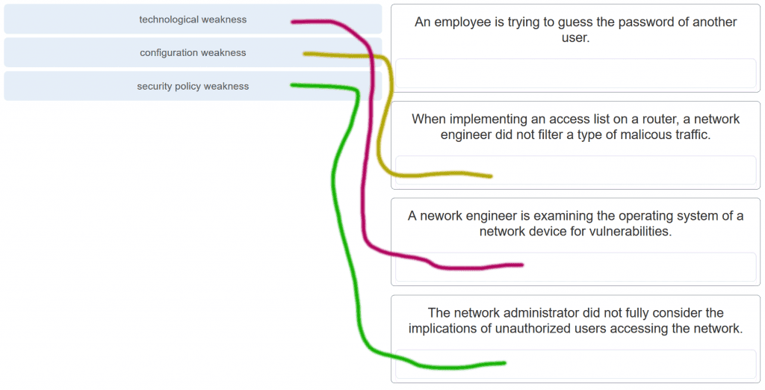

CCNA 1 v7.0 Modules 16 – 17 Exam Answers p5

**6. Match the type of information security threat to the scenario. (Not all options are used.)**

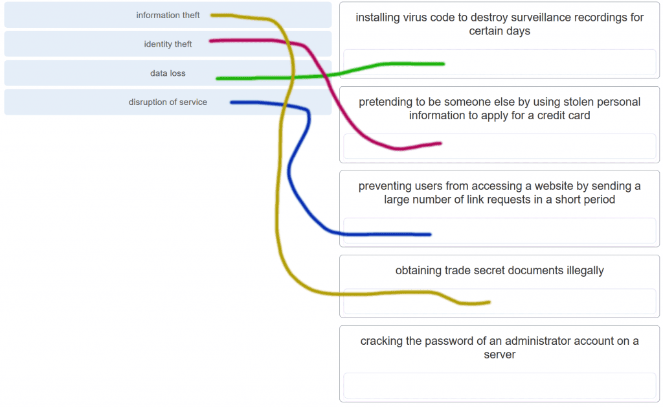

CCNA 1 v7.0 Modules 16 – 17 Exam Answers p6

**7. Which example of malicious code would be classified as a Trojan horse?**

**malware that was written to look like a video game\***  
malware that requires manual user intervention to spread between systems  
malware that attaches itself to a legitimate program and spreads to other programs when launched  
malware that can automatically spread from one system to another by exploiting a vulnerability in the target

**8. What is the difference between a virus and a worm?**

Viruses self-replicate but worms do not.  
**Worms self-replicate but viruses do not.\***  
Worms require a host file but viruses do not.  
Viruses hide in legitimate programs but worms do not.

**Explanation:**Worms are able to self-replicate and exploit vulnerabilities on computer networks without user participation.

**9. Which attack involves a compromise of data that occurs between two end points?**

denial-of-service  
**man-in-the-middle attack\***  
extraction of security parameters  
username enumeration

**Explanation:** Threat actors frequently attempt to access devices over the internet through communication protocols. Some of the most popular remote exploits are as follows:  
***Man-In-the-middle attack (MITM)*** – The threat actor gets between devices in the system and intercepts all of the data being transmitted. This information could simply be collected or modified for a specific purpose and delivered to its original destination.  
***Eavesdropping attack***– When devices are being installed, the threat actor can intercept data such as security keys that are used by constrained devices to establish communications once they are up and running.  
***SQL injection (SQLi)*** – Threat actors uses a flaw in the Structured Query Language (SQL) application that allows them to have access to modify the data or gain administrative privileges.  
***Routing attack*** – A threat actor could either place a rogue routing device on the network or modify routing packets to manipulate routers to send all packets to the chosen destination of the threat actor. The threat actor could then drop specific packets, known as selective forwarding, or drop all packets, known as a sinkhole attack.

**10. Which type of attack involves an adversary attempting to gather information about a network to identify vulnerabilities?**

**Reconnaissance\***  
DoS  
dictionary  
man-in-the-middle

**11. Match the description to the type of firewall filtering. (Not all options are used.)**

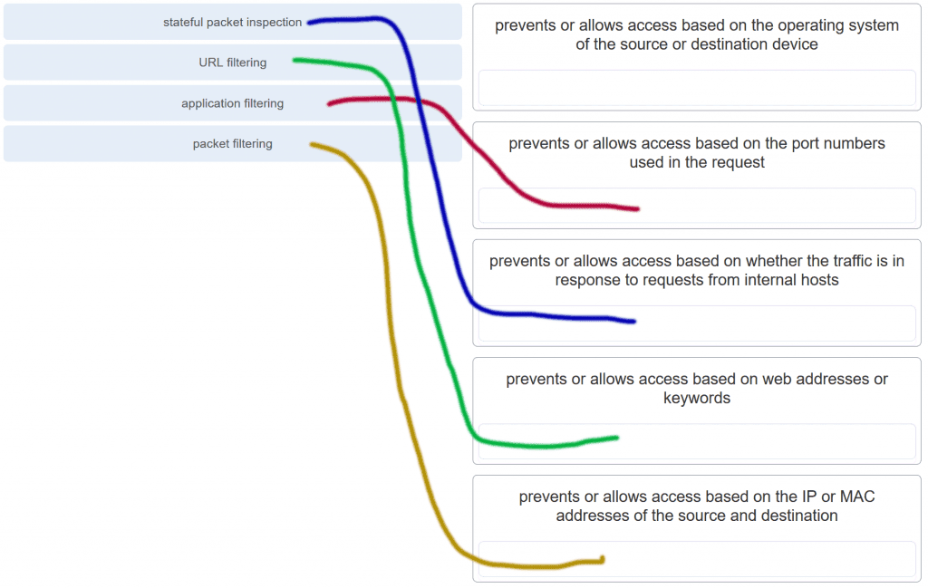

CCNA 1 v7.0 Modules 16 – 17 Exam Answers p11

**12. What is the purpose of the network security authentication function?**

**to require users to prove who they are\***  
to determine which resources a user can access  
to keep track of the actions of a user  
to provide challenge and response questions

**Explanation:** Authentication, authorization, and accounting are network services collectively known as AAA. Authentication requires users to prove who they are. Authorization determines which resources the user can access. Accounting keeps track of the actions of the user.

**13. Which firewall feature is used to ensure that packets coming into a network are legitimate responses to requests initiated from internal hosts?**

**stateful packet inspection\***  
URL filtering  
application filtering  
packet filtering

**14. When applied to a router, which command would help mitigate brute-force password attacks against the router?**

exec-timeout 30  
service password-encryption  
banner motd $Max failed logins = 5$  
**login block-for 60 attempts 5 within 60\***

**Explanation:** The login block-for command sets a limit on the maximum number of failed login attempts allowed within a defined period of time. If this limit is exceeded, no further logins are allowed for the specified period of time. This helps to mitigate brute-force password cracking since it will significantly increase the amount of time required to crack a password. The exec-timeout command specifies how long the session can be idle before the user is disconnected. The service password-encryption command encrypts the passwords in the running configuration. The banner motd command displays a message to users who are logging in to the device.

**15. Identify the steps needed to configure a switch for SSH. The answer order does not matter. (Not all options are used.)**

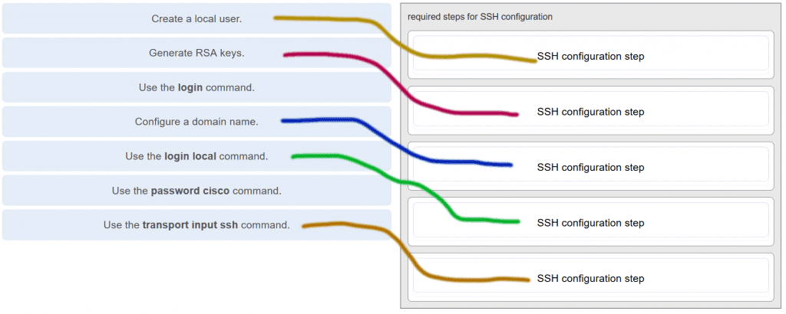

CCNA 1 v7.0 Modules 16 – 17 Exam Answers p15

**Explanation:** The login and password cisco commands are used with Telnet switch configuration, not SSH configuration.

**16. What feature of SSH makes it more secure than Telnet for a device management connection?**

confidentiality with IPsec  
stronger password requirement  
random one-time port connection  
**login information and data encryption\***

**Explanation:** Secure Shell (SSH) is a protocol that provides a secure management connection to a remote device. SSH provides security by providing encryption for both authentication (username and password) and the transmitted data. Telnet is a protocol that uses unsecure plaintext transmission. SSH is assigned to TCP port 22 by default. Although this port can be changed in the SSH server configuration, the port is not dynamically changed. SSH does not use IPsec.

**17. What is the advantage of using SSH over Telnet?**

SSH is easier to use.  
SSH operates faster than Telnet.  
**SSH provides secure communications to access hosts.\***  
SSH supports authentication for a connection request.

**Explanation:** SSH provides a secure method for remote access to hosts by encrypting network traffic between the SSH client and remote hosts. Although both Telnet and SSH request authentication before a connection is established, Telnet does not support encryption of login credentials.

**18. What is the role of an IPS?**

**detecting and blocking of attacks in real time\***  
connecting global threat information to Cisco network security devices  
authenticating and validating traffic  
filtering of nefarious websites

**Explanation:** An intrusion prevention system (IPS) provides real-time detection and blocking of attacks.

**19. A user is redesigning a network for a small company and wants to ensure security at a reasonable price. The user deploys a new application-aware firewall with intrusion detection capabilities on the ISP connection. The user installs a second firewall to separate the company network from the public network. Additionally, the user installs an IPS on the internal network of the company. What approach is the user implementing?**

attack based  
risk based  
structured  
**layered\***

**Explanation:** Using different defenses at various points of the network creates a layered approach.

**20. What is an accurate description of redundancy?**

configuring a router with a complete MAC address database to ensure that all frames can be forwarded to the correct destination  
configuring a switch with proper security to ensure that all traffic forwarded through an interface is filtered  
designing a network to use multiple virtual devices to ensure that all traffic uses the best path through the internetwork  
**designing a network to use multiple paths between switches to ensure there is no single point of failure\***

**Explanation:** Redundancy attempts to remove any single point of failure in a network by using multiple physically cabled paths between switches in the network.

**21. A network administrator is upgrading a small business network to give high priority to real-time applications traffic. What two types of network services is the network administrator trying to accommodate? (Choose two.)**

**voice\***  
**video\***  
instant messaging  
FTP  
SNMP

**22. What is the purpose of a small company using a protocol analyzer utility to capture network traffic on the network segments where the company is considering a network upgrade?**

to identify the source and destination of local network traffic  
to capture the Internet connection bandwidth requirement  
**to document and analyze network traffic requirements on each network segment\***  
to establish a baseline for security analysis after the network is upgraded

**Explanation:** An important prerequisite for considering network growth is to understand the type and amount of traffic that is crossing the network as well as the current traffic flow. By using a protocol analyzer in each network segment, the network administrator can document and analyze the network traffic pattern for each segment, which becomes the base in determining the needs and means of the network growth.

**23. Refer to the exhibit.**

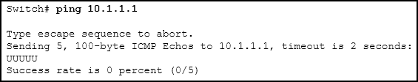

CCNA 1 v7.0 Modules 16 – 17 Exam Answers p23

**An administrator is testing connectivity to a remote device with the IP address 10.1.1.1. What does the output of this command indicate?**

Connectivity to the remote device was successful.  
**A router along the path did not have a route to the destination.\***  
A ping packet is being blocked by a security device along the path.  
The connection timed out while waiting for a reply from the remote device.

**Explanation:** In the output of the ping command, an exclamation mark (!) indicates a response was successfully received, a period (.) indicates that the connection timed out while waiting for a reply, and the letter “U” indicates that a router along the path did not have a route to the destination and sent an ICMP destination unreachable message back to the source.

**24. Which method is used to send a ping message specifying the source address for the ping?**

Issue the ping command from within interface configuration mode.  
**Issue the ping command without specifying a destination IP address.\***  
Issue the ping command without extended commands.  
Issue the ping command after shutting down un-needed interfaces.

**Explanation:** By issuing the ping command without a destination IP address in privileged EXEC mode, the Cisco IOS enters extended ping mode. This allows the user to implement extended commands which include source IP address.​

**25. A network engineer is analyzing reports from a recently performed network baseline. Which situation would depict a possible latency issue?**

a change in the bandwidth according to the show interfaces output  
a next-hop timeout from a traceroute  
**an increase in host-to-host ping response times\***  
a change in the amount of RAM according to the show version output

**Explanation:** While analyzing historical reports an administrator can compare host-to-host timers from the ping command and depict possible latency issues.​

**26. Which statement is true about Cisco IOS ping indicators?​**

‘!’ indicates that the ping was unsuccessful and that the device may have issues finding a DNS server.  
**‘U’ may indicate that a router along the path did not contain a route to the destination address and that the ping was unsuccessful.\***  
‘.’ indicates that the ping was successful but the response time was longer than normal.  
A combination of ‘.’ and ‘!’ indicates that a router along the path did not have a route to the destination address and responded with an ICMP unreachable message.​

**Explanation:** The most common indicators of a ping issued from the Cisco IOS are “!”, “.”, and “U”. The “!” indicates that the ping completed successfully, verifying connectivity at Layer 3. The “.” may indicate that a connectivity problem, routing problem, or device security issue exists along the path and that an ICMP destination unreachable message was not provided. The “U” indicates that a router along the path may not have had a route to the destination address, and that it responded with an ICMP unreachable message.

**27. A user reports a lack of network connectivity. The technician takes control of the user machine and attempts to ping other computers on the network and these pings fail. The technician pings the default gateway and that also fails. What can be determined for sure by the results of these tests?**

The NIC in the PC is bad.  
The TCP/IP protocol is not enabled.  
The router that is attached to the same network as the workstation is down.  
**Nothing can be determined for sure at this point.\***

**Explanation:** In networks today, a failed ping could mean that the other devices on the network are blocking pings. Further investigation such as checking network connectivity from other devices on the same network is warranted.

**28. A network technician issues the C:\> tracert -6 www.cisco.com command on a Windows PC. What is the purpose of the -6 command option?**

**It forces the trace to use IPv6.\***  
It limits the trace to only 6 hops.  
It sets a 6 milliseconds timeout for each replay.  
It sends 6 probes within each TTL time period.

**29. Why would a network administrator use the tracert utility?**

to determine the active TCP connections on a PC  
to check information about a DNS name in the DNS server  
**to identify where a packet was lost or delayed on a network\***  
to display the IP address, default gateway, and DNS server address for a PC

**Explanation:** The tracert utility is used to identify the path a packet takes from source to destination. Tracert is commonly used when packets are dropped or not reaching a specific destination.

**30. A ping fails when performed from router R1 to directly connected router R2. The network administrator then proceeds to issue the show cdp neighbors command. Why would the network administrator issue this command if the ping failed between the two routers?**

The network administrator suspects a virus because the ping command did not work.  
**The network administrator wants to verify Layer 2 connectivity.\***  
The network administrator wants to verify the IP address configured on router R2.  
The network administrator wants to determine if connectivity can be established from a non-directly connected network.

**Explanation:** The show cdp neighbors command can be used to prove that Layer 1 and Layer 2 connectivity exists between two Cisco devices. For example, if two devices have duplicate IP addresses, a ping between the devices will fail, but the output of show cdp neighbors will be successful. The show cdp neighbors detail could be used to verify the IP address of the directly connected device in case the same IP address is assigned to the two routers.

**31. A network engineer is troubleshooting connectivity issues among interconnected Cisco routers and switches. Which command should the engineer use to find the IP address information, host name, and IOS version of neighboring network devices?**

show version  
show ip route  
show interfaces  
**show cdp neighbors detail\***

**Explanation:** The show cdp neighbors detail command reveals much information about neighboring Cisco devices, including the IP address, the capabilities, host name, and IOS version. The show interfaces and show version commands display information about the local device.

**32. What information about a Cisco router can be verified using the show version command?**

the routing protocol version that is enabled  
**the value of the configuration register\***  
the operational status of serial interfaces  
the administrative distance used to reach networks

**Explanation:** The value of the configuration register can be verified with the show version command.

**33. Which command should be used on a Cisco router or switch to allow log messages to be displayed on remotely connected sessions using Telnet or SSH?**

debug all  
logging synchronous  
show running-config​  
**terminal monitor\***

**34. Which command can an administrator issue on a Cisco router to send debug messages to the vty lines?**

**terminal monitor\***  
logging console  
logging buffered  
logging synchronous

**Explanation:** Debug messages, like other IOS log messages, are sent to the console line by default. Sending these messages to the terminal lines requires the terminal monitor command.

**35. By following a structured troubleshooting approach, a network administrator identified a network issue after a conversation with the user. What is the next step that the administrator should take?**

Verify full system functionality.  
Test the theory to determine cause.  
**Establish a theory of probable causes.\***  
Establish a plan of action to resolve the issue.

**Explanation:** A structured network troubleshooting approach should include these steps in sequence:  
1. Identify the problem.  
2. Establish a theory of probable causes.  
3. Test the theory to determine cause.  
4. Establish a plan of action to resolve the issue.  
5. Verify full system functionality and implement preventive measures.  
6. Document findings, actions, and outcomes.

**36. Users are complaining that they are unable to browse certain websites on the Internet. An administrator can successfully ping a web server via its IP address, but cannot browse to the domain name of the website. Which troubleshooting tool would be most useful in determining where the problem is?**

netstat  
tracert  
**nslookup\***  
ipconfig

**Explanation:** The nslookup command can be used to look up information about a particular DNS name in the DNS server. The information includes the IP address of the DNS server being used as well as the IP address associated with the specified DNS name. This command can help verify the DNS that is used and if the domain name to IP address resolution works.

**37. An employee complains that a Windows PC cannot connect to the Internet. A network technician issues the ipconfig command on the PC and is shown an IP address of 169.254.10.3. Which two conclusions can be drawn? (Choose two.)**

**The PC cannot contact a DHCP server.\***  
The DNS server address is misconfigured.  
The default gateway address is not configured.  
**The PC is configured to obtain an IP address automatically.\***  
The enterprise network is misconfigured for dynamic routing.

**38. Refer to the exhibit.**

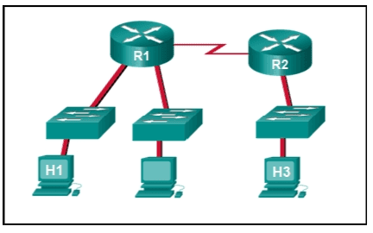

CCNA 1 v7.0 Modules 16 – 17 Exam Answers p38

**Host H3 is having trouble communicating with host H1. The network administrator suspects a problem exists with the H3 workstation and wants to prove that there is no problem with the R2 configuration. What tool could the network administrator use on router R2 to prove that communication exists to host H1 from the interface on R2, which is the interface that H3 uses when communicating with remote networks?**

traceroute  
show cdp neighbors  
Telnet  
**an extended ping\***

**39. Refer to the exhibit.**



CCNA 1 v7.0 Modules 16 – 17 Exam Answers p39

**Baseline documentation for a small company had ping round trip time statistics of 36/97/132 between hosts H1 and H3. Today the network administrator checked connectivity by pinging between hosts H1 and H3 that resulted in a round trip time of 1458/2390/6066. What does this indicate to the network administrator?**

Connectivity between H1 and H3 is fine.  
H3 is not connected properly to the network.  
Something is causing interference between H1 and R1.  
Performance between the networks is within expected parameters.  
**Something is causing a time delay between the networks.\***

**40. Which network service automatically assigns IP addresses to devices on the network?**

**DHCP\***  
Telnet  
DNS  
traceroute

**Explanation:** Dynamic Host Configuration Protocol (DHCP) can be used to allow end devices to automatically configure IP information, such as their IP address, subnet mask, DNS server, and default gateway. The DNS service is used to provide domain name resolution, mapping hostnames to IP addresses. Telnet is a method for remotely accessing a CLI session of a switch or router. Traceroute is a command used to determine the path a packet takes as it traverses the network.

**41. Which command can an administrator execute to determine what interface a router will use to reach remote networks?**

show arp  
show interfaces  
**show ip route\***  
show protocols

**Explanation:** The show ip route command is used to display the IP routing table of the router. The IP routing table will show a list of known local and remote networks and the interfaces that the router will use to reach those networks.

**42. On which two interfaces or ports can security be improved by configuring executive timeouts? (Choose two.)**

Fast Ethernet interfaces  
**console ports\***  
serial interfaces  
**vty ports\***  
loopback interfaces

**Explanation:** Executive timeouts allow the Cisco device to automatically disconnect users after they have been idle for the specified time. Console, vty, and aux ports can be configured with executive timeouts.

**43. When configuring SSH on a router to implement secure network management, a network engineer has issued the login local and transport input ssh line vty commands. What three additional configuration actions have to be performed to complete the SSH configuration? (Choose three.)**

Set the user privilege levels.  
**Generate the asymmetric RSA keys.\***  
**Configure the correct IP domain name.\***  
Configure role-based CLI access.  
**Create a valid local username and password database.\***  
Manually enable SSH after the RSA keys are generated.

**Explanation:** SSH is automatically enabled after the RSA keys are generated. Setting user privilege levels and configuring role-based CLI access are good security practices but are not a requirement of implementing SSH.

**44. What is considered the most effective way to mitigate a worm attack?**

Change system passwords every 30 days.  
Ensure that all systems have the most current virus definitions.  
Ensure that AAA is configured in the network.  
**Download security updates from the operating system vendor and patch all vulnerable systems.\***

**Explanation:** Because worms take advantage of vulnerabilities in the system itself, the most effective way to mitigate worm attacks is to download security updates from the operating system vendor and patch all vulnerable systems.

**45. Which statement describes the ping and tracert commands?**

**Tracert shows each hop, while ping shows a destination reply only.\***  
Tracert uses IP addresses; ping does not.  
Both ping and tracert can show results in a graphical display.  
Ping shows whether the transmission is successful; tracert does not.

**Explanation:** The ping utility tests end-to-end connectivity between the two hosts. However, if the message does not reach the destination, there is no way to determine where the problem is located. On the other hand, the traceroute utility (tracert in Windows) traces the route a message takes from its source to the destination. Traceroute displays each hop along the way and the time it takes for the message to get to that network and back.

**46. A technician is to document the current configurations of all network devices in a college, including those in off-site buildings. Which protocol would be best to use to securely access the network devices?**

FTP  
HTTP  
**SSH\***  
Telnet

**Explanation:** Telnet sends passwords and other information in clear text, while SSH encrypts its data. FTP and HTTP do not provide remote device access for configuration purposes.

**47. Open the PT Activity. Perform the tasks in the activity instructions and then answer the question.**

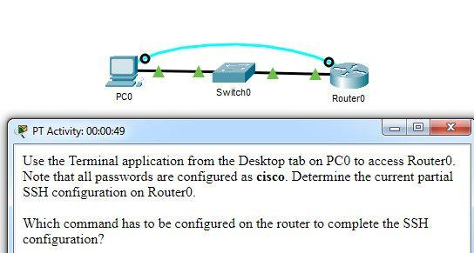

CCNA 1 v7.0 Modules 16 – 17 Exam Answers p47

**Which command has to be configured on the router to complete the SSH configuration?**

service password-encryption  
**transport input ssh\***  
enable secret class  
ip domain-name cisco.com

**Explanation:** The missing command to complete the SSH configuration is transport input ssh in line vty 0 4 mode.The commands service password-encryption and enable secret class do configure secure features on the router, but are not required to configure SSH. The command ip domain-name cisco.com is not required because the command ip domain-name span.com has been used.

**48. An administrator decides to use “WhatAreyouwaiting4” as the password on a newly installed router. Which statement applies to the password choice?**

**It is strong because it uses a passphrase.\***  
It is weak because it is often the default password on new devices.  
It is weak since it uses easily found personal information.  
It is weak since it is a word that is easily found in the dictionary.

**49. An administrator decides to use “pR3s!d7n&0” as the password on a newly installed router. Which statement applies to the password choice?**

**It is strong because it uses a minimum of 10 numbers, letters and special characters.\***  
It is weak because it is often the default password on new devices.  
It is weak since it uses easily found personal information.  
It is weak since it is a word that is easily found in the dictionary.

**50. An administrator decides to use “5$7*4#033!” as the password on a newly installed router. Which statement applies to the password choice?**

**It is strong because it contains 10 numbers and special characters.\***  
It is weak because it is often the default password on new devices.  
It is weak since it uses easily found personal information.  
It is strong because it uses a minimum of 10 numbers, letters and special characters.

**51. An administrator decides to use “pR3s!d7n&0” as the password on a newly installed router. Which statement applies to the password choice?**

**It is strong because it uses a minimum of 10 numbers, letters and special characters.\***  
It is weak since it is a word that is easily found in the dictionary.  
It is strong because it uses a passphrase.  
It is strong because it contains 10 numbers and special characters.

**52. An administrator decides to use “12345678!” as the password on a newly installed router. Which statement applies to the password choice?**

**It is weak because it uses a series of numbers or letters.\***  
It is strong because it uses a passphrase.  
It is weak since it is a word that is easily found in the dictionary.  
It is strong because it uses a minimum of 10 numbers, letters and special characters.

**53. An administrator decides to use “admin” as the password on a newly installed router. Which statement applies to the password choice?**

**It is weak because it is often the default password on new devices.\***  
It is strong because it uses a passphrase.  
It is strong because it uses a minimum of 10 numbers, letters and special characters.  
It is strong because it contains 10 numbers and special characters.

**54. An administrator decides to use “Feb121978” as the password on a newly installed router. Which statement applies to the password choice?**

**It is weak because it uses easily found personal information.\***  
It is strong because it uses a passphrase.  
It is weak since it is a word that is easily found in the dictionary.  
It is strong because it uses a minimum of 10 numbers, letters and special characters.

**55. An administrator decides to use “password” as the password on a newly installed router. Which statement applies to the password choice?**

**It is weak because it is a commonly used password.\***  
It is weak since it is a word that is easily found in the dictionary.  
It is strong because it uses a passphrase.  
It is strong because it uses a minimum of 10 numbers, letters and special characters.

**56. An administrator decides to use “RobErT” as the password on a newly installed router. Which statement applies to the password choice?**

**It is weak since it uses easily found personal information.\***  
It is strong because it uses a passphrase.  
It is strong because it uses a minimum of 10 numbers, letters and special characters.  
It is strong because it contains 10 numbers and special characters.

**57. An administrator decides to use “Elizabeth” as the password on a newly installed router. Which statement applies to the password choice?**

**It is weak because it uses easily found personal information.\***  
It is strong because it uses a passphrase.  
It is weak since it is a word that is easily found in the dictionary.  
It is strong because it uses a minimum of 10 numbers, letters and special characters.

Rules for strong passwords:  
* minimum of 8 characters, preferably 10.  
* use complex combinations of numbers, special characters, and upper and lower case letters.  
* avoid repetition, common dictionary words, letter or number sequences.  
* avoid names of children, relatives, pets, birthdays, or any easily identifiable personal information.  
* can be created by misspelling words or replacing vowels with numbers or special characters.

**58. A network technician is troubleshooting an issue and needs to verify the IP addresses of all interfaces on a router. What is the best command to use to accomplish the task?**

**show ip interface brief\***  
nslookup  
ipconfig getifaddr en0  
show ip route

**59. Students who are connected to the same switch are having slower than normal response times. The administrator suspects a duplex setting issue. What is the best command to use to accomplish the task?**

**show interfaces\***  
ipconfig getifaddr en0  
copy running-config startup-config  
show ip nat translations

**60. A user wants to know the IP address of the PC. What is the best command to use to accomplish the task?**

**Ipconfig\***  
copy running-config startup-config  
show interfaces  
show ip nat translations

**61. A student wants to save a router configuration to NVRAM. What is the best command to use to accomplish the task?**

**copy running-config startup-config\***  
show interfaces  
show ip nat translations  
show ip route

**62. A support technician needs to know the IP address of the wireless interface on a MAC. What is the best command to use to accomplish the task?**

**ipconfig getifaddr en0\***  
copy running-config startup-config  
show interfaces  
show ip nat translations

**63. A network technician is troubleshooting an issue and needs to verify all of the IPv6 interface addresses on a router. What is the best command to use to accomplish the task?**

**show ipv6 interface\***  
show interfaces  
show ip nat translations  
show ip route

**64. A teacher is having difficulties connecting his PC to the classroom network. He needs to verify that a default gateway is configured correctly. What is the best command to use to accomplish the task?**

**Ipconfig\***  
copy running-config startup-config  
show interfaces  
show ip nat translations

**65. Only employees connected to IPv6 interfaces are having difficulty connecting to remote networks. The analyst wants to verify that IPv6 routing has been enabled. What is the best command to use to accomplish the task?**

**show running-config\***  
show interfaces  
copy running-config startup-config  
show ip nat translations

**66. An administrator is troubleshooting connectivity issues and needs to determine the IP address of a website. What is the best command to use to accomplish the task?**

**Nslookup\***  
show ipv6 route  
show ipv6 interface  
copy startup-config running-config

**67. Only employees connected to IPv6 interfaces are having difficulty connecting to remote networks. The analyst wants to verify that IPv6 routing has been enabled. What is the best command to use to accomplish the task?**

**show running-config\***  
show ipv6 route  
show ipv6 interface  
copy startup-config running-config

**Modules 16 – 17: Building and Securing a Small Network Exam Answers (Additional)**

**1. Which component is designed to protect against unauthorized communications to and from a computer?**

security center  
port scanner  
antimalware  
antivirus  
**firewall\***

**2. Which command will block login attempts on RouterA for a period of 30 seconds if there are 2 failed login attempts within 10 seconds?**

RouterA(config)# login block-for 10 attempts 2 within 30  
**RouterA(config)# login block-for 30 attempts 2 within 10\***  
RouterA(config)# login block-for 2 attempts 30 within 10  
RouterA(config)# login block-for 30 attempts 10 within 2

**3. What is the purpose of the network security accounting function?**

to require users to prove who they are  
to determine which resources a user can access  
**to keep track of the actions of a user\***  
to provide challenge and response questions

**4. What type of attack may involve the use of tools such as nslookup and fping?**

access attack  
**reconnaissance attack\***  
denial of service attack  
worm attack

**5. Which benefit does SSH offer over Telnet for remotely managing a router?**

**Encryption\***  
TCP usage  
authorization  
connections via multiple VTY lines

**6. What is one of the most effective security tools available for protecting users from external threats?**

**Firewalls\***  
router that run AAA services  
patch servers  
password encryption techniques

**7. Which type of network threat is intended to prevent authorized users from accessing resources?**

**DoS attacks\***  
access attacks  
reconnaissance attacks  
trust exploitation

**8. Which three services are provided by the AAA framework? (Choose three.)**

**accounting\***  
automation  
**authorization\***  
**authentication\***  
autobalancing  
autoconfiguration

**9. Which malicious code attack is self-contained and tries to exploit a specific vulnerability in a system being attacked?**

virus  
**worm\***  
Trojan horse  
social engineering

**10. Some routers and switches in a wiring closet malfunctioned after an air conditioning unit failed. What type of threat does this situation describe?**

configuration  
**environmental\***  
electrical  
maintenance

**11. What does the term vulnerability mean?**

**a weakness that makes a target susceptible to an attack\***  
a computer that contains sensitive information  
a method of attack to exploit a target  
a known target or victim machine  
a potential threat that a hacker creates

**12. What three configuration steps must be performed to implement SSH access to a router? (Choose three.)**

a password on the console line  
**an IP domain name\***  
**a user account\***  
an enable mode password  
**a unique hostname\***  
an encrypted password

**13. What is the objective of a network reconnaissance attack?**

**discovery and mapping of systems\***  
unauthorized manipulation of data  
disabling network systems or services  
denying access to resources by legitimate users

**14. For security reasons a network administrator needs to ensure that local computers cannot ping each other. Which settings can accomplish this task?**

smartcard settings  
**firewall settings\***  
MAC address settings  
file system settings

**15. A network administrator establishes a connection to a switch via SSH. What characteristic uniquely describes the SSH connection?**

out-of-band access to a switch through the use of a virtual terminal with password authentication  
remote access to the switch through the use of a telephone dialup connection  
on-site access to a switch through the use of a directly connected PC and a console cable  
**remote access to a switch where data is encrypted during the session\***  
direct access to the switch through the use of a terminal emulation program

**16. Which network design consideration would be more important to a large corporation than to a small business?**

Internet router  
firewall  
low port density switch  
**redundancy\***

**17. A newly hired network technician is given the task of ordering new hardware for a small business with a large growth forecast. Which primary factor should the technician be concerned with when choosing the new devices?**

devices with a fixed number and type of interfaces  
devices that have support for network monitoring  
redundant devices  
**devices with support for modularity\***

**18. What type of traffic would most likely have the highest priority through the network?**

FTP  
instant messaging  
**voice\***  
SNMP

**19. A network technician is investigating network connectivity from a PC to a remote host with the address 10.1.1.5. Which command, when issued on a Windows PC, will display the path to the remote host?**

trace 10.1.1.5  
traceroute 10.1.1.5  
**tracert 10.1.1.5\***  
ping 10.1.1.5

**20. A user is unable to reach the website when typing ht​tp://ww​w.cisco.com in a web browser, but can reach the same site by typing ht​tp://72.163.4.161. What is the issue?**

default gateway  
DHCP  
**DNS\***  
TCP/IP protocol stack

**21. Where are Cisco IOS debug output messages sent by default?**

memory buffers  
vty lines  
Syslog server  
**console line\***

**22. Which element of scaling a network involves identifying the physical and logical topologies?**

traffic analysis  
**network documentation\***  
device inventory  
cost analysis

**23. What mechanism can be implemented in a small network to help minimize network latency for real-time streaming applications?**

**QoS\***  
PoE  
AAA  
ICMP

**24. Which process failed if a computer cannot access the internet and received an IP address of 169.254.142.5?**

IP  
DNS  
**DHCP\***  
HTTP

**25. A small company has only one router as the exit point to its ISP. Which solution could be adopted to maintain connectivity if the router itself, or its connection to the ISP, fails?**

Activate another router interface that is connected to the ISP, so the traffic can flow through it.  
**Have a second router that is connected to another ISP.\***  
Purchase a second least-cost link from another ISP to connect to this router.  
Add more interfaces to the router that is connected to the internal network.

**26. When should an administrator establish a network baseline?**

when the traffic is at peak in the network  
when there is a sudden drop in traffic  
at the lowest point of traffic in the network  
**at regular intervals over a period of time\***

**27. Which two traffic types require delay sensitive delivery? (Choose two.)**

email  
web  
FTP  
**Voice\***  
**Video\***

**28. A network technician suspects that a particular network connection between two Cisco switches is having a duplex mismatch. Which command would the technician use to see the Layer 1 and Layer 2 details of a switch port?**

**show interfaces\***  
show running-config  
show ip interface brief​  
show mac-address-table

**29. Which statement is true about CDP on a Cisco device?​**

The show cdp neighbor detail command will reveal the IP address of a neighbor only if there is Layer 3 connectivity​.  
To disable CDP globally, the no cdp enable command in interface configuration mode must be used.  
**CDP can be disabled globally or on a specific interface​.\***  
Because it runs at the data link layer​, the CDP protocol can only be implemented in switches.

**30. What factor should be considered in the design of a small network when devices are being chosen?**

**cost of devices\***  
redundancy  
traffic analysis  
ISP

**. A client packet is received by a server. The packet has a destination port number of 22. What service is the client requesting?**

**SSH\***  
TFTP  
DHCP  
DNS

**2. Refer to the exhibit.**

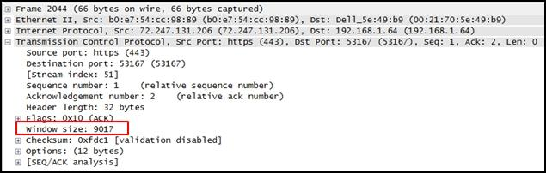

CCNA 1 v7 ITN Practice Final Exam Answers p2

**What does the value of the window size specify?**

the amount of data that can be sent at one time  
**the amount of data that can be sent before an acknowledgment is required\***  
the total number of bits received during this TCP session  
a random number that is used in establishing a connection with the 3-way handshake

**Explanation:** The window size determines the number of bytes that can be sent before expecting an acknowledgment. The acknowledgment number is the number of the next expected byte.

**3. To which TCP port group does the port 414 belong?**

**well-known\***  
private or dynamic  
public  
registered

**Explanation:** Well Known Ports: 0 through 1023.  
Registered Ports: 1024 through 49151.  
Dynamic/Private : 49152 through 65535.

**4. Refer to the exhibit.**

CCNA 1 v7 ITN Practice Final Exam Answers p4

CCNA 1 v7 ITN Practice Final Exam Answers p4

**An administrator is trying to configure the switch but receives the error message that is displayed in the exhibit. What is the problem?**

The entire command, configure terminal, must be used.  
The administrator is already in global configuration mode.  
**The administrator must first enter privileged EXEC mode before issuing the command.\***  
The administrator must connect via the console port to access global configuration mode.

**Explanation:** In order to enter global configuration mode, the command configure terminal, or a shortened version such as config t, must be entered from privileged EXEC mode. In this scenario the administrator is in user EXEC mode, as indicated by the > symbol after the hostname. The administrator would need to use the enable command to move into privileged EXEC mode before entering the configure terminal command.

**5. What is a user trying to determine when issuing a ping 10.1.1.1 command on a PC?**

if the TCP/IP stack is functioning on the PC without putting traffic on the wire  
**if there is connectivity with the destination device\***  
the path that traffic will take to reach the destination  
what type of device is at the destination

**Explanation:** The ping destination command can be used to test connectivity.

**6. What is a characteristic of a switch virtual interface (SVI)?​**

**An SVI is created in software and requires a configured IP address and a subnet mask in order to provide remote access to the switch.\***  
Although it is a virtual interface, it needs to have physical hardware on the device associated with it.  
SVIs do not require the no shutdown command to become enabled.  
SVIs come preconfigured on Cisco switches.

**Explanation:** Cisco IOS Layer 2 switches have physical ports for devices to connect. These ports do not support Layer 3 IP addresses. Therefore, switches have one or more switch virtual interfaces (SVIs). These are virtual interfaces because there is no physical hardware on the device associated with it. An SVI is created in software.  
The virtual interface lets you remotely manage a switch over a network using IPv4 and IPv6. Each switch comes with one SVI appearing in the default configuration “out-of-the-box.” The default SVI is interface VLAN1.

**7. Match the descriptions to the terms. (Not all options are used.)**

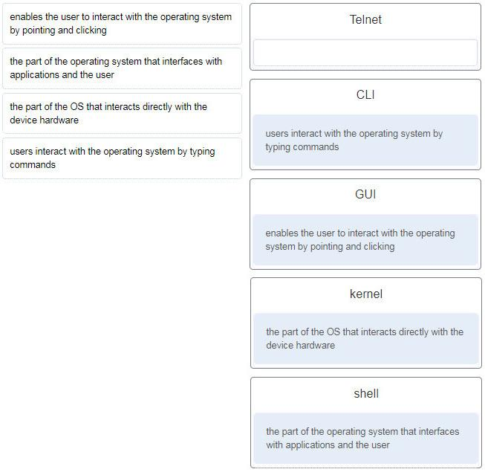

CCNA 1 v7 ITN Practice Final Exam Answers p7

**8. What happens when a switch receives a frame and the calculated CRC value is different than the value that is in the FCS field?**

The switch notifies the source of the bad frame.  
The switch places the new CRC value in the FCS field and forwards the frame.  
**The switch drops the frame.\***  
The switch floods the frame to all ports except the port through which the frame arrived to notify the hosts of the error.

**9. Two network engineers are discussing the methods used to forward frames through a switch. What is an important  
concept related to the cut-through method of switching?**

**The fragment-free switching offers the lowest level of latency.\***  
Fast-forward switching can be viewed as a compromise between store-and-forward switching and fragment-free switching.  
Fragment-free switching is the typical cut-through method of switching.  
Packets can be relayed with errors when fast-forward switching is used.

**10. Which two issues can cause both runts and giants in Ethernet networks? (Choose two.)**

**using the incorrect cable type\***  
half-duplex operations  
**a malfunctioning NIC\***  
electrical interference on serial interfaces  
CRC errors

**11. Which two functions are performed at the LLC sublayer of the OSI Data Link Layer to facilitate Ethernet communication? (Choose two.)**

places information in the Ethernet frame that identifies which network layer protocol is being encapsulated by the frame*  
**adds Ethernet control information to network protocol data\***  
implements CSMA/CD over legacy shared half-duplex media  
applies source and destination MAC addresses to Ethernet frame  
integrates Layer 2 flows between 10 Gigabit Ethernet over fiber and 1 Gigabit Ethernet over copper

**12. Which two commands could be used to check if DNS name resolution is working properly on a Windows PC? (Choose two.)**

**nslookup cisco.com\***  
**ping cisco.com\***  
ipconfig /flushdns  
net cisco.com  
nbtstat cisco.com

**13. A small advertising company has a web server that provides critical business service. The company connects to the Internet through a leased line service to an ISP. Which approach best provides cost effective redundancy for the Internet connection?**

Add a second NIC to the web server.  
**Add a connection to the Internet via a DSL line to another ISP.\***  
Add another web server to prepare failover support.  
Add multiple connections between the switches and the edge router.

**14. Only employees connected to IPv6 interfaces are having difficulty connecting to remote networks. The analyst wants to verify that IPv6 routing has been enabled. What is the best command to use to accomplish the task?**

copy running-config startup-config  
show interfaces  
show ip nat translations  
**show running-config\***

**15. Refer to the exhibit. A network administrator is connecting a new host to the Registrar LAN. The host needs to communicate with remote networks. What IP address would be configured as the default gateway on the new host?**

Floor(config)# interface gi0/1

Floor(config-if)# description Connects to the Registrar LAN

Floor(config-if)# ip address 192.168.235.234 255.255.255.0

Floor(config-if)# no shutdown

Floor(config-if)# interface gi0/0

Floor(config-if)# description Connects to the Manager LAN

Floor(config-if)# ip address 192.168.234.114 255.255.255.0

Floor(config-if)# no shutdown

Floor(config-if)# interface s0/0/0

Floor(config-if)# description Connects to the ISP

Floor(config-if)# ip address 10.234.235.254 255.255.255.0

Floor(config-if)# no shutdown

Floor(config-if)# interface s0/0/1

Floor(config-if)# description Connects to the Head Office WAN

Floor(config-if)# ip address 203.0.113.3 255.255.255.0

Floor(config-if)# no shutdown

Floor(config-if)# end

**192.168.235.234\***  
203.0.113.3  
192.168.235.1  
10.234.235.254  
192.168.234.114

**16. Match the command with the device mode at which the command is entered. (Not all options are used.)**

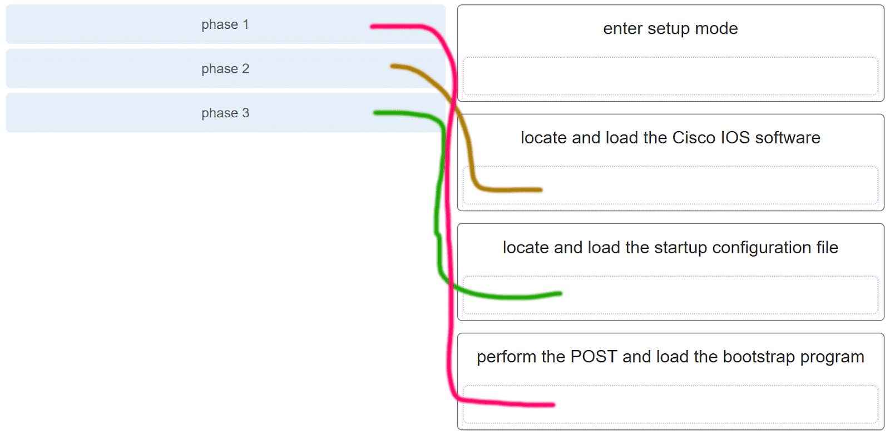

CCNA 1 v7 ITN Practice Final Exam Answers p16

**Explanation:** The enable command is entered in R1> mode. The login command is entered in R1(config-line)# mode. The copy running-config startup-config command is entered in R1# mode. The ip address 192.168.4.4 255.255.255.0 command is entered in R1(config-if)# mode. The service password-encryption command is entered in global configuration mode.

**17. A router boots and enters setup mode. What is the reason for this?**

The IOS image is corrupt.  
Cisco IOS is missing from flash memory.  
**The configuration file is missing from NVRAM.\***  
The POST process has detected hardware failure.

**Explanation:** The startup configuration file is stored in NVRAM and contains the commands needed to initially configure a router. It also creates the running configuration file that is stored in in RAM.

**18. What service is provided by POP3?**

**Retrieves email from the server by downloading the email to the local mail application of the client.\***  
An application that allows real-time chatting among remote users.  
Allows remote access to network devices and servers.  
Uses encryption to provide secure remote access to network devices and servers.

**19. Two students are working on a network design project. One student is doing the drawing, while the other student is writing the proposal. The drawing is finished and the student wants to share the folder that contains the drawing so that the other student can access the file and copy it to a USB drive. Which networking model is being used?**

**peer-to-peer\***  
client-based  
master-slave  
point-to-point

**Explanation:** In a peer-to-peer (P2P) networking model, data is exchanged between two network devices without the use of a dedicated server.

**20. Which command is used to manually query a DNS server to resolve a specific host name?**

tracert  
ipconfig /displaydns  
**nslookup\***  
net

**21. Which PDU is processed when a host computer is de-encapsulating a message at the transport layer of the TCP/IP model?**

bits  
frame  
packet  
**segment\***

**Explanation:** At the transport layer, a host computer will de-encapsulate a segment to reassemble data to an acceptable format by the application layer protocol of the TCP/IP model.

**22. Which two OSI model layers have the same functionality as two layers of the TCP/IP model? (Choose two.)**

data link  
**network\***  
physical  
session  
**transport\***

**Explanation:** The OSI transport layer is functionally equivalent to the TCP/IP transport layer, and the OSI network layer is equivalent to the TCP/IP internet layer. The OSI data link and physical layers together are equivalent to the TCP/IP network access layer. The OSI session layer (with the presentation layer) is included within the TCP/IP application layer.

**23. Which three layers of the OSI model are comparable in function to the application layer of the TCP/IP model? (Choose three.)**

**presentation\***  
physical  
network  
data link  
transport  
**application\***  
**sesión\***

**24. Network information:**

* local router LAN interface: 172.19.29.254 / fe80:65ab:dcc1::10

* local router WAN interface: 198.133.219.33 / 2001:db8:FACE:39::10

* remote server: 192.135.250.103

**What task might a user be trying to accomplish by using the ping 2001:db8:FACE:39::10 command?**

verifying that there is connectivity within the local network  
creating a network performance benchmark to a server on the company intranet  
determining the path to reach the remote server  
**verifying that there is connectivity to the internet\***

**25. Which two ICMP messages are used by both IPv4 and IPv6 protocols? (Choose two.)​**

neighbor solicitation  
router advertisement  
router solicitation  
**protocol unreachable\***  
route redirection

**26. A network technician types the command ping 127.0.0.1 at the command prompt on a computer. What is the technician trying to accomplish?**

pinging a host computer that has the IP address 127.0.0.1 on the network  
tracing the path to a host computer on the network and the network has the IP address 127.0.0.1  
checking the IP address on the network card  
**testing the integrity of the TCP/IP stack on the local machine\***

**27. Although CSMA/CD is still a feature of Ethernet, why is it no longer necessary?**

the virtually unlimited availability of IPv6 addresses  
the use of CSMA/CA  
**the use of full-duplex capable Layer 2 switches\***  
the development of half-duplex switch operation  
the use of Gigabit Ethernet speeds

**Explanation:** The use of Layer 2 switches operating in full-duplex mode eliminates collisions, thereby eliminating the need for CSMA/CD.

**28. What does a router do when it receives a Layer 2 frame over the network medium?**

re-encapsulates the packet into a new frame  
**forwards the new frame appropriate to the medium of that segment of the physical network\***  
determines the best path  
de-encapsulates the frame

**29. Which two acronyms represent the data link sublayers that Ethernet relies upon to operate? (Choose two.)**

SFD  
**LLC\***  
CSMA  
**MAC\***  
FCS

**30. A network team is comparing topologies for connecting on a shared media. Which physical topology is an example of a hybrid topology for a LAN?**

bus  
**extended star\***  
ring  
partial mesh

**Explanation:** An extended star topology is an example of a hybrid topology as additional switches are interconnected with other star topologies. A partial mesh topology is a common hybrid WAN topology. The bus and ring are not hybrid topology types.

**31. Given network 172.18.109.0, which subnet mask would be used if 6 host bits were available?**

255.255.192.0  
255.255.224.0  
255.255.255.192  
**255.255.255.248\***  
255.255.255.252

**32. Three devices are on three different subnets. Match the network address and the broadcast address with each subnet where these devices are located. (Not all options are used.)**

Device 1: IP address 192.168.10.77/28 on subnet 1

Device 2: IP address192.168.10.17/30 on subnet 2

Device 3: IP address 192.168.10.35/29 on subnet 3

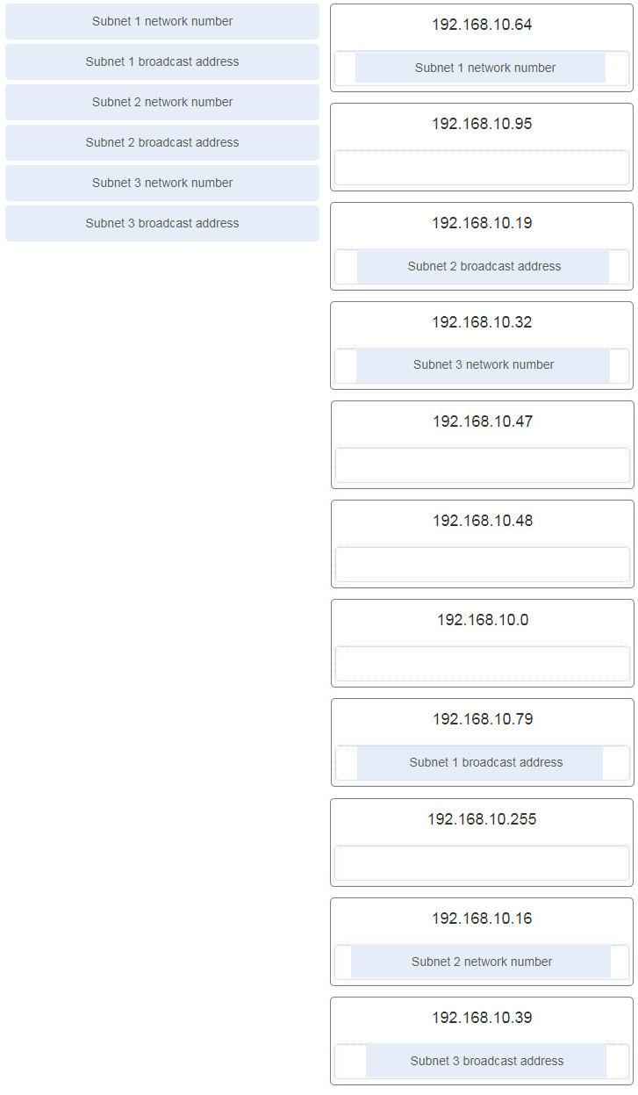

CCNA 1 v7 ITN Practice Final Exam Answers p32

To calculate any of these addresses, write the device IP address in binary. Draw a line showing where the subnet mask 1s end. For example, with Device 1, the final octet (77) is 01001101. The line would be drawn between the 0100 and the 1101 because the subnet mask is /28. Change all the bits to the right of the line to 0s to determine the network number (01000000 or 64). Change all the bits to the right of the line to 1s to determine the broadcast address (01001111 or 79).

**33. What type of address is 198.133.219.162?**

link-local  
**public\***  
loopback  
multicast

**34. What does the IP address 192.168.1.15/29 represent?**

subnetwork address  
unicast address  
multicast address  
**broadcast address\***

**35. Why is NAT not needed in IPv6?​**

Because IPv6 has integrated security, there is no need to hide the IPv6 addresses of internal networks.​  
The problems that are induced by NAT applications are solved because the IPv6 header improves packet handling by intermediate routers.​  
The end-to-end connectivity problems that are caused by NAT are solved because the number of routes increases with the number of nodes that are connected to the Internet.  
**Any host or user can get a public IPv6 network address because the number of available IPv6 addresses is extremely large.​\***

**36. What routing table entry has a next hop address associated with a destination network?**

directly-connected routes  
local routes  
**remote routes\***  
C and L source routes

**Explanation:** Routing table entries for remote routes will have a next hop IP address. The next hop IP address is the address of the router interface of the next device to be used to reach the destination network. Directly-connected and local routes have no next hop, because they do not require going through another router to be reached.

**37. Which term describes a field in the IPv4 packet header that contains a unicast, multicast, or broadcast address?**

**destination IPv4 address\***  
protocol  
TTL  
header checksum

**38. If the default gateway is configured incorrectly on the host, what is the impact on communications?**

There is no impact on communications.  
The host is unable to communicate on the local network.  
**The host can communicate with other hosts on the local network, but is unable to communicate with hosts on remote networks.\***  
The host can communicate with other hosts on remote networks, but is unable to communicate with hosts on the local network.

**39. Which is the compressed format of the IPv6 address fe80:0000:0000:0000:0220:0b3f:f0e0:0029?**

fe80:9ea:0:2200::fe0:290  
fe80:9ea0::2020::bf:e0:9290  
**fe80::220:b3f:f0e0:29\***  
fe80:9ea0::2020:0:bf:e0:9290

**40. Refer to the exhibit.**

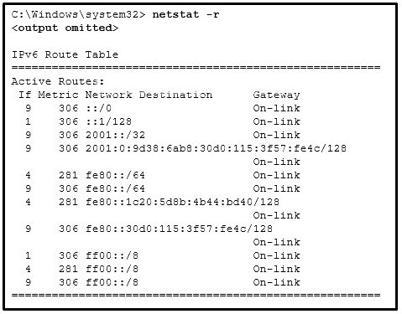

CCNA 1 v7 ITN Practice Final Exam Answers p40

**A user issues the command netstat –r on a workstation. Which IPv6 address is one of the link-local addresses of the workstation?**

::1/128  
**fe80::30d0:115:3f57:fe4c/128\***  
fe80::/64  
2001:0:9d38:6ab8:30d0:115:3f57:fe4c/128

**Explanation:** In the IPv6 address scheme, the network of fe80::/10 is reserved for link-local addresses. The address fe80::/64 is a network address that indicates, in this workstation, fe80::/64 is actually used for link-local addresses. Thus the address fe80::30d0:115:3f57:fe4c/128 is a valid IPv6 link-local address.

**41. What type of IPv6 address is represented by ::1/128?**

EUI-64 generated link-local  
global unicast  
unspecified  
**loopback\***

**42. Which statement describes network security?**

It supports growth over time in accordance with approved network design procedures.  
It synchronizes traffic flows using timestamps.  
**It ensures sensitive corporate data is available for authorized users.\***  
It prioritizes data flows in order to give priority to delay-sensitive traffic.

**43. Which two devices would be described as intermediary devices? (Choose two.)**

**wireless LAN controller\***  
server  
**assembly line robots\***  
IPS  
gaming console  
retail scanner

**44. What characteristic describes spyware?**

**software that is installed on a user device and collects information about the user\***  
the use of stolen credentials to access private data  
an attack that slows or crashes a device or network service  
a network device that filters access and traffic coming into a network

**45. Refer to the exhibit.**

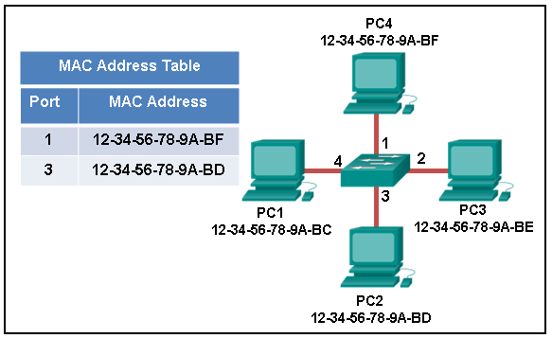

CCNA 1 v7 ITN Practice Final Exam Answers p45

**The exhibit shows a small switched network and the contents of the MAC address table of the switch. PC1 has sent a frame addressed to PC3. What will the switch do with the frame?**

The switch will discard the frame.  
The switch will forward the frame to all ports.  
The switch will forward the frame only to port 2.  
The switch will forward the frame only to ports 1 and 3.  
**The switch will forward the frame to all ports except port 4.\***

**46. Which destination address is used in an ARP request frame?**

0.0.0.0  
255.255.255.255  
the physical address of the destination host  
**FFFF.FFFF.FFFF\***  
AAAA.AAAA.AAAA

**47. Refer to the exhibit.**

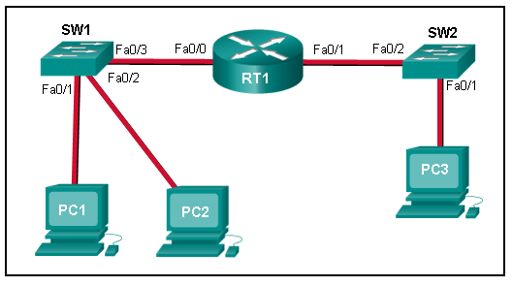

CCNA 1 v7 ITN Practice Final Exam Answers p47

**PC1 issues an ARP request because it needs to send a packet to PC3. In this scenario, what will happen next?**

SW1 will send an ARP reply with its Fa0/1 MAC address.  
**RT1 will send an ARP reply with its own Fa0/0 MAC address.\***  
RT1 will forward the ARP request to PC3.  
RT1 will send an ARP reply with the PC3 MAC address.  
RT1 will send an ARP reply with its own Fa0/1 MAC address.

**48. A network administrator is issuing the login block-for 180 attempts 2 within 30 command on a router. Which threat is the network administrator trying to prevent?**

**a user who is trying to guess a password to access the router\***  
a worm that is attempting to access another part of the network  
an unidentified individual who is trying to access the network equipment room  
a device that is trying to inspect the traffic on a link

**Explanation:** The login block-for 180 attempts 2 within 30 command will cause the device to block authentication after 2 unsuccessful attempts within 30 seconds for a duration of 180 seconds. A device inspecting the traffic on a link has nothing to do with the router. The router configuration cannot prevent unauthorized access to the equipment room. A worm would not attempt to access the router to propagate to another part of the network.

**49. Which statement describes the characteristics of packet-filtering and stateful firewalls as they relate to the OSI model?**

**A packet-filtering firewall uses session layer information to track the state of a connection, whereas a stateful firewall uses application layer information to track the state of a connection.\***  
Both stateful and packet-filtering firewalls can filter at the application layer.  
A packet-filtering firewall typically can filter up to the transport layer, whereas a stateful firewall can filter up to the session layer.  
A stateful firewall can filter application layer information, whereas a packet-filtering firewall cannot filter beyond the network layer.

**50. What are two ways to protect a computer from malware? (Choose two.)**

Empty the browser cache.  
**Use antivirus software.\***  
Delete unused software.  
**Keep software up to date.\***  
Defragment the hard disk.

**Explanation:** At a minimum, a computer should use antivirus software and have all software up to date to defend against malware.

**51. The employees and residents of Ciscoville cannot access the Internet or any remote web-based services. IT workers quickly determine that the city firewall is being flooded with so much traffic that a breakdown of connectivity to the Internet is occurring. Which type of attack is being launched at Ciscoville?**

access  
Trojan horse  
reconnaissance  
**DoS\***

**52. Which two statements describe the characteristics of fiber-optic cabling? (Choose two.)**

**Fiber-optic cabling does not conduct electricity.\***  
Multimode fiber-optic cabling carries signals from multiple sending devices.  
**Fiber-optic cabling is primarily used as backbone cabling.\***  
Fiber-optic cabling uses LEDs for single-mode cab​les and laser technology for multimode cables.  
Fiber-optic cabling has high signal loss.

**53. What OSI physical layer term describes the measure of the transfer of bits across a medium over a given period of time?**

latency  
goodput  
**throughput\***  
bandwidth

**54. Refer to the exhibit.**

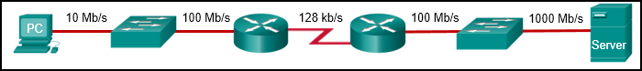

CCNA 1 v7 ITN Practice Final Exam Answers p54

**What is the maximum possible throughput between the PC and the server?**

10 Mb/s  
1000 Mb/s  
**128 kb/s\***  
100 Mb/s

**55. Match the description with the media. (Not all options are used.)**

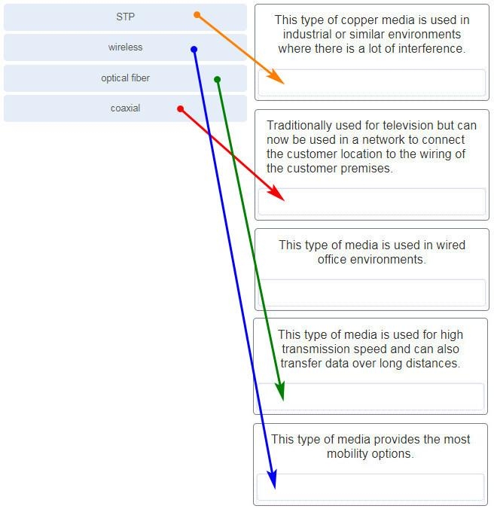

**What two ICMPv6 message types must be permitted through IPv6 access control lists to allow resolution of Layer 3 addresses to Layer 2 MAC addresses? (Choose two.)**

**neighbor solicitations\***  
echo requests  
**neighbor advertisements\***  
echo replies  
router solicitations  
router advertisements

**2. Which range of link-local addresses can be assigned to an IPv6-enabled interface?**

FEC0::/10  
FDEE::/7  
**FE80::/10\***  
FF00::/8

**Explanation:**  
Link-local addresses are in the range of FE80::/10 to FEBF::/10. The original IPv6 specification defined site-local addresses and used the prefix range FEC0::/10, but these addresses were deprecated by the IETF in favor of unique local addresses. FDEE::/7 is a unique local address because it is in the range of FC00::/7 to FDFF::/7. IPv6 multicast addresses have the prefix FF00::/8.

**3. What would be the interface ID of an IPv6 enabled interface with a MAC address of 1C-6F-65-C2-BD-F8 when the interface ID is generated by using the EUI-64 process?**

0C6F:65FF:FEC2:BDF8  
**1E6F:65FF:FEC2:BDF8\***  
C16F:65FF:FEC2:BDF8  
106F:65FF:FEC2:BDF8

**4. An organization is assigned an IPv6 address block of 2001:db8:0:ca00::/56. How many subnets can be created without using bits in the interface ID space?**

**256\***  
512  
1024  
4096

**5. Refer to the exhibit.**

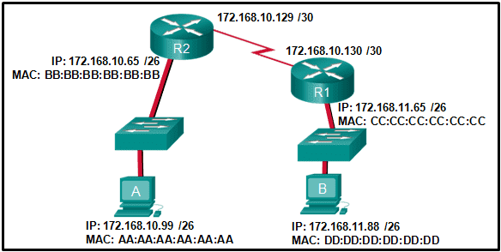

**If host A sends an IP packet to host B, what will the destination address be in the frame when it leaves host A?**

DD:DD:DD:DD:DD:DD  
172.168.10.99  
CC:CC:CC:CC:CC:CC  
172.168.10.65  
**BB:BB:BB:BB:BB:BB\***  
AA:AA:AA:AA:AA:AA

**Explanation:**  
When a host sends information to a distant network, the Layer 2 frame header will contain a source and destination MAC address. The source address will be the originating host device. The destination address will be the router interface that connects to the same network. In the case of host A sending information to host B, the source address is AA:AA:AA:AA:AA:AA and the destination address is the MAC address assigned to the R2 Ethernet interface, BB:BB:BB:BB:BB:BB.

**6. When a switch configuration includes a user-defined error threshold on a per-port basis, to which switching method will the switch revert when the error threshold is reached?**

cut-through  
**store-and-forward\***  
fast-forward  
fragment-free

**7. Which two statements are correct about MAC and IP addresses during data transmission if NAT is not involved? (Choose two.)**

**Destination IP addresses in a packet header remain constant along the entire path to a target host.\***  
Destination MAC addresses will never change in a frame that goes across seven routers.  
Every time a frame is encapsulated with a new destination MAC address, a new destination IP address is needed.  
**Destination and source MAC addresses have local significance and change every time a frame goes from one LAN to another.\***  
A packet that has crossed four routers has changed the destination IP address four times.

**8. What is one main characteristic of the data link layer?**

It generates the electrical or optical signals that represent the 1 and 0 on the media.  
It converts a stream of data bits into a predefined code.  
**It shields the upper layer protocol from being aware of the physical medium to be used in the communication.\***  
It accepts Layer 3 packets and decides the path by which to forward the packet to a remote network.

**9. What are three characteristics of the CSMA/CD process? (Choose three.)**

The device with the electronic token is the only one that can transmit after a collision.  
**A device listens and waits until the media is not busy before transmitting.\***  
**After detecting a collision, hosts can attempt to resume transmission after a random time delay has expired.\***  
**All of the devices on a segment see data that passes on the network medium.\***  
A jam signal indicates that the collision has cleared and the media is not busy.  
Devices can be configured with a higher transmission priority.

**10. What are two primary responsibilities of the Ethernet MAC sublayer? (Choose two.)**

error detection  
frame delimiting  
**accessing the media\***  
**data encapsulation\***  
logical addressing

**11. Which two commands can be used on a Windows host to display the routing table? (Choose two.)**

netstat -s  
**route print\***  
show ip route  
**netstat –r\***  
tracert

**Explanation:**  
On a Windows host, the route print or netstat -r commands can be used to display the host routing table. Both commands generate the same output. On a router, the show ip route command is used to display the routing table. The netstat –s command is used to display per-protocol statistics. The tracert command is used to display the path that a packet travels to its destination.

**12. What are two functions that are provided by the network layer? (Choose two.)**

**directing data packets to destination hosts on other networks\***  
placing data on the network medium  
carrying data between processes that are running on source and destination hosts  
providing dedicated end-to-end connections  
**providing end devices with a unique network identifier\***

**13. Which two statements describe features of an IPv4 routing table on a router? (Choose two.)​**

Directly connected interfaces will have two route source codes in the routing table: C and S.  
**If there are two or more possible routes to the same destination, the route associated with the higher metric value is included in the routing table.\***  
The netstat -r command can be used to display the routing table of a router.​  
The routing table lists the MAC addresses of each active interface.  
It stores information about routes derived from the active router interfaces.  
**If a default static route is configured in the router, an entry will be included in the routing table with source code S.\***

**14. How does the service password-encryption command enhance password security on Cisco routers and switches?**

It requires encrypted passwords to be used when connecting remotely to a router or switch with Telnet.  
**It encrypts passwords that are stored in router or switch configuration files.\***  
It requires that a user type encrypted passwords to gain console access to a router or switch.  
It encrypts passwords as they are sent across the network.

**Explanation:** The service password-encryption command encrypts plaintext passwords in the configuration file so that they cannot be viewed by unauthorized users.

**15. Why would a Layer 2 switch need an IP address?**

to enable the switch to send broadcast frames to attached PCs  
to enable the switch to function as a default gateway  
**to enable the switch to be managed remotely\***  
to enable the switch to receive frames from attached PCs

**Explanation:**  A switch, as a Layer 2 device, does not need an IP address to transmit frames to attached devices. However, when a switch is accessed remotely through the network, it must have a Layer 3 address. The IP address must be applied to a virtual interface rather than to a physical interface. Routers, not switches, function as default gateways.

**16. What characteristic describes identity theft?**

**the use of stolen credentials to access private data\***  
software on a router that filters traffic based on IP addresses or applications  
software that identifies fast-spreading threats  
a tunneling protocol that provides remote users with secure access into the network of an organization

**17. Match each description to its corresponding term. (Not all options are used.)**

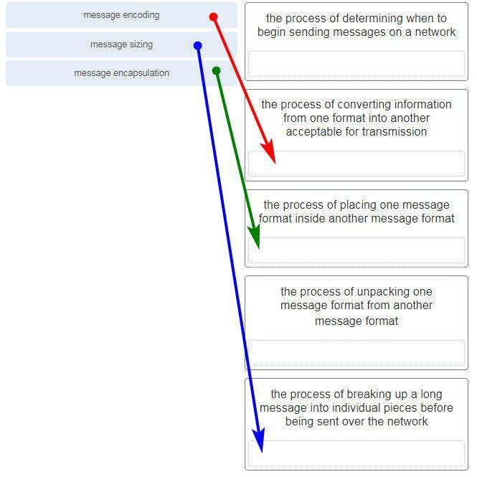

**18. A user sends an HTTP request to a web server on a remote network. During encapsulation for this request, what information is added to the address field of a frame to indicate the destination?**

the network domain of the destination host  
the IP address of the default gateway  
the MAC address of the destination host  
**the MAC address of the default gateway\***

**19. Data is being sent from a source PC to a destination server. Which three statements correctly describe the function of TCP or UDP in this situation? (Choose three.)**

**The source port field identifies the running application or service that will handle data returning to the PC.\***  
The TCP process running on the PC randomly selects the destination port when establishing a session with the server.  
**UDP segments are encapsulated within IP packets for transport across the network.\***  
**The UDP destination port number identifies the application or service on the server which will handle the data.\***  
TCP is the preferred protocol when a function requires lower network overhead.  
The TCP source port number identifies the sending host on the network.

**Explanation:** Layer 4 port numbers identify the application or service which will handle the data. The source port number is added by the sending device and will be the destination port number when the requested information is returned. Layer 4 segments are encapsulated within IP packets. UDP, not TCP, is used when low overhead is needed. A source IP address, not a TCP source port number, identifies the sending host on the network. Destination port numbers are specific ports that a server application or service monitors for requests.

**20. Match each description with the corresponding TCP mechanism. (Not all options are used.)**

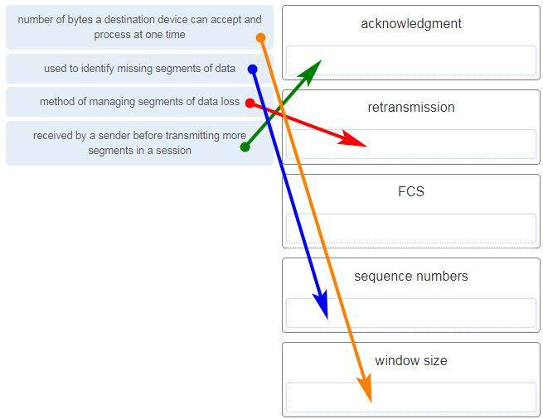

**21. Refer to the exhibit.**

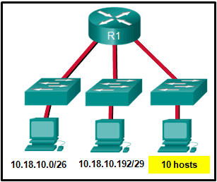

**Which two network addresses can be assigned to the network containing 10 hosts? Your answers should waste the fewest addresses, not reuse addresses that are already assigned, and stay within the 10.18.10.0/24 range of addresses. (Choose two.)**

10.18.10.200/28  
**10.18.10.208/28\***  
10.18.10.240/27  
10.18.10.200/27  
10.18.10.224/27  
**10.18.10.224/28\***

**Explanation:** Addresses 10.18.10.0 through 10.18.10.63 are taken for the leftmost network. Addresses 192 through 199 are used by the center network. Because 4 host bits are needed to accommodate 10 hosts, a /28 mask is needed. 10.18.10.200/28 is not a valid network number. Two subnets that can be used are 10.18.10.208/28 and 10.18.10.224/28.

**22. Refer to the exhibit.**

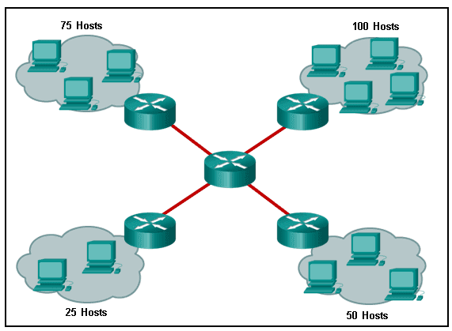

**A company uses the address block of 128.107.0.0/16 for its network. What subnet mask would provide the maximum number of equal size subnets while providing enough host addresses for each subnet in the exhibit?**

255.255.255.192  
255.255.255.0  
**255.255.255.128\***  
255.255.255.240  
255.255.255.224

**Explanation:** The largest subnet in the topology has 100 hosts in it so the subnet mask must have at least 7 host bits in it (27-2=126). 255.255.255.0 has 8 hosts bits, but this does not meet the requirement of providing the maximum number of subnets.

**23. A network administrator wants to have the same subnet mask for three subnetworks at a small site. The site has the following networks and numbers of devices:**

Subnetwork A: IP phones – 10 addresses

Subnetwork B: PCs – 8 addresses

Subnetwork C: Printers – 2 addresses

**What single subnet mask would be appropriate to use for the three subnetworks?**

255.255.255.0  
**255.255.255.240\***  
255.255.255.248  
255.255.255.252

**Explanation:**  
If the same mask is to be used, then the network with the most hosts must be examined for number of hosts. Because this is 10 hosts, 4 host bits are needed. The /28 or 255.255.255.240 subnet mask would be appropriate to use for these networks. ​

**24. Match each item to the type of topology diagram on which it is typically identified. (Not all options are used.)**

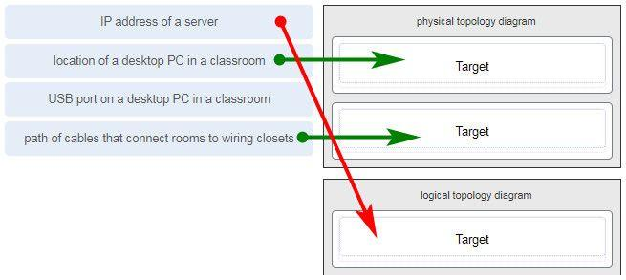

**25. What two pieces of information are displayed in the output of the show ip interface brief command? (Choose two.)**

**IP addresses\***  
interface descriptions  
MAC addresses  
next-hop addresses  
**Layer 1 statuses\***  
speed and duplex settings

**Explanation:** The command show ip interface brief shows the IP address of each interface, as well as the operational status of the interfaces at both Layer 1 and Layer 2. In order to see interface descriptions and speed and duplex settings, use the command show running-config interface. Next-hop addresses are displayed in the routing table with the command show ip route, and the MAC address of an interface can be seen with the command show interfaces.

**26. A user is complaining that an external web page is taking longer than normal to load.The web page does eventually load on the user machine. Which tool should the technician use with administrator privileges in order to locate where the issue is in the network?**

ping  
nslookup  
**tracert\***  
ipconfig /displaydns

**27. A network technician is researching the use of fiber optic cabling in a new technology center. Which two issues should be considered before implementing fiber optic media? (Choose two.)**

**Fiber optic cabling requires different termination and splicing expertise from what copper cabling requires.\***  
Fiber optic cabling requires specific grounding to be immune to EMI.  
Fiber optic cabling is susceptible to loss of signal due to RFI.  
Fiber optic cable is able to withstand rough handling.  
**Fiber optic provides higher data capacity but is more expensive than copper cabling.\***

**28. What technique is used with UTP cable to help protect against signal interference from crosstalk?**

wrapping a foil shield around the wire pairs  
**twisting the wires together into pairs\***  
terminating the cable with special grounded connectors  
encasing the cables within a flexible plastic sheath

**Explanation:** To help prevent the effects of crosstalk, UTP cable wires are twisted together into pairs. Twisting the wires together causes the magnetic fields of each wire to cancel each other out.

**29. A network administrator is designing the layout of a new wireless network. Which three areas of concern should be accounted for when building a wireless network? (Choose three.)**

extensive cabling  
mobility options  
packet collision  
**interference\***  
**security\***  
**coverage área\***

**Explanation:** The three areas of concern for wireless networks focus on the size of the coverage area, any nearby interference, and providing network security. Extensive cabling is not a concern for wireless networks, as a wireless network will require minimal cabling for providing wireless access to hosts. Mobility options are not a component of the areas of concern for wireless networks.

**30. Match each description with an appropriate IP address. (Not all options are used.)**

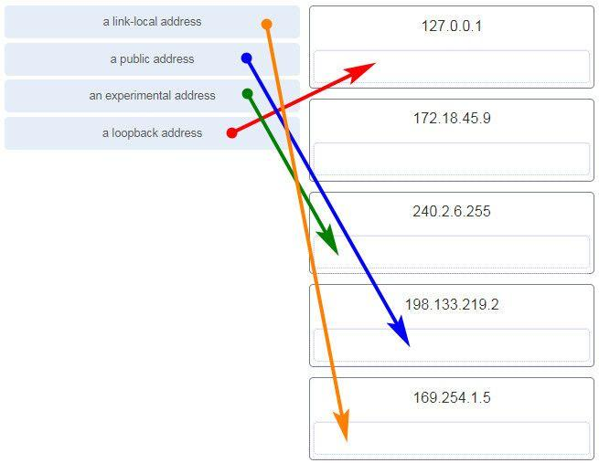

**31. Users report that the network access is slow. After questioning the employees, the network administrator learned that one employee downloaded a third-party scanning program for the printer. What type of malware might be introduced that causes slow performance of the network?**

virus  
**worm\***  
phishing  
spam

**Explanation:** A cybersecurity specialist needs to be familiar with the characteristics of the different types of malware and attacks that threaten an organization.

**32. Which scenario describes a function provided by the transport layer?**

A student is using a classroom VoIP phone to call home. The unique identifier burned into the phone is a transport layer address used to contact another network device on the same network.  
A student is playing a short web-based movie with sound. The movie and sound are encoded within the transport layer header.  
**A student has two web browser windows open in order to access two web sites. The transport layer ensures the correct web page is delivered to the correct browser window.\***  
A corporate worker is accessing a web server located on a corporate network. The transport layer formats the screen so the web page appears properly no matter what device is being used to view the web site.

**Explanation:**  
The source and destination port numbers are used to identify the correct application and window within that application.

**33. Refer to the exhibit.**

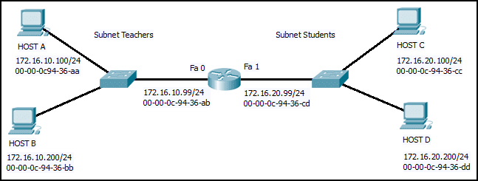

**Host B on subnet Teachers transmits a packet to host D on subnet Students. Which Layer 2 and Layer 3 addresses are contained in the PDUs that are transmitted from host B to the router?**

**Layer 2 destination address = 00-00-0c-94-36-ab**  
**Layer 2 source address = 00-00-0c-94-36-bb**  
**Layer 3 destination address = 172.16.20.200**  
**Layer 3 source address = 172.16.10.200\*\*\*\***

Layer 2 destination address = 00-00-0c-94-36-dd  
Layer 2 source address = 00-00-0c-94-36-bb  
Layer 3 destination address = 172.16.20.200  
Layer 3 source address = 172.16.10.200

Layer 2 destination address = 00-00-0c-94-36-cd  
Layer 2 source address = 00-00-0c-94-36-bb  
Layer 3 destination address = 172.16.20.99  
Layer 3 source address = 172.16.10.200

Layer 2 destination address = 00-00-0c-94-36-ab  
Layer 2 source address = 00-00-0c-94-36-bb  
Layer 3 destination address = 172.16.20.200  
Layer 3 source address = 172.16.100.200

**34. What does the term “attenuation” mean in data communication?**

strengthening of a signal by a networking device  
leakage of signals from one cable pair to another  
time for a signal to reach its destination  
**loss of signal strength as distance increases\***

**35. Refer to the exhibit.**

**CCNA%2B1%2Bv7%2BFinal%2BExam%2BAnswers%2Bp35**

**An administrator is trying to configure the switch but receives the error message that is displayed in the exhibit. What is the problem?**

The entire command, configure terminal, must be used.  
The administrator is already in global configuration mode.  
**The administrator must first enter privileged EXEC mode before issuing the command.\***  
The administrator must connect via the console port to access global configuration mode.

**36. Which two protocols operate at the top layer of the TCP/IP protocol suite? (Choose two.)**

TCP  
IP  
UDP  
**POP\***  
**DNS\***  
Ethernet

**37. A company has a file server that shares a folder named Public. The network security policy specifies that the Public folder is assigned Read-Only rights to anyone who can log into the server while the Edit rights are assigned only to the network admin group. Which component is addressed in the AAA network service framework?**

automation  
accounting  
authentication  
**authorization\***

**Explanation:**  
After a user is successfully authenticated (logged into the server), the authorization is the process of determining what network resources the user can access and what operations (such as read or edit) the user can perform.

**38. What three requirements are defined by the protocols used in network communcations to allow message transmission across a network? (Choose three.)**

**message size\***  
**message encoding\***  
connector specifications  
media selection  
**delivery options\***  
end-device installation

**39. What are two characteristics of IP? (Choose two.)**

**does not require a dedicated end-to-end connection\***  
**operates independently of the network media\***  
retransmits packets if errors occur  
re-assembles out of order packets into the correct order at the receiver end  
guarantees delivery of packets

**Explanation:**  
The Internet Protocol (IP) is a connectionless, best effort protocol. This means that IP requires no end-to-end connection nor does it guarantee delivery of packets. IP is also media independent, which means it operates independently of the network media carrying the packets.

**40. An employee of a large corporation remotely logs into the company using the appropriate username and password. The employee is attending an important video conference with a customer concerning a large sale. It is important for the video quality to be excellent during the meeting. The employee is unaware that after a successful login, the connection to the company ISP failed. The secondary connection, however, activated within seconds. The disruption was not noticed by the employee or other employees. What three network characteristics are described in this scenario? (Choose three.)**

**security\***  
**quality of service\***  
scalability  
powerline networking  
integrity  
**fault tolerance\***

**41. What are two common causes of signal degradation when using UTP cabling? (Choose two.)**

**improper termination\***  
low-quality shielding in cable  
installing cables in conduit  
**low-quality cable or connectors\***  
loss of light over long distances

**42. Which subnet would include the address 192.168.1.96 as a usable host address?**

**192.168.1.64/26\***  
192.168.1.32/27  
192.168.1.32/28  
192.168.1.64/29

**Explanation:** For the subnet of 192.168.1.64/26, there are 6 bits for host addresses, yielding 64 possible addresses. However, the first and last subnets are the network and broadcast addresses for this subnet. Therefore, the range of host addresses for this subnet is 192.168.1.65 to 192.168.1.126. The other subnets do not contain the address 192.168.1.96 as a valid host address.

**43. Refer to the exhibit.**

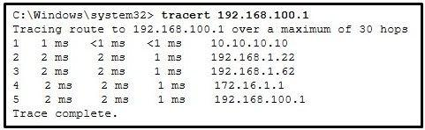

**On the basis of the output, which two statements about network connectivity are correct? (Choose two.)**

This host does not have a default gateway configured.  
**There are 4 hops between this device and the device at 192.168.100.1.\***  
**There is connectivity between this device and the device at 192.168.100.1.\***  
The connectivity between these two hosts allows for videoconferencing calls.  
The average transmission time between the two hosts is 2 milliseconds.

**Explanation:**  
The output displays a successful Layer 3 connection between a host computer and a host at 19.168.100.1. It can be determined that 4 hops exist between them and the average transmission time is 1 milliseconds. Layer 3 connectivity does not necessarily mean that an application can run between the hosts.

**44. Which two statements describe how to assess traffic flow patterns and network traffic types using a protocol analyzer? (Choose two.)**

Capture traffic on the weekends when most employees are off work.  
**Capture traffic during peak utilization times to get a good representation of the different traffic types.\***  
Only capture traffic in the areas of the network that receive most of the traffic such as the data center.  
**Perform the capture on different network segments.\***  
Only capture WAN traffic because traffic to the web is responsible for the largest amount of traffic on a network.

**Explanation:** Traffic flow patterns should be gathered during peak utilization times to get a good representation of the different traffic types. The capture should also be performed on different network segments because some traffic will be local to a particular segment.

**45. What is the consequence of configuring a router with the ipv6 unicast-routing global configuration command?​**

All router interfaces will be automatically activated.  
**The IPv6 enabled router interfaces begin sending ICMPv6 Router Advertisement messages.\***  
Each router interface will generate an IPv6 link-local address.​  
It statically creates a global unicast address on this router.​

**46. Which three layers of the OSI model map to the application layer of the TCP/IP model? (Choose three.)**

**Application\***  
network  
data link  
**sesión\***  
**presentation\***  
transport

**Explanation:** The TCP/IP model consists of four layers: application, transport, internet, and network access. The OSI model consists of seven layers: application, presentation, session, transport, network, data link, and physical. The top three layers of the OSI model: application, presentation, and session map to the application layer of the TCP/IP model.

**47. Refer to the exhibit.**

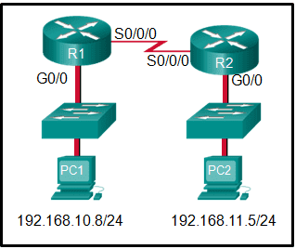

**If PC1 is sending a packet to PC2 and routing has been configured between the two routers, what will R1 do with the Ethernet frame header attached by PC1?**

nothing, because the router has a route to the destination network  
open the header and use it to determine whether the data is to be sent out S0/0/0  
open the header and replace the destination MAC address with a new one  
**remove the Ethernet header and configure a new Layer 2 header before sending it out S0/0/0\***

**Explanation:** When PC1 forms the various headers attached to the data one of those headers is the Layer 2 header. Because PC1 connects to an Ethernet network, an Ethernet header is used. The source MAC address will be the MAC address of PC1 and the destination MAC address will be that of G0/0 on R1. When R1 gets that information, the router removes the Layer 2 header and creates a new one for the type of network the data will be placed onto (the serial link).

**48. What will happen if the default gateway address is incorrectly configured on a host?**

The host cannot communicate with other hosts in the local network.  
**The host cannot communicate with hosts in other networks.\***  
A ping from the host to 127.0.0.1 would not be successful.  
The host will have to use ARP to determine the correct address of the default gateway.  
The switch will not forward packets initiated by the host.

**49. What are two features of ARP? (Choose two.)**

When a host is encapsulating a packet into a frame, it refers to the MAC address table to determine the mapping of IP addresses to MAC addresses.  
An ARP request is sent to all devices on the Ethernet LAN and contains the IP address of the destination host and its multicast MAC address.  
**If a host is ready to send a packet to a local destination device and it has the IP address but not the MAC address of the destination, it generates an ARP broadcast.\***  
If no device responds to the ARP request, then the originating node will broadcast the data packet to all devices on the network segment.  
**If a device receiving an ARP request has the destination IPv4 address, it responds with an ARP reply.\***

**50. A network administrator is adding a new LAN to a branch office. The new LAN must support 90 connected devices. What is the smallest network mask that the network administrator can use for the new network?**

**255.255.255.128\***  
255.255.255.240  
255.255.255.248  
255.255.255.224

**51. What are two ICMPv6 messages that are not present in ICMP for IPv4? (Choose two.)**

**Neighbor Solicitation\***  
Destination Unreachable  
Host Confirmation  
Time Exceeded  
**Router Advertisement\***  
Route Redirection

**52. A client packet is received by a server. The packet has a destination port number of 80. What service is the client requesting?**

DHCP  
SMTP  
DNS  
**HTTP\***

**53. What is an advantage for small organizations of adopting IMAP instead of POP?**

POP only allows the client to store messages in a centralized way, while IMAP allows distributed storage.  
**Messages are kept in the mail servers until they are manually deleted from the email client.\***  
When the user connects to a POP server, copies of the messages are kept in the mail server for a short time, but IMAP keeps them for a long time.  
IMAP sends and retrieves email, but POP only retrieves email.

**Explanation:** IMAP and POP are protocols that are used to retrieve email messages. The advantage of using IMAP instead of POP is that when the user connects to an IMAP-capable server, copies of the messages are downloaded to the client application. IMAP then stores the email messages on the server until the user manually deletes those messages.

**54. A technician can ping the IP address of the web server of a remote company but cannot successfully ping the URL address of the same web server. Which software utility can the technician use to diagnose the problem?**

tracert  
ipconfig  
netstat  
**nslookup\***

**Explanation:**  
Traceroute (tracert) is a utility that generates a list of hops that were successfully reached along the path from source to destination.This list can provide important verification and troubleshooting information. The ipconfig utility is used to display the IP configuration settings on a Windows PC. The Netstat utility is used to identify which active TCP connections are open and running on a networked host. Nslookup is a utility that allows the user to manually query the name servers to resolve a given host name. This utility can also be used to troubleshoot name resolution issues and to verify the current status of the name servers.

**55. Which two functions are performed at the LLC sublayer of the OSI Data Link Layer to facilitate Ethernet communication? (Choose two.)**

implements CSMA/CD over legacy shared half-duplex media  
**enables IPv4 and IPv6 to utilize the same physical medium\***  
integrates Layer 2 flows between 10 Gigabit Ethernet over fiber and 1 Gigabit Ethernet over copper  
implements a process to delimit fields within an Ethernet 2 frame  
**places information in the Ethernet frame that identifies which network layer protocol is being encapsulated by the frame\***

**Explanation:** The data link layer is actually divided into two sublayers:  
+ Logical Link Control (LLC): This upper sublayer defines the software processes that provide services to the network layer protocols. It places information in the frame that identifies which network layer protocol is being used for the frame. This information allows multiple Layer 3 protocols, such as IPv4 and IPv6, to utilize the same network interface and media.  
+ Media Access Control (MAC): This lower sublayer defines the media access processes performed by the hardware. It provides data link layer addressing and delimiting of data according to the physical signaling requirements of the medium and the type of data link layer protocol in use.

**56. The global configuration command ip default-gateway 172.16.100.1 is applied to a switch. What is the effect of this command?**

The switch can communicate with other hosts on the 172.16.100.0 network.  
**The switch can be remotely managed from a host on another network.\***  
The switch is limited to sending and receiving frames to and from the gateway 172.16.100.1.  
The switch will have a management interface with the address 172.16.100.1.

**Explanation:** A default gateway address is typically configured on all devices to allow them to communicate beyond just their local network.In a switch this is achieved using the command ip default-gateway .

**57. What happens when the transport input ssh command is entered on the switch vty lines?**

The SSH client on the switch is enabled.  
The switch requires a username/password combination for remote access.  
**Communication between the switch and remote users is encrypted.\***  
The switch requires remote connections via a proprietary client software.

**Explanation:** The transport input ssh command when entered on the switch vty (virtual terminal lines) will encrypt all inbound controlled telnet connections.

**58. Match the type of threat with the cause. (Not all options are used.)**

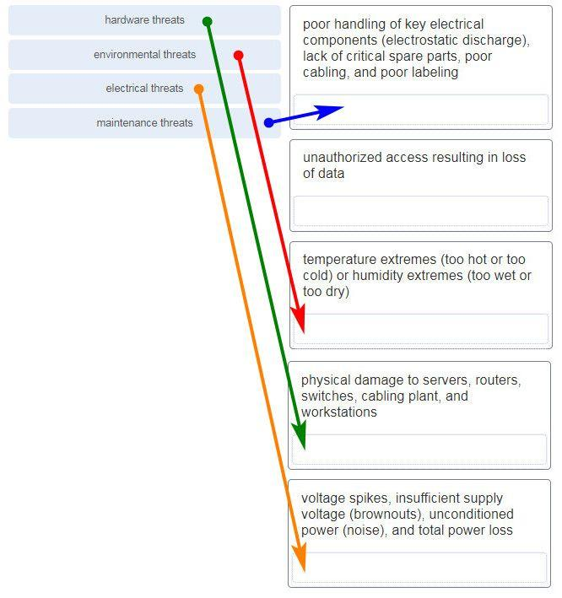

**59. A disgruntled employee is using some free wireless networking tools to determine information about the enterprise wireless networks. This person is planning on using this information to hack the wireless network. What type of attack is this?**

DoS  
access  
**reconnaissance\***  
Trojan horse

**60. What service is provided by HTTP?**

Uses encryption to secure the exchange of text, graphic images, sound, and video on the web.  
Allows for data transfers between a client and a file server.  
An application that allows real-time chatting among remote users.  
**A basic set of rules for exchanging text, graphic images, sound, video, and other multimedia files on the web.\***

**61. A client packet is received by a server. The packet has a destination port number of 67. What service is the client requesting?**

FTP  
**DHCP\***  
Telnet  
SSH

**62. What are two problems that can be caused by a large number of ARP request and reply messages? (Choose two.)**

Switches become overloaded because they concentrate all the traffic from the attached subnets.  
**The ARP request is sent as a broadcast, and will flood the entire subnet.\***  
The network may become overloaded because ARP reply messages have a very large payload due to the 48-bit MAC address and 32-bit IP address that they contain.  
**A large number of ARP request and reply messages may slow down the switching process, leading the switch to make many changes in its MAC table.\***  
All ARP request messages must be processed by all nodes on the local network.

**63. A group of Windows PCs in a new subnet has been added to an Ethernet network. When testing the connectivity, a technician finds that these PCs can access local network resources but not the Internet resources. To troubleshoot the problem, the technician wants to initially confirm the IP address and DNS configurations on the PCs, and also verify connectivity to the local router. Which three Windows CLI commands and utilities will provide the necessary information? (Choose three.)**

netsh interface ipv6 show neighbor  
arp -a  
tracert  
**ping\***  
**ipconfig\***  
**nslookup\***  
telnet

**64. During the process of forwarding traffic, what will the router do immediately after matching the destination IP address to a network on a directly connected routing table entry?**

analyze the destination IP address  
**switch the packet to the directly connected interface\***  
look up the next-hop address for the packet  
discard the traffic after consulting the route table

**65. What characteristic describes antispyware?**

**applications that protect end devices from becoming infected with malicious software\***  
a network device that filters access and traffic coming into a network  
software on a router that filters traffic based on IP addresses or applications  
a tunneling protocol that provides remote users with secure access into the network of an organization

**66. A network administrator needs to keep the user ID, password, and session contents private when establishing remote CLI connectivity with a switch to manage it. Which access method should be chosen?**

Telnet  
AUX  
**SSH\***  
Console

**67. What are the two most effective ways to defend against malware? (Choose two.)**

Implement a VPN.  
Implement network firewalls.  
Implement RAID.  
Implement strong passwords.  
**Update the operating system and other application software.\***  
**Install and update antivirus software.\***

**Explanation:** A cybersecurity specialist must be aware of the technologies and measures that are used as countermeasures to protect the organization from threats and vulnerabilities.

**68. Which type of security threat would be responsible if a spreadsheet add-on disables the local software firewall?**

brute-force attack  
**Trojan horse\***  
DoS  
buffer overflow

**Explanation:** A Trojan horse is software that does something harmful, but is hidden in legitimate software code. A denial of service (DoS) attack results in interruption of network services to users, network devices, or applications. A brute-force attack commonly involves trying to access a network device. A buffer overflow occurs when a program attempts to store more data in a memory location than it can hold.

**69. Match the header field with the appropriate layer of the OSI model. (Not all options are used.)**

**70. Which frame field is created by a source node and used by a destination node to ensure that a transmitted data signal has not been altered by interference, distortion, or signal loss?**

User Datagram Protocol field  
transport layer error check field  
flow control field  
**frame check sequence field\***  
error correction process field

**71. A network administrator is adding a new LAN to a branch office. The new LAN must support 4 connected devices. What is the smallest network mask that the network administrator can use for the new network?**

**255.255.255.248\***  
255.255.255.0  
255.255.255.128  
255.255.255.192

**72. What service is provided by POP3?**

**Retrieves email from the server by downloading the email to the local mail application of the client.\***  
An application that allows real-time chatting among remote users.  
Allows remote access to network devices and servers.  
Uses encryption to provide secure remote access to network devices and servers.

**73. What two security solutions are most likely to be used only in a corporate environment? (Choose two.)**

antispyware  
**virtual private networks\***  
**intrusion prevention systems\***  
strong passwords  
antivirus software

**74. What characteristic describes antivirus software?**

**applications that protect end devices from becoming infected with malicious software\***  
a network device that filters access and traffic coming into a network  
a tunneling protocol that provides remote users with secure access into the network of an organization  
software on a router that filters traffic based on IP addresses or applications

**75. What mechanism is used by a router to prevent a received IPv4 packet from traveling endlessly on a network?**

It checks the value of the TTL field and if it is 0, it discards the packet and sends a Destination Unreachable message to the source host.  
It checks the value of the TTL field and if it is 100, it discards the packet and sends a Destination Unreachable message to the source host.  
**It decrements the value of the TTL field by 1 and if the result is 0, it discards the packet and sends a Time Exceeded message to the source host.\***  
It increments the value of the TTL field by 1 and if the result is 100, it discards the packet and sends a Parameter Problem message to the source host.

**76. A client packet is received by a server. The packet has a destination port number of 69. What service is the client requesting?**

DNS  
DHCP  
SMTP  
**TFTP\***

**77. An administrator defined a local user account with a secret password on router R1 for use with SSH. Which three additional steps are required to configure R1 to accept only encrypted SSH connections? (Choose three.)**

Configure DNS on the router.  
Generate two-way pre-shared keys.  
**Configure the IP domain name on the router.\***  
**Generate the SSH keys.\***  
**Enable inbound vty SSH sessions.\***  
Enable inbound vty Telnet sessions.

**78. Which two functions are performed at the MAC sublayer of the OSI Data Link Layer to facilitate Ethernet communication? (Choose two.)**

**places information in the Ethernet frame that identifies which network layer protocol is being encapsulated by the frame\***  
adds Ethernet control information to network protocol data  
responsible for internal structure of Ethernet frame  
enables IPv4 and IPv6 to utilize the same physical medium  
**implements trailer with frame check sequence for error detection\***

**79. An IPv6 enabled device sends a data packet with the destination address of FF02::2. What is the target of this packet?​**

all IPv6 enabled devices on the local link​  
all IPv6 DHCP servers​  
all IPv6 enabled devices across the network​  
**all IPv6 configured routers on the local link​\***

**80. What are the three parts of an IPv6 global unicast address? (Choose three.)**

**subnet ID\***  
subnet mask  
broadcast address  
**global routing prefix\***  
**interface ID\***

**81. A client is using SLAAC to obtain an IPv6 address for its interface. After an address has been generated and applied to the interface, what must the client do before it can begin to use this IPv6 address?**

It must send a DHCPv6 INFORMATION-REQUEST message to request the address of the DNS server.  
It must send a DHCPv6 REQUEST message to the DHCPv6 server to request permission to use this address.  
It must send an ICMPv6 Router Solicitation message to determine what default gateway it should use.  
**It must send an ICMPv6 Neighbor Solicitation message to ensure that the address is not already in use on the network.\***

**82. A new network administrator has been asked to enter a banner message on a Cisco device. What is the fastest way a network administrator could test whether the banner is properly configured?**

Enter CTRL-Z at the privileged mode prompt.  
Exit global configuration mode.  
Power cycle the device.  
Reboot the device.  
**Exit privileged EXEC mode and press Enter.\***

**83. What method is used to manage contention-based access on a wireless network?**

token passing  
**CSMA/CA\***  
priority ordering  
CSMA/CD

**84. What is a function of the data link layer?**

provides the formatting of data  
provides end-to-end delivery of data between hosts  
provides delivery of data between two applications  
**provides for the exchange of frames over a common local media\***

**85. What is the purpose of the TCP sliding window?**

to ensure that segments arrive in order at the destination  
to end communication when data transmission is complete  
to inform a source to retransmit data from a specific point forward  
**to request that a source decrease the rate at which it transmits data\***

**86. What characteristic describes spyware?**

a network device that filters access and traffic coming into a network  
**software that is installed on a user device and collects information about the user\***  
an attack that slows or crashes a device or network service  
the use of stolen credentials to access private data

**87. Which switching method drops frames that fail the FCS check?**

**store-and-forward switching\***  
borderless switching  
ingress port buffering  
cut-through switching

**88. Two pings were issued from a host on a local network. The first ping was issued to the IP address of the default gateway of the host and it failed. The second ping was issued to the IP address of a host outside the local network and it was successful. What is a possible cause for the failed ping?**

The default gateway is not operational.  
The default gateway device is configured with the wrong IP address.  
**Security rules are applied to the default gateway device, preventing it from processing ping requests.\***  
The TCP/IP stack on the default gateway is not working properly.

**89. What service is provided by FTP?**

A basic set of rules for exchanging text, graphic images, sound, video, and other multimedia files on the web.  
An application that allows real-time chatting among remote users.  
**Allows for data transfers between a client and a file server.\***  
Uses encryption to secure the exchange of text, graphic images, sound, and video on the web.

**90. A user is attempting to access http://www.cisco.com/ without success. Which two configuration values must be set on the host to allow this access? (Choose two.)**

**DNS server\***  
source port number  
HTTP server  
source MAC address  
**default Gateway\***

**91. Which two statements accurately describe an advantage or a disadvantage when deploying NAT for IPv4 in a network? (Choose two.)**

NAT adds authentication capability to IPv4.  
**NAT introduces problems for some applications that require end-to-end connectivity.\***  
NAT will impact negatively on switch performance.  
**NAT provides a solution to slow down the IPv4 address depletion.\***  
NAT improves packet handling.  
NAT causes routing tables to include more information.

**92. What subnet mask is needed if an IPv4 network has 40 devices that need IP addresses and address space is not to be wasted?**

255.255.255.0  
255.255.255.240  
255.255.255.128  
**255.255.255.192\***  
255.255.255.224

**93. Refer to the exhibit.**

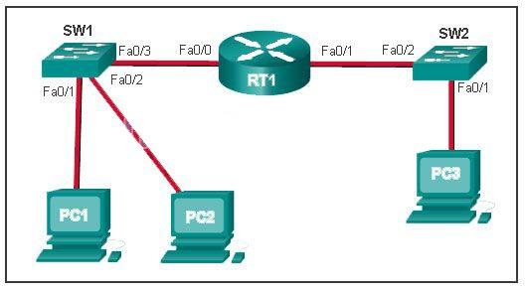

**PC1 issues an ARP request because it needs to send a packet to PC2. In this scenario, what will happen next?**

**PC2 will send an ARP reply with its MAC address.\***  
RT1 will send an ARP reply with its Fa0/0 MAC address.  
RT1 will send an ARP reply with the PC2 MAC address.  
SW1 will send an ARP reply with the PC2 MAC address.  
SW1 will send an ARP reply with its Fa0/1 MAC address.

**Explanation:**  
When a network device wants to communicate with another device on the same network, it sends a broadcast ARP request. In this case, the request will contain the IP address of PC2. The destination device (PC2) sends an ARP reply with its MAC address.

**94. What service is provided by BOOTP?**

Uses encryption to secure the exchange of text, graphic images, sound, and video on the web.  
Allows for data transfers between a client and a file server.  
**Legacy application that enables a diskless workstation to discover its own IP address and find a BOOTP server on the network.\***  
A basic set of rules for exchanging text, graphic images, sound, video, and other multimedia files on the web.

**95. What characteristic describes adware?**

a network device that filters access and traffic coming into a network  
**software that is installed on a user device and collects information about the user\***  
the use of stolen credentials to access private data  
an attack that slows or crashes a device or network service

**96. What is a benefit of using cloud computing in networking?**

Technology is integrated into every-day appliances allowing them to interconnect with other devices, making them more ‘smart’ or automated.  
**Network capabilities are extended without requiring investment in new infrastructure, personnel, or software.\***  
End users have the freedom to use personal tools to access information and communicate across a business network.  
Home networking uses existing electrical wiring to connect devices to the network wherever there is an electrical outlet, saving the cost of installing data cables.

**97. Match a statement to the related network model. (Not all options are used.)**

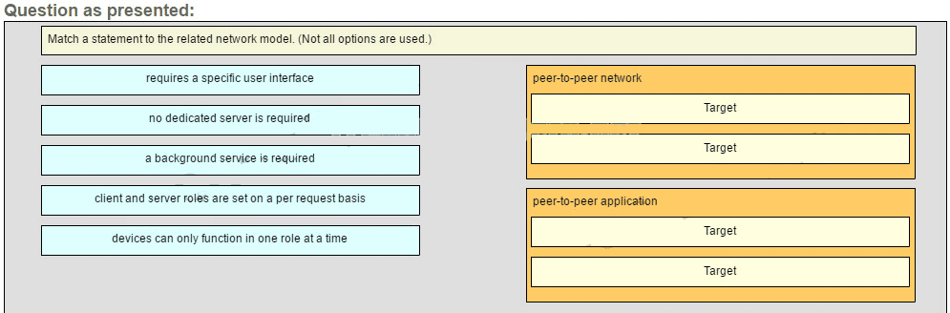

**Place the options in the following order:**

**peer-to-peer network**

**[+] no dedicated server is required**  
**[+] client and server roles are set on a per request basis**

**peer-to-peer aplication**

**[#] requires a specific user interface**  
**[#] a background service is required**

**Explanation:**  
Peer-to-peer networks do not require the use of a dedicated server, and devices can assume both client and server roles simultaneously on a per request basis. Because they do not require formalized accounts or permissions, they are best used in limited situations. Peer-to-peer applications require a user interface and background service to be running, and can be used in more diverse situations.

**98. Which information does the show startup-config command display?**

the IOS image copied into RAM  
the bootstrap program in the ROM  
the contents of the current running configuration file in the RAM  
**the contents of the saved configuration file in the NVRAM\***

**Explanation:**  
The show startup-config command displays the saved configuration located in NVRAM. The show running-config command displays the contents of the currently running configuration file located in RAM.​

**99. Refer to the exhibit.**

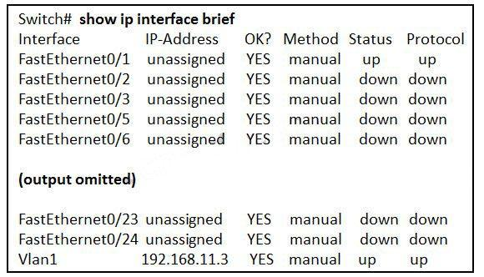

**What three facts can be determined from the viewable output of the show ip interface brief command? (Choose three.)**

Two physical interfaces have been configured.  
**The switch can be remotely managed.\***  
**One device is attached to a physical interface.\***  
Passwords have been configured on the switch.  
Two devices are attached to the switch.  
**The default SVI has been configured.\***

**Explanation:**  
Vlan1 is the default SVI. Because an SVI has been configured, the switch can be configured and managed remotely. FastEthernet0/0 is showing up and up, so a device is connected.

**100. Match each type of frame field to its function. (Not all options are used.)**

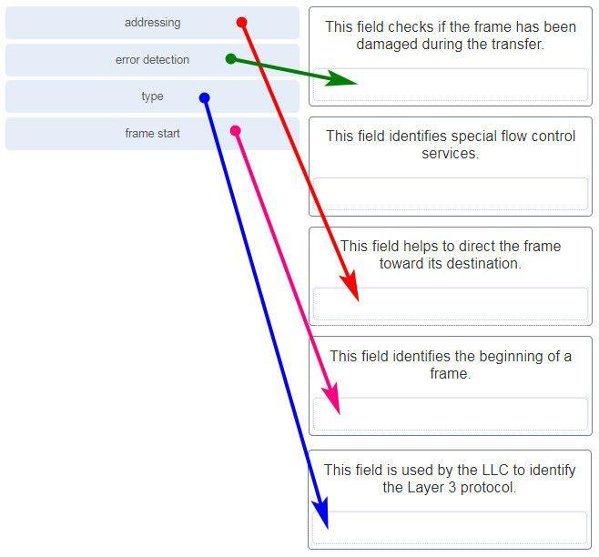

**101. What is the subnet ID associated with the IPv6 address 2001:DA48:FC5:A4:3D1B::1/64?**

2001:DA48::/64​  
2001:DA48:FC5::A4:/64​  
**2001:DA48:FC5:A4::/64​\***  
2001::/64

**102. Match the firewall function to the type of threat protection it provides to the network. (Not all options are used.)**

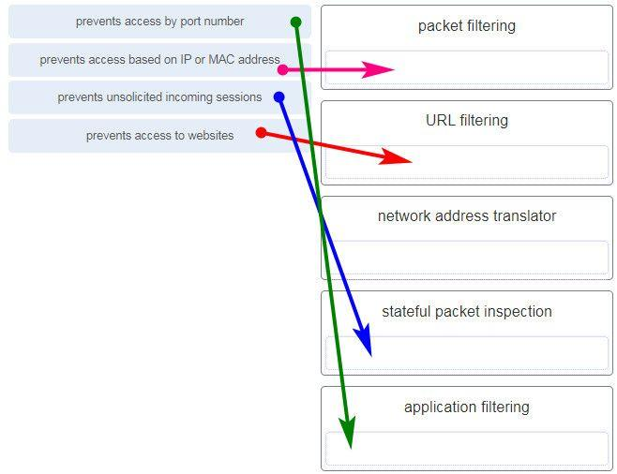

packet filtering – prevents access based on IP or MAC address  
URL filtering – prevents access to websites  
network address translator – (none)  
stateful packet inspection – prevents unsolicited incoming sessions  
application filtering – prevents access by port number

**Explanation:**Firewall products come packaged in various forms. These products use different techniques for determining what will be permitted or denied access to a network. They include the following:  
+ Packet filtering – Prevents or allows access based on IP or MAC addresses  
+ Application filtering – Prevents or allows access by specific application types based on port numbers  
+ URL filtering – Prevents or allows access to websites based on specific URLs or keywords  
+ Stateful packet inspection (SPI) – Incoming packets must be legitimate responses to requests from internal hosts. Unsolicited packets are blocked unless permitted specifically. SPI can also include the capability to recognize and filter out specific types of attacks, such as denial of service (DoS)

**103. Users are reporting longer delays in authentication and in accessing network resources during certain time periods of the week. What kind of information should network engineers check to find out if this situation is part of a normal network behavior?**

syslog records and messages  
**the network performance baseline\***  
debug output and packet captures  
network configuration files

**104. What characteristic describes a VPN?**

software on a router that filters traffic based on IP addresses or applications  
software that identifies fast-spreading threats  
**a tunneling protocol that provides remote users with secure access into the network of an organization\***  
a network device that filters access and traffic coming into a network

**105. Which two statements are correct in a comparison of IPv4 and IPv6 packet headers? (Choose two.)**

**The Source Address field name from IPv4 is kept in IPv6.\***  
The Version field from IPv4 is not kept in IPv6.  
The Destination Address field is new in IPv6.  
The Header Checksum field name from IPv4 is kept in IPv6.  
**The Time-to-Live field from IPv4 has been replaced by the Hop Limit field in IPv6.\***

**106. A network administrator wants to have the same network mask for all networks at a particular small site. The site has the following networks and number of devices:**

IP phones – 22 addresses

PCs – 20 addresses needed

Printers – 2 addresses needed

Scanners – 2 addresses needed

**The network administrator has deemed that 192.168.10.0/24 is to be the network used at this site. Which single subnet mask would make the most efficient use of the available addresses to use for the four subnetworks?**

255.255.255.192  
255.255.255.252  
255.255.255.240  
255.255.255.248  
255.255.255.0  
**255.255.255.224\***

**107. What is an advantage to using a protocol that is defined by an open standard?**

A company can monopolize the market.  
The protocol can only be run on equipment from a specific vendor.  
An open standard protocol is not controlled or regulated by standards organizations.  
**It encourages competition and promotes choices.\***

**Explanation:**  
A monopoly by one company is not a good idea from a user point of view. If a protocol can only be run on one brand, it makes it difficult to have mixed equipment in a network. A proprietary protocol is not free to use. An open standard protocol will in general be implemented by a wide range of vendors.

**108. A network administrator is adding a new LAN to a branch office. The new LAN must support 200 connected devices. What is the smallest network mask that the network administrator can use for the new network?**

255.255.255.240  
**255.255.255.0\***  
255.255.255.248  
255.255.255.224

**109. What are three commonly followed standards for constructing and installing cabling? (Choose three.)**

cost per meter (foot)  
**cable lengths\***  
connector color  
**pinouts\***  
**connector types\***  
tensile strength of plastic insulator

**110. Refer to the exhibit.**



**What is wrong with the displayed termination?**

The woven copper braid should not have been removed.  
The wrong type of connector is being used.  
**The untwisted length of each wire is too long.\***  
The wires are too thick for the connector that is used.

**Explanation:** When a cable to an RJ-45 connector is terminated, it is important to ensure that the untwisted wires are not too long and that the flexible plastic sheath surrounding the wires is crimped down and not the bare wires. None of the colored wires should be visible from the bottom of the jack.

**111. Match the characteristic to the category. (Not all options are used.)**

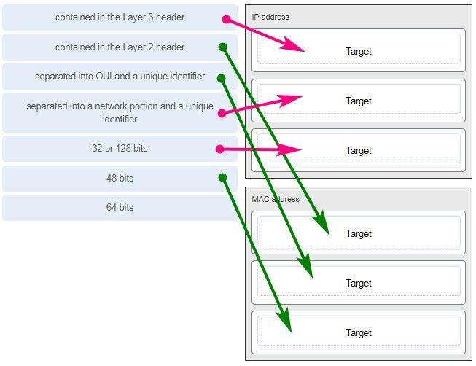

**112. A client packet is received by a server. The packet has a destination port number of 143. What service is the client requesting?**

**IMAP\***  
FTP  
SSH  
Telnet

**113. What are two characteristics shared by TCP and UDP? (Choose two.)**

default window size  
connectionless communication  
**port numbering\***  
3-way handshake  
ability to to carry digitized voice  
**use of checksum\***

**Explanation:**  
Both TCP and UDP use source and destination port numbers to distinguish different data streams and to forward the right data segments to the right applications. Error checking the header and data is done by both protocols by using a checksum calculation to determine the integrity of the data that is received. TCP is connection-oriented and uses a 3-way handshake to establish an initial connection. TCP also uses window to regulate the amount of traffic sent before receiving an acknowledgment. UDP is connectionless and is the best protocol for carry digitized VoIP signals.

**114. Which value, that is contained in an IPv4 header field, is decremented by each router that receives a packet?**

Header Length  
Differentiated Services  
**Time-to-Live\***  
Fragment Offset

**115. A client packet is received by a server. The packet has a destination port number of 21. What service is the client requesting?**

**FTP\***  
LDAP  
SLP  
SNMP

**116. What attribute of a NIC would place it at the data link layer of the OSI model?**

attached Ethernet cable  
IP address  
**MAC address\***  
RJ-45 port  
TCP/IP protocol stack

**117. A network administrator is adding a new LAN to a branch office. The new LAN must support 10 connected devices. What is the smallest network mask that the network administrator can use for the new network?**

255.255.255.192  
255.255.255.248  
255.255.255.224  
**255.255.255.240\***

**118. A user is executing a tracert to a remote device. At what point would a router, which is in the path to the destination device, stop forwarding the packet?**

when the router receives an ICMP Time Exceeded message  
when the RTT value reaches zero  
when the host responds with an ICMP Echo Reply message  
**when the value in the TTL field reaches zero\***  
when the values of both the Echo Request and Echo Reply messages reach zero

**Explanation:**  
When a router receives a traceroute packet, the value in the TTL field is decremented by 1. When the value in the field reaches zero, the receiving router will not forward the packet, and will send an ICMP Time Exceeded message back to the source.

**119. Refer to the exhibit.**

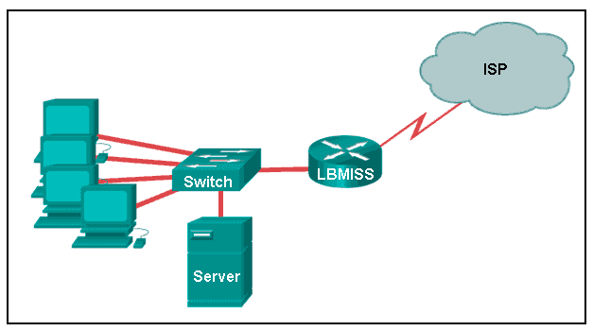

**The network administrator has assigned the LAN of LBMISS an address range of 192.168.10.0. This address range has been subnetted using a /29 prefix. In order to accommodate a new building, the technician has decided to use the fifth subnet for configuring the new network (subnet zero is the first subnet). By company policies, the router interface is always assigned the first usable host address and the workgroup server is given the last usable host address. Which configuration should be entered into the properties of the workgroup server to allow connectivity to the Internet?**

IP address: 192.168.10.65 subnet mask: 255.255.255.240, default gateway: 192.168.10.76  
IP address: 192.168.10.38 subnet mask: 255.255.255.240, default gateway: 192.168.10.33  
**IP address: 192.168.10.38 subnet mask: 255.255.255.248, default gateway: 192.168.10.33\***  
IP address: 192.168.10.41 subnet mask: 255.255.255.248, default gateway: 192.168.10.46  
IP address: 192.168.10.254 subnet mask: 255.255.255.0, default gateway: 192.168.10.1

**Explanation:**  
Using a /29 prefix to subnet 192.168.10.0 results in subnets that increment by 8:

192.168.10.0 (1)  
192.168.10.8 (2)  
192.168.10.16 (3)  
192.168.10.24 (4)  
192.168.10.32 (5)

**120. Refer to the exhibit.**

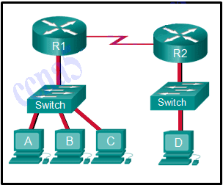

**The switches are in their default configuration. Host A needs to communicate with host D, but host A does not have the MAC address for its default gateway. Which network hosts will receive the ARP request sent by host A?**

only host D  
only router R1  
only hosts A, B, and C  
only hosts A, B, C, and D  
only hosts B and C  
**only hosts B, C, and router R1\***

**Explanation:**  
Since host A does not have the MAC address of the default gateway in its ARP table, host A sends an ARP broadcast. The ARP broadcast would be sent to every device on the local network. Hosts B, C, and router R1 would receive the broadcast. Router R1 would not forward the message.

**121. Which two traffic types use the Real-Time Transport Protocol (RTP)? (Choose two.)**

**video\***  
web  
file transfer  
**voice\***  
peer to peer

**122. Which wireless technology has low-power and data rate requirements making it popular in home automation applications?**

**ZigBee\***  
LoRaWAN  
5G  
Wi-Fi

**123. Which layer of the TCP/IP model provides a route to forward messages through an internetwork?**

application  
network access  
**internet\***  
transport

**Explanation:**  
The OSI model network layer corresponds directly to the internet layer of the TCP/IP model and is used to describe protocols that address and route messages through an internetwork.

**124. Which type of server relies on record types such as A, NS, AAAA, and MX in order to provide services?**

**DNS\***  
email  
file  
web

**Explanation:**  
A DNS server stores records that are used to resolve IP addresses to host names. Some DNS record types include the following:  
A – an end device IPv4 address  
NS – an authoritative name server  
AAAA – an end device IPv6 address  
MX – a mail exchange record

**125. What are proprietary protocols?**

protocols developed by private organizations to operate on any vendor hardware  
protocols that can be freely used by any organization or vendor  
**protocols developed by organizations who have control over their definition and operation\***  
a collection of protocols known as the TCP/IP protocol suite

**Explanation:**  
Proprietary protocols have their definition and operation controlled by one company or vendor. Some of them can be used by different organizations with permission from the owner. The TCP/IP protocol suite is an open standard, not a proprietary protocol.

**126. What service is provided by DNS?**

**Resolves domain names, such as cisco.com, into IP addresses.\***  
A basic set of rules for exchanging text, graphic images, sound, video, and other multimedia files on the web.  
Allows for data transfers between a client and a file server.  
Uses encryption to secure the exchange of text, graphic images, sound, and video on the web.

**127. A client packet is received by a server. The packet has a destination port number of 110. What service is the client requesting?**

DNS  
DHCP  
SMTP  
**POP3\***

**128. What command can be used on a Windows PC to see the IP configuration of that computer?**

show ip interface brief  
ping  
show interfaces  
**ipconfig\***

**129. A wired laser printer is attached to a home computer. That printer has been shared so that other computers on the home network can also use the printer. What networking model is in use?**

client-based  
master-slave  
point-to-point  
**peer-to-peer (P2P)\***

**Explanation:** Peer-to-peer (P2P) networks have two or more network devices that can share resources such as printers or files without having a dedicated server.

**130. What characteristic describes a virus?**

a network device that filters access and traffic coming into a network  
the use of stolen credentials to access private data  
an attack that slows or crashes a device or network service  
**malicious software or code running on an end device\***

**131. Three bank employees are using the corporate network. The first employee uses a web browser to view a company web page in order to read some announcements. The second employee accesses the corporate database to perform some financial transactions. The third employee participates in an important live audio conference with other corporate managers in branch offices. If QoS is implemented on this network, what will be the priorities from highest to lowest of the different data types?**

financial transactions, web page, audio conference  
audio conference, financial transactions, web page  
**financial transactions, audio conference, web page\***  
audio conference, web page, financial transactions

**132. Match the description to the IPv6 addressing component. (Not all options are used.)**

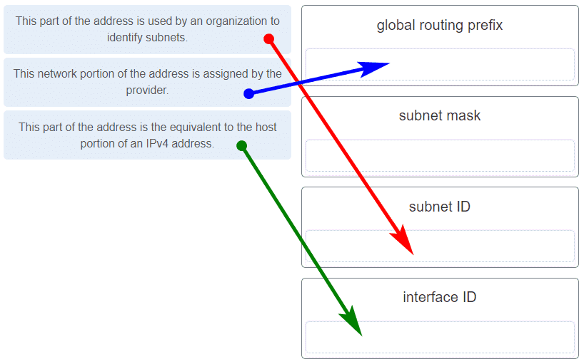

**133. Refer to the exhibit.**

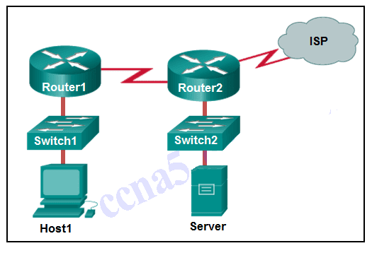

**If Host1 were to transfer a file to the server, what layers of the TCP/IP model would be used?**

only application and Internet layers  
only Internet and network access layers  
only application, Internet, and network access layers  
**application, transport, Internet, and network access layers\***  
only application, transport, network, data link, and physical layers  
application, session, transport, network, data link, and physical layers

**Explanation:** The TCP/IP model contains the application, transport, internet, and network access layers. A file transfer uses the FTP application layer protocol. The data would move from the application layer through all of the layers of the model and across the network to the file server.

**134. Match the characteristic to the forwarding method. (Not all options are used.)**

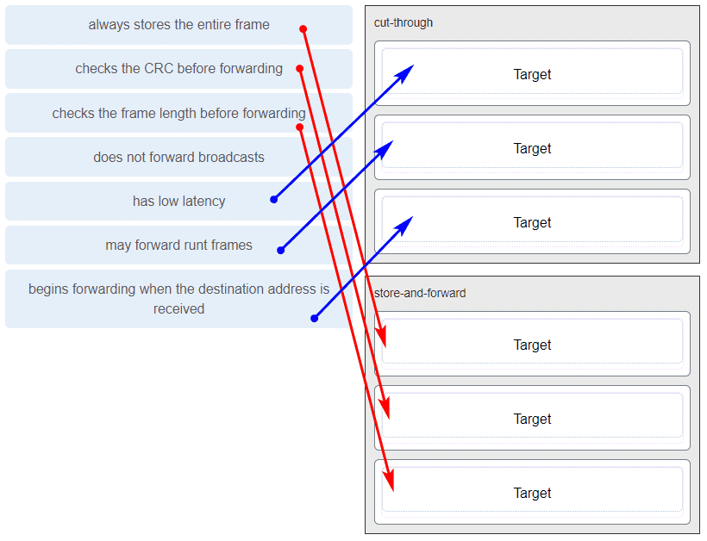

**Explanation:** A store-and-forward switch always stores the entire frame before forwarding, and checks its CRC and frame length. A cut-through switch can forward frames before receiving the destination address field, thus presenting less latency than a store-and-forward switch. Because the frame can begin to be forwarded before it is completely received, the switch may transmit a corrupt or runt frame. All forwarding methods require a Layer 2 switch to forward broadcast frames.

**135. Refer to the exhibit.**

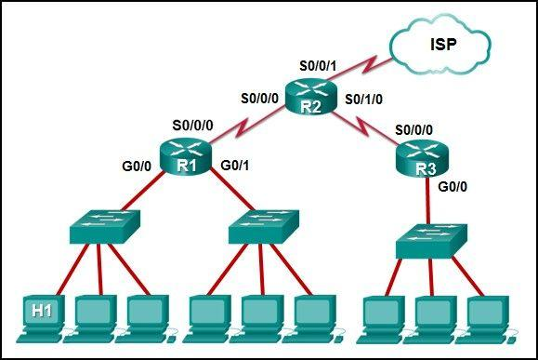

**The IP address of which device interface should be used as the default gateway setting of host H1?**

R1: S0/0/0  
R2: S0/0/1  
**R1: G0/0\***  
R2: S0/0/0

**136. What service is provided by Internet Messenger?**

**An application that allows real-time chatting among remote users.\***  
Allows remote access to network devices and servers.  
Resolves domain names, such as cisco.com, into IP addresses.  
Uses encryption to provide secure remote access to network devices and servers.

**137. Refer to the exhibit.**



**Match the network with the correct IP address and prefix that will satisfy the usable host addressing requirements for each network.**

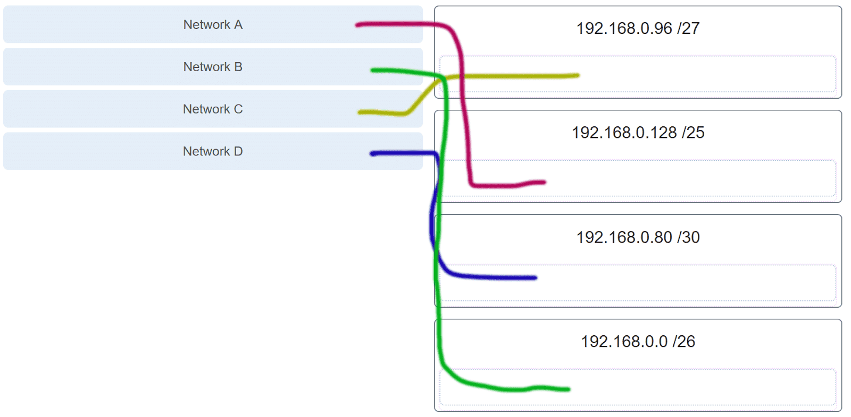

**Explanation:** Network A needs to use 192.168.0.128 /25, which yields 128 host addresses.  
Network B needs to use 192.168.0.0 /26, which yields 64 host addresses.  
Network C needs to use 192.168.0.96 /27, which yields 32 host addresses.  
Network D needs to use 192.168.0.80/30, which yields 4 host addresses.

**138. Refer to the exhibit. Which protocol was responsible for building the table that is shown?**

interface: 192.168.1.67 — 0xa

internet address physical address type

192.168.1.254 64-0f-29-0d-36-91 dynamic

.

.

.

interface: 10.82.253.91 —- 0x10

DHCP  
**ARP\***  
DNS  
ICMP

**139. A network administrator notices that some newly installed Ethernet cabling is carrying corrupt and distorted data signals. The new cabling was installed in the ceiling close to fluorescent lights and electrical equipment. Which two factors may interfere with the copper cabling and result in signal distortion and data corruption? (Choose two.)**

crosstalk  
extended length of cabling  
**RFI​\***  
**EMI\***  
signal attenuation

**140. A host is trying to send a packet to a device on a remote LAN segment, but there are currently no mappings in its ARP cache. How will the device obtain a destination MAC address?**

It will send the frame and use its own MAC address as the destination.  
It will send an ARP request for the MAC address of the destination device.  
It will send the frame with a broadcast MAC address.  
It will send a request to the DNS server for the destination MAC address.  
**It will send an ARP request for the MAC address of the default gateway.\***

**141. Which two functions are performed at the MAC sublayer of the OSI Data Link Layer to facilitate Ethernet communication?**

**integrates Layer 2 flows between 10 Gigabit Ethernet over fiber and 1 Gigabit Ethernet over copper\***  
enables IPv4 and IPv6 to utilize the same physical medium  
handles communication between upper layer networking software and Ethernet NIC hardware  
adds Ethernet control information to network protocol data  
**implements CSMA/CD over legacy shared half-duplex media\***

**142. A client packet is received by a server. The packet has a destination port number of 53. What service is the client requesting?**

**DNS\***  
NetBIOS (NetBT)  
POP3  
IMAP

**143. A network administrator is adding a new LAN to a branch office. The new LAN must support 25 connected devices. What is the smallest network mask that the network administrator can use for the new network?**

255.255.255.128  
255.255.255.192  
**255.255.255.224\***  
255.255.255.240

**144. What characteristic describes a Trojan horse?**

**malicious software or code running on an end device\***  
an attack that slows or crashes a device or network service  
the use of stolen credentials to access private data  
a network device that filters access and traffic coming into a network

**145. What service is provided by HTTPS?**

Uses encryption to provide secure remote access to network devices and servers.  
Resolves domain names, such as cisco.com, into IP addresses.  
**Uses encryption to secure the exchange of text, graphic images, sound, and video on the web.\***  
Allows remote access to network devices and servers.

**146. A technician with a PC is using multiple applications while connected to the Internet. How is the PC able to keep track of the data flow between multiple application sessions and have each application receive the correct packet flows?**

The data flow is being tracked based on the destination MAC address of the technician PC.  
**The data flow is being tracked based on the source port number that is used by each application.\***  
The data flow is being tracked based on the source IP address that is used by the PC of the technician.  
The data flow is being tracked based on the destination IP address that is used by the PC of the technician.

**Explanation:**  
The source port number of an application is randomly generated and used to individually keep track of each session connecting out to the Internet. Each application will use a unique source port number to provide simultaneous communication from multiple applications through the Internet.

**147. A network administrator is adding a new LAN to a branch office. The new LAN must support 61 connected devices. What is the smallest network mask that the network administrator can use for the new network?**

255.255.255.240  
255.255.255.224  
**255.255.255.192\***  
255.255.255.128

**148. Refer to the exhibit.**

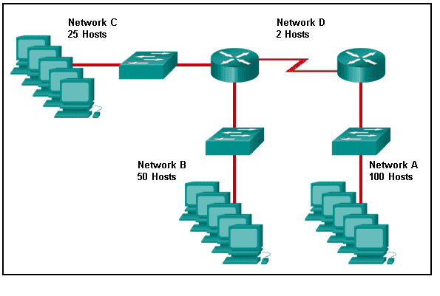

**Match the network with the correct IP address and prefix that will satisfy the usable host addressing requirements for each network. (Not all options are used.)**

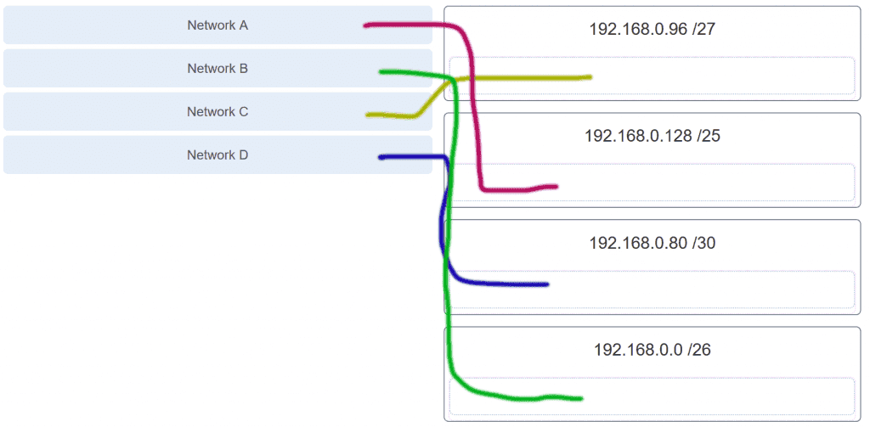

**Explanation:**  
Network A needs to use 192.168.0.0 /25 which yields 128 host addresses.  
Network B needs to use 192.168.0.128 /26 which yields 64 host addresses.  
Network C needs to use 192.168.0.192 /27 which yields 32 host addresses.  
Network D needs to use 192.168.0.224 /30 which yields 4 host addresses.

**149. What characteristic describes a DoS attack?**

the use of stolen credentials to access private data  
a network device that filters access and traffic coming into a network  
software that is installed on a user device and collects information about the user  
**an attack that slows or crashes a device or network service\***

**150. Match the application protocols to the correct transport protocols**

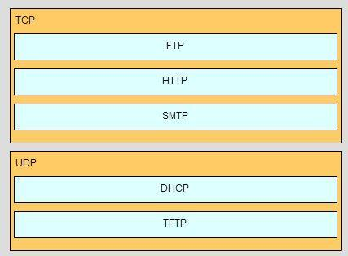

**151. What service is provided by SMTP?**

**Allows clients to send email to a mail server and the servers to send email to other servers.\***  
Allows remote access to network devices and servers.  
Uses encryption to provide secure remote access to network devices and servers.  
An application that allows real-time chatting among remote users.

**152. Match a statement to the related network model. (Not all options are used.)**

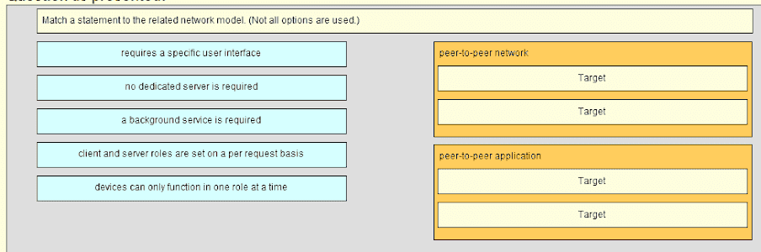

**Place the options in the following order:**

**peer-to-peer network**

**[+] no dedicated server is required**  
**[+] client and server roles are set on a per request basis**

**peer-to-peer aplication**

**[#] requires a specific user interface**  
**[#] a background service is required**

**Explanation:**  
Peer-to-peer networks do not require the use of a dedicated server, and devices can assume both client and server roles simultaneously on a per request basis. Because they do not require formalized accounts or permissions, they are best used in limited situations. Peer-to-peer applications require a user interface and background service to be running, and can be used in more diverse situations.

**153. Match the application protocols to the correct transport protocols.**

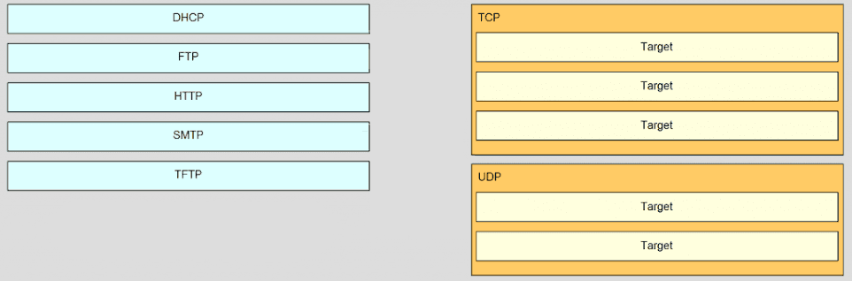

**Answer.**

**TCP**

**FTP**  
**HTTP**  
**SMTP**

**UDP**

**DHCP**  
**TFTP**

**154. Refer to the exhibit.**

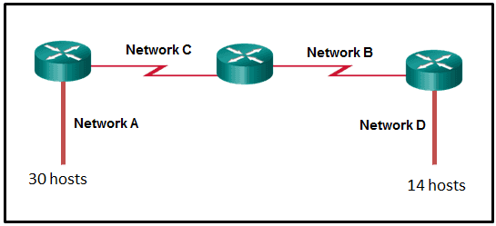

**A network engineer has been given the network address of 192.168.99.0 and a subnet mask of 255.255.255.192 to subnet across the four networks shown. How many total host addresses are unused across all four subnets?**

88  
**200\***  
72  
224  
158

**155. Which two functions are performed at the MAC sublayer of the OSI Data Link Layer to facilitate Ethernet communication? (Choose two.)**

**places information in the Ethernet frame that identifies which network layer protocol is being encapsulated by the frame\***  
handles communication between upper layer networking software and Ethernet NIC hardware  
adds Ethernet control information to network protocol data  
**applies source and destination MAC addresses to Ethernet frame\***  
applies delimiting of Ethernet frame fields to synchronize communication between nodes

**156. Which connector is used with twisted-pair cabling in an Ethernet LAN?**

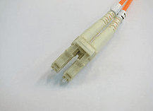

LC conector

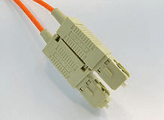

SC conector

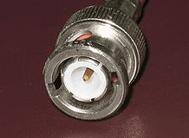

BNC

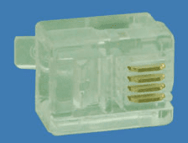

RJ 11

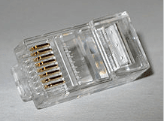

**RJ 45 (TRUE ANSWERS)\***

**157. A client packet is received by a server. The packet has a destination port number of 22. What service is the client requesting?**

**SSH\***  
SMB/CIFS  
HTTPS  
SLP

**158. What characteristic describes an IPS?**

a tunneling protocol that provides remote users with secure access into the network of an organization  
a network device that filters access and traffic coming into a network  
**software that identifies fast-spreading threats\***  
software on a router that filters traffic based on IP addresses or applications

**159. What service is provided by DHCP?**

**Dynamically assigns IP addresses to end and intermediary devices.\***

**160. Which two functions are performed at the LLC sublayer of the OSI Data Link Layer to facilitate Ethernet communication? (Choose two.)**

responsible for internal structure of Ethernet frame  
applies source and destination MAC addresses to Ethernet frame  
integrates Layer 2 flows between 10 Gigabit Ethernet over fiber and 1 Gigabit Ethernet over copper  
**enables IPv4 and IPv6 to utilize the same physical medium\***  
**handles communication between upper layer networking software and Ethernet NIC hardware\***

**161. Which two functions are performed at the LLC sublayer of the OSI Data Link Layer to facilitate Ethernet communication? (Choose two.)**

**adds Ethernet control information to network protocol data\***  
responsible for internal structure of Ethernet frame  
implements trailer with frame check sequence for error detection  
**enables IPv4 and IPv6 to utilize the same physical medium\***  
applies source and destination MAC addresses to Ethernet frame

**162. Which two functions are performed at the MAC sublayer of the OSI Data Link Layer to facilitate Ethernet communication? (Choose two.)**

**implements CSMA/CD over legacy shared half-duplex media\***  
enables IPv4 and IPv6 to utilize the same physical medium  
adds Ethernet control information to network protocol data  
handles communication between upper layer networking software and Ethernet NIC hardware  
**integrates Layer 2 flows between 10 Gigabit Ethernet over fiber and 1 Gigabit Ethernet over copper\***

**163. Which two functions are performed at the MAC sublayer of the OSI Data Link Layer to facilitate Ethernet communication? (Choose two.)**

**places information in the Ethernet frame that identifies which network layer protocol is being encapsulated by the frame\***  
handles communication between upper layer networking software and Ethernet NIC hardware  
adds Ethernet control information to network protocol data  
**applies source and destination MAC addresses to Ethernet frame\***  
applies delimiting of Ethernet frame fields to synchronize communication between nodes

[Question]: Which of the following networks use store-and-forward switching operation?

A, Computer networks

B, Telegraph networks

C, Telephone networks

D, Wireless Networks

[Answer]: AB

[Question]: There are similarities between message switching and packet switching. Which of following that applies to packet switching but not to message switching?

A, Variable length of information block

B, Supporting multiple applications

C, Store-and-forward

D, All of the above

[Answer]: B

[Question]: Which of the following networks can be connection-oriented?

A, Telegraph networks

B, Computer networks

C, Telephone networks

D, All of the above

[Answer]: BC

[Question]: A protocol is a set of precise and unambiguous rules that governs

A, How two or more communicating entities in a layer are to interact

B, Messages that can be sent and received

C, Actions that are to be taken when a certain event occurs

D, All of the above

[Answer]: D

[Question]: DNS is a domain-name-service that responds to queries of domain name to IP address or IP address to domain name. DNS uses services provided by

A, TCP

B, UDP

C, HTTP

D, None of the above

[Answer]: B

[Question]: A network used to join the individual networks at different sites into one extended network is called

A, PAN

B, LAN

C, SAN

D, VPN

[Answer]: D

[Question]: Upon receipt of a bad segment, UDP?

A, It does flow control

B, It does not do flow and error control

C, It does error control

D, Retransmission

[Answer]: B

[Question]: Which of following protocol is HTTP built upon?

A, IP

B, TCP

C, UDP

D, SMTP

[Answer]: B

[Question]: Which of following requirements are necessary for packet networks to support multiple and diverse applications?

A, Transfer arbitrary message size

B, Low delay for interactive applications

C, Packets have maximum length

D, All of the above

[Answer]: D

[Question]: What was the concern of the telephone system that motivated the ARPANET design?

A, Scalability

B, Vulnerability

C, Efficiency

D, None of the above

[Answer]: B

[Question]: Question 4

Which of the following is an application layer protocol?

A, HTTP

B, UDP

C, DNS

D, TCP

[Answer]: A

[Question]: Which of the following are features of ARPANET design?

A, Connectionless packet transmission

B, Routing tables at the packet switches

C, Destinations identified by unique addresses

D, All of the above

[Answer]: D

[Question]: Bluetooth is an example of

A, Local Area Network

B, Wide Area Network

C, Metropolitan Area Network

D, Personal Area Network

[Answer]: D

[Question]: In the layer hierarchy as the data packet moves from the upper to the lower layers, headers are

A, Removed

B, Modified

C, Added

D, Rearranged

[Answer]: C

[Question]: The ________ is the physical path over which a message travels

A, Protocol

B, Route

C, Medium

D, Path

[Answer]: C

[Question]: Three or more devices share a link in ________ connection

A, Unipoint

B, Multipoint

C, Point to Point

D, None of the above

[Answer]: B

[Question]: Which of the following is true for Transport Control Protocol

A, Connection oriented

B, Process to Process

C, Transport layer protocol

D, Connectionless

[Answer]: A

[Question]: Which OSI layer is responsible for providing end-to-end communication with reliable service?

A, Transport layer

B, Network layer

C, Session layer

D, Data link layer

[Answer]: A

[Question]: Which OSI layer is responsible for dividing the transmitted bit stream into frames?

A, Network layer

B, Transport layer

C, Application layer

D, Data link layer

[Answer]: D

[Question]: Which OSI layer is responsible for determining which route through the network to use?

A, Network layer

B, Data link layer

C, Transport layer

D, None of the above

[Answer]: A

[Question]: Question 4

Which feature does the data link layer and transport layer have in common?

A, Medium access control

B, All of the above

C, Congestion control

D, Flow control

[Answer]: D

[Question]: Which protocol glues the network of networks together as the Internet?

A, TCP

B, UDP

C, IP

D, None of the above

[Answer]: C

[Question]: In a LAN, which address is used to transfer frames to appropriate destination?

A, IP address

B, Physical address

C, Domain name

D, None of the above

[Answer]: B

[Question]: Question 2

Suppose an application layer entity wants to send an L-byte message to its peer process, using an existing TCP connection. The TCP segment consists of the message plus 20 bytes of header. The segment is encapsulated into an IP packet that has an additional 20 bytes of header. The IP packet in turn goes inside an Ethernet frame that has 18 bytes of header and trailer. What is the bandwidth utilization in terms of the percentage of the transmitted bits in the physical layer corresponds to message information if L = 500 bytes?

A, 100%

B, 70%

C, 90%

D, 80%

[Answer]: C

[Question]: Of the following services, which service(s) does the IP layer provides?

A, Error control

B, Flow control

C, Connection-based data transfer

D, None of the above

[Answer]: D

[Question]: Which of the following is true about the ways in which the OSI reference model and TCP/IP reference model differ.

A, They differ in the number of layers

B, TCP/IP model does not have presentation layer, but OSI model has

C, TCP/IP model does not have session layer, but OSI model has

D, All of the above

[Answer]: D

[Question]: Which of following statements is true about how the data link layer and transport layer differ?

A, Data link layer is concerned with framing and the transport layer is not

B, Data link layer is concerned with flow control and the transport layer is not

C, Data link layer is concerned with multiplexing and the transport layer is not

D, All of the above

[Answer]: A

[Question]: This layer is an addition to OSI model

A, Application layer

B, Presentation layer

C, Session layer

D, Presentation layer and Session layer

[Answer]: D

[Question]: The functionalities of presentation layer includes

A, Data compression

B, Data encryption

C, Data decryption

D, All of the above

[Answer]: D

[Question]: Which of the following applications would you select TCP protocol for?

A, File transfer

B, Domain name service

C, Web browsing

D, None of the above

[Answer]: AC

[Question]: In BSD socket API, which type of socket is used to create a TCP socket?

A, SOCK_STREAM

B, SOCK_RAW

C, SOCK_DGRAM

D, None of the above

[Answer]: A

[Question]: Question 3

In BSD socket API, which type of socket is used to create a UDP socket?

A, SOCK_STREAM

B, SOCK_DGRAM

C, SOCK_RAW

D, None of the above

[Answer]: B

[Question]: In BSD socket API, which system call is used to assign a network address to the socket?

A, listen()

B, None of the above

C, connect()

D, bind()

[Answer]: D

[Question]: Question 5

In BSD socket API, if a client knows the server name but not server's network address, what system call should the client use to get server's network address?

A, Connect()

B, gethostbyname()

C, None of the above

D, gettimeofday()

[Answer]: B

[Question]: In a transmission system, which of the following statement is true for a receiver

A, Receives energy from medium

B, Converts information into signal suitable for transmission

C, Converts received signal suitable for delivery to user

D, All of the above

[Answer]: AC

[Question]: In digital transmission, long distance digital communications require the use of a generator to recover original data sequence and re-transmits on next segment

A. True

B, False

[Answer]: A

[Question]: Question 8

In twisted pair, a category 5 UTP cable can support a data rate of up to 16MHz

A, True

B, False

[Answer]: B

[Question]: Which of the following statement is true for optical fiber

A, Plentiful bandwidth for new services

B, Dominates long distance transmission

C, Distance less of a cost factor in communications

D, All of the above

[Answer]: D

[Question]: Which of the following are advantages of optical fiber

A, Noise immunity

B, No corrosion

C, Extremely low bandwidth

D, Wavelength dependency

[Answer]: AB

[Question]: Given a 7-bit information frame (0, 1, 0, 1, 1, 0, 1), what is the even parity bit?

A, 1

B, 0

C, None of the above

[Answer]: B

[Question]: Which of following statements are true for single-bit parity error detection?

A, It can detect all single bit errors in an information frame

B, It can detect all double bit errors in an information frame

C, It can detect all tripe bit errors in an information frame

D, None of the above

[Answer]: AC

[Question]: Which of following statements are true for two-dimensional parity error detection?

A, It can detect all single bit errors in an information frame

B, It can correct all single bit errors in an information frame

C, It can detect all double bit errors in an information frame

D, All of the above

[Answer]: D

[Question]: Assume bit errors occur at random. If each bit has 50% probability to be in error by transmission. What is the probability of a four-bit frame to be in error by transmission?

A, 1/4

B, 1/8

C, 1/16

D, None of the above

[Answer]: C

[Question]: What is the binary sequence that corresponds to polynomial code X^3 + x^2 + 1?

A, 1110

B, 0111

C, 1101

D, 111

[Answer]: C

[Question]: Block codes are generated using _____.

A, Generator matrix

B, Generator polynomial

C, Both of the mentioned

D, None of the mentioned

[Answer]: A

[Question]: Which of the following is true for two-dimensional parity check

A, Arrange information in rows

B, More parity bit to improve coverage

C, Arrange information in columns

D, Add multiple parity bits to each column

[Answer]: BC

[Question]: Polynomial codes are implemented using shift register circuits

A, True

B, False

[Answer]: A

[Question]: Question 9

What is the binary equivalent of the following polynomial arithmetic

x^7 + x^6 + x^5 + x^2 + 1

A, 11101101

B, 11100111

C, 11011101

D, 1100101

[Answer]: D

[Question]: Using Euclidean Division, what will be the remainder of 70 by 999 where 70 is the divisor and 999 is the dividend

A, 17

B, 14

C, 21

D, 19

[Answer]: D

[Question]: In networks where errors are infrequent, which approach is favored for efficiency?

A, Hop-by-hop approach

B, End-to-end approach

C, Either one of the above

D, Neither one of the above

[Answer]: B

[Question]: Which of the following statements is true about the stop-and-wait ARQ protocol?

A, Stop-and-wait is only efficient if the link delay-bandwidth product is large

B, Stop-and-wait is only efficient if the link delay-bandwidth product is small

C, Stop-and-wait is only efficient if the link bandwidth is low

D, Stop-and-wait is only efficient if the link bandwidth is high

[Answer]: B

[Question]: Consider a situation where an interactive application produces a packet to send each keystroke from the client and the server echoes each keystroke that it receives from the client. Which of following strategies for sending ACK frames in a Go-Back-N is appropriate for the situation?

A, send an ACK frame immediately after each frame is received

B, send an ACK frame after every other frame is received

C, send an ACK frame when the next piggyback opportunity arises

D, Any one of the above

[Answer]: C

[Question]: Consider a bulk data transfer application where a server sends a large file that is segmented in a number of full-size packets that are to be transferred to the client. Assume the channel has a low probability of error. Which of following strategies for sending ACK frames in a Go-Back-N is appropriate for the situation?

A, send an ACK frame when the next piggyback opportunity arises

B, send an ACK frame immediately after each frame is received

C, send an ACK frame after every other frame is received

D, Any one of the above

[Answer]: C

[Question]: ARQ protocols combine error detection, retransmission and sequence numbering to provide reliability

A, True

B, False

[Answer]: A

[Question]: A service model specifies a level of performance that can be expected in the transfer of information.

A, True

B, False

[Answer]: A

[Question]: A service offered at a given layer can include which of the following feature(s)

A, Sequencing

B, Reliability

C, Timing

D, All of the above

[Answer]: D

[Question]: Digital communication technologies may introduce errors in communication, which of the following can be used to provide reliable communication

A, TCP

B, DNS

C, UDP

D, HDLC

[Answer]: AD

[Question]: Ensuring that information is not altered during transfer is associated with

A, Authentication

B, Confidentiality

C, Integrity

D, Availability

[Answer]: C

[Question]: Given 3 bits for sequence numbers, what is the maximum sliding window size at the receiver in Go Back 3 ARQ?

A, 3

B, 7

C, 8

D, None of the above

[Answer]: B

[Question]: Given 3 bits for sequence numbers in Selective Repeat ARQ. If the sender already set the sliding window size to be 4, what is the maximum sliding window size at the receiver?

A, 3

B, 8

C, 7

D, None of the above

[Answer]: D

[Question]: In the scenario above, what should be the value of frame number y at receiver B?

A, 3

B, 8

C, 7

D, None of the above

[Answer]: C

[Question]: If the probability of error is very low in a communication link, which of the following statements is true about performance of ARQ protocol?

A, Stop-and-wait and Go-back-N ARQ protocols have similar performance

B, Stop-and-wait and Selective Repeat ARQ protocols have similar performance

C, Go-back-N ARQ and Selective Repeat ARQ protocols have similar performance

D, None of the above

[Answer]: C

[Question]: In peer-to-peer protocol, the purpose of Automatic Repeat Request is

A, to ensure a sequence of information packet is delivered with an ACK request

B, to ensure a sequence of information packet is delivered in order

C, to ensure a sequence of information packet is delivered without errors or duplication despite transmission errors and losses

D, to ensure a sequence of information packet is delivered out-of-order

[Answer]: BC

[Question]: Which of the basic elements of ARQ is associated with negative acknowledgement

A, Timeout mechanism

B, ACKs

C, NAKs

D, Error detecting code

[Answer]: C

[Question]: In Go-Back-N ARQ, a procedure where transmission of a new frame is begun before the completion of time of the previous frame transmission is called

A, Transitioning

B, Pipelining

C, Channeling

D, None of the above

[Answer]: B

[Question]: In Stop-and-Wait protocol, sequence number are not required

A, True

B, False

[Answer]: B

[Question]: The disadvantage of Stop-and-Wait protocol

A, Error free communication channel does not exist

B, Acknowledgement may get lost

C, Deadlock situation may occur

D, All of the above

[Answer]: D

[Question]: Which of the following statements are true for the best-effort service of IP?

A, Packets can arrive with errors or be lost

B, Packets can arrive out-of-order

C, Packets can arrive after very long delays

D, All of the above

[Answer]: D

[Question]: Which of following services belong to the data link layer?

A, Insert framing information into the transmitted stream to indicate the boundaries that define frames

B, Provide error control to ensure reliable transmission

C, Provide flow control to prevent the transmitter from overrunning the receiver buffer

D, All of the above

[Answer]: D

[Question]: Which ARQ flow control protocol is used by TCP?

A, Stop-and-Wait

B, Selective Repeat

C, Go-back-N

D, None of the above

[Answer]: B

[Question]: By framing, frame boundaries can be determined using

A, Character Counts

B, Control Characters

C, Flags

D, All of the above

[Answer]: D

[Question]: Which of following statements are true about framing protocols?

A, PPP uses character-based framing which requires byte stuffing

B, HDLC uses Flag-based framing which required bit stuffing

C, All of the above

D, None of the above

[Answer]: C

[Question]: In IP network, which of the following statement is incorrect

A, Packets can arrive out-of-order

B, Packets can arrive with errors or be lost

C, Packets can arrive after long delays

D, Packets always arrive on time

[Answer]: D

[Question]: Framing involves identifying the beginning and end of a block of information within a digital stream

A, True

B, False

[Answer]: A

[Question]: Which of the following statements are true for PPP byte stuffing

A, Malicious users may inflate bandwidth

B, Size of frame varies unpredictably due to byte insertion

C, All of the above

D, None of the above

[Answer]: C

[Question]: In PPP authentication, which of the following is true for Password Authentication Protocol

A, After several attempts, LCP closes link

B, Initiator and authenticator share a secret key

C, Transmitted unencrypted, susceptible to eavesdropping

D, Initiator must send ID and password

[Answer]: ACD

[Question]: In HDLC frame format, flag is used to identify secondary station (1 or more octets)

A, True

B, False

[Answer]: B

[Question]: Question 1

Perform the bit stuffing procedure for the following binary sequence: 1101111111011111110101. What is the outcome?

A, 110111110110111110110101

B, 110111111101111111010100

C, 0010000000100000001010

D, None of the above

[Answer]: A

[Question]: Perform bit de-stuffing for the following sequence: 11101111101111100111110.

A, 11101111111111011111

B, 00010000010000011000001

C, 11100111111110011111

D, None of the above

[Answer]: A

[Question]: PPP is a data link protocol for point-to-point lines in Internet. Its framing is based on which of the following?

A, Byte stuffing

B, Bit stuffing

C, Word stuffing

D, None of the above

[Answer]: A

[Question]: HDLC is another data link control protocol widely in use. Its framing is based on which of the following?

A, Byte stuffing

B, Bit stuffing

C, Word stuffing

D, None of the above

[Answer]: B

[Question]: Which of following statements are true for HDLC?

A, supports various data transfer modes

B, supports multi-point links and point to point links

C, implements error control and flow control mechanisms

D, All of the above

[Answer]: D

[Question]: Question 6

In PPP authentication, which of the following is true for Challenge-Handshake Authentication Protocol (CHAP)

A, Initiator and authenticator share a secret key

B, Initiator must send ID and password

C, After several attempts, LCP closes link

D, Authenticator can reissue challenge during session

[Answer]: AD

[Question]: In error detection and loss recovery, which of the following statement is correct

A, Frames may undergo errors in transmission

B, CRCs detect errors and such frames treated as lost

C, Frames lost due to loss-of-synchronization or receiver buffer overflow

D, All of the above

[Answer]: D

[Question]: In multiplexing, Last IN First Out (LIFO) is used to determine the order of packet transmission

A, True

B, False

[Answer]: B

[Question]: Generic Framing Procedure (GFP) allows the implementation of multiple transport modes that may coexist within the same transport channel

A, True

B, False

[Answer]: A

[Question]: In Generic Framing Procedure (GFP), which of the following sentences are correct

A, GFP uses a variation of HEC-based self delineation technique

B, GFP provides flexible encapsulation framework that supports either a fixed or variable length frame structure

C, GFP uses an explicit payload length indicator provided in its frame header to accommodate variable length PDUs

D, GFP rely on byte-stuffing mechanism to delineate protocol data units (PDUs)

[Answer]: ABC

[Question]: What is the primary function of medium access control?

A, It is to deal with the flow control of a shared communication link.

B, It is to minimize or eliminate the incidence of collisions of a shared communication link.

C, It is to deal with the congestion control of a shared communication link.

D, None of the above

[Answer]: B

[Question]: What is the primary benefit provided by the Slotted ALOHA compared to ALOHA?

A, Higher maximum throughput

B, Lower access delay

C, Both of the above

D, None of the above

[Answer]: A

[Question]: What is the vulnerable period of collisions in ALOHA?

A, Round-trip propagation delay

B, One frame transmission time

C, Two frame transmission time

D, None of the above

[Answer]: C

[Question]: What is the vulnerable period of collisions in Slotted ALOHA?

A, Round-trip propagation delay

B, One frame transmission time

C, Two frame transmission time

D, None of the above

[Answer]: B

[Question]: What is the vulnerable period of collisions in Carrier Sense Multiple Access (CSMA)?

A, One frame transmission time

B, None of the above

C, Round-trip propagation delay

D, One propagation delay

[Answer]: D

[Question]: The primary function of Media Access Control is to minimize or eliminate the instance of the collisions to achieve a reasonable utilization of the medium

A, True

B, False

[Answer]: A

[Question]: In media sharing techniques, which of the following are channelization approaches

A, Data Division Multiple Access

B, Time Division Multiple Access

C, Code Division Multiple Access

D, Frequency Division Multiple Access

[Answer]: BCD

[Question]: Corresponding box of Carrier Sense Multiple Access/Collision Detection can be replaced by one of the

A, Persistent process

B, P-persistent process

C, Non-persistent process

D, I-persistent process

[Answer]: A

[Question]: Random access is also called the

A, Controlled access

B, Channelization

C, Authentication

D, Contention methods

[Answer]: D

[Question]: In Carrier Sense Multiple Access (CSMA), possibility of collision still exist because of

A, Propagation delay

B, Collision delay

C, Transmit delay

D, None of the above

[Answer]: A

[Question]: Polling is a scheduling approach for dynamic medium access control. Which of following statements are correct?

A, Polling can provide bounds on access delay to the shared medium

B, All of the above

C, Polling can provide fairness through regulated access opportunities

D, Polling performance can deteriorate with large delay-bandwidth product

[Answer]: B

[Question]: In a collision-free reservation system that has a large number of light-traffic stations, and the delay-bandwidth product is larger than 1. Which of following MAC protocol is a good fit for stations to reserve mini-slots?

A, 1-persistent CSMA

B, Slotted ALOHA

C, CSMA/CD

D, None of the above

[Answer]: B

[Question]: In Carrier Sense Multiple Access with collision detection (CSMA-CD), how long will it take a collision to be detected and resolved?

A, Round-trip propagation delay

B, One propagation delay

C, One frame transmission time

D, None of the above

[Answer]: A

[Question]: Suppose that the ALOHA protocol is used to share a 56 kbps satellite channel. Suppose that frames are 1000 bits long. What is the maximum throughput of the system in number of frames per second.

A, 1 frame per second

B, 10 frames per second

C, 100 frames per second

D, None of the above

[Answer]: B

[Question]: Consider building a CSMA/CD network running at 1Gbps over a 1-km cable. The signal speed in the cable is 200,000 km/sec. What is the minimum frame size?

A, 64 Bytes

B, 640 Bytes

C, 1250 Bytes

D, None of the above

[Answer]: C

[Question]: In media access control, which of the following statements are true for Channelization

A, Inflexible in allocating bandwidth to users with different requirements

B, Does not scale well to large numbers of users

C, Widely used in internet traffic

D, Inefficient for bursty traffic

[Answer]: ABD

[Question]: Time-out period is equal to maximum possible propagation delay of

A, Round-trip

B, Triangle-trip

C, Square-trip

D, Rectangle-trip

[Answer]: A

[Question]: In Carrier Sense Multiple Access (CSMA), if station senses medium before trying to use it then chance of collision can be

A, Increased

B, Reduced

C, Doubled

D, Highlighted

[Answer]: B

[Question]: Carrier Sense Multiple Access (CSMA) is based on medium called

A, Sense before transmit

B, Listen before sending

C, Listen before talk

D, Sense before Collision

[Answer]: A

[Question]: Which of the following is not true for MAC scheduling

A, More efficient channel utilization

B, Less variability in delays

C, Can provide fairness to stations

D, Reduced computational or procedural complexity

[Answer]: D

[Question]: Which of following features are typically true for local area networks?

A, All of the above

B, Low error rate

C, High speed

D, Low round-trip delay

[Answer]: A

[Question]: Use HDLC and Ethernet to identify similarities between medium access control and data link control protocols. Which of following statements are true?

A, Both contains framing information that delineates the beginning and end of each frame.

B, Both check the CRC in the received frames for errors

C, Both implement error control and flow control for reliable transmission.

D, None of the above

[Answer]: AB

[Question]: Use IEEE 802.3 and IEEE 802.11 to discuss differences between wired and wireless LANs. Which of following statements are true about the differences?

A, Station mobility

B, Error rate

C, Collision detection

D, All of the above

[Answer]: D

[Question]: Which of following is not a primary responsibility of the MAC sublayer in LANs?

A, Reliable connection-oriented service

B, Channel access

C, Protocol data unit addressing

D, Fragmentation and reassembly of MAC service data unit

[Answer]: A

[Question]: In Ethernet, slot time that is at least the round-trip propagation delay, is the critical system parameter for

A, upper bound on time to detect collision

B, All of the above

C, upper bound on time to acquire channel

D, quantum for re-transmission scheduling

[Answer]: B

[Question]: Which one of the following event is not possible in wireless LAN.

A, Acknowledgement of data frames

B, Collision detection

C, Multi-mode data transfer

D, Collision avoidance

[Answer]: B

[Question]: In 802.11 protocol, MAC can alternate between Contention Periods (CPs) and Contention-Free Periods (CFPs)

A, True

B, False

[Answer]: A

[Question]: CSMA/CD is not used in DCF because

A, a station is unable to listen to the channel for collisions while transmitting

B, physical carrier sense detects the presence of other WLAN users

C, in idle state, a station is unable to listen to the channel for collisions

D, None of the above

[Answer]: A

[Question]: In infrastructure network supporting voice and data traffic, data traffic is transported through the CP and voice traffic through the CFP

A, True

B, False

[Answer]: B

[Question]: In 802.11 protocol, which of the following statements are true for Basic Service Set (BSS)

A, Stations in BSS can communicate with each other

B, Multiple BSSs interconnected by Central System (CS)

C, Distinct collocated BSS's cannot coexist

D, Location in a Basic Service Area (BSA)

[Answer]: AD

[Question]: Consider a Gigabit Ethernet hub with stations at a 100-meter distance and average frame size of 512 bytes. Assume the propagation speed is at 2/3 of light speed. What is the value of normalized delay-bandwidth product?

A, 0.0122

B, 0.122

C, 1.22

D, None of the above

[Answer]: BNormalized delay-bandwidth product equals to (Propagation delay / Frame transmission time). Propagation delay = 5*10^-7. Frame transmission time is 512 * 8 / 10^ 9.

[Question]: Wireless data communication is compelling, because of

A, Its easy and low-cost deployment

B, Its support to personal and mobile devices

C, Its high reliability to noise and interference

D, All of the above

[Answer]: AB

[Question]: Why not use CSMA/CD in a wireless LAN? The primary reason is

A, The round-trip delay in a wireless LAN is too large

B, The frame is usually very small in a wireless LAN

C, The hidden station problem

D, All of the above

[Answer]: C

[Question]: In IEEE 802.11 MAC for wireless LANs, which of following inter-frame space (IFS) is used to transmit high-priority frames such as ACKs?

A, SIFS

B, DIFS

C, None of the above

D, PIFS

[Answer]: A

[Question]: Which of following statements identifies the similarity between HDLC (data link control) and Ethernet (medium access control)

A, All of the above

B, Both contain framing information that delineates the beginning and end of each frame

C, Both implement error control and flow control functions to provide reliable transmission

D, Both provide connection-oriented packet transfer services to the network layer

[Answer]: B

[Question]: Which multiple access technique is used by IEEE 802.11 standard for wireless LAN?

A, ALOHA

B, CDMA

C, CSMA/CD

D, CSMA/CA

[Answer]: D

[Question]: Which of the following are management services offered by the MAC sublayer in wireless LAN

A, Network management

B, Storage management

C, Roaming within ESS

D, Power management

[Answer]: CD

[Question]: In CSMA/CA, An amount of time divided into slots called

A, Contention window

B, Contention procedure

C, Contention energy

D, Contention signals

[Answer]: A

[Question]: In medium access control sublayer, medium usage is mediated by the access control during contention period

A, True

B, False

[Answer]: B

[Question]: In Carrier Sense Multiple Access/Collision Detection (CSMA/CD), to continue transmission process we use a

A, Signal

B, Station

C, Access point

D, Loop

[Answer]: D

[Question]: Which layer LAN bridges work on?

A. Transport layer

B. Network layer

C. Medium access control

D. None of above

[Answer]: C

[Question]: ( 2 Answers )

One can use repeaters, bridges and routers to interconnect two LANs. Which of the following approaches will make local traffic stay in its own LAN?

A. repeaters

B. routers

C. bridges

D. All of the above

[Answer]: BC

[Question]: Of the following network layer functions, which one is optional?

A. Routing

B. Forwarding

C. Congestion control

D. None of the above

[Answer]: C

[Question]: Of the following, which is a basic function of transparent bridge?

A. All of the above

B. Learns where stations are attached to the LAN

C. Prevents loops in the topology

D .Forwards frames from one LAN to another

[Answer]: A

[Question]: It is possible for a network layer to provide a choice of services to the user of the network. Which of following the IP network layer offers

A. All of the above

B. connection-oriented transfer of packets with delay guarantee

C. Best-effort connectionless service

D. connection-oriented reliable stream service

[Answer]: C

[Question]: ( 3 Answers )

The network layer is considered the most complex layer because of the following reasons

A. Requires coordinated actions of multiple, geographically distributed network elements

B. Responsible for displaying received information to users

C. Challenges such as addressing and routing

D. User scalability

[Answer]: ACD

[Question]: An end-to-end function is best implemented at a lower level than at a higher level

A. True

B. False

[Answer]: B

[Question]: Which of the following is an essential network function

A. Forwarding

B. Routing

C. Priority and scheduling

D. All of the above

[Answer]: D

[Question]: In network layer, which of the following statement is true for packet networks

A. Individual packet streams are highly bursty

B. User demand can undergo dramatic change

C. Internet structure is highly decentralized

D. All of the above

[Answer]: D

[Question]: The main purpose of access multiplexer is to combine the typically bursty traffic flows from the individual computers into aggregate flows

A. True

B. False

[Answer]: A

[Question]: Which of the following functions can a home router perform?

A. Private IP addresses in home by network address translation

B. All of the above

C. Local area network access using WiFi

D. Single global IP address using DHCP

[Answer]: B

[Question]: Consider a three hop network from the source to the destination. Let m be the packet transmission time at each hop. Let n be the propagation delay at each hop. Assume there is no queuing delay and processing time at each hop. Based on store-and-forward, what is the total time for the packet to be transmitted to the destination?

A. m + n

B. 3m + n

C. 3m + 3n

D. None of the above

[Answer]: C

[Question]: Consider a three hop network from the source to the destination. Let m be the message transmission time at each hop. Let n be the propagation delay of each hop. Assume there is no queueing delay and processing time at each hop. Based on store-and-forward, what is the total time for three packets to be transmitted to the destination by packet pipelining?

A. 3m + 3n

B. 5m + 3n

C. 9m + 9n

D. None of the above

[Answer]: B

[Question]: One can use repeaters, bridges and routers to interconnect two LANs. Which of the following approaches will make local traffic appear in both LANs?

A. Repeater

B. Routers

C. Bridges

D. All of the above

[Answer]: A

[Question]: Packet pipelining can lead to latency in message delivery

A. True

B. False

[Answer]: B

[Question]: In internet, switching is done by using datagram approach to packet switching at the

A. Data link layer

B. Application layer

C. Physical layer

D. Network layer

[Answer]: D

[Question]: A transparent bridge's duties include

A. Forwarding

B. Blocking

C. Filtering frame

D .All of the above

[Answer]: D

[Question]: For a 10Mbps Ethernet link, if the length of the packet is 32bits, the transmission delay is(in microseconds)

A. 0.32

B. 320

C. 3.2

D. 32

[Answer]: C

[Question]: Which of following networks represents an example of virtual circuit switching at the network layer?

A. IP

B. ATM

C. Both of the above

D. All of the above

[Answer]: B

[Question]: Consider a three hop network from the source to the destination. Let m be the message transmission time at each hop. Let n be the propagation delay of each hop. Assume there is no queueing delay and processing time at each hop. Based on cut-through switching, what is the total time for three packets to be transmitted to the destination?

A. 3m + 3n

B. 5m + 3n

C. 9m + 9n

D. None of the above

[Answer]: A

[Question]: Which of following issue exists in virtual-circuit subnet but not in datagram subnet?

A. Addressing

B. State information

C. Routing

D. None of the above

[Answer]: B

[Question]: Which of following describe general goals in a routing algorithm?

A. Rapid responsiveness to network changes

B. Robustness under high load and link failure

C. Low overhead for implementation

D. All of the above

[Answer]: D

[Question]: Which of following describe benefits of flooding, a specialized routing approach?

A. No routing table needed for routers

B. Useful in propagating information to all nodes

C. All of the above

D. Always reach the destination by the fastest path

[Answer]: C

[Question]: A Virtual-Circuit Network (VCN) is normally implemented in the

A. session layer

B. data link layer

C. network layer

D. Physical layer

[Answer]: B

[Question]: ( 2 answers )

In routing approaches, which of the following statement is true for deflection routing

A. Fixed, preset routing procedures

B. No route synthesis

C. Useful in starting up network

D. Predefined source to destination route

[Answer]: AB

[Question]: To reduce size of routing table, routers do lookup table on MAC address

A. True

B. False

[Answer]: B

[Question]: Flooding may easily swamp the network as one packet creates multiple packets, possibly in exponential growth rate. What are possible means to reduce resource consumption in the network?

A. Use a time-to-live field in each packet to limit its lifetime

B. Add a unique identifier to a packet for removing its duplicate

C. Use address and sequence number to discard duplicates

D. All of the above

[Answer]: D

[Question]: What are possible metrics for routing?

A. Hop count

B. Delay

C. Bandwidth

D. All of the above

[Answer]: D

[Question]: In link state routing, after the construction of link state packets new routes are computed using

A. Dijkstra's algorithm

B. Bellman Ford algorithm

C. Leaky bucket algorithm

D. None of the above

[Answer]: A

[Question]: A subset of a network that includes all the routers but contains no loops is called

A. Broadcast structure

B. spanning tree

C. Multi-destination routing structure

D. None of the above

[Answer]: B

[Question]: In a router, which of the following statement is true for creating routing tables

A. Need information on state of links

B. Need to distribute link state information using a routing protocol

C. Need to compute routes based on information

D. All of the above

[Answer]: D

[Question]: In a virtual-circuit packet network, routing is determined during connection set-up

A. True

B. False

[Answer]: A

[Question]: In deflection routing, bufferless operation is considered a disadvantage due to packet loss

A. True

B. False

[Answer]: B

[Question]: What is the root problem of Bellman-Ford algorithm for distance vector approach?

A. Counting to infinity

B. Flooding overhead

C. Cannot work in IP

D. All of the above

[Answer]: A

[Question]: What is the root problem of link state routing?

A. Counting to infinity

B. Flooding overhead

C. Slow reaction to link failures

D. All of the above

[Answer]: B

[Question]: Which of following describe the benefits of link state routing compared to distance vector routing?

A. Fast convergence

B. Support for multiple metrics

C. Support for multiple paths to a destination

D. All of the above

[Answer]: D

[Question]: Which of following is the implementation of distance vector approach in the IP routing protocol?

A. RIP

B. OSPF

C. BGP

D. None of the above

[Answer]: A

[Question]: Which of following is the implementation of link state approach in the IP routing protocol?

A. RIP

B. OSPF

C. BGP

D. None of the above

[Answer]: B

[Question]: In Routing Information Protocol (RIP), the use of max number limited to 15 limits the count-to-infinity problem

A. True

B. False

[Answer]: A

[Question]: In an OSPF network, routers in area only knows complete topology inside area and limits the flooding of link-state information to area

A. True

B. False

[Answer]: A

[Question]: (2 answers)

In link state routing, which of the following are possible steps taken to resolve the problem of old update messages

A. Add time stamp to each update message

B. Add sequence number to each update message

C. Add a null number to each update message

D. None of the above

[Answer]: AB

[Question]: In Asynchronous Transfer Mode (ATM), which of the following is an examples of supported services

A. Real time voice and video

B. Circuit emulation for digital transport

C. Data traffic with bandwidth guarantees

D. All of the above

[Answer]: D

[Question]: In Asynchronous Transfer Mode (ATM), the packet structure attribute simplifies implementation and ensures high speed transfer

A. True

B. False

[Answer]: B

[Question]: Which of the following features are true for asynchronous transfer mode (ATM)?

A. It supports quality of service

B. All of the above

C. It only supports fixed-length packets

D. It is connection-oriented

[Answer]: B

[Question]: In RIP operation, which of the following statement is correct

A. Router sends update message to neighbors every 30 sec

B. To deal with changes in topology such as a link failure, a router

expects an update from each of its neighbors within 180 sec

C. Convergence speed up by triggered updates

D. All of the above

[Answer]: D

[Question]: ( 2 answers )

What are the limitations of RIP protocol

A. Limited metric use

B. Slow convergence

C. Fixed number of hops

D. Update message overhead

[Answer]: AB

[Question]: ( 3 answers )

In Open Shortest Path First (OSPF), which of the following statements are correct

A. Enables each router to learn complete network topology

B. OSPF typically converges slower than RIP when there is a failure in the network

C. Allows routers to build shortest path tree with router as root

D. Each router builds an identical link-state database

[Answer]: ACD

[Question]: Which of the following is a type of router defined in OSPF

A. Internal router

B. Area border router

C. Backbone router

D. All of the above

[Answer]: D

[Question]: In a distance vector routing, if a link fails

A. All routers immediately update their link database and recalculate their shortest path

B. Neighboring routers exchange routing tables that may use failed links

C. Routers set link distance to infinity and floods the network with an update packet

D. All of the above

[Answer]: B

[Question]: Based on traffic granularity, which of the following levels is traffic management not usually classified into?

A. Flow level

B. Byte level

C. Flow-aggregated level

D. Packet level

[Answer]: B

[Question]: Which of following statements is true for FIFO queueing?

A. In FIFO queueing, all packet flows share the same buffer

B. FIFO queueing cannot provide differentiated QoS to packet flows

C. All of the above

D. In FIFO queueing, arriving packets will be discarded if the buffer is full

[Answer]: C

[Question]: Which of following is not a packet-level mechanism?

A. Fair queueing

B. Token bucket shaping

C. Head-of-line priority queueing

D. Random early detection

[Answer]: B

[Question]: What are typical end-to-end Quality-of-Service factors?

A. Jitter

B. Packet delay

C. Packet loss rate

D. All of the above

[Answer]: D

[Question]: By Random Early Detection (RED), when a given source transmits at a higher rate than others, the source will

A. Achieves a higher bandwidth

B. Suffers a higher packet-dropping rate

C. Achieves a lower waiting delay

D. Suffers a lower packet-dropping rate

[Answer]: B

[Question]: The simplest approach to queue scheduling is First-In, First-out queueing, where all packet flow make use of different buffer

A. True

B. False

[Answer]: B

[Question]: In FIFO queueing, delay and loss of packets depends on _________ and _________

A. Packet size, sequence number

B. inter-arrival, packet lengths

C. routing path, sequence number

D. RTT value, packet lengths

[Answer]: B

[Question]: Which of the following is a feature of fair queueing

A. Every user flows share the same logical buffer

B. Idealized system assumes fluid flow from queues

C. Addresses different users by order or request

D. None of the above

[Answer]: B

[Question]: In buffer management, drop priorities requires packet to drop when buffer is full

A. True

B. False

[Answer]: B

[Question]: ( 3 answers )

What are the key mechanisms in Open-Loop Control

A. Traffic shaping

B. Admission control

C. Re-routing

D. Policing

[Answer]: ABD

[Question]: Which of the following statements is wrong about fair queuing?

A. Fair queueing is a packet-level traffic management

B. Fair queueing attempts to provide equal-size buffers to flows

C. Fair queueing attempts to provide equitable access to transmission bandwidth

D. All of the above

[Answer]: B

[Question]: To guarantee network performance during the lifetime of admitted flows, open-loop control relies on the following mechanism except:

A. Head-of-Line queueing

B. Traffic shaping

C. Traffic policing

D. Admission control

[Answer]: A

[Question]: Which of following statements about leaky bucket is wrong?

A. In leaky bucket, when the bucket is full, the new arriving packets may be discarded

B. Leaky bucket is a flow-level traffic management mechanism

C. In the leaky bucket, the packet output rate can be variable

D. In the leaky bucket, the packet output rate is always constant

[Answer]: C

[Question]: Consider a token bucket approach for traffic shaping. A token is generated every 5 micro-seconds. Each packet can hold 48 bytes of data. What is the sustainable data transmission rate by the token bucket?

A. 7.68 Mbps

B. 76.8 Mbps

C. 768 Mbps

D. None of the above

[Answer]: B

[Question]: Upon which of the following condition is token bucket and leaky bucket the same?

A. Leaky bucket size is zero

B. Token bucket size is infinite

C. Leaky bucket size is infinite

D. Token bucket size is zero

[Answer]: D

[Question]: ( 2 answers )

In Head of Line (HOL) priority queueing, which of the following statement is true for this approach

A. High priority queue has higher waiting time

B. Buffers can be dimensioned for different loss probabilities

C. High priority queue has lower waiting time

D. High priority queue services until empty

[Answer]: CD

[Question]: In buffer management, which feature requires packet to drop when buffer is full

A. Drop priorities

B. Fairness

C. Drop strategy

D. Aggregation

[Answer]: C

[Question]: ( 2 answers )

In buffer management, which of the following statement is correct for Random Early Detection (RED) technique

A. Improves performance of cooperating TCP sources

B. Reduce loss probability of misbehaving sources

C. Packets produced by TCP will reduce input rate in response to network congestion

D. Early drop causes some sources to reduce rate before others, causing gradual reduction in in aggregate input rate

[Answer]: AC

[Question]: ( 2 answers )

In Closed-Loop flow control, which of the following mechanism is used in congestion control to regulate the flow from sources into network

A. Buffer length

B. Link utilization

C. Packet header size

D. Round-Trip Time

[Answer]: AB

[Question]: In congestion warning, the feedback mechanism can be implicit or explicit. Which of the following is an example of implicit feedback

A. A time-out due to missing acknowledgement

B. The warning bit in ACKs

C. Choke packets to the source

D. None of the above

[Answer]: A

[Question]: Which of the following protocols work at IP layer?

A. ICMP

B. ARP

C. IGMP

D. All of the above

[Answer]: D

[Question]: Which of the following packet header length cannot be used in an IPv4 packet header?

A. 20 Bytes

B. 30 Bytes

C. 60 Bytes

D. 64 Bytes

[Answer]: B

[Question]: How many bits used for header checksum in IPv4 packets?

A. 8 bits

B. 16 bits

C. 32 bits

D. None of the above

[Answer]: B

[Question]: What is the dotted notation of an IP address of 10000000 10000111 01000100 00000101 ?

A. 128.135.65.5

B. 128.135.65.5

C. 128.135.68.5

D. 128.133.68.5

[Answer]: C

[Question]: Given a network address 128.100.0.0, what is its network class type?

A. Class A

B. Class B

C. Class C

D. None of the above

[Answer]: B

[Question]: Which of the following is provided at the IP layer

A. Connectionless

B. Best effort delivery service

C. Both of the above

D. None of the above

[Answer]: C

[Question]: You need to subnet a network that has 5 subnets, each with at least 16 hosts. Which will be your closest choice

A. 255.255.255.224

B. 255.255.255.192

C. 255.255.255.240

D. 255.255.255.248

[Answer]: A

[Question]: What is the subnetwork number of a host with an IP address of 172.16.66.0/21

A. 172.16.48.0

B. 172.16.64.0

C. 172.16.0.0

D. 172.16.36.0

[Answer]: B

[Question]: What is the first valid host on the subnetwork that the node 172.30.190.198/24 belongs to?

A. 172.30.190.0

B. 172.30.190.1

C. 172.30.190.100

D. None of the above

[Answer]: B

[Question]: Based on 1.1.1.0/24, the IP address would be:

A. Class A

B. Class B

C. Class C

D. Class D

[Answer]: A

[Question]: Which of following is the range of IPv4 addresses spanned by Class C?

A. 1.0.0.0 to 127.255.255.255

B. 128.0.0.0 to 191.255.255.255

C. 192.0.0.0 to 223.255.255.255

D. None of the above

[Answer]: C

[Question]: If a subnet needs to accommodate up to 500 hosts. How many bits for HostID would be sufficient?

A. 9

B. 5

C. 8

D. 7

[Answer]: A

[Question]: Consider a Class B network, where the subnet ID takes 9 bits. What will be the subnet mask?

A. 11111111 11111111 11111110 00000000

B. 11111111 11111111 11111111 10000000

C. 11111111 11111111 00000000 00000000

D. None of the above

[Answer]: B

[Question]: Given a subnet mask 255.255.255.240, how many hosts the subnet can support?

A. 14

B. 30

C. 62

D. None of the above

[Answer]: A

[Question]: A host in an organization has an IP address 150.32.64.34 and a subnet mask 255.255.240.0. What is the address of this subnet?

A. 150.32.64.16

B. 150.32.64.24

C. 150.32.64.0

D. 150.32.64.32

[Answer]: C

[Question]: What is the maximum number of IP addresses that can be assigned to hosts on a local subnet that uses the 255.255.255.224 subnet mask

A. 14

B. 15

C. 30

D. 62

[Answer]: C

[Question]: ( 2 answers )

When calculating usable hosts per subnet, the following formula is used 2^bits - 2. For what reason is two subtracted? (choose two)

A. Broadcast

B. Network

C. Unicast

D. Multicast

[Answer]: AB

[Question]: How many hosts can be addressed on 10.0.0.0/16?

A. 16

B. 254

C. 65536

D. 65534

[Answer]: D

[Question]: Which of the following is a valid IP host address given the network ID of 191.254.0.0 while using 11 bits for subnetting?

A. 191.254.1.29

B. 191.254.0.32

C. 191.54.1.64

D. 191.254.0.96

[Answer]: A

[Question]: DISCO Corporation has been assigned the Class B network address 165.87.0.0. DISCO needs to divide the network into eight subnets. What subnet mask should be applied to the network to provide the most hosts per subnet?

A. 255.255.240.0

B. 255.255.248.0

C. 255.255.192.0

D. 255.255.224.0

[Answer]: A

[Question]: Which class of IP addresses does CIDR performs aggregation on?

A. Class C

B. Class D

C. Class B

D. Class A

[Answer]: A

[Question]: Using a CIDR notation, a prefix 205.100.0.0 of length 22 is written as 205.100.0.0/22. What network mask that the /22 notation indicates?

A. 205.255.255.0

B. 255.255.252.0

C. 255.255.22.0

D. None of the above

[Answer]: B

[Question]: Perform CIDR aggregation on the following /24 IP addresses: 128.58.24.0/24, 128.58.25.0/24, 128.58.26.0/24, 128.58.27.0/24. What is the CIDR outcome?

A. 128.58.28.0/22

B. 128.58.24.0/22

C. 128.58.28.0/24

D. None of the above

[Answer]: B

[Question]: Which protocol provides conversion from an IP address to a physical address?

A. ARP

B. IGRP

C. DNS

D. ICMP

[Answer]: A

[Question]: Which protocol is used to assign temporary IP addresses to hosts?

A. ICMP

B. DHCP

C. ARP

D. None of the above

[Answer]: B

[Question]: In order to maximize the usage of limited IP addresses, which of the following protocol is commonly used

A. NAT

B. DHCP

C. Both of the above

D. None of the above

[Answer]: C

[Question]: The internet protocol allows IP fragmentation so that datagrams can be fragmented into pieces small enough to pass over a link with a smaller MTU than the original datagram size

A. True

B. False

[Answer]: A

[Question]: Which of the following statement is correct for IPv6

A. Addresses are not hierarchical and are randomly assigned

B. There are 2.7 billion available addresses

C. Broadcast in IPv4 have been replaced with multicast in IPv6

D. Does not support multiple multiple IPv6 address per interface

[Answer]: C

[Question]: Bootstrap Protocol (BOOTP) allows a diskless workstation to be remotely booted up in a network with TCP port designation for both client and server

A. True

B. False

[Answer]: B

[Question]: ( 3 answers )

In NAT operations, which of the following statements are correct

A. NAT maps each private IP address and port number into shared global IP address and available port number

B. Hosts inside private networks generate packets with private IP address and TCP/UDP port numbers

C. Translation table allows packets to be routed unambiguously

D. Translation table allows packets to be routed ambiguously

[Answer]: ABC

[Question]: Packet is to be forwarded to a network with MTU of 592 bytes. The packet has an IP header of 20 bytes and a data part of 1484 bytes. Which of following maximum data length per fragment is legitimate?

A. 592

B. 572

C. 568

D. 562

[Answer]: C

[Question]: What information is used as the entry of the lookup table in a Network Address Translation box?

A. UDP port number

B. IP address

C. All of the above

D. TCP port number

[Answer]: C

[Question]: IPv6 allows fragmentation at

A. Source only

B. Intermediate routers only

C. Both source and intermediate routers

D. None of the above

[Answer]: A

[Question]: Which of following fields that IPv6 dropped from IPv4?

A. Header length

B. Header checksum

C. All the above

D. ID/flags/frag offset

[Answer]: C

[Question]: in practical IPv6 application, a technology encapsulates IPv6 packets inside IPv4 packets, this technology is called

A. Routing

B. IP tunneling

C. Network address translation

D. Dynamic host configuration protocol

[Answer]: B

[Question]: (3 answers )

Which fields in IP packet provide for fragmentation of datagrams to allow differing MTUs in the internet

A. Type of service

B. Fragmentation offset

C. Identification

D. Flags

[Answer]: BCD

[Question]: IPv6 has a much larger space of

A. 2^8

B. 2^16

C. 2^32

D. 2^128

[Answer]: D

[Question]: (2 answers)

Which of these statements are true of IPv6 representation?

A. The first 64 bits represent the dynamically created interface ID.

B. Leading zeros in an IPv6 16-bit hexadecimal field are mandatory

C. A single interface may be assigned multiple IPv6 addresses of any type

D. Every IPv6 interface contains at least one loopback address

[Answer]: CD

[Question]: Which of the following statement is true for DHCP

A. Used extensively to assign temporary IP addresses to hosts

B. Allows ISP to maximize usage of their limited IP addresses

C Time threshold to enforce lease time

D. All of the above

[Answer]: D

[Question]: In Network Address Translation (NAT), which of the following statement is true for a packet with an associated private IP address at the routers in the global internet

A. Discarded due to the nature of the packet address

B. Redirected to other routers for address confirmation

C. Create an exception and then forward the packet to the destination address in the header

D. Forwarded to the destination address in the packet header

[Answer]: A

[Question]: Which of following control is enabled in UDP?

A. Flow control

B. Error control

C. Congestion control

D. None of the above

[Answer]: D

[Question]: Which of following information is not used in UDP de-multiplexing?

A. Source IP address

B. Destination IP address

C. Source port number

D. Destination port number

[Answer]: C

[Question]: TCP adopts selective repeat ARQ protocol for flow control. In TCP flow control implementation, the window slides at

A. Per-packet basis

B. Per-byte basis

C. Per-bit basis

D. None of the above

[Answer]: B

[Question]: Which flag bit in TCP header must be set when a TCP client initiates a three-way handshake?

A. SYN

B. ACK

C. RST

D. None of the above

[Answer]: A

[Question]: Which flag bit in TCP header must be set when a TCP entity wants to terminate a connection?

A. FIN

B. SYN

C. RST

D. ACK

[Answer]: A

[Question]: In Transmission Control Protocol (TCP), When a segment carries a combination of data and control information, it uses a

A. Sequence Number

B. Source Number

C. Slot Number

D. Port Number

[Answer]: A

[Question]: Transmission Control Protocol (TCP), has same Checksum controlling like

A. TCP/IP

B. ICMP

C. UDP

D. IP

[Answer]: C

[Question]: ( 2 answers )

In TCP connection management, which of the following statements are true

A. Select initial sequence numbers (ISN) to protect against segments from prior connections

B. High bandwidth connection pose a problem

C. Use global clock to select ISN sequence number

D. Time for clock to go through a full cycle should be less than the maximum lifetime of a segment

[Answer]: AB

[Question]: In phases of congestion behavior, when arrival rate is greater than outgoing line bandwidth

A. Knee

B. Congestion onset

C. Light traffic

D. Congestion collapse

[Answer]: D

[Question]: Which of the following services are provided by UDP

A. IP

B. De-multiplexing

C. Error Checking

D. All of the above

[Answer]: D

[Question]: When a TCP client initiates a three-way handshake with a sequence number x, what will be the acknowledgement number when the TCP server replies?

A. x

B. x + 1

C. x + y (where y is the sequence number proposed by TCP server)

D. None of the above

[Answer]: B

[Question]: TCP header has a field called window size. What value is the value window size set to?

A. Advertised window size for congestion control

B. Round-trip delay

C. Advertised window size for flow control

D. None of the above

[Answer]: D

[Question]: In general, there are three phases of congestion behavior, i.e., light traffic, knee, congestion collapse. Which phase does TCP congestion avoidance maps to?

A. Light traffic

B. Knee

C. Congestion collapse

D. None of the above

[Answer]: B

[Question]: When three duplicate acknowledgements arrive before timeout expires, what will TCP congestion control algorithm reset congestion threshold to for fast re-transmission and fast recovery?

A. Reset congestion threshold to 1

B. Reset congestion threshold to half of the current congestion window size

C. Reset congestion threshold to the current congestion window size

D. None of the above

[Answer]: B

[Question]: Assume a TCP source writes a 1200-byte message in one write. Which of following is possible for the destination to receive the message?

A. It receives three reads of 400 bytes each

B. It receives two reads of 600 bytes each

C. It receives a 1200-byte message in one read

D. All of the above

[Answer]: D

[Question]: The process of combining multiple outgoing protocol streams at the Transport and Network layers in TCP/IP is called Multiplexing

A. True

B. False

[Answer]: A

[Question]: TIMELY provides a framework for rate control that depends on transport layer protocol for reliability

A. True

B. False

[Answer]: B

[Question]: The operation of TCP congestion control can be divided into three phases, which phase requires that the congestion window size be increased by one segment upon receiving an ACK from receiver

A. Congestion avoidance

B. Slow start

C. Congestion

D. None of the above

[Answer]: B

[Question]: In a router, the control of the transmission rate at the sender's side such that the router's buffer will not be over-filled is called _________ if sender is transmitting too fast

A. Network under-utilization

B. Host flooding

C. Network congestion

D. None of the above

[Answer]: C

[Question]: Congestion control is associated with the window size field

A. True

B. False

[Answer]: B

[Question]: Which of following protocol allows a host to signal its multicast group membership to its attached routers?

A. ICMP

B. IGMP

C. OPSF

D. None of the above

[Answer]: B

[Question]: Which of following statements most accurately describes the reverse-path broadcasting?

A. It assumes that the shortest path from the source to a given router should be the same as the shortest path from the router to the source

B. Each link in the network to be symmetric

C. Each packet is forwarded by a router exactly once

D. All of the above

[Answer]: A

[Question]: Which class of IP address does the reverse-path broadcasting uses?

A. Class A

B. Class B

C. Class C

D. Class D

[Answer]: D

[Question]: Attackers attempt to gain unauthorized access to server. What type of network security threat it imposes?

A. Client imposter

B. Server imposter

C. Man-in-Middle

D. None of the above

[Answer]: A

[Question]: In mobile IP, when a home agent wants to send a packet to a mobile host in a foreign network, each IP packet at the home agent will be encapsulated with an outer IP header. What is the destination IP address in the outer IP header?

A. Care-of address

B. Mobile host's address

C. Home agent's address

D. None of the above

[Answer]: A

[Question]: An IP address associated with a mobile node while visiting a foreign link

A. Handover address

B. Home address

C. Care of address

D. Home link

[Answer]: C

[Question]: TCP SYN flood attack exploits the TCP three-way handshake

A. True

B. False

[Answer]: A

[Question]: In multicast communication, relationship is

A. one to one

B. many to one

C. one to many

D. one to all

[Answer]: C

[Question]: What is the security requirement in case of Denial of Service?

A. Privacy

B. Availability

C. Integrity

D. None of the above

[Answer]: B

[Question]: In a software defined network (SDN), which of the architectural layer is responsible for switch configuration and forwarding instruction?

A. Middle layer

B. Infrastructure layer

C. Security layer

D. None of the above

[Answer]: A

[Question]: What is the security requirement in case of Malicious Code?

A. Privacy

B. Availability

C. Integrity

D. All of the above

[Answer]: D

[Question]: Which of the following is not a general misconception of SDN?

A. SDN is a mechanism

B. SDN is an open API for that provides standard interface for programming switches

C. SDN is a framework to solve a set of problems

D. All of the above

[Answer]: C

[Question]: Which component of NFV comprises of hardware and software required to deploy, manage and execute VNFs.

A. Network function

B. Network function modules

C. NFVI

D. None of the above

[Answer]: C

[Question]: ( 2 answers )

In Reverse-Path Broadcasting (RPB) scenario, assume each router knows current shortest path to source node. Which of the following statement denotes the router's action

A. If shortest path to source is through different port, router drops the packet

B. The router stores the packet in a buffer and wait for an explicit routing request from the source

C. Upon receipt of a multicast packet, router records the packet's destination address and the forwarding port

D. If shortest path to source is through the same port, router forwards the packet to all other ports

[Answer]: AD

[Question]: A peer with which a mobile node is communicating is called

A. Mobile node

B. Correspondent node

C. Foreign agent

D. Home agent

[Answer]: B

[Question]: Reverse Path Multicasting (RPM) is used to increase

A. Efficiency

B. Performance

C. Accuracy

D. Strength

[Answer]: A

[Question]: In Reverse Path Forwarding, router receives a packet and extracts the

A. Source address

B. Protocol address

C. IP address

D. Standard address

[Answer]: A

[Question]: A network can receive a multicast packet from a particular source only through a

A. designated parent resolve

B. designated parent router

C. designated protocol router

D. None of the above

[Answer]: B

[Question]: What is the delay in the amount of time for data to travel between two points on a network?

bandwidth

latency

goodput

throughput

[Answer]: B

[Question]: What terms represent the maximum and actual speed that can be utilized by a device to transfer data?

bandwidth; throughput

throughput; bandwidth

bandwidth; goodput

throughput; goodput

[Answer]: A

[Question]: Which items are collectively referred to as network media?

routers and switches

wires and radio waves

firewalls and servers

PCs and laptops

[Answer]: B

[Question]: Which term is used to describe a network device with the primary function of providing information to other devices?

workstation

console

server

client

[Answer]: C

[Question]: Which criterion can be used to select the appropriate type of network media for a network?

the types of data that need to be prioritized

the cost of the end devices that are used in the network

the number of intermediary devices that are installed in the network

the environment where the selected medium is to be installed

[Answer]: D

[Question]: Which two devices are considered end devices? (Choose two.)

router

switch

hub

laptop

printer

[Answer]: DE

[Question]: Which data unit term and value are correctly matched? (select 4)

A bit = a one or a zero

A bit = eight bytes

A byte = a one or a zero

A byte = eight bits

A gigabyte = one billion bytes

A gigabyte = one million bytes

A megabyte = one million bytes

[Answer]: ADEG

[Question]: Which three descriptions of data are correct? (Choose 3.)

Data bits are converted into signals before being transmitted over the medium.

ASCII is a commonly used code for representing letters, numbers and special characters in bits that can be interpreted by a computer.

Volunteered data is created and explicitly shared by individuals.

Inferred data involves information that is captured by recording of actions of individuals, such as location data when using cell phones.

[Answer]: ABC

[Question]: When a learner is visiting an e-learning site to learn about networking, the user computer is acting as what type of device?

an intermediary device

a client

a web server

a console

an email server

[Answer]: B

[Question]: What is the internet?

the largest network owned and managed by a company in the US

an application used to access the World Wide Web

a worldwide collection of interconnected networks

the type of physical media used by computers to access the Word Wide Web

[Answer]: C

[Question]: What is a technology used in a cellular telephone network?

Bluetooth

fiber-optic

Global System for Mobile Communications (GSM)

Wi-Fi

[Answer]: C

[Question]: A wireless network was recently installed in a coffee shop. The coffee shop staff are able to access the Internet but customer mobile devices are not receiving network configuration information. What should be done to correct the problem?

Check the connection of the DNS server to the Internet.

Provide peripheral devices to customers.

Make sure the DHCP server is functional.

Ensure that the default gateway device is working properly.

[Answer]: C

[Question]: Which network device is primarily used to translate a domain name to the associated IP address?

router

DNS server

DHCP server

default gateway

[Answer]: B

[Question]: Which wireless technology can be used to connect wireless headphones to a computer?

NFC

Bluetooth

Wi-Fi

4G-LTE

[Answer]: B

[Question]: Which IP configuration parameter provides the IP address of a network device that a computer would use to access the Internet?

default gateway

host IP address

subnet mask

DNS server

[Answer]: A

[Question]: Which type of network component is used to interconnect computing devices?

shared peripheral

host

intermediate device

default gateway

[Answer]: C

[Question]: Which menu can be used to access tutorials and more information about the Packet Tracer version?

File

Extensions

Help

Options

[Answer]: C

[Question]: What can be created in the Physical Workspace?

a new city or building

a simulation

[Answer]: A

[Question]: Which three features can be seen in the PT Physical View but not the Logical View? (Choose 3.)

device configuration

ability to power cycle the devices

link lights

attached cables

wiring rack

[Answer]: CDE

[Question]: Where can you create a new building and wiring closet?

Logical Workspace

Physical Workspace

Simulation Workspace

Virtual Workspace

[Answer]: B

[Question]: Which type of network cable is commonly used in backbone networks and telephone companies?

coaxial cable

fiber-optic cable

twisted-pair cable

shielded twisted-pair cable

[Answer]: B

[Question]: Which type of Ethernet cable should be used to directly connect two devices that both use the same pins for transmitting and receiving data?

straight-through twisted-pair cable

fiber-optic cable

coaxial cable

crossover twisted-pair cable

[Answer]: D

[Question]: What are three characteristics of UTP cabling? (Choose three.)

uses light to transmit data

easiest type of networking cable to install

commonly used between buildings

most commonly used networking cable

susceptible to EMI and RFI

[Answer]: BDE

[Question]: Which two criteria are used to help select a network medium for a network? (Choose two.)

the distance the selected medium can successfully carry a signal

the environment where the selected medium is to be installed

the number of intermediate devices that are installed in the network

the types of data that need to be prioritized

the cost of the end devices that are used in the network

[Answer]: AB

[Question]: Which type of network cable contains multiple copper wires and uses extra shielding to prevent interference?

STP

UTP

fiber-optic

coax

[Answer]: A

[Question]: Which type of network cable is used to connect the components that make up satellite communication systems?

coaxial

fiber-optic

shielded twisted-pair

unshielded twisted-pair

[Answer]: A

[Question]: What are two wiring schemes defined by the TIA/EIA organization for Ethernet installation in homes and businesses? (Choose two.)

UTP

STP

T568B

T568A

RJ-45

[Answer]: CD

[Question]: Which term describes the interference when electrical impulses from one cable cross over to an adjacent cable?

crossover

crosstalk

RFI

collision

[Answer]: B

[Question]: What are two sources of electromagnetic interference that can affect data transmissions? (Choose two.)

fluorescent light fixture

LED monitor

corded telephone

infrared remote control

microwave oven

[Answer]: AE

[Question]: What is the purpose of an IP address?

It identifies the physical location of a data center.

It identifies a location in memory from which a program runs.

It identifies a return address for replying to email messages.

It identifies the source and destination of data packets on a network.

[Answer]: D

[Question]: What type of network is defined by two computers that can both send and receive requests for resources?

client/server

peer-to-peer

enterprise

campus

[Answer]: B

[Question]: Which statement describes the ping and tracert commands?

Tracert shows each hop, while ping shows a destination reply only.

Tracert uses IP addresses; ping does not.

Both ping and Tracert can show results in a graphical display.

ping shows whether the transmission is successful; Tracert does not.

[Answer]: A

[Question]: What is an advantage of the peer-to-peer network model?

scalability

high level of security

ease of setup

centralized administration

[Answer]: C

[Question]: Which type of network model describes the functions that must be completed at a particular layer, but does not specify exactly how each protocol should work?

TCP/IP model

protocol model

reference model

hierarchical design model

[Answer]: C

[Question]: Which three elements do all communication methods have in common? (Choose three.)

transmission medium

message type

message source

message destination

message data

[Answer]: ACD

[Question]: Which three layers of the OSI model make up the application layer of the TCP/IP model? (Choose three.)

application

presentation

session

transport

data link

network

[Answer]: ABC

[Question]: Which two layers of the OSI model specify protocols that are associated with Ethernet standards? (Choose two.)

pointphysical layer

transport layer

data link layer

session layer

[Answer]: AC

[Question]: Which term refers to the set of rules that define how a network operates?

model

standard

protocol

domain

[Answer]: B

[Question]: Question 6

What makes it possible for e-mail to be sent and received on a wide variety of devices, including cell phones, PDAs, laptops, and desktop computers?

All of the devices run the same operating system software.

There is a single provider of e-mail server software.

The devices use the same e-mail client software, so they are compatible.

E-mail software is written using standards and protocols that ensure compatibility.

[Answer]: D

[Question]: Question 1

Which term is used to refer to a Layer 2 PDU?​

packet

frame

segment

bit

[Answer]: B

[Question]: When a computer assembles a frame to be sent over the network, what is the maximum size of an Ethernet frame?

64 bytes

128 bytes

1024 bytes

1518 bytes

[Answer]: D

[Question]: What are two reasons to create a hierarchical network design for an Ethernet network? (Choose 2.)

It allows for duplicate MAC addresses on the network since they are running out.

It will help to minimize the amount of broadcast traffic that Ethernet hosts will have to process.

IP addresses can be used as a physical address to locate the device.

Locating a host in a smaller network is easier than one large Ethernet network.

[Answer]: BD

[Question]: What are the three layers of the hierarchical design model? (Choose 3.)

transport layer

network access layer

distribution layer

core layer

application layer

access layer

internet layer

[Answer]: CDF

[Question]: Which layer provides connections to hosts in a local Ethernet network?

application layer

network access layer

core layer

network layer

internet layer

access layer

[Answer]: F

[Question]: What address type does a switch use to make selective forwarding decisions?

source IP

destination IP

source MAC

destination MAC

[Answer]: D

[Question]: What role does a router play on a network?

forwarding Layer 2 broadcasts

forwarding frames based on a MAC address

selecting the path to destination networks

connecting smaller networks into a single broadcast domain

[Answer]: C

[Question]: What type of information is contained in a switch MAC table?

switch ports associated with destination MAC addresses

domain name to IP address mappings

routes to reach destination networks

switch ports associated with IP address mappings

[Answer]: A

[Question]: Question 4

What is the purpose of the core layer in the Cisco hierarchical network design model?

network access to end devices

high-speed backbone switching

aggregation point for smaller networks

flow control between networks

[Answer]: B

[Question]: A technician is setting up equipment on a network. Which three devices will need IP addresses? (Choose three.)

a wireless mouse

an IP phone

a server with two NICs

a printer with an integrated NIC

a web camera that is attached directly to a host

[Answer]: BCD

[Question]: What are three characteristics of multicast transmission? (Choose three.)

A single packet can be sent to a group of hosts.

Computers use multicast transmission to request IPv4 addresses.

The source address of a multicast transmission is in the range of 224.0.0.0 to 224.0.0.255.

The range of 224.0.0.0 to 224.0.0.255 is reserved to reach multicast groups on a local network.

Multicast transmission can be used by routers to exchange routing information.

[Answer]: ADE

[Question]: What type of message is sent to a specific group of hosts?

unicast

dynamic

multicast

broadcast

[Answer]: C

[Question]: What are two differences between binary and decimal numbers? (Choose two.)

Numbers typed on a keyboard are entered as binary and converted to decimal by the computer.

Decimal numbers are based on powers of 1.

Decimal numbers include 0 through 9.

Binary numbers consist of three states: on, off, null. Decimal numbers do not have states.

Binary numbers are based on powers of 2.

[Answer]: CE

[Question]: How many usable hosts are available given a Class C IP address with the default subnet mask?

252

254

255

256

[Answer]: B

[Question]: Which network does a host with IP address 172.32.65.13 reside on if it is using a default subnet mask?

172.32.65.0

172.32.65.32

172.32.0.0

172.32.32.0

[Answer]: C

[Question]: Which IP address type is intended for a specific host?

broadcast

multicast

simulcast

unicast

[Answer]: D

[Question]: What are three private IPv4 address? (Choose three.)

10.1.1.1

172.16.4.4

172.32.5.2

192.168.5.5

192.167.10.10

[Answer]: ABD

[Question]: When IPv4 is configured for a computer on a network, what does the subnet mask identify?

the dynamic subnetwork configuration

the part of the IP address that identifies the network

the pool of addresses assigned within the network

the device that the computer uses to access another network

[Answer]: B

[Question]: What is the destination MAC address that is used in a DHCP Discover frame?

255.255.255.255

1.1.1.1

AA-AA-AA-AA-AA-AA

FF-FF-FF-FF-FF-FF

[Answer]: D

[Question]: Which destination IPv4 address does a DHCPv4 client use to send the initial DHCP Discover packet when the client is looking for a DHCP server?

127.0.0.1

224.0.0.1

255.255.255.255

the IP address of the default gateway

[Answer]: C

[Question]: Which type of packet is sent by a DHCP server after receiving a DHCP Discover message?

DHCP ACK

DHCP Discover

DHCP Offer

DHCP Request

[Answer]: C

[Question]: Which three addresses are not allowed to be in the DCHP pool for clients? (Choose 3.)

network address

network broadcast address

244.0.0.1

FF-FF-FF-FF-FF-FF

router interface address

any address that has a host portion of .1

[Answer]: ABE

[Question]: In which order do the DHCP messages occur when a client and server are negotiating address configuration?

DHCPREQUEST, DHCPDISCOVER, DHCPACK, DHCPOFFER

DHCPOFFER, DHCPACK, DHCPDISCOVER, DHCPREQUEST

DHCPACK, DHCPREQUEST, DHCPOFFER, DHCPDISCOVER

DHCPDISCOVER, DHCPOFFER, DHCPREQUEST, DHCPACK

[Answer]: D

[Question]: Which function does NAT perform in a wireless router?

NAT takes a source IP address and translates it to a default gateway address.

NAT takes a local IP address and translates it to an internal source IP address.

NAT takes a destination IP address and translates it to a global IP address.

NAT takes an internal source IP address and translates it to a global IP address.

[Answer]: D

[Question]: What is the primary motivation for development of IPv6?

security

header format simplification

expanded addressing capabilities

addressing the need for simplification

[Answer]: C

[Question]: How many binary bits exist within an IPv6 address?

32

48

64

128

256

[Answer]: D

[Question]: At which layer of the TCP/IP model does TCP operate?

transport

application

internetwork

network access

[Answer]: A

[Question]: Which two protocols are used in the process of sending and receiving emails? (Choose two.)

HTTP

POP

SSH

SMTP

FTP

[Answer]: BD

[Question]: At what layer of the OSI model are port numbers addressed?​

transport

network

application

physical

[Answer]: A

[Question]: What is a "best effort" protocol well suited for streaming audio and VoIP?

TCP

IP

UDP

SSH

[Answer]: C

[Question]: What is used by TCP and UDP to track multiple individual conversations between clients and servers?​

domain names

URLs

IP addresses

port numbers

[Answer]: D

[Question]: Which three pieces of information are identified by a URL? (Choose three.)

the protocol that is being used

the version of the browser

the domain name that is being accessed

the location of the resource

the MAC address of the web server

the IP address of the gateway

[Answer]: ACD

[Question]: What is the advantage of using SSH over Telnet?

SSH provides secure communications to access hosts.

SSH operates faster than Telnet.

SSH is easier to use.

SSH supports authentication for a connection request.

[Answer]: A

[Question]: Which two applications provide virtual terminal access to remote servers? (Choose two.)

Telnet

DHCP

DNS

SSH

SMTP

[Answer]: AD

[Question]: What action does a DNS server take if it does not have an entry for a requested URL?

The server drops the request.

The server returns a "page not found" response to the client.

The server checks with another DNS server to see if it has an entry.

The server assigns a temporary IP address to the name and sends this IP address to the client.

[Answer]: C

[Question]: Which three protocols operate at the application layer of the TCP/IP model? (Choose three.)

DHCP

UDP

TCP

ARP

POP3

FTP

[Answer]: AEF

[Question]: Which communication tool allows multiple users to communicate with each other in real time by using a smartphone application or social media site?

blog

instant messaging

email

web mail

[Answer]: B

[Question]: What type of server would use IMAP?

DNS

DHCP

email

FTP

Telnet

[Answer]: C

[Question]: What are three advantages of wireless over wired LAN technology? (Choose three.)

longer transmission distance

ease of installation

ease of expansion

higher level of security

lower on-going costs

[Answer]: BCE

[Question]: What type of device is commonly connected to the Ethernet ports on a home wireless router?

wireless antenna

LAN device

cable modem

DSL modem

[Answer]: B

[Question]: Which type of network technology is used for low-speed communication between peripheral devices?

Bluetooth

802.11

Ethernet

channels

[Answer]: A

[Question]: What purpose would a home user have for implementing Wi-Fi?​

to connect a keyboard to a PC

to hear various radio stations

to connect wireless headphones to a mobile device

to create a wireless network usable by other devices

[Answer]: D

[Question]: What is CSMA/CA on a network?

an access method that is used by any technology that has excessive collisions

an access method that is used by wireless technology to avoid collisions

an access method that is used by wired Ethernet technology to avoid collisions

an access method that is used by wireless technology to avoid duplicate SSIDs

[Answer]: B

[Question]: A user wants to connect to a wireless network at a shopping center. What wireless network setting tells the user the name of the network?

domain name

SSID

passphrase

hostname

[Answer]: B

[Question]: Which two statements characterize wireless network security? (Choose two.)

Wireless guest mode provides open access to a protected LAN.

Using the default IP address on an access point makes hacking easier.

An attacker needs physical access to at least one network device to launch an attack.

Wireless networks offer the same security features as wired networks offer.

With SSID broadcast disabled, an attacker must know the SSID to connect.

[Answer]: BE

[Question]: Question 3

What are two types of wired high-speed Internet connections? (Choose two.)

DSL

dial-up

cellular

satellite

cable

[Answer]: AE

[Question]: What can be used to allow visitor mobile devices to connect to a wireless network and restrict access of those devices to only the Internet?

SSH

guest SSID

authentication

[Answer]: B

[Question]: Which type of device provides an Internet connection through the use of a phone jack?

cable modem

DSL modem

satellite modem

Wi-Fi AP

[Answer]: B

[Question]: When is a client considered to be "authenticated" when using MAC address filtering to control network access to a wireless network?

when the client gives the access point the correct secret key

when the client sends the MAC address to the access point

when the access point verifies that the MAC address is in the MAC table and sends a confirmation message to the client

when the access point sends the MAC address to the server and receives notification that the MAC address is a valid one

[Answer]: C

[Question]: What type of authentication do most access points use by default?

Open

PSK

WEP

EAP

[Answer]: A

[Question]: What wireless router configuration would reduce the risk of outsiders accessing or viewing content from your home network?

IP address

encryption

router location

network name

[Answer]: B

[Question]: Which term is used for bulk advertising emails flooded to as many end users as possible?

phishing

brute force

spam

adware

[Answer]: C

[Question]: What is a characteristic of a computer worm?

Malicious software that copies itself into other executable programs

Tricks users into running the infected software

A set of computer instructions that lies dormant until triggered by a specific event

Exploits vulnerabilities with the intent of propagating itself across a network

[Answer]: D

[Question]: How does a phisher typically contact a victim?

email

telephone

adware

spyware

[Answer]: A

[Question]: A network administrator attempted to access the company website and received a "page not found" error. The next day the administrator checked the web server logs and noticed that during the same hour that the site failed to load, there was an unusually large number of requests for the website home page. All of the requests originated from the same IP address. Given this information, what might the network administrator conclude?

It is normal web surfing activity.

It is likely that someone attempted a DoS attack.

The link to the website does not have enough capacity and needs to be increased.

The web server was turned off and was not able to service requests.

[Answer]: B

[Question]: Which three attacks exploit vulnerabilities in software? (Choose three.)

viruses

phishing

worms

vishing

Trojan horses

[Answer]: ACE

[Question]: Which type of attack attempts to overwhelm network links and devices with useless data?

virus

spyware

brute force

denial of service

[Answer]: D

[Question]: What type of program installs and gathers personal information, including password and account information, from a computer without permission or knowledge of the user?

adware

pop-ups

spyware

pop-unders

[Answer]: C

[Question]: What type of attack is the ping of death?

brute force

virus

social engineering

denial of service

[Answer]: D

[Question]: True or False?

Authorized users are not considered a security threat to the network.

true

false

[Answer]: B

[Question]: Which type of attack exploits human behavior to gain confidential information?​

virus

social engineering

denial of service

spyware

[Answer]: B

[Question]: Which type of attack involves an attacker using a powerful computer to try a large number of possible passwords in rapid succession to gain access to a system​?

brute force

phishing

pretexting

DDoS

[Answer]: A

[Question]: Which two networking devices are used in enterprise networks for providing network connectivity to end devices? (Choose two.)

firewall

router

wireless access point

DNS server

LAN switch

[Answer]: CE

[Question]: Which two protocols can be used to access a Cisco switch for in-band management? (Choose two.)

SSH

FTP

Telnet

DHCP

SMTP

[Answer]: AC

[Question]: Which two files are loaded into RAM of a Cisco switch when it is booted? (Choose two.)

IOS image file

bootstrap program

startup configuration file

file that contains customer settings

running configuration file

[Answer]: AC

[Question]: A Cisco switch has Gigabit Ethernet ports. HostA has a 10/100 Ethernet NIC and HostB has a 10/100/1000 Ethernet NIC. At what speed will each host operate if they are connected to the Gigabit Ethernet ports? (Choose 2.)

Host B will operate at 100Mb/s.

Host B will operate at 10Mb/s.

Host A will operate at 100Mb/s.

Host A will operate at 1000Mb/s.

Host B will operate at 1000Mb/s.

Host A will operate at 10Mb/s.

[Answer]: CE

[Question]: What is the purpose of the console port?

provide in-band management of the switch

send data between two host computers

provide out-of-band management for a router or switch

to connect the switch to the router

[Answer]: C

[Question]: A network administrator is working on a Cisco router. The CLI prompt is Router1(config-if)#. Which operation is the administrator likely to configure next?

the console port

a LAN interface

the vty lines

[Answer]: B

[Question]: What is the difference between the terms keyword and argument in the IOS command structure?

A keyword is entered with a predefined length. An argument can be any length.

A keyword is a specific parameter. An argument is not a predefined variable.

A keyword is required to complete a command. An argument is not.

A keyword always appears directly after a command. An argument does not.

[Answer]: B

[Question]: A network administrator is troubleshooting inter-connection issues between routers. Which show command can be used to check which networks the router is connected?

show ip route

show interfaces

show arp

show protocols

[Answer]: A

[Question]: While troubleshooting a network problem, a network administrator issues the show version command on a router. What information can be found by using this command?

the amount of NVRAM, DRAM, and flash memory installed on the router

the bandwidth, encapsulation, and traffic statistics on each of the interfaces

the current running configuration

the MAC address to IP address mapping for connected devices

[Answer]: A

[Question]: Which Cisco IOS mode displays a prompt of Router#?

global configuration mode

setup mode

user EXEC mode

privileged EXEC mode

[Answer]: D

[Question]: Which command can be used to encrypt all passwords in the configuration file?

service password-encryption

enable secret

enable password

password

[Answer]: A

[Question]: Which configuration step should be performed first when enabling SSH on a Cisco device?

Generate RSA key pairs.

Configure an IP domain name.

Configure an encrypted password for the console line.

Disable Telnet on vty lines.

[Answer]: B

[Question]: What is the purpose of assigning an IP address to the VLAN1 interface on a Cisco Layer 2 switch?

to enable remote access to the switch to manage it

to enable the switch to route packets between networks

to permit IP packets to be forwarded by the switch

to create a new IP local network on the switch

[Answer]: A

[Question]: What is the purpose of configuring a default gateway address on a host?

to identify the logical address of a networked computer and uniquely identify it to the rest of the network

to provide a permanent address to a computer

to identify the device that allows local network computers to communicate with devices on other networks

to identify the network to which a computer is connected

[Answer]: C

[Question]: A user calls the help desk to report a workstation problem. Which three questions would produce the most helpful information for troubleshooting? (Choose three.)

If you received an error message, what was it?

What changes have you made to your workstation?

Do you have the warranty for your workstation?

What operating system version is running on your workstation?

Have you used a network monitoring tool on your workstation?

[Answer]: ABD

[Question]: A network administrator can successfully ping the server at www.cisco.com, but cannot ping the company web server located at an ISP in another city. Which tool or command would help identify the specific router where the packet was lost or delayed?

ipconfig

netstat

telnet

traceroute

[Answer]: D

[Question]: Which command would a technician use to display network connections on a host computer?

ipconfig

nslookup

tracert

netstat

[Answer]: D

[Question]: A customer called the cable company to report that the Internet connection is unstable. After trying several configuration changes, the technician decided to send the customer a new cable modem to try. What troubleshooting technique does this represent?

substitution

divide-and-conquer

bottom-up

top-down

[Answer]: A

[Question]: A small office uses a wireless router to connect to a cable modem for Internet access. The network administrator receives a call that one office computer cannot access external websites. The first troubleshooting step that the network administrator performs is to ping the wireless router from the office computer. Which troubleshooting technique does this represent?

divide-and-conquer

bottom-up

substitution

top-down

[Answer]: A

[Question]: Using a systematic troubleshooting approach, a help desk technician suspects a problem at Layer 3 of the OSI model. In gathering information, which two questions are associated with Layer 3? (Choose two.)

Is the PC configured for DHCP?

Does a browser connection to www.cisco.com work?

From the PC, is the default gateway reachable using the ping command?

Is there a link light on the network card?

Is the network cable plugged in?

[Answer]: AC

[Question]: A small SOHO uses a wireless integrated router for employee workstations to connect to the Internet. For security consideration, the SSID is not broadcast and the IP address configuration is provided by the DHCP server in the router. An employee reports that the workstation cannot connect to the Internet. A technician verifies that other workstations can successfully connect to the Internet. What are two possible reasons for the problem? (Choose two.)

A default gateway is improperly configured on the wireless router.

The wireless client is not configured for DHCP.

An incorrect default gateway is manually configured on the client.

An invalid SSID is configured.

A bad cable exists between the client and the integrated router.

[Answer]: BD

[Question]: During a move, employee workstations were disconnected from the network and reconnected in new offices. However, after the move a few workstations cannot get a valid IP address. What should be checked first to identify the root cause of the problem?

Check the operation status of the DHCP server.

Install all software updates.

Make sure the cables are functional and properly plugged.

Test if these workstations can ping the default gateway.

[Answer]: C

[Question]: The home computer of a user is working properly. However, the user cannot access the Internet. The Internet connection is provided through a cable company. The user cannot identify the cause of the problem. Who should the user contact for further help?

the operating system vendor

the help line of the cable company

the help line of the computer manufacturer

the support web site of the computer vendor

[Answer]: B

[Question]: What are two common causes of a physical layer network connectivity problem? (Choose two.)

an Ethernet cable plugged into a wrong port

a faulty Ethernet cable

an incorrect default gateway

a monitor unplugged

an unassigned IP address

[Answer]: AB

[Question]: How does an activity LED on wireless routers indicate that traffic is moving through a port?

by staying a solid green color

by staying a solid amber color

by staying turned off

by flashing

[Answer]: D

[Question]: A technician has been asked to troubleshoot a simple network problem that seems to be caused by software. Which troubleshooting approach should be used?

top-down

substitution

divide and conquer

bottom-up

[Answer]: A

[Question]: A customer calls the help line to report a computer problem. The help line technician responds and works with the customer for some time. However, the technician cannot identify the root cause of the problem. What should the technician do to help the customer?

Ask for the email address of the customer in order to send all the support documents for the computer.

Tell the customer that a replacement computer will be shipped immediately.

Tell the customer that a ticket is created and another technician will contact the user soon.

Suggest that the customer visit the support website for more detailed information.

[Answer]: C

[Question]: What terms represent the maximum and actual speed that can be utilized by a device to transfer data?

1 / 1 point

bandwidth; throughput

throughput; bandwidth

bandwidth; goodput

throughput; goodput

[Answer]: latency

[Question]: Which term correctly identifies the device type that is included in the area B?

1 / 1 point

source

end

transfer

intermediary

[Answer]: bandwidth; throughput

[Question]: Which items are collectively referred to as network media?

1 / 1 point

routers and switches

wires and radio waves

firewalls and servers

PCs and laptops

[Answer]: intermediary

[Question]: Which term is used to describe a network device with the primary function of providing information to other devices?

1 / 1 point

workstation

console

server

client

[Answer]: wires and radio waves

[Question]: Which criterion can be used to select the appropriate type of network media for a network?

1 / 1 point

the types of data that need to be prioritized

the cost of the end devices that are used in the network

the number of intermediary devices that are installed in the network

the environment where the selected medium is to be installed

[Answer]: server

[Question]: Which two devices are considered end devices? (Choose two.)

2 / 2 points

printer

hub

switch

laptop

[Answer]: the environment where the selected medium is to be installed

[Question]: Which data unit term and value are correctly matched?

4 / 4 points

A bit = a one or a zero

A bit = eight bytes

A byte = a one or a zero

A byte = eight bits

A gigabyte = one billion bytes

A gigabyte = one million bytes

A megabyte = one million bytes

[Answer]: laptopprinter

[Question]: In fiber-optic media, the signals are represented as patterns of ___________.

[Answer]: A bit = a one or a zeroA byte = eight bitsA gigabyte = one billion bytesA megabyte = one million bytes

[Question]: Information in its raw or unorganized form that represents something is known as __________.

[Answer]: light

[Question]: Which three descriptions of data are correct? (Choose 3.)

3 / 3 points

ASCII is a commonly used code for representing letters, numbers and special characters in bits that can be interpreted by a computer.

Volunteered data is created and explicitly shared by individuals.

Inferred data involves information that is captured by recording of actions of individuals, such as location data when using cell phones.

Data bits are converted into signals before being transmitted over the medium.

[Answer]: data

[Question]: When a learner is visiting an e-learning site to learn about networking, the user computer is acting as what type of device?

1 / 1 point

A. an intermediary device

B. an email server

C. a web server

D. a client

E. a console

[Answer]: ASCII is a commonly used code for representing letters, numbers and special characters in bits that can be interpreted by a computer.Data bits are converted into signals before being transmitted over the medium.Volunteered data is created and explicitly shared by individuals.

[Question]: What is the internet?

1 / 1 point

A. the largest network owned and managed by a company in the US

B. an application used to access the World Wide Web

C. a worldwide collection of interconnected networks

D. the type of physical media used by computers to access the Word Wide Web

[Answer]: D. a client

[Question]: What is a technology used in a cellular telephone network?

1 / 1 point

A. Bluetooth

B. fiber-optic

C. Global System for Mobile Communications (GSM)

D. Wi-Fi

[Answer]: C. a worldwide collection of interconnected networks

[Question]: A wireless network was recently installed in a coffee shop. The coffee shop staff are able to access the Internet but customer mobile devices are not receiving network configuration information. What should be done to correct the problem?

1 / 1 point

A. Check the connection of the DNS server to the Internet.

B. Provide peripheral devices to customers.

C. Make sure the DHCP server is functional.

D. Ensure that the default gateway device is working properly.

[Answer]: C. Global System for Mobile Communications (GSM)

[Question]: Which network device is primarily used to translate a domain name to the associated IP address?

1 / 1 point

A. router

B. DNS server

C. DHCP server

D. default gateway

[Answer]: C. Make sure the DHCP server is functional.

[Question]: Which wireless technology can be used to connect wireless headphones to a computer?

1 / 1 point

A. NFC

B. Bluetooth

C. Wi-Fi

D. 4G-LTE

[Answer]: B. DNS server

[Question]: Which IP configuration parameter provides the IP address of a network device that a computer would use to access the Internet?

1 / 1 point

A. default gateway

B. host IP address

C. subnet mask

D. DNS server

[Answer]: B. Bluetooth

[Question]: Which type of network component is used to interconnect computing devices?

1 / 1 point

A. shared peripheral

B. host

C. intermediate device

D. default gateway

[Answer]: A. default gateway

[Question]: Fill in the blank. When a network is installed in a high school, it is important for a network admin to create a _______________ topology diagram to document where each host is located and how they are connected to the network.

[Answer]: C. intermediate device

[Question]: Which three features can be seen in the PT Physical View but not the Logical View? (Choose 3.)

3 / 3 points

A. ability to power cycle the devices

B. wiring rack

C. link lights

D. attached cables

E. device configuration

[Answer]: physical

[Question]: Where can you create a new building and wiring closet?

1 / 1 point

A. Logical Workspace

B. Physical Workspace

C. Simulation Workspace

D. Virtual Workspace

[Answer]: B. wiring rackC. link lightsD. attached cables

[Question]: Which button allows you to switch between workspaces?

1 / 1 point

1

2

3

4

5

[Answer]: B. Physical Workspace

[Question]: What is the cable type of the lightning icon?

1 / 1 point

A. Apple Lightning Cable

B. Serial WAN Cable

C. Fiber Optical Cable

D. Automatically Choose Connection Type

[Answer]: 1

[Question]: In the Building_a_network.pkt, explore the network. What is the IP address of the FastEthernet0 interface of PC0?

1 / 1 point

192.168.1.1

192.168.1.2

192.168.2.1

192.168.2.2

[Answer]: D. Automatically Choose Connection Type

[Question]: In the Building_a_network.pkt, explore the network. Which device is the default gateway for PC0?

1 / 1 point

PC0 acts as its own default gateway.

Switch S1

Switch S2

Router R1

[Answer]: 192.168.1.2

[Question]: In the Building_a_network.pkt, explore the network. What type of media is used between the different devices?

1 / 1 point

fiber-optic

serial WAN

cross-over Ethernet

straight-through Ethernet

wireless

[Answer]: Router R1

[Question]: In the Building_a_network.pkt, explore the network.

Click on PC0.

Open the Desktop.

Open the Command Prompt.

Ping the other host in the network.

How many successful packets were received by PC0?

[Answer]: straight-through Ethernet

[Question]: What three tasks can be done in area 5 shown in the exhibit (Choose 3.)?

3 / 3 points

A. create a network

B. save the packet tracer file

C. switch between real-time and simulation mode

D. watch simulations

E. explore device configurations

[Answer]: 3

[Question]: Which menu can be used to access tutorials and more information about the Packet Tracer version?

1 / 1 point

File

Extensions

Help

Options

[Answer]: A. create a networkD. watch simulationsE. explore device configurations

[Question]: What can be created in the Physical Workspace?

1 / 1 point

a new city or building

a simulation

[Answer]: Help

[Question]: Which three methods can be used to identify an IP address on the source device? (Choose 3.)

3 / 3 points

A. use the traceroute command

B. use the ping command

C. use ipconfig or ipconfig/ all (or ifconfig when using Linux)

D. view the IP address from the Network Adapter settings (or Network Connections on a Mac)

E. view the IP address from the Internet Protocol/IPv4 Properties in a Windows machine.

[Answer]: a new city or building

[Question]: Which protocol translates the URL (www.cisco.com) to an IP address?

[Answer]: C. use ipconfig or ipconfig/ all (or ifconfig when using Linux)D. view the IP address from the Network Adapter settings (or Network Connections on a Mac)E. view the IP address from the Internet Protocol/IPv4 Properties in a Windows machine.

[Question]: Which two commands will display the list of routers that a message or packet will traverse between source and destination? (Choose 2.)

2 / 2 points

A. ping 209.165.200.226

B. traceroute 209.165.200.226

C. whois 209.165.200.226

D. IP address 209.165.200.226

E. tracert 209.165.200.226

[Answer]: Domain Name Service

[Question]: Which type of network cable is commonly used in backbone networks and telephone companies?

1 / 1 point

A. coaxial cable

B. fiber-optic cable

C. twisted-pair cable

D. shielded twisted-pair cable

[Answer]: B. traceroute 209.165.200.226E. tracert 209.165.200.226

[Question]: Which type of Ethernet cable should be used to directly connect two devices that both use the same pins for transmitting and receiving data?

1 / 1 point

A. straight-through twisted-pair cable

B. fiber-optic cable

C. coaxial cable

D. crossover twisted-pair cable

[Answer]: B. fiber-optic cable

[Question]: What are three characteristics of UTP cabling? (Choose three.)

3 / 3 points

A. easiest type of networking cable to install

B. uses light to transmit data

C. most commonly used networking cable

D. susceptible to EMI and RFI

E. commonly used between buildings

[Answer]: D. crossover twisted-pair cable

[Question]: Which two criteria are used to help select a network medium for a network? (Choose two.)

2 / 2 points

A. the number of intermediate devices that are installed in the network

B. the cost of the end devices that are used in the network

C. the environment where the selected medium is to be installed

D. the types of data that need to be prioritized

E. the distance the selected medium can successfully carry a signal

[Answer]: A. easiest type of networking cable to installC. most commonly used networking cableD. susceptible to EMI and RFI

[Question]: Which type of network cable contains multiple copper wires and uses extra shielding to prevent interference?

1 / 1 point

A. STP

B. UTP

C. fiber-optic

D. coax

[Answer]: C. the environment where the selected medium is to be installedE. the distance the selected medium can successfully carry a signal

[Question]: Which type of network cable is used to connect the components that make up satellite communication systems?

1 / 1 point

A. coaxial

B. fiber-optic

C. shielded twisted-pair

D. unshielded twisted-pair

[Answer]: A. STP

[Question]: What are two wiring schemes defined by the TIA/EIA organization for Ethernet installation in homes and businesses? (Choose two.)

2 / 2 points

A. UTP

B. T568B

C. T568A

D. RJ-45

E. STP

[Answer]: A. coaxial

[Question]: Which term describes the interference when electrical impulses from one cable cross over to an adjacent cable?

1 / 1 point

crossover

crosstalk

RFI

collision

[Answer]: B. T568BC. T568A

[Question]: What are two sources of electromagnetic interference that can affect data transmissions? (Choose two.)

2 / 2 points

fluorescent light fixture

corded telephone

LED monitor

microwave oven

infrared remote control

[Answer]: crosstalk

[Question]: What is the purpose of an IP address?

1 / 1 point

It identifies the physical location of a data center.

It identifies a location in memory from which a program runs.

It identifies a return address for replying to email messages.

It identifies the source and destination of data packets on a network.

[Answer]: fluorescent light fixturemicrowave oven

[Question]: What type of network is defined by two computers that can both send and receive requests for resources?

1 / 1 point

client/server

peer-to-peer

enterprise

campus

[Answer]: It identifies the source and destination of data packets on a network.

[Question]: Which statement describes the ping and tracert commands?

1 / 1 point

Tracert shows each hop, while ping shows a destination reply only.

Tracert uses IP addresses; ping does not.

Both ping and Tracert can show results in a graphical display.

ping shows whether the transmission is successful; Tracert does not.

[Answer]: peer-to-peer

[Question]: What is an advantage of the peer-to-peer network model?

1 / 1 point

scalability

high level of security

ease of setup

centralized administration

[Answer]: Tracert shows each hop, while ping shows a destination reply only.

[Question]: What is the number of hexadecimal digits used to represent a MAC address?

[Answer]: ease of setup

[Question]: Which three statements describes a MAC address and how it functions? (Choose 3.)

3 / 3 points

It contains binary digits.

The MAC address is the only unique, public address assigned to a device.

The MAC address represents the physical address for the device.

A device can have more than one MAC address.

Every Ethernet NIC is assigned a MAC address when it is manufactured.

[Answer]: 12

[Question]: Which command is used to identify the MAC address of a PC?

1 / 1 point

ipconfig /all

wireshark OUI lookup

ipconfig

Command Prompt

OUI

[Answer]: The MAC address represents the physical address for the device.A device can have more than one MAC address.Every Ethernet NIC is assigned a MAC address when it is manufactured.

[Question]: Question 1

Which type of network model describes the functions that must be completed at a particular layer, but does not specify exactly how each protocol should work?

1 / 1 point

TCP/IP model

protocol model

reference model

hierarchical design model

[Answer]: ipconfig /all

[Question]: Which three elements do all communication methods have in common? (Choose three.)

3 / 3 points

message source

message destination

message type

message data

transmission medium

[Answer]: reference model

[Question]: Which three layers of the OSI model make up the application layer of the TCP/IP model? (Choose three.)

3 / 3 points

network

data link

presentation

application

transport

session

[Answer]: message sourcemessage destinationtransmission medium

[Question]: Which two layers of the OSI model specify protocols that are associated with Ethernet standards? (Choose two.)

1 / 1 point

transport layer

physical layer

session layer

data link layer

[Answer]: presentationapplicationsession

[Question]: Which term refers to the set of rules that define how a network operates?

1 / 1 point

standard

domain

protocol

model

[Answer]: physical layerdata link layer

[Question]: What makes it possible for e-mail to be sent and received on a wide variety of devices, including cell phones, PDAs, laptops, and desktop computers?

1 / 1 point

All of the devices run the same operating system software.

There is a single provider of e-mail server software.

The devices use the same e-mail client software, so they are compatible.

E-mail software is written using standards and protocols that ensure compatibility.

[Answer]: standard

[Question]: The _________ address is a physical address assigned to every Ethernet network interface.​

[Answer]: E-mail software is written using standards and protocols that ensure compatibility.

[Question]: The __________ is an organization that develops and maintains Ethernet and wireless standards.​

[Answer]: MAC

[Question]: The _______ model breaks network communications down into seven functional layers.

[Answer]: IEEE

[Question]: Which term is used to refer to a Layer 2 PDU?​

1 / 1 point

packet

frame

segment

bit

[Answer]: OSI

[Question]: When a computer assembles a frame to be sent over the network, what is the maximum size of an Ethernet frame?

1 / 1 point

64 bytes

128 bytes

1024 bytes

1518 bytes

[Answer]: frame

[Question]: What are two reasons to create a hierarchical network design for an Ethernet network? (Choose 2.)

2 / 2 points

IP addresses can be used as a physical address to locate the device.

It will help to minimize the amount of broadcast traffic that Ethernet hosts will have to process.

It allows for duplicate MAC addresses on the network since they are running out.

Locating a host in a smaller network is easier than one large Ethernet network.

[Answer]: 1518 bytes

[Question]: What are the three layers of the hierarchical design model? (Choose 3.)

3 / 3 points

internet layer

application layer

network access layer

transport layer

core layer

distribution layer

access layer

[Answer]: It will help to minimize the amount of broadcast traffic that Ethernet hosts will have to process.Locating a host in a smaller network is easier than one large Ethernet network.

[Question]: Which layer provides connections to hosts in a local Ethernet network?

1 / 1 point

application layer

network access layer

core layer

network layer

internet layer

access layer

[Answer]: core layerdistribution layeraccess layer

[Question]: What should always be enabled or configured for a wireless NIC when available?

1 / 1 point

local area connection

DHCP

security

network speed

[Answer]: access layer

[Question]: What two methods can be used to find the IP address for a wireless connection on a Windows 10 PC? (Choose 2.)

2 / 2 points

Issue the ipconfig /all from the command prompt.

Click Details from the Wireless Connection Status window.

Open the Network Sharing Window.

Look at the SSID to find the host portion of the IP address and the Network properties for the network portion.

Look at the NIC port on the machine.

[Answer]: security

[Question]: What are three reasons to use Wireshark? (Choose 3.)

3 / 3 points

capture and analyze data packets

open the Command Prompt on a PC

troubleshoot network connectivity

separate broadcast domains

view the MAC and IP address of multiple hosts

[Answer]: Issue the ipconfig /all from the command prompt.Click Details from the Wireless Connection Status window.

[Question]: Which two statements are indicators that a data frame in a packet capture is an ARP request? (Choose 2.)

1 / 1 point

The target MAC address in the ARP request is all 0's.

The sender's IPv4 address is all F's.

The destination MAC address in the frame is all F's.

The target IP address is all 0's.

The Protocol listed in Wireshark will be Ethernet.

[Answer]: capture and analyze data packetstroubleshoot network connectivityview the MAC and IP address of multiple hosts

[Question]: Which device will not forward an ARP request to other hosts in the network?

1 / 1 point

Switch

Hub

PDU

Router

[Answer]: The target MAC address in the ARP request is all 0's.The destination MAC address in the frame is all F's.

[Question]: Which command is used on a Windows PC to display the ARP table?

1 / 1 point

command prompt

arp -a

ipconfig

ipconfig/ all

[Answer]: Router

[Question]: What is found in the ARP table of a Windows PC?

1 / 1 point

default gateway address and the connected networks

IP addresses and the corresponding subnet mask

IP addresses and the corresponding MAC address

MAC addresses and the connected port numbers

[Answer]: arp -a

[Question]: What address type does a switch use to make selective forwarding decisions?

1 / 1 point

source IP

destination IP

source MAC

destination MAC

[Answer]: IP addresses and the corresponding MAC address

[Question]: What is the purpose of the core layer in the Cisco hierarchical network design model?

1 / 1 point

network access to end devices

high-speed backbone switching

aggregation point for smaller networks

flow control between networks

[Answer]: switch ports associated with destination MAC addresses

[Question]: A default ______ must be configured on an IP-enabled end device so that the device can communicate with devices on different IP networks.​

1 / 1 point

[Answer]: high-speed backbone switching

[Question]: How many LANs connect PCs to the wireless router in the activity?

[Answer]: gateway

[Question]: What devices will process a broadcast message sent from PC1? (Choose all that apply.)

2 / 2 points

PC1

PC2

Wireless Router

The www.cisco.com server.

The Internet devices.

3.

[Answer]: 1

[Question]: What are two possible reasons that you may want to connect a device through the wired ports of a wireless router? (Choose 2.)

1 / 1 point

Some older devices may not have a wireless NIC to connect to the wireless portion of the router.

Protocols in the TCP/IP model do not work on wireless networks.

Wireless devices do not use IP addresses.

The Internet can only be accessed by wired devices.

Wired connections are typically faster and more secure than wireless connections.

[Answer]: PC2Wireless Router

[Question]: When a ping is sent from PC0 to test connectivity between the PC0 and the LearnIP Web Server, what will be the destination IP address in the packet?

1 / 1 point

172.33.100.50

192.168.1.100

The IP address of the Internet router on the left.

The IP address of the default gateway.

[Answer]: Some older devices may not have a wireless NIC to connect to the wireless portion of the router.Wired connections are typically faster and more secure than wireless connections.

[Question]: How does PC0 know that it must send the packets to its default gateway to reach the LearnIP Web Server?

1 / 1 point

Since there are no other devices on the network, PC0 knows it needs to send the packet to the default gateway.

PCs must always send all packets to a default gateway to communicate on a network.

The subnet mask on PC0 is used with the IP address of the server and shows that it is on a different network.

[Answer]: 172.33.100.50

[Question]: PC0 knows that it needs to send a ping to the server to test connectivity. Initially, PC0 does not know the MAC address for the destination. What three things will most likely happen? (Choose 3.)

3 / 3 points

The router will respond with its own MAC address since the server is on a different network.

PC0 will use the ARP process to find the destination MAC address.

The first ping request may time out.

PC0 will ping the router first.

The server will respond with its MAC address since it is the intended destination.

[Answer]: The subnet mask on PC0 is used with the IP address of the server and shows that it is on a different network.

[Question]: What is the binary equivalent of 254?

1 / 1 point

[Answer]: The router will respond with its own MAC address since the server is on a different network.PC0 will use the ARP process to find the destination MAC address.The first ping request may time out.

[Question]: What is the decimal equivalent of 11011011?

[Answer]: 11111110

[Question]: A network designer provided 3 bits for hosts addresses. How many hosts addresses are available to be assigned to hosts?

1 / 1 point

6

8

14

16

222

224

[Answer]: 219

[Question]: A network designer provided 8 bits for hosts addresses. How many hosts addresses are available to be assigned to hosts?

1 / 1 point

[Answer]: 6

[Question]: A technician is setting up equipment on a network. Which three devices will need IP addresses? (Choose three.)

3 / 3 points

a wireless mouse

a web camera that is attached directly to a host

a server with two NICs

a printer with an integrated NIC

an IP phone

[Answer]: 254

[Question]: Question 2

What are three characteristics of multicast transmission? (Choose three.)

3 / 3 points

The range of 224.0.0.0 to 224.0.0.255 is reserved to reach multicast groups on a local network.

The source address of a multicast transmission is in the range of 224.0.0.0 to 224.0.0.255.

Computers use multicast transmission to request IPv4 addresses.

Multicast transmission can be used by routers to exchange routing information.

A single packet can be sent to a group of hosts.

[Answer]: a server with two NICsa printer with an integrated NICan IP phone

[Question]: What type of message is sent to a specific group of hosts?

1 / 1 point

unicast

dynamic

multicast

broadcast

[Answer]: The range of 224.0.0.0 to 224.0.0.255 is reserved to reach multicast groups on a local network.Multicast transmission can be used by routers to exchange routing information.A single packet can be sent to a group of hosts.

[Question]: What are two differences between binary and decimal numbers? (Choose two.)

2 / 2 points

Binary numbers consist of three states: on, off, null. Decimal numbers do not have states.

Decimal numbers are based on powers of 1.

Binary numbers are based on powers of 2.

Numbers typed on a keyboard are entered as binary and converted to decimal by the computer.

Decimal numbers include 0 through 9.

[Answer]: multicast

[Question]: How many usable hosts are available given a Class C IP address with the default subnet mask?

1 / 1 point

252

254

255

256

[Answer]: Binary numbers are based on powers of 2.Decimal numbers include 0 through 9.

[Question]: Which network does a host with IP address 172.32.65.13 reside on if it is using a default subnet mask?

1 / 1 point

172.32.65.0

172.32.65.32

172.32.0.0

172.32.32.0

[Answer]: 254

[Question]: Which IP address type is intended for a specific host?

1 / 1 point

broadcast

multicast

simulcast

unicast

[Answer]: 172.32.0.0

[Question]: Question 8

What are three private IPv4 address? (Choose three.)

3 / 3 points

192.167.10.10

192.168.5.5

172.16.4.4

172.32.5.2

10.1.1.1

[Answer]: unicast

[Question]: When IPv4 is configured for a computer on a network, what does the subnet mask identify?

1 / 1 point

the dynamic subnetwork configuration

the part of the IP address that identifies the network

the pool of addresses assigned within the network

the device that the computer uses to access another network

[Answer]: 192.168.5.5172.16.4.410.1.1.1

[Question]: How do you enable DHCP on a Windows PC client?

[Answer]: the part of the IP address that identifies the network

[Question]: What is a benefit of assigning a static IP address to a client?

1 / 1 point

less time to configure and manage network

easy and consistent access to a device in use by everyone such as a printer or server.

eliminates errors in configuration

[Answer]: Go into TCP/IP properties and click Obtain an IP address automatically

[Question]: You decided to statically assign an address to your network. After using the ping command to verify connectivity, the ping request replies timeout. What is the most likely cause of the problem?

1 / 1 point

The subnet mask is not valid.

Hosts are not allowed to have an address where the host portion is above 100.

The default gateway and the hosts are not on the same network.

The assigned IP is not private.

[Answer]: easy and consistent access to a device in use by everyone such as a printer or server.

[Question]: What is the purpose of DHCP?

1 / 1 point

gives clients the option to statically or dynamically assign itself an address

provides DNS addressing information to clients

allows for the reuse of addresses on a network

provides a mechanism for the automatic assignment of addressing information for a client

[Answer]: The default gateway and the hosts are not on the same network.

[Question]: What three parameters are configured on a typical wireless home router with DHCP services enabled to provide host addressing configuration to DHCP clients? (Choose 3.)

3 / 3 points

the protocols allowed on the client

DHCP pool range

Max number of DHCP users

list of static IP address that are not to be used

the address verification method.

Starting IP Address

[Answer]: provides a mechanism for the automatic assignment of addressing information for a client

[Question]: What three key pieces of information must the DHCP server provide to the client to allow for network connectivity? (Choose 3.)

3 / 3 points

network broadcast

DNS address

DHCP available pool range

IP address

default gateway

subnet mask

[Answer]: DHCP pool rangeMax number of DHCP usersStarting IP Address

[Question]: What is the destination MAC address that is used in a DHCP Discover frame?

1 / 1 point

255.255.255.255

1.1.1.1

AA-AA-AA-AA-AA-AA

FF-FF-FF-FF-FF-FF

[Answer]: IP addressdefault gatewaysubnet mask

[Question]: Which destination IPv4 address does a DHCPv4 client use to send the initial DHCP Discover packet when the client is looking for a DHCP server?

1 / 1 point

127.0.0.1

224.0.0.1

255.255.255.255

the IP address of the default gateway

[Answer]: FF-FF-FF-FF-FF-FF

[Question]: Which type of packet is sent by a DHCP server after receiving a DHCP Discover message?

1 / 1 point

DHCP ACK

DHCP Discover

DHCP Offer

DHCP Request

[Answer]: 255.255.255.255

[Question]: Which three addresses are not allowed to be in the DCHP pool for clients? (Choose 3.)

1 / 1 point

network address

any address that has a host portion of .1

FF-FF-FF-FF-FF-FF

244.0.0.1

router interface address

network broadcast address

[Answer]: DHCP Offer

[Question]: In which order do the DHCP messages occur when a client and server are negotiating address configuration?

1 / 1 point

DHCPDISCOVER, DHCPOFFER, DHCPREQUEST, DHCPACK

DHCPREQUEST, DHCPDISCOVER, DHCPACK, DHCPOFFER

DHCPOFFER, DHCPACK, DHCPDISCOVER, DHCPREQUEST

DHCPACK, DHCPREQUEST, DHCPOFFER, DHCPDISCOVER

[Answer]: network addressrouter interface addressnetwork broadcast address

[Question]: What type of address does the router receive from the ISP and why?

1 / 1 point

The router receives a public IP address so data coming from the network is routable.

The router receives a broadcast address so that all of the host can access the ISP.

The router receives a private IP address so that it can distribute private addresses to the hosts on the LAN.

The router receives a network address to place on its interface so that it knows the network to which it belongs.

[Answer]: DHCPDISCOVER, DHCPOFFER, DHCPREQUEST, DHCPACK

[Question]: What address changes in a packet during the NAT process as the packet leaves the router destined for a remote host over the Internet?

1 / 1 point

global source IP address

local destination IP address

local source IP address

global destination IP address

[Answer]: The router receives a public IP address so data coming from the network is routable.

[Question]: If all of the hosts are using the same public IP address to send packets, how does the router distinguish the data

[Answer]: local source IP address

[Question]: Which function does NAT perform in a wireless router?

1 / 1 point

NAT takes a source IP address and translates it to a default gateway address.

NAT takes a local IP address and translates it to an internal source IP address.

NAT takes a destination IP address and translates it to a global IP address.

NAT takes an internal source IP address and translates it to a global IP address.

[Answer]: It builds and stores a Network Address Translation (NAT) table that shows the mappings of the inside local host address to the inside global host address.

[Question]: What is the primary motivation for development of IPv6?

1 / 1 point

security

header format simplification

expanded addressing capabilities

addressing the need for simplification

[Answer]: NAT takes an internal source IP address and translates it to a global IP address.

[Question]: How many binary bits exist within an IPv6 address?

1 / 1 point

32

48

64

128

256

[Answer]: expanded addressing capabilities

[Question]: What is an equivalent representation of the full IPv6 address?

1 / 1 point

2031:300::C0:8:130B

2031:0:300::C0:8000:130B

2031:0:3::C0:8000:130B

2031::0300::C0:8::130B

[Answer]: 128

[Question]: A technician has configured a user workstation with the information shown. Although the user can access all local LAN resources, the user cannot access any Internet sites by using either domain names or IP addresses. What is causing this failure?

1 / 1 point

The DNS server addresses are incorrect.

The workstation is not in the same network as the DNS servers.

The wrong subnet mask was assigned to the workstation.

The default gateway address is incorrect.

[Answer]: 2031:0:300::C0:8000:130B

[Question]: What is common between all of the protocols and services listed in the activity?

1 / 1 point

They can only be enabled on PCs.

They all belong to the TCP/IP protocol suite.

They all must be enabled to allow the host to connect to the Internet.

They only function over the Internet.

[Answer]: The default gateway address is incorrect.

[Question]: Which three protocols are associated with sending, receiving and processing email between a client and a server? (Choose 3.)

3 / 3 points

IMAP

HTTP

DNS

SMTP

POP3

[Answer]: They all belong to the TCP/IP protocol suite.

[Question]: What protocol is used to transfer information between web clients and servers?

1 / 1 point

HTTP

FTP

DHCP

SMTP

[Answer]: IMAPSMTPPOP3

[Question]: In the activity, you typed "www.example.com" into the URL box of the web browser for the PC. What two steps must the PC take to determine if the network that houses www.example.com is local or remote? (Choose 2.)

2 / 2 points

Use FTP to download the web page.

Use the subnet mask configured on the PC to determine if the network is local or remote.

Use DNS services to resolve the URL to an IP address.

Send a ping request to the server.

Use ARP to find the IP address of the server.

[Answer]: HTTP

[Question]: What destination port number was used in the segment that went from the client to the web server for the web page request?

[Answer]: Use the subnet mask configured on the PC to determine if the network is local or remote.Use DNS services to resolve the URL to an IP address.

[Question]: What allows the server to process different requests and to distinguish between the DNS and web services requested by the host?

1 / 1 point

port numbers

UDP

TCP

IP addresses

[Answer]: 80

[Question]: At which layer of the TCP/IP model does TCP operate?

1 / 1 point

transport

application

internetwork

network access

[Answer]: port numbers

[Question]: Which two protocols are used in the process of sending and receiving emails? (Choose two.)

2 / 2 points

HTTP

SMTP

POP

FTP

SSH

[Answer]: transport

[Question]: At what layer of the OSI model are port numbers addressed?​

1 / 1 point

transport

network

application

physical

[Answer]: SMTPPOP

[Question]: What is a "best effort" protocol well suited for streaming audio and VoIP?

1 / 1 point

TCP

IP

UDP

SSH

[Answer]: transport

[Question]: What is used by TCP and UDP to track multiple individual conversations between clients and servers?​

1 / 1 point

domain names·

URLs·

IP addresses

port numbers

[Answer]: UDP

[Question]: A _______ is a host that runs software to provide information, such as web content, to other hosts.

[Answer]: port numbers

[Question]: A _______ center is a facility used to house computer systems in an enterprise network.

[Answer]: server

[Question]: Transport layer ports 1 through _______ are used to identify well-known ports.

[Answer]: data

[Question]: Which three pieces of information are identified by a URL? (Choose three.)

3 / 3 points

the version of the browser

the location of the resource

the protocol that is being used

the MAC address of the web server

the IP address of the gateway

the domain name that is being accessed

[Answer]: 1023

[Question]: You type the command ping www.cisco.com. What is the one of the first tasks that must occur before the first successful ping can occur?

1 / 1 point

The domain name must be translated to an IP address.

The PC sends a request for the default gateway on the Cisco network.

The PC sends a DNSOFFER broadcast to find the closest DNS server.

[Answer]: the location of the resourcethe protocol that is being usedthe domain name that is being accessed

[Question]: What information is provided when the nslookup command is issued at the command prompt?

1 / 1 point

ECHO requests and replies

DHCPOFFER and DHCPACK results

list of files transferred to a server in the last day

IPv4 and IPv6 addresses for the domain name

[Answer]: The domain name must be translated to an IP address.

[Question]: What is the IP address of the ciscolearn.web.com server?

1 / 1 point

192.168.1.1

192.168.1.10

172.16.15.1

172.16.15.200

[Answer]: IPv4 and IPv6 addresses for the domain name

[Question]: In the activity, you filtered the protocol traffic. If the filter was not used, what other protocols might appear in the list when for this web requests and response? (Choose 2.)

2 / 2 points

ARP

Default Gateway

DNS

DHCP

FTP

[Answer]: 172.16.15.200

[Question]: What is the difference between HTML and HTTP?

1 / 1 point

HTTP is more commonly used to format web pages than HTML.

HTML uses UDP while HTTP used TCP.

HTML is used to create and format Web pages while HTTP is used to transmit the web pages over the network.

HTML operates on port 443 while HTTP operates on port 80.

[Answer]: ARPDNS

[Question]: What is the advantage of using SSH over Telnet?

1 / 1 point

SSH provides secure communications to access hosts.

SSH operates faster than Telnet.

SSH is easier to use.

SSH supports authentication for a connection request.

[Answer]: HTML is used to create and format Web pages while HTTP is used to transmit the web pages over the network.

[Question]: Which two applications provide virtual terminal access to remote servers? (Choose two.)

2 / 2 points

SSH

DHCP

DNS

Telnet

SMTP

[Answer]: SSH provides secure communications to access hosts.

[Question]: What action does a DNS server take if it does not have an entry for a requested URL?

1 / 1 point

The server drops the request.

The server returns a "page not found" response to the client.

The server checks with another DNS server to see if it has an entry.

The server assigns a temporary IP address to the name and sends this IP address to the client.

[Answer]: SSHTelnet

[Question]: Which three protocols operate at the application layer of the TCP/IP model? (Choose three.)

3 / 3 points

DHCP

UDP

FTP

ARP

POP3

TCP

[Answer]: The server checks with another DNS server to see if it has an entry.

[Question]: Which communication tool allows multiple users to communicate with each other in real time by using a smartphone application or social media site?

1 / 1 point

instant messaging

blog

email

web mail

[Answer]: DHCPFTPPOP3

[Question]: What type of server would use IMAP?

1 / 1 point

DNS

DHCP

email

FTP

Telnet

[Answer]: instant messaging

[Question]: Which protocol allows a user to type www.cisco.com instead of an IP address to access the web server?

1 / 1 point

FTP

HTTP

DNS

SNMP

HTML

[Answer]: email

[Question]: Which router port connects to the modem provided by the service provider?

1 / 1 point

A

B

C

D

[Answer]: DNS

[Question]: What are three advantages of wireless over wired LAN technology? (Choose three.)

3 / 3 points

ease of installation

longer transmission distance

higher level of security

ease of expansion

lower on-going costs

[Answer]: C

[Question]: What type of device is commonly connected to the Ethernet ports on a home wireless router?

1 / 1 point

LAN device

cable modem

wireless antenna

DSL modem

[Answer]: ease of installationease of expansionlower on-going costs

[Question]: Which type of network technology is used for low-speed communication between peripheral devices?

1 / 1 point

channels

802.11

Bluetooth

Ethernet

[Answer]: LAN device

[Question]: What purpose would a home user have for implementing Wi-Fi?​

1 / 1 point

to hear various radio stations

to connect a keyboard to a PC

to create a wireless network usable by other devices

to connect wireless headphones to a mobile device

[Answer]: Bluetooth

[Question]: What is CSMA/CA on a network?

1 / 1 point

an access method that is used by any technology that has excessive collisions

an access method that is used by wireless technology to avoid collisions

an access method that is used by wired Ethernet technology to avoid collisions

an access method that is used by wireless technology to avoid duplicate SSIDs

[Answer]: to create a wireless network usable by other devices

[Question]: What three features can be implemented to help protect your wireless network? (Choose 3.)

3 / 3 points

add DHCP services

add a passphrase

enable mac address filtering

configure mixed mode

disable SSID broadcasting

[Answer]: an access method that is used by wireless technology to avoid collisions

[Question]: What two statements are true of the SSID? (Choose 2.)

2 / 2 points

Turning off SSID broadcast prevents unauthorized users from accessing the network.

The SSID is case-sensitive.

The SSID identifies a specific wireless network or the name of the network.

The SSID must be different for each type of device connected.

It must be configured on all wired and wireless devices in the network for full network connectivity.

[Answer]: add a passphraseenable mac address filteringdisable SSID broadcasting

[Question]: A user wants to connect to a wireless network at a shopping center. What wireless network setting tells the user the name of the network?

1 / 1 point

domain name

SSID

passphrase

hostname

[Answer]: The SSID is case-sensitive.The SSID identifies a specific wireless network or the name of the network.

[Question]: Which two statements characterize wireless network security? (Choose two.)

2 / 2 points

Using the default IP address on an access point makes hacking easier.

With SSID broadcast disabled, an attacker must know the SSID to connect.

Wireless guest mode provides open access to a protected LAN.

Wireless networks offer the same security features as wired networks offer.

An attacker needs physical access to at least one network device to launch an attack.

[Answer]: SSID

[Question]: What are two types of wired high-speed Internet connections? (Choose two.)

2 / 2 points

cellular

DSL

cable

satellite

dial-up

[Answer]: Using the default IP address on an access point makes hacking easier.With SSID broadcast disabled, an attacker must know the SSID to connect.

[Question]: What can be used to allow visitor mobile devices to connect to a wireless network and restrict access of those devices to only the Internet?

1 / 1 point

SSH

guest SSID

authentication

[Answer]: DSLcable

[Question]: Which type of device provides an Internet connection through the use of a phone jack?

1 / 1 point

cable modem

DSL modem

satellite modem

Wi-Fi AP

[Answer]: guest SSID

[Question]: What was the SSID for the network?

1 / 1 point

Network123

admin

WPA2

Academy

[Answer]: DSL modem

[Question]: What two things could be done to further strengthen the security of this router? (Choose 2).

2 / 2 points

change the login password from the default password

disable DHCP

disable the SSID broadcast

change the wireless security to WEP for more encryption

[Answer]: Academy

[Question]: What statement describes WPA2?

1 / 1 point

WPA2 provides a static key on all devices in the wireless LAN for more security.

WPA2 is used to implement MAC address filtering.

WPA2 uses a pre-shared key, the configured passphrase, for security.

[Answer]: change the login password from the default passworddisable the SSID broadcast

[Question]: When is a client considered to be "authenticated" when using MAC address filtering to control network access to a wireless network?

1 / 1 point

when the client gives the access point the correct secret key

when the client sends the MAC address to the access point

when the access point verifies that the MAC address is in the MAC table and sends a confirmation message to the client

when the access point sends the MAC address to the server and receives notification that the MAC address is a valid one

[Answer]: WPA2 uses a pre-shared key, the configured passphrase, for security.

[Question]: What type of authentication do most access points use by default?

1 / 1 point

open

PSK

WEP

EAP

[Answer]: when the access point verifies that the MAC address is in the MAC table and sends a confirmation message to the client

[Question]: What wireless router configuration would reduce the risk of outsiders accessing or viewing content from your home network?

1 / 1 point

IP address

encryption

router location

network name

[Answer]: open

[Question]: Which term is used for bulk advertising emails flooded to as many end users as possible?

1 / 1 point

phishing

brute force

spam

adware

[Answer]: encryption

[Question]: What is a characteristic of a computer worm?

1 / 1 point

malicious software that copies itself into other executable programs

tricks users into running the infected software

a set of computer instructions that lies dormant until triggered by a specific event

exploits vulnerabilities with the intent of propagating itself across a network

[Answer]: spam

[Question]: How does a phisher typically contact a victim?

1 / 1 point

email

telephone

adware

spyware

[Answer]: exploits vulnerabilities with the intent of propagating itself across a network

[Question]: A network administrator attempted to access the company website and received a "page not found" error. The next day the administrator checked the web server logs and noticed that during the same hour that the site failed to load, there was an unusually large number of requests for the website home page. All of the requests originated from the same IP address. Given this information, what might the network administrator conclude?

1 / 1 point

It is normal web surfing activity.

It is likely that someone attempted a DoS attack.

The link to the website does not have enough capacity and needs to be increased.

The web server was turned off and was not able to service requests.

[Answer]: email

[Question]: Which three attacks exploit vulnerabilities in software? (Choose three.)

3 / 3 points

viruses

Trojan horses

worms

vishing

phishing

[Answer]: It is likely that someone attempted a DoS attack.

[Question]: Which type of attack attempts to overwhelm network links and devices with useless data?

1 / 1 point

virus

spyware

brute force

denial of service

[Answer]: virusesTrojan horsesworms

[Question]: What type of program installs and gathers personal information, including password and account information, from a computer without permission or knowledge of the user?

1 / 1 point

adware

pop-ups

spyware

pop-unders

[Answer]: denial of service

[Question]: What type of attack is the ping of death?

1 / 1 point

brute force

virus

social engineering

denial of service

[Answer]: spyware

[Question]: Authorized users are not considered a security threat to the network.

1 / 1 point

true

false

[Answer]: denial of service

[Question]: Which type of attack exploits human behavior to gain confidential information?​

1 / 1 point

virus

social engineering

denial of service

spyware

[Answer]: false

[Question]: Which type of attack involves an attacker using a powerful computer to try a large number of possible passwords in rapid succession to gain access to a system​?

1 / 1 point

brute force

phishing

pretexting

DDoS

[Answer]: social engineering

[Question]: A ____________ is a device usually installed between two or more networks to block undesirable traffic.

[Answer]: brute force

[Question]: What two types of rules are typically created in the Advanced Settings of the Windows 10 Firewall? (Choose 2.)

[Answer]: firewall

[Question]: The _________ is a part of the network that is used for servers which are accessible by both internal and external users.

[Answer]: rules to allow/block programsrules to allow/block ports

[Question]: H3 needs to send a web request to the internal Web Server. What three actions are occurring inside of the wireless router in this transaction if a DMZ is created?

[Answer]: DMZ

[Question]: What is port triggering?

[Answer]: The routing function drops any broadcasts from H3 but allows unicast traffic from H3 on port 80 or port 443 to the internal networkThe firewall blocks traffic to H1 and H2 from H3 based on rules for ports, IP or MAC addressesThe switching function directs H3 traffic from the routing function to the specific port connected directly to the server."

[Question]: What type of program was used to access the switch configuration through the console port?

1 / 1 point

a terminal emulation program

a web browser

an FTP server

Telnet

[Answer]: a feature that allows the router to temporarily forward data through inbound TCP or UDP ports to a specific device

[Question]: What type of cable was used to connect the PC to the console port of the switch?

1 / 1 point

console cable

serial wan cable

modem cable

straight-through cable

[Answer]: a terminal emulation program

[Question]: What is true of the components or ports used on a router?

2 / 2 points

AUX ports and SSH both allow remote access and management to the router.

Console ports and SSH are two ways to physically connect to the router.

The Gigabit Ethernet interfaces are used to perform the initial configuration of the router.

Telnet requires telephone line to access the router.

[Answer]: console cable

[Question]: What is the purpose of the bootstrap program?

1 / 1 point

It allows for remote access to the router through the console port.

It finds and loads the router operating system.

It performs hardware checks on the router.

It turns the router on/off remotely.

[Answer]: AUX ports and SSH both allow remote access and management to the router.

[Question]: What is the significance of the three locations listed to the left of the Configuration block?

1 / 1 point

The router will look in each of the locations in order until the configuration file is found.

The router will look in all three locations each time the router is reloaded.

The router will use the three locations to edit the operating system.

[Answer]: It finds and loads the router operating system.

[Question]: Which two networking devices are used in enterprise networks for providing network connectivity to end devices? (Choose two.)

2 / 2 points

firewall

wireless access point

DNS server

LAN switch

router

[Answer]: The router will look in each of the locations in order until the configuration file is found.

[Question]: Which two protocols can be used to access a Cisco switch for in-band management? (Choose two.)

2 / 2 points

Telnet

SSH

FTP

SMTP

DHCP

[Answer]: wireless access pointLAN switch

[Question]: Which two files are loaded into RAM of a Cisco switch when it is booted? (Choose two.)

1 / 1 point

IOS image file

startup configuration file

file that contains customer settings

running configuration file

bootstrap program

[Answer]: TelnetSSH

[Question]: A Cisco switch has Gigabit Ethernet ports. HostA has a 10/100 Ethernet NIC and HostB has a 10/100/1000 Ethernet NIC. At what speed will each host operate if they are connected to the Gigabit Ethernet ports? (Choose 2.)

2 / 2 points

Host B will operate at 1000Mb/s.

Host A will operate at 10Mb/s.

Host A will operate at 100Mb/s.

Host B will operate at 100Mb/s.

Host A will operate at 1000Mb/s.

Host B will operate at 10Mb/s.

[Answer]: IOS image filestartup configuration file

[Question]: What is the purpose of the console port?

1 / 1 point

provide in-band management of the switch

provide out-of-band management for a router or switch

to connect the switch to the router

send data between two host computers

[Answer]: Host B will operate at 1000Mb/s.Host A will operate at 100Mb/s.

[Question]: When you first log into the router, in which command mode do you enter as indicated by the > symbol?

1 / 1 point

privileged EXEC mode

user EXEC mode

line configuration mode

global configuration mode

[Answer]: provide out-of-band management for a router or switch

[Question]: In which mode can you issue the ? command for help?

1 / 1 point

only in user EXEC mode and privileged EXEC mode

only in global configuration mode

during startup

in all configuration modes

[Answer]: user EXEC mode

[Question]: What is the result of pressing the Tab key after entering part of a command?

1 / 1 point

Help with the command is provided.

The remaining portion of the command is displayed.

The command syntax is checked.

The command is executed immediately.

[Answer]: in all configuration modes

[Question]: Which mode does not allow the execution of any commands that might change the configuration of the device?

1 / 1 point

user EXEC mode

privileged EXEC mode

global config mode

interface configuration mode

[Answer]: The remaining portion of the command is displayed.

[Question]: A network administrator is working on a Cisco router. The CLI prompt is Router1(config-if)#. Which operation is the administrator likely to configure next?

1 / 1 point

the vty lines

the console port

a LAN interface

[Answer]: user EXEC mode

[Question]: What is the difference between the terms keyword and argument in the IOS command structure?

1 / 1 point

A keyword is entered with a predefined length. An argument can be any length.

A keyword always appears directly after a command. An argument does not.

A keyword is a specific parameter. An argument is not a predefined variable.

A keyword is required to complete a command. An argument is not.

[Answer]: a LAN interface

[Question]: A network administrator is troubleshooting inter-connection issues between routers. Which show command can be used to check which networks the router is connected?

1 / 1 point

show arp

show protocols

show interfaces

show ip route

[Answer]: A keyword is a specific parameter. An argument is not a predefined variable.

[Question]: While troubleshooting a network problem, a network administrator issues the show version command on a router. What information can be found by using this command?

1 / 1 point

the amount of NVRAM, DRAM, and flash memory installed on the router

the bandwidth, encapsulation, and traffic statistics on each of the interfaces

the current running configuration

the MAC address to IP address mapping for connected devices

[Answer]: show ip route

[Question]: Which Cisco IOS mode displays a prompt of Router#?

1 / 1 point

global configuration mode

user EXEC mode

privileged EXEC mode

setup mode

[Answer]: the amount of NVRAM, DRAM, and flash memory installed on the router

[Question]: During the activity, you issued the command show ip interface brief on the switch S1. What results were displayed?

1 / 1 point

ip address of the S1 switch virtual interface

ip address of the host connected to the S1

ip address of the switch S2

ip address of the default gateway

[Answer]: privileged EXEC mode

[Question]: What command is used to save the switch configuration?

1 / 1 point

save config

copy running-config startup-config

ipconfig/ all

copy config

save config all

[Answer]: ip address of the S1 switch virtual interface

[Question]: How many FastEthernet interfaces does the router have?

[Answer]: copy running-config startup-config

[Question]: What command was used to verify the router configurations?

1 / 1 point

copy running-config startup-config

view configuration

show running-config

verify config

letmein

[Answer]: 4

[Question]: Why the Telnet attempt fail in Part 3 of the activity?

1 / 1 point

The vty lines were configured for SSH access only.

The crypto key was not generated for the Telnet sessions.

The router rejected the insecure Telnet password.

A username was not configured for the Telnet password.

[Answer]: show running-config

[Question]: Which command can be used to encrypt all passwords in the configuration file?

1 / 1 point

password

service password-encryption

enable secret

enable password

[Answer]: The vty lines were configured for SSH access only.

[Question]: Which configuration step should be performed first when enabling SSH on a Cisco device?

1 / 1 point

Disable Telnet on vty lines.

Configure an IP domain name.

Generate RSA key pairs.

Configure an encrypted password for the console line.

[Answer]: service password-encryption

[Question]: What is the purpose of assigning an IP address to the VLAN1 interface on a Cisco Layer 2 switch?

1 / 1 point

to enable remote access to the switch to manage it

to enable the switch to route packets between networks

to permit IP packets to be forwarded by the switch

to create a new IP local network on the switch

[Answer]: Configure an IP domain name.

[Question]: What is the purpose of configuring a default gateway address on a host?

1 / 1 point

to identify the logical address of a networked computer and uniquely identify it to the rest of the network

to provide a permanent address to a computer

to identify the device that allows local network computers to communicate with devices on other networks

to identify the network to which a computer is connected

[Answer]: to enable remote access to the switch to manage it

[Question]: What is the code displayed on the web page?

3 / 3 points

Good

Correct

Success

Welldone

[Answer]: to identify the device that allows local network computers to communicate with devices on other networks

[Question]: What three things were configured the same on the router and the switch? (Choose 3.)

3 / 3 points

console password

default gateway

hostname

privileged EXEC mode password

service password-encryption

[Answer]: Correct

[Question]: Why is the default gateway for PC-A different than the default gateway for PC-B?

1 / 1 point

PC-A and PC-B are on different networks.

PC-A uses the switch as its default gateway and PC-B uses the router as its default gateway.

The default gateway can be configured as any address as long as it is unique.

[Answer]: console passwordprivileged EXEC mode passwordservice password-encryption

[Question]: Which PC had the incorrect configurations?

1 / 1 point

PC1

PC2

PC3

PC4

[Answer]: PC-A and PC-B are on different networks.

[Question]: What needed to be done to establish connectivity for the PC?

1 / 1 point

change the subnet mask to 255.255.255.0.

correct the IP address

add a default-gateway address

change the type of cabling (either from wired to wireless or wireless to wired)

[Answer]: PC2

[Question]: Which four commands can be used on a Windows PC to help troubleshoot network connectivity issues? (Choose 4.)

4 / 4 points

nslookup

show version

netstat

ping

tracert

show ip route

[Answer]: correct the IP address

[Question]: What three problems can cause a computer to receive an APIPA address from the address range 169.254.0.0/16? (Choose 3.)

3 / 3 points

There are no more available addresses in the DHCP pool.

There is no DHCP server on the network.

The DHCP server is inaccessible from this computer.

The PC was manually assigned an address from the wrong network.

The command ping 127.0.0.1 failed.

[Answer]: nslookupnetstatpingtracert

[Question]: A user calls the help desk to report a workstation problem. Which three questions would produce the most helpful information for troubleshooting? (Choose three.)

1 / 1 point

If you received an error message, what was it?

What changes have you made to your workstation?

Do you have the warranty for your workstation?

What operating system version is running on your workstation?

Have you used a network monitoring tool on your workstation?

[Answer]: There are no more available addresses in the DHCP pool.There is no DHCP server on the network.The DHCP server is inaccessible from this computer.

[Question]: A network administrator can successfully ping the server at www.cisco.com, but cannot ping the company web server located at an ISP in another city. Which tool or command would help identify the specific router where the packet was lost or delayed?

1 / 1 point

ipconfig

netstat

telnet

traceroute

[Answer]: If you received an error message, what was it?What changes have you made to your workstation?What operating system version is running on your workstation?

[Question]: Which command would a technician use to display network connections on a host computer?

1 / 1 point

netstat

nslookup

ipconfig

tracert

[Answer]: traceroute

[Question]: A customer called the cable company to report that the Internet connection is unstable. After trying several configuration changes, the technician decided to send the customer a new cable modem to try. What troubleshooting technique does this represent?

1 / 1 point

bottom-up

substitution

top-down

divide-and-conquer

[Answer]: netstat

[Question]: A small office uses a wireless router to connect to a cable modem for Internet access. The network administrator receives a call that one office computer cannot access external websites. The first troubleshooting step that the network administrator performs is to ping the wireless router from the office computer. Which troubleshooting technique does this represent?

1 / 1 point

bottom-up

top-down

divide-and-conquer

substitution

[Answer]: substitution

[Question]: Using a systematic troubleshooting approach, a help desk technician suspects a problem at Layer 3 of the OSI model. In gathering information, which two questions are associated with Layer 3? (Choose two.)

2 / 2 points

Is there a link light on the network card?

Does a browser connection to www.cisco.com work?

From the PC, is the default gateway reachable using the ping command?

Is the PC configured for DHCP?

Is the network cable plugged in?

[Answer]: divide-and-conquer

[Question]: A small SOHO uses a wireless integrated router for employee workstations to connect to the Internet. For security consideration, the SSID is not broadcast and the IP address configuration is provided by the DHCP server in the router. An employee reports that the workstation cannot connect to the Internet. A technician verifies that other workstations can successfully connect to the Internet. What are two possible reasons for the problem? (Choose two.)

2 / 2 points

A default gateway is improperly configured on the wireless router.

The wireless client is not configured for DHCP.

An invalid SSID is configured.

An incorrect default gateway is manually configured on the client.

A bad cable exists between the client and the integrated router.

[Answer]: From the PC, is the default gateway reachable using the ping command?Is the PC configured for DHCP?

[Question]: During a move, employee workstations were disconnected from the network and reconnected in new offices. However, after the move a few workstations cannot get a valid IP address. What should be checked first to identify the root cause of the problem?

1 / 1 point

Check the operation status of the DHCP server.

Test if these workstations can ping the default gateway.

Make sure the cables are functional and properly plugged.

Install all software updates.

[Answer]: The wireless client is not configured for DHCP.An invalid SSID is configured.

[Question]: The home computer of a user is working properly. However, the user cannot access the Internet. The Internet connection is provided through a cable company. The user cannot identify the cause of the problem. Who should the user contact for further help?

1 / 1 point

the support web site of the computer vendor

the operating system vendor

the help line of the cable company

the help line of the computer manufacturer

[Answer]: Make sure the cables are functional and properly plugged.

[Question]: What are two common causes of a physical layer network connectivity problem? (Choose two.)

2 / 2 points

an incorrect default gateway

an Ethernet cable plugged into a wrong port

a faulty Ethernet cable

a monitor unplugged

an unassigned IP address

[Answer]: the help line of the cable company

[Question]: How does an activity LED on wireless routers indicate that traffic is moving through a port?

1 / 1 point

by staying a solid amber color

by staying turned off

by staying a solid green color

by flashing

[Answer]: an Ethernet cable plugged into a wrong porta faulty Ethernet cable

[Question]: A web designer calls to report that the web server web-s1.cisco.com is not reachable through a web browser. The technician uses command line utilities to verify the problem and to begin the troubleshooting process. Which two things can be determined about the problem? (Choose two.)

2 / 2 points

The default gateway between the source host and the server at 192.168.0.10 is down.

DNS cannot resolve the IP address for the server web-s1.cisco.com.

The web server at 192.168.0.10 is reachable from the source host.

A router is down between the source host and the server web-s1.cisco.com.

There is a problem with the web server software on web-s1.cisco.com.

[Answer]: by flashing

[Question]: A technician has been asked to troubleshoot a simple network problem that seems to be caused by software. Which troubleshooting approach should be used?

1 / 1 point

divide and conquer

top-down

substitution

bottom-up

[Answer]: DNS cannot resolve the IP address for the server web-s1.cisco.com.The web server at 192.168.0.10 is reachable from the source host.

[Question]: A customer calls the help line to report a computer problem. The help line technician responds and works with the customer for some time. However, the technician cannot identify the root cause of the problem. What should the technician do to help the customer?

1 / 1 point

Tell the customer that a replacement computer will be shipped immediately.

Ask for the email address of the customer in order to send all the support documents for the computer.

Tell the customer that a ticket is created and another technician will contact the user soon.

Suggest that the customer visit the support website for more detailed information.

[Answer]: top-down

[Question]: A network technician enters the command ipconfig /release followed by ipconfig /renew in order to ensure that the DHCP IP configuration on a workstation is updated. However, the workstation does not receive a valid IP configuration for the network. Which two problems may exist on the network? (Choose two.)

2 / 2 points

The DHCP lease time is misconfigured.

There is a DHCP server issue.

The gateway router address needs to be updated.

The ipconfig /all command must be issued to restore all IP configurations.

There is no network connectivity to the DHCP server.

[Answer]: Tell the customer that a ticket is created and another technician will contact the user soon.

[Question]: QN=4 (8661) Which delay mainly depends on the congestion of the network?

a. Queuing delay

b. Transmission delay

c. Processing delay

d. Propagation delay

[Answer]: a

[Question]: QN=5 (8672) What is the order of the 5 layers in the Internet model?

a. Application, transport, network, physical, link

b. Application, network, link, physical, transport

c. Application, transport, link, physical network,

d. Application, transport, network, link, physical

[Answer]: d

[Question]: QN=6 (8681) Vulnerability Attack, Bandwidth Flooding, and Connection Flooding belongs to

a. Bogus Attack

b. Internet DoS Attack

c. Sniffer

d. Snoofing

[Answer]: b

[Question]: QN=7 (8685) A packet of L bits is transmitted via the link with the transmission rate of R bits/sec; the transmission delay is

a. L/R

b. R/L

c. 2L/R

d. 2R/L

[Answer]: a

[Question]: QN=10 (8713) If the router's buffer memory is empty and no other packet is currently being transmitted, then the packet's____ will be zero

a. Propagation delay

b. Transmission delay

c. Queueing delay

d. Processing Delay

[Answer]: c

[Question]: QN=12 (8749) In the file distribution of the client-server model, the server has to send ____ of file to many hosts, consuming a large amount of_____

a. Copies...bandwidth

b. Copies...transmission

c. Duplicate...bandwidth

d. Portion...transmission

[Answer]: a

[Question]: QN=14 (8769) When you use ftp client (a utility in Windows), what is command used to get files from ftp server?

a. get

b. retr

c. recv

d. ls

[Answer]: a

[Question]: QN=15 (8774) This command identifies the receiver of the message in email.

a. MAIL FROM

b. RCPT TO

c. HELO

d. DATA

[Answer]: b

[Question]: QN=23 (8862) Which protocol is better for real-time video application over the Internet in term of minimizing the average transmission delay?

a. ARP

b. TCP

c. ICMP

d. UDP

[Answer]: d

[Question]: QN=24 (8869) Which the following is the individual characteristic of rdt3.0?

a. Requires countdown timer.

b. Packet retransmission on receipt of NAK

c. Handling duplicate packets.

d. Retransmit current packet on receipt of duplicate ACK.

[Answer]: a

[Question]: QN=25 (8878) The acknowledgment number in TCP segment is ________.

a. cumulative

b. randomly generated

c. independent

d. 0

[Answer]: a

[Question]: QN=33 (8960) If the fragment offset has a value of 100 and MF = 0, it means that _______.

a. the first byte of the datagram is byte 100.

b. the datagram is 100 bytes in size.

c. this is the last fragment.

d. the datagram has not been fragmented.

[Answer]: c

[Question]: QN=35 (8958) In Datagram networks and in Virtual networks:

a. One has each packet to route independently; one has all packet to route in one path, respectively

b. One has all packet to route in one path; One has each packet to route independently, respectively

c. All packets follow one unique path for the same source-destination pair for both those network

d. Senders have to wait for ACK for each packet before sending a new packet for both those networks

[Answer]: a

[Question]: QN=37 (8975) Which layer does ICMP reside in?

a. Network

b. Data link

c. Physical

d. Transport

[Answer]: a

[Question]: QN=38 (8979) What does the IP header's protocol field identify?

a. The application that generated the message carried in the datagram

b. The data link layer protocol that will carry the datagram

c. The physical layer specification of the network that will carry the datagram

d. The transport layer protocol that generated the information in the data field

[Answer]: d

[Question]: QN=40 (9000) Which is the function of NAT router?

a. Translate the IP address to a port number

b. Adaptively replacing the broken route by a new working route

c. Replacing IP address with MAC address

d. Replacing source IP address and port # with NAT IP address and new port # for every outgoing datagram and doing vice verse for every incoming datagram

[Answer]: d

[Question]: QN=45 (9061) In datalink layer, there are two types of networks links:

a. Point-to-point link and broadcast link

b. Point-to-point link and unicast link

c. Unicast link and broadcast link

d. Multiple link and broadcast link

[Answer]: a

[Question]: QN=46 (9067) Which one is not a service provided by the link layer?

a. Congestion control

b. Flow control

c. Error Detection

d. Error Correction

[Answer]: a

[Question]: QN=48 (9090) Channel partitioning, random access, and taking turns are______

a. MAC protocols

b. Channel Access Protocols

c. CSMA/CA

d. CSMA/CD

[Answer]: a

[Question]: QN=49 (9103) What does that mean by "Carrier Sense" in CSMA/CD?

a. The host waits for carrier signal from other adapter to arrive before any transmission

b. The host listens for the carrier signal from other adapters before any transmission

c. The host cancels its transmission after a random access time

d. The host sends multiple signals to detect collision

[Answer]: b

[Question]: QN=53 (9136) In the exponential backoff phase of CSMA/CD, after 3rd collision of a frame, the adapter then waits K x 512 bit times before sensing the channel again, where K is chosen at a random from

a. {0,1}

b. {0,1,2,3,}

c. {0,1,2,3,4,5,6,7}

d. 3

[Answer]: c

[Question]: What is the MAC protocol used in 802.11 network?

CSMA/CA

CSMA/CD

Token passing

TDMA

[Answer]: a

[Question]: QN=55 (8725) Examples of _______include copper wire, coaxial cable, optical fiber, and satellite radio.

a. Transmission technique

b. Data link transmission media

c. Transmission channel

d. physical transmission media

[Answer]: d

[Question]: QN=56 (8735) In _____, the network establishes a dedicated end-to-end connection between two hosts

a. Circuit switching

b. Packet switching

c. Time switching

d. Channel switching

[Answer]: a

[Question]: QN=57 (8830) IMAP and POP are_________

a. Web access protocols

b. Mail access protocols

c. Protocols used in the post office

d. Multimedia transmission protocols

[Answer]: b

[Question]: QN=58 (8937) Regarding TCP, what can happen if timeout is much larger than the round-trip time?

a. When a segment is lost, TCP would not quickly retransmit the segment, resulting in long data transfer delays into the application.

b. The sender may sleep for longer time

c. Triple duplicate ACKs of TCP congestion control phase will be activated, resulting unnecessary retransmission

d. Fast transmission will be used

[Answer]: a

[Question]: QN=2 (8645) The Internet provides two types of services to its applications:

a. pipeline service and non-pipeline service.

b. Non-connection service and connection-oriented service.

c. wireless service and wire-oriented service.

d. connectionless service and connection-oriented service

[Answer]: d

[Question]: QN=3 (8658) That the frequency spectrum of a link is shared among the connections established across the link is called.....

a. Channel division multiplexing

b. Frequency-Time division multiplexing

c. Packet division multiplexing

d. Frequency division multiplexing

[Answer]: d

[Question]: QN=4 (8666) If the buffer of the router in the Internet is full, the router will____

a. Drop incoming packets, resulting packet loss

b. Modify the packets to make it smaller

c. Transmit packets faster

d. Automatically enlarge the buffer so that it can store more packets

[Answer]: a

[Question]: QN=10 (8714) The time delay for checking bit-level error in the packet that occurs at the router can be classified as the _____

a. Processing Delay

b. Transmission delay

c. Propagation delay

d. Queueing delay

[Answer]: a

[Question]: QN=12 (8748) Which one is not belong to application layer?

a. DNS

b. HTTP

c. ARP

d. P2P

[Answer]: c

[Question]: QN=13 (8760) An HTTP request message always contains _______.

a. a header and a body

b. a request line and a header

c. a status line, a header, and a body

d. a reply code

[Answer]: b

[Question]: QN=15 (8777) To talk with a mail server (with name serverName), we can use command

a. put serverName 21

b. telnet serverName 80

c. telnet serverName 21

d. telnet serverName 25

[Answer]: d

[Question]: QN=20 (8821) Which statement is correct about cookie technology?

a. Most major commercial Web sites today use cookies

b. None of them

c. Web server does not has back-end database to record user's last activity

d. User's browser has a back-end database to contain the web's content

[Answer]: a

[Question]: QN=23 (8858) Electronic mail uses ____ while streaming multimedia typically uses___________________

a. TCP........UDP

b. UDP........TCP

c. TCP........HTTP

d. FTP........DNS

[Answer]: a

[Question]: QN=3 (8859) Which one is incorrect about UDP?

a. No connection state.

b. No connection establishment.

c. Has congestion control

d. Smaller segment header overhead in comparison with TCP

[Answer]: c

[Question]: QN=5 (8881) To accomplish flow control, TCP uses a ___________ window protocol.

a. sliding

b. limited-size

c. fixed-size

d. Variable-size

[Answer]: a

[Question]: QN=6 (8889) In the ________ algorithm of the TCP congestion control, the size of the CONGWIN (congestion window) increases exponentially.

a. slow start

b. congestion detection

c. congestion avoidance

d. Exponential increasing

[Answer]: a

[Question]: QN=19 (9027) Suppose a subnet has a block of IP addresses 101.101.101.0/24, which address belongs to that block?

a. 101.121.101.111

b. 101.101.121.122

c. 101.101.101.122

d. 101.101.131.131

[Answer]: c

[Question]: QN=21 (9059) Which of the following is the service of link layer?

a. Delay guarantees.

b. Connection setup.

c. Congestion control.

d. Error detection.

[Answer]: d

[Question]: QN=22 (9075) In CRC, both receiver and sender knows

a. Divided Frame

b. The Correct Frame

c. The Generator

d. Polynomial

[Answer]: c

[Question]: QN=24 (9088) CSMA/CA belong to______ group, one of three broad classes of MAC protocols.

a. Multiple channels

b. Random access

c. Channel partitioning

d. Resource reservation

[Answer]: b

[Question]: QN=25 (9096) CSMA/CD stands for

a. Carrier Sense Medium Access/Collision Detection

b. Caring System Medium Access/ Collision Detection

c. Carrier Sense Medium Access/Career Detection

d. Carrier Sense Medium Access/Carrier Detection

[Answer]: a

[Question]: QN=27 (9116) ARP is

a. Plug-and-play

b. Autonomous

c. Implemented by network administrators

d. An authorative protocol

[Answer]: a

[Question]: QN=15 (8778) MIME is short for

a. Message Internet Mail External

b. Multiple Internet Mail Extensions

c. Multipurpose Internet Mail Extensions

d. Multipurpose Internet Message Extensions

[Answer]: c

[Question]: QN=35 (8985) What type of routing algorithm that OSPF use?

a. Link State Routing Algorithm

b. Distance Vector Routing Algorithm

c. Longest Path Routing Algorithm

d. Multicast Routing Algorithm

[Answer]: a

[Question]: QN=8 (8701) What is the total delay for transmission of 1.25MB of images over fiber optic cable with distance of 4500 km with transmission rate of 1Gbps (ignore all other delays). Assume that the speed of propagation is 300,000km/sec.

a. 25msec

b. 2.5msec

c. 250msec

d. 20msec

[Answer]: a

[Question]: QN=16 (8787) ____ are responsible for domains such as com, org, gov, and all of the country domains such as uk, fr, ca, and jp

a. Top-level domain servers

b. Root DNS servers

c. Authoritative severs

d. Country DNS servers

[Answer]: a

[Question]: QN=17 (8794) In DNS, TLD is short for

a. Top Lookup Domain

b. Tier-1 Level Domain

c. Time Lookup Domain

d. Top-Level Domain

[Answer]: d

[Question]: QN=32 (8959) A Virtual Circuit maintains

a. Path from source to destination and forwarding tables in routers along path

b. Address tables in routers along path

c. A MAC address of the destination host

d. Port numbers of the path from source to destination

[Answer]: a

[Question]: QN=33 (8974) Who can send ICMP error-reporting messages?

a. Routers and destination hosts

b. destination port

c. Switch

d. repeaters and senders

[Answer]: a

[Question]: QN=47 (9117) The destination address field in an Ethernet frame is

a. 4-byte long

b. 6-byte long

c. 16-byte long

d. 48-byte long

[Answer]: b

[Question]: QN=14 (9092) Channel partitioning, random access, and taking turns are______

a. Channel Access Protocols

b. MAC protocols

c. ALOHA

d. CSMA/CD

[Answer]: b

[Question]: QN=16 (9108) What is the framing method used in PPP?

a. Byte stuffing.

b. Bit stuffing.

c. Character count.

d. Synchronizing.

[Answer]: a

[Question]: QN=30 (9166) Which one is correct about ALOHA?

a. Much better bandwidth utilization than any other random access protocols

b. Only used for wired network

c. Less bandwidth utilization than CSMA/CA

d. Has another version called CSMA/CD

[Answer]: c

[Question]: QN=3 (8652) Which statement is correct about packet switching and circuit switching?

a. Circuit switching is always more efficient than packet-switching in term of delay performance and number of users

b. With the same delay performance, packet-switching allows less number of users than circuit switching

c. With the same delay performance, packet-switching allows more number of users than circuit switching

d. Circuit switching and Packet switching have the same performance and utilization

[Answer]: c

[Question]: QN=4 (8660) Total nodal delay is accumulated from the following delays:

a. Processing delay, queuing delay, transmission delay and propagation delay

b. Queuing delay, transmission delay and propagation delay

c. Transmission delay and propagation delay

d. Transmission delay and buffering delay

[Answer]: a

[Question]: QN=5 (8676) Which layer in the Internet that connects directly to wire?

a. Network Layer

b. Link Layer

c. Transport layer

d. None of them

[Answer]: d

[Question]: QN=6 (8678) Which one is correct about Denial of Service (DoS) attack?

a. Attackers make control the whole server

b. Attackers put some malware in a hidden part of some otherwise useful software

c. The web program is infected a virus by receiving object (e.g., e-mail attachment)

d. Attackers make network resources unavailable by overwhelming resource with bogus traffic

[Answer]: d

[Question]: QN=7 (8687) Suppose there are 3 routers between the source host and the destination host, 10ms is the processing delay at each router or host, 12ms is the propagation delay at each link, and 2ms is the transmission delay out of each router and the source, then the total delay is (ignore all other delays)

a. 72ms

b. 96ms

c. 48ms

d. 24ms

[Answer]: b

[Question]: QN=9 (8711) There are 4 serial links between the client and the server, with the transmission rates being 1Mbps, 3Mbps, 2 Mbps, and 1 Mbps. What is the throughput between the client and the server?

a. 1 Mbps

b. 2 Mbps

c. 3 Mbps

d. 4 Mbps

[Answer]: a

[Question]: QN=10 (8721) The lower the _____ of the router, the higher the ______

a. Layer....processing delay

b. Speed....routing speed

c. Speed....processing delay

d. Layer....transmission delay

[Answer]: c

[Question]: QN=11 (8739) As soon as the browser receives the IP address from____, it can initiate a TCP connection to the HTTP server located at port_____ at that IP address

a. User...80

b. HTTP... 80

c. DNS... 80

d. Client...60

[Answer]: c

[Question]: QN=12 (8746) While the____ significantly relies on always-on infrastructure servers, the____does not (or minimally relies on)

a. Peer-to-Peer model ...Client-server model

b. Client-server model...Peer-to-Peer model

c. Client-server model...DNS

d. DNS... Client-server model

[Answer]: b

[Question]: QN=13 (8763) A Web page consists of _______ such as a HTML file, a JPEG image, a GIF image, a Java applet, an audio clip, etc.

a. Files

b. Blocks

c. Objects

d. Structures

[Answer]: c

[Question]: QN=14 (8771) FTP uses port____ for sending identification and password and port____ for sending data

a. 20...80

b. 20...21

c. 21...20

d. 80..20

[Answer]: c

[Question]: QN=16 (8782) The DNS servers that together implement the _____, store____ for the hostname to IP address mappings.

a. Root servers....IP address

b. IP Records...DNS data

c. DNS database ....Resource Records

d. Root servers...IP address and port number

[Answer]: c

[Question]: QN=17 (8798) An ISP has a DNS server that holds both names of Web servers and their IP addresses. That DNS servers is called

a. Cooperative

b. Centralized

c. Distributed

d. Authorative

[Answer]: d

[Question]: QN=18 (8806) The ability of P2P networks to handle many peers is called

a. Multiplexing

b. Scalability

c. Multiple client-server model

d. Self-controlled

[Answer]: b

[Question]: QN=19 (8811) Assume the RTT 100ms, the size of the Web object 1kb and the transmission rate 100kbps, how long does it take to download that object from the Web Server to a client if using non-persistent HTTP?

a. 110ms

b. 220ms

c. 410ms

d. 210ms

[Answer]: b

[Question]: QN=20 (8826) Which one is INCORRECT about proxy?

a. Proxy helps to remove the bottleneck of access link

b. Proxy reduces the response time for a client request to a webserver

c. Proxy reduces the traffic on the institution's access link to the Internet

d. None of them

[Answer]: a

[Question]: QN=21 (8845) Which of the following is the pipelining protocol:

a. Selective Repeat

b. Sliding Window

c. Premature Timeout

d. Stop and Wait

[Answer]: a

[Question]: QN=22 (8850) This job of delivering the data in a.... to the correct.... is called de-multiplexing

a. IP address... application port

b. transport-layer segment..... IP address

c. Data link frame..... application process

d. transport-layer segment..... application process

[Answer]: d

[Question]: QN=23 (8860) Which one is not in UDP segment header?

a. Destination port

b. Source port

c. ACK number

d. Length

[Answer]: c

[Question]: QN=24 (8871) Reliable data transfer in TCP ensures that data is delivered from sending process to receiving process__________

a. In any order

b. Correctly and in order

c. Without congestion

d. Unreliably

[Answer]: b

[Question]: QN=25 (8882) TCP allows the sending process to deliver data as a _______of bytes and allows the receiving process to obtain data as a _________ of bytes.

a. Frame; frame

b. message; message

c. block; block

d. stream; stream

[Answer]: d

[Question]: QN=26 (8887) In Congestion avoidance of TCP congestion control, if timeout occurs while the current congestion window size is 16, the congestion window will_______________

a. Reduce to 0

b. Reduce to 8

c. Remain 16

d. Reduce to 1

[Answer]: d

[Question]: QN=27 (8900) UDP and TCP use 1s complement checksum. Suppose you have the followings 2 bytes: 00111101 and 01010001. What is the 1s complement of the sum of those thow bytes?

a. 10001110

b. 01110001

c. 10001111

d. 01110010

[Answer]: b

[Question]: QN=28 (8907) Suppose that Host A then sends two segments to Host B over a TCP connection. The first and second segments contain 20 and 40 bytes of data, respectively. In the first segment, the sequence number is 145. In the acknowledgement of the first arriving segment, what is the acknowledgment number?

a. 165

b. 185

c. 205

d. 125

[Answer]: a

[Question]: QN=29 (8919) Host A and B are communicating over a TCP connection, host A send to host B the first segment with size 105 bytes, sequence number 600, the source port 1028, the destination port 1029. What is the ACK number, the source port number, the destination port number in the ACK segment sent by host B to host A

a. ACK number: 706, source port: 1028, destination port: 1029

b. ACK number: 705, source port: 1029, destination port: 1028

c. ACK number: 700, source port: 1029, destination port: 1028

d. ACK number: 705, source port:1028, destination port: 1029

[Answer]: b

[Question]: QN=30 (8925) In the congestion avoidance phase of TCP congestion control, if the timeout occurs while the current______ size is 64, the ____size will reduce to 1

a. congestion window.... congestion window

b. Timeout window......timeout window

c. Flow window...control window

d. Timeout window... congestion window

[Answer]: a

[Question]: QN=1 (8642) Which method of networks access has the biggest difference between download and upstream speed?

a. HFC

b. DSL

c. LAN

d. ADSL

[Answer]: d

[Question]: QN=2 (8651) That an application can rely on the connection to deliver all of its data without error and in the proper order is called

a. Non-Error data transfer

b. Correctable data transfer

c. Reliable data transfer

d. Approximated data transfer

[Answer]: c

[Question]: QN=3 (8654) What are two fundamental switching approaches for building a network core?

a. Frame switching and circuit switching

b. Message switching and automatic switching

c. Channel switching and datagram switching

d. Circuit switching and packet switching

[Answer]: d

[Question]: QN=4 (8664) When does packet loss happen?

a. Packet errors by noise

b. Packet arriving to the full queue at the routers

c. Packet is sent by server with limited bandwidth

d. Packet contains 7-bits ASCII characters

[Answer]: b

[Question]: QN=5 (8669) Which layer in the Internet that connects directly to wire?

a. Application layer

b. Network layer

c. Transport layer

d. None of them

[Answer]: d

[Question]: QN=6 (8683) What is DDoS stand for?

a. Data Denial-of-Service

b. Distributed Denial-of-Service

c. Data Domain Open System

d. Directed Denial-of-Service

[Answer]: b

[Question]: QN=7 (8686) In the transmission delay calculation t = L/R, what is R?

a. Link bandwidth of the link

b. Speed of switch

c. Propagation speed

d. Time to process at router

[Answer]: a

[Question]: QN=8 (8700) Assume that an image is about 1000 x 800 pixels with 1 byte/pixel and it is uncompressed. How long does it take to transmit it over a 1 Mbps channel?

a. 6.4sec

b. 64 sec

c. 0.8 sec

d. 8 sec

[Answer]: a

[Question]: QN=9 (8706) There are 4 serial links between the client and the server, with the transmission rates being 1Mbps, 3Mbps, 2 Mbps, and 0.5 Mbps. What is the throughput between the client and the server?

a. 0.5 Mbps

b. 1 Mbps

c. 3 Mbps

d. 2 Mbps

[Answer]: a

[Question]: QN=10 (8715) The higher the _____ of the router, the lower the ______

a. Layer....processing delay

b. Speed....transmission delay

c. Speed....processing delay

d. Layer....transmission delay

[Answer]: c

[Question]: QN=11 (8741) As soon as the browser receives the IP address from____, it can initiate a TCP connection to the HTTP server located at port_____ at that IP address

a. FTP... 20 and 21

b. DNS... 80

c. User...80

d. Client...60

[Answer]: b

[Question]: QN=12 (8754) The client-server model significantly relies on ____ infrastructure servers, the Peer-to-Peer model, instead, pairs of interminably connected peers, communicates ____ with each other

a. Always-off....indirectly

b. Always-on....directly

c. Rarely-on...indirectly

d. Rarely-off...indirectly

[Answer]: b

[Question]: QN=13 (8761) Although HTTP is____, if the webserver wants to identify the users, ____is used

a. Heavy...Cookies

b. Stateless...Caches

c. Heavy...Password

d. Stateless...Cookies

[Answer]: d

[Question]: QN=14 (8770) FTP uses port 21 for sending.... and port 20 for sending.....

a. Data file...Control signal

b. Data file... Identification and password

c. Identification and password.... Data file

d. Identification... Control signal

[Answer]: c

[Question]: QN=15 (8778) MIME is short for

a. Multipurpose Internet Mail Extensions

b. Multiple Internet Mail Extensions

c. Message Internet Mail External

d. Multipurpose Internet Message Extensions

[Answer]: a

[Question]: QN=16 (8789) Regarding to the DNS, IP addresses such as 209.191.122.70 or 10.22.8.8 are ____ to remember by human, but _____ to process by routers

a. Easy...Difficult

b. Difficult... Easy

c. Easy...clear

d. Difficult...heavy

[Answer]: b

[Question]: QN=17 (8791) What type of DNS Server has the IP addresses of all names in the Autonomous?

a. root

b. top level

c. authoritative

d. local

[Answer]: c

[Question]: QN=18 (8803) Which of the following is hybrid of client-server and P2P?

a. EBay

b. BitTorrent

c. Telnet

d. Skype

[Answer]: d

[Question]: QN=19 (8814) Assume the RTT 40ms, the size of the Web object 0.2Mb and the transmission rate 20Mbps, how long does it take to download that object from a Web Server to a client if using non-persistent HTTP??

a. 90ms

b. 50ms

c. 170ms

d. 60ms

[Answer]: a

[Question]: QN=20 (8828) Which one is incorrect about proxy?

a. Client caches the whole website to improve the downloading speed

b. Proxy reduces the response time for a client request to a webserver

c. Proxy reduces the traffic on the institution's access link to the Internet

d. Proxy can reduce the cost for ISP and the Institution

[Answer]: a

[Question]: QN=21 (8848) The connection establishment procedure in TCP is susceptible to a serious security problem called the _________ attack.

a. FIN flooding

b. SYN flooding

c. ACK flooding

d. POST flooding

[Answer]: b

[Question]: QN=22 (8853) The job of delivering the data in a transport-layer segment to the correct socket is called_________.

a. multiplexing

b. De-multiplexing

c. Congestion control

d. De-capsulation

[Answer]: b

[Question]: QN=23 (8863) Which one is not in UDP segment header?

a. Destination port

b. Source port

c. Receiving Windows

d. Length

[Answer]: c

[Question]: QN=24 (8867) rdt 1.1 assumes that the channel is

a. Error vulnerable

b. Fiber optic

c. Perfectly reliable

d. Unlimited bandwidth

[Answer]: c

[Question]: QN=25 (8877) TCP connection provides ___________.

a. One way communications

b. Half-duplex service

c. Simplex service

d. Full-duplex service

[Answer]: d

[Question]: QN=26 (8888) In TCP congestion control, two important variables the sender has to keep track are

a. Congestion window and socket number

b. Congestion window and the threshold

c. Threshold and Receiving window

d. MSS and RTT

[Answer]: b

[Question]: QN=27 (8899) UDP and TCP use 1s complement checksum. Suppose you have the followings 2 bytes: 00110111 and 01011100. What is the 1s complement of the sum of those two bytes?

a. 01101100

b. 10010011

c. 10010010

d. 01101101

[Answer]: a

[Question]: QN=28 (8910) If the segment has sequence number of 128 and length of 8 bytes, the receiving computer will send ACK with value of _________

a. 138

b. 128

c. 137

d. 136

[Answer]: d

[Question]: QN=29 (8915) Host A and B are communicating over a TCP connection, host A send to host B the first segment with size 45 bytes, sequence number 200, the source port 1038, the destination port 80. What is the ACK number, the source port number, the destination port number in the ACK segment sent by host B to host A

a. ACK number: 245, source port:1038, destination port: 80

b. ACK number: 246, source port: 1038, destination port: 80

c. ACK number: 200, source port: 80, destination port: 1038

d. ACK number: 245, source port: 80, destination port: 1038

[Answer]: d

[Question]: QN=30 (8933) In ________, if timeout occurs while the current congestion window size is 64, the congestion window will reduce to 1

a. The timeout phase of UDP flow control

b. The congestion avoidance phase of UDP congestion control

c. The timeout phase of TCP flow control

d. The congestion avoidance phase of TCP congestion control

[Answer]: d

[Question]: QN=31 (8948) How many default gateway addresses does a computer need to function on a LAN (assume that not connect to other network)?

a. 0

b. 1

c. 2

d. 3

[Answer]: a

[Question]: QN=32 (8956) In a Datagram networks,

a. Packets must take the same path for the same source-destination pair

b. No call setup and packets must take strictly one path for the same source-destination pair

c. No call setup and packets may take different paths for the same source-destination pair

d. Need the call setup

[Answer]: c

[Question]: QN=33 (8973) The purpose of echo request and echo reply is to

a. Echo error

b. check node-to-node communication

c. check packet lifetime

d. Prevent congestion

[Answer]: b

[Question]: QN=34 (8980) Which field in the IP header is used to prevent an IP packet from continuously looping through a network?

a. Identifier

b. Header Checksum

c. Time-to-Live (TTL)

d. Port number

[Answer]: c

[Question]: QN=35 (8985) What type of routing algorithm that OSPF use?

a. Multicast Routing Algorithm

b. Distance Vector Routing Algorithm

c. Longest Path Routing Algorithm

d. Link State Routing Algorithm

[Answer]: d

[Question]: QN=36 (8998) What is (are) correct about DHCP?

a. DHCP server offer message has the IP destination address: 255.255.255.255

b. It is "plug and play"

c. DHCP server discovery message has the IP destination address: 255.255.255.255

d. All of the others

[Answer]: d

[Question]: QN=38 (9012) What is the 32-bit binary equivalent of the IP address 254.1.8.252?

a. 11111110.00000001.00001000.11111100

b. 11111111.00000001.00001000.11111101

c. 11111110.00000011.00001000.11111100

d. 11111110.00000001.00001000.11111101

[Answer]: a

[Question]: QN=39 (9021) Suppose an ISP owns the block of addresses of the form 101.101.101.128/30, which address can be assigned to its customer?

a. 101.101.101.118

b. 101.101.101.129

c. 101.101.101.128

d. 101.101.101.127

[Answer]: b

[Question]: QN=40 (9034) Suppose datagrams are limited to 1500bytes including IP header of 20 bytes. UDP header is 8 bytes. How many datagrams would be required to send an MP3 of 50000 bytes

a. 32

b. 33

c. 34

d. 35

[Answer]: c

[Question]: QN=41 (9065) _____ in link layer guarantees to move each _____ datagrams across the link without error

a. Reliable delivery.....network

b. Appropriate delivery...network

c. Error-free transmission ....transport

d. Reliable delivery... transport

[Answer]: a

[Question]: QN=42 (9068) Single parity check can

a. Detect a single bit error and correct it

b. Detect a single bit error

c. Detect a bust of bit errors

d. Correct a bust of bit errors

[Answer]: b

[Question]: QN=43 (9079) Assume the original message to be sent 101110, the generator is 1001. What is the remainder resulted during the CRC computation?

a. 011

b. 100

c. 001

d. 101

[Answer]: a

[Question]: QN=44 (9094) ______is used in Ethernet

a. CSMA/CA

b. ALOHA

c. CDMA

d. CSMA/CD

[Answer]: d

[Question]: QN=45 (9099) Ethernet technologies provides ____ to the network layer

a. Safe service

b. Reliable service

c. Unreliable service

d. Unsafe service

[Answer]: c

[Question]: QN=46 (9112) Switch has a characteristic of

a. Interactive

b. Self-learning

c. Self-connecting

d. Self-improving

[Answer]: b

[Question]: QN=47 (9121) While MAC address is ___bit long, IP address is___ bit long

a. 128...32

b. 32...48

c. 48...32

d. 64...32

[Answer]: c

[Question]: QN=48 (9126) Which one is a MAC address:

a. FF-62-DE-6F-D2

b. GF-D0-56-F2-05-12

c. F0-F0-16-F2-15-00

d. F0-62-DE5-75E-EA6

[Answer]: c

[Question]: QN=49 (9144) In the exponential backoff phase of CSMA/CD for a 50Mbps Ethernet, after the first collision of a frame, the adapter then waits .... before sensing the channel again.

a. 512 microseconds

b. 0 microsecond or 51.2 microseconds

c. 1 microsecond

d. Either 0 or 10.24 microseconds

[Answer]: d

[Question]: QN=50 (9149) Which is a protocol for wireless LAN

a. Ethernet

b. 802.11

c. CSMA/CD

d. 802.3

[Answer]: b

[Question]: QN=51 (8726) There are two categories of physical transmission medium:

a. Wireless and Radio

b. Optical medium and copper medium

c. Guided medium and unguided medium

d. Satellite and Terrestrial

[Answer]: c

[Question]: QN=52 (8732) What are the two methods of circuit switching?

a. FDM and TDM

b. FDM and PDM

c. TDM and PPP

d. TDM and Multiplexing

[Answer]: a

[Question]: QN=53 (8829) POP3 is short for

a. Popular Open Protocol-Level 3

b. Post Office Protocol-Version 3

c. Palm Open Protocol-Server 3

d. People Open Protocol-Version 3

[Answer]: b

[Question]: QN=54 (8839) Assume a webpage has only 10 different images, using non-persistent HTTP, a client needs ______ to the server to load.

a. Only 1 TCP connection

b. 10 different UDP connections

c. 11 different TCP connections

d. 10 different TCP connections

[Answer]: d

[Question]: QN=55 (8935) In TCP, what can happen if timeout is much larger than the round-trip time?

a. The sender may sleep for longer time

b. When a segment is lost, TCP would not quickly retransmit the segment, resulting in long data transfer delays into the application.

c. Triple ACK will be activated

d. Fast transmission will be used

[Answer]: b

[Question]: QN=56 (8943) The transport layer protocol provides logical communication between ______, while the network layer protocol provides logical communication between _____.

a. Layers....Hosts

b. Hosts.....Processes

c. Points.....Processing

d. Processes.....Hosts

[Answer]: d

[Question]: QN=57 (9043) While IPv4 is ...byte-long, IPv6 is ... byte-long

a. 4....6

b. 4....16

c. 4....8

d. 6....16

[Answer]: b

[Question]: QN=58 (9051) Given the subnet with address 201.14.78.0 and the subnet mask 255.255.255.0, which address belongs to that subnet?

a. 201.14.79.68

b. 201.14.78.64

c. 201.14.79.32

d. 211.14.78.0

[Answer]: b

[Question]: QN=59 (9153) Manchester encoding is to

a. Synchronize between the sender and the receiver

b. Avoid bit 0 and bit 1

c. Increase bit rate

d. Decrease bit error rate

[Answer]: a

[Question]: QN=60 (9160) Slotted Aloha efficiency (useful transmission time) is approximately

a. 80%

b. 40%

c. 70%

d. 100%

[Answer]: b

[Question]: QN=1 (8640) .... are sets of rules or guidelines that govern interactions between two computer systems in a computer network

a. Network policies

b. Network conventions

c. Network protocols

d. Network rules

[Answer]: c

[Question]: QN=2 (8648) The packets in the application layer is called

a. Frame

b. Message

c. Segment

d. Datagram

[Answer]: b

[Question]: QN=3 (8657) Today's Internet is a _______________network.

a. Telephone

b. circuit-switched

c. data-switched

d. packet-switched

[Answer]: d

[Question]: QN=4 (8665) Total nodal delay is accumulated from the following delays:

a. Processing delay, queuing delay, transmission delay and propagation delay

b. Queuing delay, and propagation delay

c. Transmission delay and propagation delay

d. Transmission delay and buffering delay

[Answer]: a

[Question]: QN=5 (8671) In OSI model, as data packet moves from the upper to the lower layer header are

a. Rearranged

b. Removed

c. Added

d. Modified

[Answer]: c

[Question]: QN=6 (8682) A program running in a network attached device that passively receives all packet passing by the device's network interface is

a. Packet proofer

b. Packet sniffer

c. Packet obtainer

d. Network virus

[Answer]: b

[Question]: QN=8 (8701) What is the total delay for transmission of 1.25MB of images over fiber optic cable with distance of 4500 km with transmission rate of 1Gbps (ignore all other delays). Assume that the speed of propagation is 300,000km/sec.

a. 2.5msec

b. 25msec

c. 250msec

d. 20msec

[Answer]: b

[Question]: QN=9 (8709) There are 4 serial links between the client and the server, with the transmission rates being 1Mbps, 1Mbps, 2 Mbps, and 0.7 Mbps. What is the throughput between the client and the server?

a. 0.7 Mbps

b. 1 Mbps

c. 3 Mbps

d. 2 Mbps

[Answer]: a

[Question]: QN=10 (8719) The ____on the physical medium of the link is a little less than or equal to the speed of light

a. Queueing delay

b. Transmission delay

c. Propagation delay

d. Processing Delay

[Answer]: c

[Question]: QN=11 (8744) HTTP, FTP, SMTP and POP3 run on top of...

a. DNS

b. UDP

c. IMAP

d. TCP

[Answer]: d

[Question]: QN=12 (8753) The client-server model significantly relies on ____ infrastructure servers, the Peer-to-Peer model, instead, pairs of interminably connected peers, communicates ____ with each other

a. Always-off....indirectly

b. Always-on....directly

c. Rarely-on...directly

d. Rarely-off...directly

[Answer]: b

[Question]: QN=14 (8767) Because FTP uses a separate control connection different from data connection, FTP is said to sent its control information_____

a. Inside-band

b. Out-of-band

c. On-Bandwidth

d. Different Band

[Answer]: b

[Question]: QN=15 (8776) Which one is correct about SMTP?

a. SMTP restricts the body of all mail messages to be in simple seven-bit ASCII.

b. SMTP is able to transfer attachment files

c. SMTP transfers files faster than HTTP

d. SMTP allows transferring multimedia files such as images, video...

[Answer]: a

[Question]: QN=16 (8787) ____ are responsible for domains such as com, org, gov, and all of the country domains such as uk, fr, ca, and jp

a. Country DNS servers

b. Root DNS servers

c. Authoritative severs

d. Top-level domain servers

[Answer]: d

[Question]: QN=17 (8794) In DNS, TLD is short for

a. Tier-1 Level Domain

b. Top-Level Domain

c. Time Lookup Domain

d. Top Lookup Domain

[Answer]: b

[Question]: QN=18 (8809) Skype is a

a. Kazza application

b. Transport Layer application

c. Network Layer application

d. None of them

[Answer]: d

[Question]: QN=19 (8813) Assume the RTT 50ms, the size of the Web object 0.4Mb and the transmission rate 10Mbps, how long does it take to download that object from a Web Server to a client if using non-persistent HTTP??

a. 240ms

b. 140ms

c. 440ms

d. 90ms

[Answer]: b

[Question]: QN=20 (8822) Which statement is correct about cookie technology?

a. Cookie files are kept on the user's end system

b. Cookie files are managed by the user's browser

c. Webserver has a back-end database to store status of user's last activity

d. All of the others

[Answer]: d

[Question]: QN=21 (8844) The combination of an IP address and a port number is called a _________.

a. service information

b. network address

c. socket

d. transport address

[Answer]: c

[Question]: QN=22 (8854) The job of gathering data at the source host from different sockets, enveloping the data and passing the segments to the network layer is called

a. Encapsulation

b. De-multiplexing

c. Data Enveloping

d. Multiplexing

[Answer]: d

[Question]: QN=23 (8864) _____ applications typically uses ____

______________

a. Loss-tolerant........TCP

b. Loss-tolerant........UDP

c. Elastic........HTTP

d. Elastic........DNS

[Answer]: b

[Question]: QN=24 (8873) ______ in the Internet is achieved through the use of acknowledgments and retransmissions.

a. Reliable data transfer

b. Interacting procedure

c. Exchanging procedure

d. Data moving

[Answer]: a

[Question]: QN=25 (8883) TCP assigns a sequence number to each segment that is being sent. The sequence number for each segment is the number of the _______ byte carried in that segment.

a. last

b. first

c. middle

d. next

[Answer]: b

[Question]: QN=26 (8894) In modern implementations of TCP, a retransmission occurs if the retransmission timer expires or ________ duplicate ACK segments have arrived

a. one

b. two

c. three

d. four

[Answer]: c

[Question]: QN=27 (8895) UDP and TCP use 1s complement checksum. Suppose you have the followings 2 bytes: 00101010 and 11001100. What is the 1s complement of the sum of those two bytes?

a. 00001001

b. 11110111

c. 11110010

d. 11110110

[Answer]: a

[Question]: QN=28 (8911) If the segment has sequence number of 118 and length of 8 bytes, the receiving computer will send ACK with value of _________

a. 128

b. 136

c. 127

d. 126

[Answer]: d

[Question]: QN=29 (8916) Host A and B are communicating over a TCP connection, host A send to host B the first segment with size 55 bytes, sequence number 100, the source port 1028, the destination port 80. What is the ACK number, the source port number, the destination port number in the ACK segment sent by host B to host A

a. ACK number: 100, source port: 80, destination port: 1028

b. ACK number: 156, source port: 1028, destination port: 80

c. ACK number: 155, source port: 80, destination port: 1028

d. ACK number: 155, source port:1028, destination port: 80

[Answer]: c

[Question]: QN=30 (8924) In the congestion avoidance phase of TCP congestion control, if ____ occurs while the current congestion window size is 32, the congestion window will____

a. Timeout......reduce to 16

b. Timeout......reduce to 1

c. Triple duplicate ACKs....reduce to 10

d. Triple duplicate ACKs....reduce to 0

[Answer]: b

[Question]: QN=31 (8954) The IP broadcast address is

a. 00.00.00.00

b. 256.256.256.256

c. FF.FF.FF.FF.FF

d. 255.255.255.255

[Answer]: d

[Question]: QN=32 (8959) A Virtual Circuit maintains

a. Path from source to destination and forwarding tables in routers along path

b. Address tables in routers along path

c. A MAC address of the destination host

d. Port numbers of the path from source to destination

[Answer]: a

[Question]: QN=33 (8974) Who can send ICMP error-reporting messages?

a. Routers and destination hosts

b. destination port

c. Switch

d. repeaters and senders

[Answer]: a

[Question]: QN=34 (8981) What is the data unit used in Internet Protocol (IP)?

a. Segment

b. Datagram

c. Frame

d. Message

[Answer]: b

[Question]: QN=35 (8991) Which statement is correct about tracert program?

a. To find the shortest path between the sender and receiver and the longest transmission time among routers

b. To find the nearest router and the shortest path

c. To determine a router on the path, the program sends three packets with the same TTL

d. To find the average path between the sender and receiver and the longest transmission time among routers

[Answer]: c

[Question]: QN=36 (9001) NAT table in router

a. Store the domain names and IP addresses

b. Store the IP address without the port number

c. Store the MAC addresses and IP addresses

d. Store pairs of the host's IP address and the port number

[Answer]: d

[Question]: QN=37 (9009) Which one is not an IP address?

a. 10.10.10.110

b. 255.222.1.171

c. 251.222.258.1

d. 10.100.200.0

[Answer]: c

[Question]: QN=38 (9019) What is the 32-bit binary equivalent of the IP address 13.253.17.252?

a. 00010011.1111101.00010001.11111100

b. 00001101.1111101.00010001.11111100

c. 00001101.1111111.00010001.11111101

d. 00001101.1111101.00010001.11111110

[Answer]: b

[Question]: QN=39 (9025) Suppose a subnet has a block of IP addresses 101.101.101.0/24, which address does not belong to that block?

a. 101.101.111.0

b. 101.101.101.1

c. 101.101.101.211

d. 101.101.101.201

[Answer]: a

[Question]: QN=40 (9033) Suppose datagrams are limited to 1500bytes including IP header of 20 bytes. UDP header is 8 bytes. How many datagrams would be required to send an MP3 of 600,000 bytes

a. 409

b. 407

c. 408

d. 406

[Answer]: c

[Question]: QN=41 (9066) What is the name of packet in Link layer of Internet protocol stack?

a. Message

b. Segment

c. Datagram

d. Frame

[Answer]: d

[Question]: QN=42 (9073) For even parity scheme (single), if the information is 101110, then information after adding parity bit is

a. 1011100

b. 1011101

c. 1111111

d. 1011111

[Answer]: a

[Question]: QN=43 (9084) Assume the original message to be sent 100001, the generator is 1001. What is the transmitted message?

a. 100001100

b. 100001101

c. 100001001

d. 100001011

[Answer]: b

[Question]: QN=44 (9093) ______is used in Ethernet

a. ATM

b. ALOHA

c. CSMA/CD

d. CSMA/CA

[Answer]: c

[Question]: QN=45 (9098) In CSMA/CD, if the adapter detects signal energy from other adapters while transmitting,

a. It continues transmitting its frame

b. It stops transmitting its frame and transmits a jam signal.

c. It continues transmitting its frame and begins to transmit a jam signal

d. It stops transmitting its frame immediately and enters a sleep mode

[Answer]: b

[Question]: QN=46 (9104) A method for encapsulating data in a PPP frame, identifying the beginning and end of the frame is called

a. Framing

b. Error detecting

c. Frame identifying

d. Datagram encapsulating

[Answer]: a

[Question]: QN=47 (9117) The destination address field in an Ethernet frame is

a. 16-byte long

b. 4-byte long

c. 6-byte long

d. 48-byte long

[Answer]: c

[Question]: QN=48 (9129) Which one is not a MAC address:

a. AF-D0-56-F2-05-12

b. A1-000-6C-2D-15-0A

c. FF-62-DE-6F-D2-DD

d. F0-62-D5-EE-EA-6B

[Answer]: b

[Question]: QN=49 (9141) Assume an Ethernet network has speed of 15Mbps. In the exponential backoff phase of CSMA/CD, after the first collision of a frame, the adapter then waits .... before sensing the channel again.

a. Either 1 or 512 microseconds

b. Either 0 or 51.2 microseconds

c. Either 1 or 34 microsecond

d. Either 0 or 34 microseconds

[Answer]: d

[Question]: QN=50 (9147) Multiple access link in 802.11 wireless LAN is a

a. Broadcast link

b. Point-to-point link

c. Single link

d. Multiple link

[Answer]: a

[Question]: QN=51 (8729) ___ is a guided transmission medium, while___ is an unguided transmission medium

a. LAN channel ......Fiber-optic cable

b. Fiber-optic cable...... Wireless LAN channel

c. LAN channel ......Copper cable

d. Fiber-optic cable...... LAN channel

[Answer]: b

[Question]: QN=52 (8737) The telephone networks are examples of __________.

a. Circuit-switched networks

b. Packet-switched networks

c. Optical network

d. Internet

[Answer]: a

[Question]: QN=53 (8835) Three popular mail access protocols are

a. POP3, IMAP and HTML

b. POP3,IMAP and HTTP

c. POP3, SMTP and HTTP

d. PAN, SMTP, and HTTP

[Answer]: b

[Question]: QN=54 (8842) Assume a website has only 15 different objects, using persistent HTTP, a client needs ______ to the server

a. 14 UDP connections

b. A single TCP connection

c. 14 TCP connections

d. Multiple TCP connections

[Answer]: b

[Question]: QN=55 (8936) In TCP, what can happen if the timeout is smaller than the connection's round-trip time?

a. It reduces slow start phase

b. It can increase transmission speed

c. It can result in unnecessary retransmissionsx

d. It has result in unnecessary adding packet overhead

[Answer]: c

[Question]: QN=56 (8942) One of the responsibilities of the transport layer protocol is to create a logical communication between:

a. Processes

b. Hosts

c. Nodes

d. Routers

[Answer]: a

[Question]: QN=57 (9042) While IPv4 address is ...bit-long, IPv6 address is ... bit-long

a. 4....16

b. 32...48

c. 32....128

d. 6....128

[Answer]: c

[Question]: QN=58 (9055) Consider an IP subnet with prefix 139.27.229.96/28. Which address belongs to the subnet?

a. 139.27.229.247

b. 139.27.229.100

c. 139.27.229.177

d. 139.27.229.199

[Answer]: b

[Question]: QN=59 (9154) And encoding technique used in Ethernet that encodes bit 1 a transition from up to down and bit 0 a transition from down to up (of electrical signal) is called

a. Manchester encoding

b. CRC encoding

c. Parity Encoding

d. ADSL encoding

[Answer]: a

[Question]: QN=60 (9162) Two types of ALOHA are:

a. CSMA-ALOHA and CDMA-ALOHA

b. Random ALOHA and Slotted ALOHA

c. Access ALOHA and Random ALOHA

d. Pure ALOHA and slotted ALOHA

[Answer]: d

[Question]: MULTIPLE CHOICES QUESTIONS:

QN=1 (8950) In classless addressing, __________ is assigned to an organization.

a. a fixed-length

b. a variable-length block

c. a fixed number of blocks

d. an infinite number of addresses

[Answer]: b

[Question]: QN=2 (8957) A datagram is fragmented into three smaller datagrams. Which of the following is true?

a. The more fragment bit is set to 0 for all three datagrams.

b. The identification field is the same for all three datagrams.

c. The do not fragment bit is set to 1 for all three datagrams.

d. The offset field is the same for all three datagrams

[Answer]: b

[Question]: QN=3 (8971) What field in the IP header changes when a datagram is forwarded by a simple router?

a. Source IP address

b. ToS

c. HL

d. TTL

[Answer]: d

[Question]: QN=4 (8977) IP is _________ datagram protocol.

a. An unreliable and connectionless

b. A connection-oriented

c. A reliable

d. A connecting

[Answer]: a

[Question]: QN=5 (8988) What is tracert or traceroute program for?

a. To find the nearest router and the shortest path

b. To find the route path between the sender and receiver and to measure transit times of packets along the path

c. To find the longest path between the sender and receiver and the longest transmission time among routers

d. To find the shortest path between the sender and receiver and the longest transmission time among routers

[Answer]: b

[Question]: QN=6 (8996) Which of the following describe the DHCP Discover message?

a. It does not use a layer 2 destination address.

b. It sent as a unicast packet to the DHCP server.

c. It uses TCP as the Transport layer protocol.

d. It uses FF:FF:FF:FF:FF:FF as a layer 2 broadcast.

[Answer]: a

[Question]: QN=7 (9004) Which one is not an IP address?

a. 30.80.80.80

b. 235.222.1.1

c. 254.322.255.1

d. 90.190.200.0

[Answer]: c

[Question]: QN=8 (9013) What is the 32-bit binary equivalent of the IP address 1.255.8.252?

a. 00000111.1111111.00001000.11111100

b. 00000011.1111110.00001000.11111100

c. 00000001.1111110.00001000.11111110

d. 00000001.1111111.00001000.11111100

[Answer]: d

[Question]: QN=9 (9024) Suppose a subnet has a block of IP addresses 101.101.101.0/24, which address does not belong to that block?

a. 101.101.101.201

b. 101.101.101.1

c. 101.101.101.11

d. 101.101.102.0

[Answer]: d

[Question]: QN=10 (9040) Consider sending a 5550-byte datagram into a link that has an MTU of 520 bytes (including IP header of 20 bytes). How many fragments are generated?

a. 12

b. 11

c. 13

d. 10

[Answer]: a

[Question]: QN=11 (9057) Where is link layer implemented?

a. IP

b. NIC

c. Bus

d. Interface

[Answer]: b

[Question]: QN=12 (9071) For even parity scheme (single), if the information is 101010, then information after adding parity bit is

a. 0101010

b. 1010101

c. 1111111

d. 1010000

[Answer]: b

[Question]: QN=13 (9081) Assume the original message to be sent 101001, the generator is 1001. What is the transmitted message?

a. 101001101

b. 101001011

c. 101001001

d. 101001111

[Answer]: c

[Question]: QN=14 (9092) Channel partitioning, random access, and taking turns are______

a. Channel Access Protocols

b. MAC protocols

c. ALOHA

d. CSMA/CD

[Answer]: b

[Question]: QN=15 (9101) The most popular Ethernet network topology today is

a. Circle

b. Bus

c. Ring

d. Star

[Answer]: d

[Question]: QN=16 (9108) What is the framing method used in PPP?

a. Byte stuffing.

b. Bit stuffing.

c. Character count.

d. Synchronizing.

[Answer]: a

[Question]: QN=17 (9122) A table has following information: < IP address; MAC address; TTL>, where TTL is Time-To-Live. This table can be a (an)

a. Mapping table

b. Routing table

c. APR table

d. MAC table

[Answer]: c

[Question]: QN=18 (9133) The broadcast MAC address in LAN is

a. 00-00-00-00-00-00

b. FF-FF-FF-EE-EE-EE

c. FF-FF-FF-FF-FF

d. FF-FF-FF-FF-FF-FF

[Answer]: d

[Question]: QN=19 (9139) In the exponential backoff phase of CSMA/CD for a 1Mbps Ethernet, after the first collision of a frame, the adapter then waits .... before sensing the channel again.

a. 512 microseconds

b. 0 microsecond

c. 1 microsecond

d. Either 0 or 512 microseconds

[Answer]: d

[Question]: QN=20 (9150) What is the MAC protocol used in 802.11 network?

a. Token passing

b. CSMA/CD

c. CSMA/CA

d. TDMA

[Answer]: c

[Question]: QN=21 (8727) There are two categories of__________: Guided medium and unguided medium

a. Transport medium

b. physical transmission medium

c. Traveling medium

d. Virtual transmission medium

[Answer]: b

[Question]: QN=22 (8735) In _____, the network establishes a dedicated end-to-end connection between two hosts

a. Circuit switching

b. Packet switching

c. Time switching

d. Channel switching

[Answer]: a

[Question]: QN=23 (8833) IMAP is designed to allow users to manipulate______, so it is more_______ than POP3

a. Remote mailboxes.... interesting

b. Local mailboxes...simple

c. Local mailboxes....complex

d. Remote mailboxes.... Complex

[Answer]: d

[Question]: QN=24 (8840) Assume a website has only 5 different images, using non-persistent HTTP, a client needs ______ to the server

a. 4 TCP connections

b. 4 UDP connections

c. 5 TCP connections

d. 6 TCP connection

[Answer]: c

[Question]: QN=25 (8934) In TCP, what can happen if the timeout is smaller than the connection's round-trip time?

a. It can increase transmission speed

b. It can result in unnecessary retransmissions

c. It reduces slow start phase

d. It reduces the transmission speed

[Answer]: b

[Question]: QN=26 (8946) The transport layer protocol provides _____ communication between ______ running on different applications

a. Logical...Hosts

b. Logical.....Processes

c. Physical...processes

d. Physical...Hosts

[Answer]: b

[Question]: QN=27 (9044) How "big" is an IPv6 Internet address?

a. 20 octets

b. 32 bytes

c. 32 bits

d. 128 bits

[Answer]: d

[Question]: QN=28 (9050) Given the IP address 201.14.78.65 and the subnet mask 255.255.255.224, what is the subnet address?

a. 201.14.79.32

b. 201.14.78.68

c. 201.14.78.64

d. 201.14.78.255

[Answer]: c

[Question]: QN=29 (9157) With the following Manchester encoding, the bit stream transmitted is _____

[file:9157.jpg]

a. 00111010

b. 11010011

c. 10100111

d. None of them

[Answer]: d

[Question]: QN=30 (9166) Which one is correct about ALOHA?

a. Less bandwidth utilization than CSMA/CA

b. Only used for wired network

c. Much better bandwidth utilization than any other random access protocols

d. Has another version called CSMA/CD

[Answer]: a

[Question]: QN=1 One of the most importance purposes of computer networks is to (select one BEST answer)

a. Make computers run faster

b. Share the common resource

c. Use a common printer

d. Increase the computational ability of computers

[Answer]: b

[Question]: QN=2 As learned in class, computer networks are classified based on:

a. The number of computers in the network, the speed of computers

b. Distance, the speed of computers

c. Switching, distance, the speed of computers

d. Distance, switching

[Answer]: d

[Question]: QN=3 Based on distance, two MOST IMPORTANT types of computer networks are:

a. Personal Area Networks and Wide Area Networks

b. Internet, Local Area Networks and Metropolitan Area Networks

c. Internet and Local Area Networks

d. Personal Area Networks and Metropolitan Area Networks

[Answer]: c

[Question]: QN=4 Ethernet is

a. Another type of Internet

b. A type of LAN (Local Area Networks)

c. A network that uses satellite for communication between two far computers

d. A WAN network with speed up to 1000 Mbps

[Answer]: b

[Question]: QN=5 Following standards: IEEE 802.11b: 11Mps; IEEE 802.11a: 54 Mpbs; IEEE 802.11g: 54 Mpbs belong to:

a. Ethernet

b. Local Area Networks (LAN)

c. Wireless LAN

d. Wide Area Networks (WAN)

[Answer]: c

[Question]: QN=6 One important role of the Transport Layer is to

a. Correct the data error resulted from wireless transmissions

b. Provide Internet applications such as Web or Email to users

c. To multiplex and de-multiplex messages

d. To perform network routing, i.e, to find the most efficient transmission route for data

[Answer]: c

[Question]: QN=7 One important role of the Network Layer is to

a. Correct the data error resulted from wireless transmissions

b. Provide Internet applications such as Web or Email to users

c. Define the interface between two terminal and how the bits, i.e., "1" and "0", in terms of voltage levels and transmission rates, are send

d. Perform network routing, i.e., to find the most efficient transmission route between two computers

[Answer]: d

[Question]: QN=8 The different between TCP and UDP is

a. TCP sets up connections, send data, and the terminate the connection while UDP just sends data without setting connections

b. TCP controls the transmissions of packets while UDP controls the transmissions of datagram

c. TCP is a protocol in the Network Layer while UDP is in the Transport Layer

d. TCP is a connectionless protocol while UDP is a connection-oriented protocol.

[Answer]: a

[Question]: QN=9 Those five primitives (Operations): LISTEN, CONNECT, RECEIVE, SEND, and DISCONNECT are for implementing

a. All services in the Application Layer such as Web or Email

b. Connection-Oriented services in the Transport Layer

c. Connectionless services in the Transport Layer

d. Routing service in the Network Layer

[Answer]: b

[Question]: QN=1 At the CRC checker, __________ if the data unit is damaged.

a. a stream of 0s

b. a stream of 1s

c. a stream alternating of 0s, 1s

d. a nonzero remainder

[Answer]: d

[Question]: QN=2 If ASCII character H is sent and the character I is received, what type of error is this (H: 01001000 and I: 01001001)?

a. single -bit

b. multiple-bit

c. burst

d. recoverable

[Answer]: a

[Question]: QN=3 If ASCII character G is sent and the character D is received, what type of error is this (G: 01000111 and D: 01000100)?

a. single -bit

b. multiple-bit

c. burst

d. recoverable

[Answer]: c

[Question]: QN=4 When a receiver must acknowledge every block of data before the next block is sent, the _____ type of flow control is being used

a. stop-and-wait

b. stop-and-check

c. sliding frame

d. sliding window

[Answer]: a

[Question]: QN=5 Parity checking _____.

a. can detect an even number of bit errors

b. adds an odd bit, even if no errors occurred, for safety

c. can detect a single bit error in a transmission

d. is not used if the circuits are at parity with one another

[Answer]: c

[Question]: QN=6 Flow control _____.

a. is a type of Error Detection

b. ensures the sender does not too much data that may overwhelm the receiver

c. controls the data flow over the Internet

d. has two techniques: Stop and Wait and Sliding window

[Answer]: BD

[Question]: QN=7 In Stop and Wait Flow Control, source______________

a. sends a large file to avoid congestion

b. waits for the acknowledgment (ACK) before sending next frame

c. sends multiple frames and waits for ACK

d. sends multiple frames without ACK

[Answer]: b

[Question]: QN=8 In Sliding Window Flow Control with window size of W, the source______________

a. sends a large file to avoid congestion

b. waits for the acknowledgment (ACK) before sending next frame

c. waits for the ACK before sending next W frames

d. sends up to W frames without ACK

[Answer]: d

[Question]: QN=9 CSMA/CD (Carrier Sense Multiple Access/Collision Detection) belongs to ____________ while CSMA/CA (Carrier Sense Multiple Access/Collision Avoidance) belongs to ____________

a. Ethernet............ Wireless LAN

b. WiFi..................LAN

c. Internet Layer..........Link Layer

d. Physical Layer.........Link Layer

[Answer]: a

[Question]: QN=1 What is the protocol that network devices (for example: modem ADSL) use to assign IP address to PCs in LAN automatically?

a. DHCP

b. HTTP

c. OSPF

d. IGRP

[Answer]: a

[Question]: QN=2 What are general functions of router?

a. Store and forward packets

b. Find path for packets and transfer them

c. Determine the next node to receive the message

d. All are correct

[Answer]: d

[Question]: QN=3 What is the data unit used in Internet Protocol (IP)?

a. Datagram

b. Packet

c. Frame

d. Message

[Answer]: a

[Question]: QN=4 How "big" is an IPv6 Internet address?

a. 32 bits

b. 32 bytes

c. 128 bits

d. 20 octets

[Answer]: c

[Question]: QN=5 A Virtual Circuit consists of

a. Path from source to destination

b. VC numbers, one number for each link along path

c. Forwarding tables in routers along path

d. All are correct

[Answer]: d

[Question]: QN=6 In a Datagram networks,

a. No call setup at network layer

b. No state about end-to-end connections at the routers

c. Packets may take different paths for the same source-destination pair

d. All are correct

[Answer]: d

[Question]: QN=7 In IP fragmentation, a 2000 byte datagram is fragmented into _______ datagrams

a. 1

b. 2

c. 3

d. None is correct

[Answer]: b

[Question]: QN=8 The "Time-To-Live" field in IP datagram

a. Decrease one on passing through each router

b. If it is zero, datagram will be discarded

c. Both are correct

d. None is correct

[Answer]: c

[Question]: QN=9 Assume that the IP address has only 8 bits; first 5 bits are used for network and the remaining bits are used for host. How many subnets and hosts in each subnets can be addressed?

a. 64 subnets and 32 hosts

b. 64 subnets and 64 hosts

c. 32 subnets and 32 hosts

d. 32 subnets and 8 hosts

[Answer]: d

[Question]: QN=10 IP address written as 200.23.16.0/23 means:

a. The first 23 bits are used for subnets and 9 bits are used for hosts

b. The first 23 bits of the corresponding mask are 1 and last 9 bits are 0

c. Both are correct

d. None of them

[Answer]: c

[Question]: QN=11 NAT router must

a. replace (source IP address, port #) of every outgoing datagram to (NAT IP address, new port #) for outgoing datagrams

b. replace (NAT IP address, new port #) in dest fields of every incoming datagram with corresponding (source IP address, port #) stored in NAT table for incoming datagrams

c. Both are correct

d. None of them

[Answer]: c

[Question]: QN=1 What is the name of the standard for Ethernet LAN

a. IEEE 802.3

b. IEEE 802.11

c. IEEE 802.16

d. IEEE 802.17

[Answer]: a

[Question]: QN=2 Which layers bridges function at?

a. Application

b. Network and Datalink

c. Physical and Transport

d. Data link and Physical

[Answer]: d

[Question]: QN=3 What does that mean by store-and-forward operation of switches?

a. The switch will transmit immediately data bits as soon as it receive

b. The switch will transmit only after it receives the whole frame

c. The switch will stop transmit when the frame is error

d. None of them

[Answer]: b

[Question]: QN=4 What does that mean by cut-through operation of switches?

a. They receive the whole frame before forwarding to next station

b. They start forwarding frames as soon as the destination header field has come in, but before the rest of frame has arrived

c. They forward the last bit first

d. None of them

[Answer]: b

[Question]: QN=5 What is the difference between the switch and the bridge?

a. Switch has address while bridge does not

b. Switch uses store-and-forward while bridge uses cut-through

c. Switch is in the application layer while bridge is in data link layer

d. Switch can handle multiple data flow while bridge can handle single one

[Answer]: d

[Question]: QN=6 Where is the LLC(Logical Link Control)?

a. It is below the application and about transport layer

b. It is a sublayer of network layer

c. It is a sublayer of the datalink layer and above the MAC sublayer of the datalink layer

d. None of them

[Answer]: c

[Question]: QN=7 Which layer repeaters function at?

a. Physical

b. Datalink

c. Network

d. None is correct

[Answer]: a

[Question]: QN=8 To connect to two similar LANs you use

a. A hub

b. A bridge

c. A repeater

d. None of them

[Answer]: b

[Question]: QN=9 Which one is the most-commonly-used cabling standard for Ethernet?

a. 10Base5

b. 10Base2

c. 10Base-T

d. 10Base-F

[Answer]: c

Which of following requirements are necessary for packet networks to support multiple and diverse applications?

a.Transfer arbitrary message size

b.Low delay for interactive applications

c.Packets have maximum length

d.All of the above

[Answer]

d

What was the concern of the telephone system that motivated the ARPANET design?

a.Scalability

b.Vulnerability

c.Efficiency

d.None of the above

[Answer]

b

Which of the following is an application layer protocol?

a.DNS

b.HTTP

c.TCP

d.UDP

[Answer]

b

Which of the following are features of ARPANET design?

a.Connectionless packet transmission

b.Routing tables at the packet switches

c.Destinations identified by unique addresses

d.All of the above

[Answer]

d

Bluetooth is an example of

a.Personal Area Network

b.Metropolitan Area Network

c.Local Area Network

d.Wide Area Network

[Answer]

a

In the layer hierarchy as the data packet moves from the upper to the lower layers, headers are

a.Modified

b.Added

c.Rearranged

d.Removed

[Answer]

b

The ________ is the physical path over which a message travels

a.Route

b.Protocol

c.Path

d.Medium

[Answer]

d

Three or more devices share a link in ________ connection

a.Unipoint

b.Multipoint

c.Point to Point

d.None of the above

[Answer]

b

Which of the following is true for Transport Control Protocol

a.Connection oriented

b.Process to Process

c.Transport layer protocol

d.Connectionless

[Answer]

a

Which OSI layer is responsible for providing end-to-end communication with reliable service?

a.Session layer

b.Network layer

c.Transport layer

d.Data link layer

[Answer]

c

Which OSI layer is responsible for dividing the transmitted bit stream into frames?

a.Network layer

b.Data link layer

c.Transport layer

d.Application layer

[Answer]

b

Which OSI layer is responsible for determining which route through the network to use?

a.Network layer

b.Data link layer

c.Transport layer

d.None of the above

[Answer]

a

Which feature does the data link layer and transport layer have in common?

a.Medium access control

b.All of the above

c.Flow control

d.Congestion control

[Answer]

c

Which protocol glues the network of networks together as the Internet?

a.TCP

b.UDP

c.IP

d.None of the above

[Answer]

c

In a LAN, which address is used to transfer frames to appropriate destination?

a.IP address

b.Physical address

c.Domain name

d.None of the above

[Answer]

b

Suppose an application layer entity wants to send an L-byte message to its peer process, using an existing TCP connection. The TCP segment consists of the message plus 20 bytes of header. The segment is encapsulated into an IP packet that has an additional 20 bytes of header. The IP packet in turn goes inside an Ethernet frame that has 18 bytes of header and trailer. What is the bandwidth utilization in terms of the percentage of the transmitted bits in the physical layer corresponds to message information if L = 500 bytes?

a.70%

b.80%

c.100%

d.90%

[Answer]

d

Of the following services, which service(s) does the IP layer provides?

a.Error control

b.Flow control

c.Connection-based data transfer

d.None of the above

[Answer]

d

Which of the following is true about the ways in which the OSI reference model and TCP/IP reference model differ.

a.All of the above

b.TCP/IP model does not have presentation layer, but OSI model has

c.They differ in the number of layers

d.TCP/IP model does not have session layer, but OSI model has

[Answer]

a

Which of following statements is true about how the data link layer and transport layer differ?

a.Data link layer is concerned with framing and the transport layer is not

b.Data link layer is concerned with flow control and the transport layer is not

c.Data link layer is concerned with multiplexing and the transport layer is not

d.All of the above

[Answer]

a

This layer is an addition to OSI model

a.Application layer

b.Presentation layer

c.Session layer

d.Presentation layer and Session layer

[Answer]

d

The functionalities of presentation layer includes

a.Data compression

b.Data encryption

c.Data decryption

d.All of the above

[Answer]

d

Which of the following applications would you select TCP protocol for? (Choose 2)

a.File transfer

b.None of the above

c.Web browsing

d.Domain name service

[Answer]

ac

In BSD socket API, which type of socket is used to create a TCP socket?

a.SOCK_STREAM

b.SOCK_RAW

c.SOCK_DGRAM

d.None of the above

[Answer]

a

In BSD socket API, which type of socket is used to create a UDP socket?

a.SOCK_STREAM

b.SOCK_DGRAM

c.SOCK_RAW

d.None of the above

[Answer]

b

In BSD socket API, which system call is used to assign a network address to the socket?

a.listen()

b.bind()

c.connect()

d.None of the above

[Answer]

b

In BSD socket API, if a client knows the server name but not server's network address, what system call should the client use to get server's network address?

a.gethostbyname()

b.Connect()

c.gettimeofday()

d.None of the above

[Answer]

a

In a transmission system, which of the following statement is true for a receiver (Choose 2)

a.Receives energy from medium

b.Converts information into signal suitable for transmission

c.Converts received signal into a form suitable for delivery to user

d.All of the above

[Answer]

ac

In digital transmission, long distance digital communications require the use of a generator to recover original data sequence and re-transmits on next segment

a.True

b.False

[Answer]

a

In twisted pair, a category 5 UTP cable can support a data rate of up to 16MHz

a.True

b.False

[Answer]

b

Which of the following statement is true for optical fiber

a.Plentiful bandwidth for new services

b.Dominates long distance transmission

c.Distance less of a cost factor in communications

d.All of the above

[Answer]

d

Which of the following are advantages of optical fiber (Choose 2)

a.No corrosion

b.Noise immunity

c.Wavelength dependency

d.Extremely low bandwidth

[Answer]

ab

In BSD socket API, which call is usually used for transmitting data in the connectionless mode?

a.accept()

b.connect()

c.sendto()

d.None of the above

[Answer]

c

Which of following statement about TCP/UDP sockets is wrong?

a.TCP socket is stream oriented

b.UDP socket is block oriented

c.TCP is faster than UDP

d.All of the above

[Answer]

c

Which of following are commonly used as digital communication medium?

a.Twisted pair

b.All of the above

c.Optical fiber

d.Coaxial cable

[Answer]

b

Consider a network link that has distance of 100 meters, and signal traverses at the speed of light in cable 2.5 x 10^8 meters per second. The link has transmission bandwidth of 100 megabits/second (100 x 10^6 bits per second). The packet size is 400 bits. What is the signal propagation delay?

a.None of the above

b.4 x 10^-7 seconds

c.4 x 10^-9 seconds

d.4 x 10^-6 seconds

[Answer]

b

Consider a network link that has distance of 100 meters, and signal traverses at the speed of light in cable 2.5 x 10^8 meters per second. The link has transmission bandwidth of 100 megabits/second (100 x 10^6 bits per second). The packet size is 400 bits. What is the packet transmission delay?

a.4 x 10^-9 seconds

b.None of the above

c.4 x 10^-7 seconds

d.4 x 10^-6 seconds

[Answer]

d

An API allows application programs to access certain resources through a predefined interface?

a.True

b.False

[Answer]

a

In transport protocol, which of the following statements is true for User Datagram Protocol

a.It enables best-effort connectionless transfer of individual block of information

b.It enables connection-oriented reliable transfer of individual block of information

c.It enables best-effort connectionless reliable transfer of a stream of bytes

d.None of the above

[Answer]

a

Which of the following sentences are true for connectionless stream mode of service (Choose 3)

a.Destination address with each block

b.Multiple write/read between peer processes

c.Send/receive to/from multiple peer processes

d.No setup overhead and delay

[Answer]

acd

In transmission delay, in order to reduce the number of bits in a message we use data compression

a.True

b.False

[Answer]

a

Which of the following is true of data compression algorithms (Choose 3)

a.Represent the information using fewer bits

b.Recover information approximately

c.Modify data headers

d.Recover original information exactly

[Answer]

abd

Given a 7-bit information frame (0, 1, 0, 1, 1, 0, 1), what is the even parity bit?

a.1

b.0

c.None of the above

[Answer]

b

Which of following statements are true for single-bit parity error detection? (Choose 2)

a.It can detect all single bit errors in an information frame

b.It can detect all double bit errors in an information frame

c.It can detect all tripe bit errors in an information frame

d.None of the above

[Answer]

ac

Which of following statements are true for two-dimensional parity error detection?

a.It can detect all single bit errors in an information frame

b.It can correct all single bit errors in an information frame

c.It can detect all double bit errors in an information frame

d.All of the above

[Answer]

d

Assume bit errors occur at random. If each bit has 50% probability to be in error by transmission. What is the probability of a four-bit frame to be in error by transmission?

a.1/4

b.1/8

c.1/16

d.None of the above

[Answer]

c

What is the binary sequence that corresponds to polynomial code X^3 + x^2 + 1?

a.1101

b.1110

c.111

d.0111

[Answer]

a

Block codes are generated using _____.

a.Generator matrix

b.Generator polynomial

c.Both of the mentioned

d.None of the mentioned

[Answer]

a

Which of the following is true for two-dimensional parity check (Choose 2)

a.Arrange information in rows

b.Arrange information in columns

c.Add multiple parity bits to each column

d.More parity bit to improve coverage

[Answer]

bd

Polynomial codes are implemented using shift register circuits

a.True

b.False

[Answer]

a

What is the binary equivalent of the following polynomial arithmetic

x7 + x6 + x5 + x2 + 1

a.11100101

b.11011101

c.11101101

d.11100111

[Answer]

a

Using Euclidean Division, what will be the remainder of 70 by 999 where 70 is the divisor and 999 is the dividend

a.21

b.19

c.17

d.14

[Answer]

b

Given an information polynomial code I(x) = X^7 + x^6 + x^1 + 1, which is its corresponding per-bit information frame?

a.11000011

b.01100011

c.10100010

d.None of the above

[Answer]

a

What is the remainder obtained by dividing x^7 + x^5 + 1 by the generator polynomial x^3 + 1?

a.None of the above

b.x^2 + 1

c.x^2 + x

d.x^2 + x + 1

[Answer]

d

Given a generator polynomial g(x) = x^3 + x + 1. Consider the information sequence 1001. By CRC method, what is the resulted codeword for transmission?

a.1001111

b.1010110

c.1001110

d.1001000

[Answer]

c

Which of following generator polynomial can detect all single bit errors in an information frame?

a.g(x) = x

b.g(x) = x^2

c.g(x) = x + 1

d.All of the above

[Answer]

c

Internet protocols use check bits to detect errors, instead of using CRC polynomial. The primary rationale is

a.Strength of error detection capability

b.Simplicity of implementation

c.CRC polynomial cannot work for Internet protocols

d.None of the above

[Answer]

b

The two basic approaches in error control are error prevention and detection, and error correction and re-transmission

a.True

b.False

[Answer]

b

Find parity bit for 1001011

a.0

b.1

c.2

d.None of the above

[Answer]

a

The divisor in a cyclic code is normally called the _________.

a.Degree

b.Redundancy

c.Generator

d.None of the above

[Answer]

c

The checksum of 0000 and 0000 is

a.0101

b.1010

c.1111

d.0000

[Answer]

c

In ASCII, a single parity bit code can detect ________ errors.

a.Two

b.An even number of

c.An odd number of

d.No errors

[Answer]

c

In networks where errors are infrequent, which approach is favored for efficiency?

a.Hop-by-hop approach

b.End-to-end approach

c.Either one of the above

d.Neither one of the above

[Answer]

b

Which of the following statements is true about the stop-and-wait ARQ protocol?

a.Stop-and-wait is only efficient if the link delay-bandwidth product is small

b.Stop-and-wait is only efficient if the link delay-bandwidth product is large

c.Stop-and-wait is only efficient if the link bandwidth is high

d.Stop-and-wait is only efficient if the link bandwidth is low

[Answer]

a

Consider a situation where an interactive application produces a packet to send each keystroke from the client and the server echoes each keystroke that it receives from the client. Which of following strategies for sending ACK frames in a Go-Back-N is appropriate for the situation?

a.send an ACK frame immediately after each frame is received

b.send an ACK frame after every other frame is received

c.send an ACK frame when the next piggyback opportunity arises

d.Any one of the above

[Answer]

c

Consider a bulk data transfer application where a server sends a large file that is segmented in a number of full-size packets that are to be transferred to the client. Assume the channel has a low probability of error. Which of following strategies for sending ACK frames in a Go-Back-N is appropriate for the situation?

a.send an ACK frame after every other frame is received

b.send an ACK frame immediately after each frame is received

c.send an ACK frame when the next piggyback opportunity arises

d.Any one of the above

[Answer]

a

Consider Selective Repeat ARQ flow control protocol. In the following scenario, what should be the value of frame number x at receiver B?

a.3

b.2

c.4

d.None of the above

[Answer]

b

ARQ protocols combine error detection, retransmission and sequence numbering to provide reliability

a.True

b.False

[Answer]

a

A service model specifies a level of performance that can be expected in the transfer of information.

a.True

b.False

[Answer]

a

A service offered at a given layer can include which of the following feature(s)

a.Sequencing

b.Reliability

c.Timing

d.All of the above

[Answer]

d

Digital communication technologies may introduce errors in communication, which of the following can be used to provide reliable communication (Choose 2)

a.DNS

b.UDP

c.TCP

d.HDLC

[Answer]

cd

Ensuring that information is not altered during transfer is associated with

a.Availability

b.Authentication

c.Confidentiality

d.Integrity

[Answer]

d

In the scenario above, what should be the value of frame number y at receiver B?

a.3

b.8

c.7

d.None of the above

[Answer]

c

If the probability of error is very low in a communication link, which of the following statements is true about performance of ARQ protocol?

a.Stop-and-wait and Go-back-N ARQ protocols have similar performance

b.Stop-and-wait and Selective Repeat ARQ protocols have similar performance

c.Go-back-N ARQ and Selective Repeat ARQ protocols have similar performance

d.None of the above

[Answer]

c

In peer-to-peer protocol, the purpose of Automatic Repeat Request is (Choose 2)

a.to ensure a sequence of information packet is delivered out-of-order

b.to ensure a sequence of information packet is delivered in order

c.to ensure a sequence of information packet is delivered without errors or duplication despite transmission errors and losses

d.to ensure a sequence of information packet is delivered with an ACK request

[Answer]

bc

Which of the basic elements of ARQ is associated with negative acknowledgement

a.Error detecting code

b.Timeout mechanism

c.ACKs

d.NAKs

[Answer]

d

In Go-Back-N ARQ, a procedure where transmission of a new frame is begun before the completion of time of the previous frame transmission is called

a.Transitioning

b.Pipelining

c.Channeling

d.None of the above

[Answer]

b

In Stop-and-Wait protocol, sequence number are not required

a.True

b.False

[Answer]

b

The disadvantage of Stop-and-Wait protocol

a.Error free communication channel does not exist

b.Acknowledgement may get lost

c.Deadlock situation may occur

d.All of the above

[Answer]

d

Which of the following statements are true for the best-effort service of IP?

a.Packets can arrive with errors or be lost

b.Packets can arrive out-of-order

c.Packets can arrive after very long delays

d.All of the above

[Answer]

d

Which of following services belong to the data link layer?

a.Insert framing information into the transmitted stream to indicate the boundaries that define frames

b.Provide error control to ensure reliable transmission

c.Provide flow control to prevent the transmitter from overrunning the receiver buffer

d.All of the above

[Answer]

d

Which ARQ flow control protocol is used by TCP?

a.Stop-and-Wait

b.Selective Repeat

c.Go-back-N

d.None of the above

[Answer]

b

By framing, frame boundaries can be determined using

a.Character Counts

b.Control Characters

c.Flags

d.All of the above

[Answer]

d

Which of following statements are true about framing protocols?

a.PPP uses character-based framing which requires byte stuffing

b.HDLC uses Flag-based framing which required bit stuffing

c.All of the above

d.None of the above

[Answer]

c

In IP network, which of the following statement is incorrect

a.Packets can arrive out-of-order

b.Packets can arrive with errors or be lost

c.Packets can arrive after long delays

d.Packets always arrive on time

[Answer]

d

Framing involves identifying the beginning and end of a block of information within a digital stream

a.True

b.False

[Answer]

a

Which of the following statements are true for PPP byte stuffing

a.Malicious users may inflate bandwidth

b.Size of frame varies unpredictably due to byte insertion

c.All of the above

d.None of the above

[Answer]

c

In PPP authentication, which of the following is true for Password Authentication Protocol (Choose 3)

a.After several attempts, LCP closes link

b.Initiator and authenticator share a secret key

c.Transmitted unencrypted, susceptible to eavesdropping

d.Initiator must send ID and password

[Answer]

acd

In HDLC frame format, flag is used to identify secondary station (1 or more octets)

a.True

b.False

[Answer]

b

Perform the bit stuffing procedure for the following binary sequence: 1101111111011111110101. What is the outcome?

a.110111110110111110110101

b.110111111101111111010100

c.0010000000100000001010

d.None of the above

[Answer]

a

Perform bit de-stuffing for the following sequence: 11101111101111100111110.

a.11101111111111011111

b.00010000010000011000001

c.11100111111110011111

d.None of the above

[Answer]

a

HDLC is another data link control protocol widely in use. Its framing is based on which of the following?

a.Byte stuffing

b.Bit stuffing

c.Word stuffing

d.None of the above

[Answer]

b

PPP is a data link protocol for point-to-point lines in Internet. Its framing is based on which of the following?

a.Byte stuffing

b.Bit stuffing

c.Word stuffing

d.None of the above

[Answer]

a

Which of following statements are true for HDLC?

a.supports various data transfer modes

b.supports multi-point links and point to point links

c.implements error control and flow control mechanisms

d.All of the above

[Answer]

d

In PPP authentication, which of the following is true for Challenge-Handshake Authentication Protocol (CHAP) (Choose 2)

a.Authenticator can reissue challenge during session

b.After several attempts, LCP closes link

c.Initiator must send ID and password

d.Initiator and authenticator share a secret key

[Answer]

ad

In error detection and loss recovery, which of the following statement is correct

a.Frames may undergo errors in transmission

b.CRCs detect errors and such frames treated as lost

c.Frames lost due to loss-of-synchronization or receiver buffer overflow

d.All of the above

[Answer]

d

In multiplexing, Last IN First Out (LIFO) is used to determine the order of packet transmission

a.True

b.False

[Answer]

b

Generic Framing Procedure (GFP) allows the implementation of multiple transport modes that may coexist within the same transport channel

a.True

b.False

[Answer]

a

In Generic Framing Procedure (GFP), which of the following sentences are correct (Choose 3)

a.GFP rely on byte-stuffing mechanism to delineate protocol data units (PDUs)

b.GFP uses an explicit payload length indicator provided in its frame header to accommodate variable length PDUs

c.GFP provides flexible encapsulation framework that supports either a fixed or variable length frame structure

d.GFP uses a variation of HEC-based self delineation technique

[Answer]

bcd

What is the primary function of medium access control?

a.It is to deal with the flow control of a shared communication link.

b.It is to minimize or eliminate the incidence of collisions of a shared communication link.

c.It is to deal with the congestion control of a shared communication link.

d.None of the above

[Answer]

b

What is the primary benefit provided by the Slotted ALOHA compared to ALOHA?

a.Higher maximum throughput

b.Lower access delay

c.Both of the above

d.None of the above

[Answer]

a

What is the vulnerable period of collisions in ALOHA?

a.Round-trip propagation delay

b.One frame transmission time

c.Two frame transmission time

d.None of the above

[Answer]

c

What is the vulnerable period of collisions in Slotted ALOHA?

a.Round-trip propagation delay

b.One frame transmission time

c.Two frame transmission time

d.None of the above

[Answer]

b

What is the vulnerable period of collisions in Carrier Sense Multiple Access (CSMA)?

a.One frame transmission time

b.Round-trip propagation delay

c.None of the above

d.One propagation delay

[Answer]

d

The primary function of Media Access Control is to minimize or eliminate the instance of the collisions to achieve a reasonable utilization of the medium

a.True

b.False

[Answer]

a

In media sharing techniques, which of the following are channelization approaches (Choose 3)

a.Data Division Multiple Access

b.Code Division Multiple Access

c.Time Division Multiple Access

d.Frequency Division Multiple Access

[Answer]

bcd

Corresponding box of Carrier Sense Multiple Access/Collision Detection can be replaced by one of the

a.Non-persistent process

b.I-persistent process

c.P-persistent process

d.Persistent process

[Answer]

d

Random access is also called the

a.Controlled access

b.Channelization

c.Authentication

d.Contention methods

[Answer]

d

In Carrier Sense Multiple Access (CSMA), possibility of collision still exist because of

a.Propagation delay

b.Collision delay

c.Transmit delay

d.None of the above

[Answer]

a

In a collision-free reservation system that has a large number of light-traffic stations, and the delay-bandwidth product is larger than 1. Which of following MAC protocol is a good fit for stations to reserve mini-slots?

a.1-persistent CSMA

b.Slotted ALOHA

c.CSMA/CD

d.None of the above

[Answer]

b

In Carrier Sense Multiple Access with collision detection (CSMA-CD), how long will it take a collision to be detected and resolved?

a.Round-trip propagation delay

b.One propagation delay

c.One frame transmission time

d.None of the above

[Answer]

a

Suppose that the ALOHA protocol is used to share a 56 kbps satellite channel. Suppose that frames are 1000 bits long. What is the maximum throughput of the system in number of frames per second.

a.1 frame per second

b.10 frames per second

c.100 frames per second

d.None of the above

[Answer]

b

Consider building a CSMA/CD network running at 1Gbps over a 1-km cable. The signal speed in the cable is 200,000 km/sec. What is the minimum frame size?

a.64 Bytes

b.640 Bytes

c.1250 Bytes

d.None of the above

[Answer]

c

In media access control, which of the following statements are true for Channelization (Choose 3)

a.Inflexible in allocating bandwidth to users with different requirements

b.Inefficient for bursty traffic

c.Widely used in internet traffic

d.Does not scale well to large numbers of users

[Answer]

abd

Time-out period is equal to maximum possible propagation delay of

a.Square-trip

b.Triangle-trip

c.Round-trip

d.Rectangle-trip

[Answer]

c

Carrier Sense Multiple Access (CSMA) is based on medium called

a.Listen before sending

b.Sense before transmit

c.Sense before Collision

d.Listen before talk

[Answer]

b

In Carrier Sense Multiple Access (CSMA), if station senses medium before trying to use it then chance of collision can be

a.Increased

b.Reduced

c.Doubled

d.Highlighted

[Answer]

b

Which of the following is not true for MAC scheduling

a.More efficient channel utilization

b.Less variability in delays

c.Can provide fairness to stations

d.Reduced computational or procedural complexity

[Answer]

d

Which of following features are typically true for local area networks?

a.All of the above

b.High speed

c.Low round-trip delay

d.Low error rate

[Answer]

a

Use HDLC and Ethernet to identify similarities between medium access control and data link control protocols. Which of following statements are true? (Choose 2)

a.Both contains framing information that delineates the beginning and end of each frame.

b.Both check the CRC in the received frames for errors

c.Both implement error control and flow control for reliable transmission.

d.None of the above

[Answer]

ab

Use IEEE 802.3 and IEEE 802.11 to discuss differences between wired and wireless LANs. Which of following statements are true about the differences?

a.Collision detection

b.Station mobility

c.All of the above

d.Error rate

[Answer]

c

Which of following is not a primary responsibility of the MAC sublayer in LANs?

a.Protocol data unit addressing

b.Fragmentation and reassembly of MAC service data unit

c.Reliable connection-oriented service

d.Channel access

[Answer]

c

In Ethernet, slot time that is at least the round-trip propagation delay, is the critical system parameter for

a.upper bound on time to detect collision

b.All of the above

c.upper bound on time to acquire channel

d.quantum for re-transmission scheduling

[Answer]

b

Which one of the following event is not possible in wireless LAN.

a.Multi-mode data transfer

b.Collision avoidance

c.Collision detection

d.Acknowledgement of data frames

[Answer]

c

In 802.11 protocol, MAC can alternate between Contention Periods (CPs) and Contention-Free Periods (CFPs)

a.True

b.False

[Answer]

a

CSMA/CD is not used in DCF because

a.a station is unable to listen to the channel for collisions while transmitting

b.physical carrier sense detects the presence of other WLAN users

c.in idle state, a station is unable to listen to the channel for collisions

d.None of the above

[Answer]

a

In infrastructure network supporting voice and data traffic, data traffic is transported through the CP and voice traffic through the CFP

a.True

b.False

[Answer]

b

In 802.11 protocol, which of the following statements are true for Basic Service Set (BSS) (Choose 2)

a.Location in a Basic Service Area (BSA)

b.Multiple BSSs interconnected by Central System (CS)

c.Distinct collocated BSS's cannot coexist

d.Stations in BSS can communicate with each other

[Answer]

ad

Consider a Gigabit Ethernet hub with stations at a 100-meter distance and average frame size of 512 bytes. Assume the propagation speed is at 2/3 of light speed. What is the value of normalized delay-bandwidth product?

a.0.0122

b.0.122

c.1.22

d.None of the above

[Answer]

b

Wireless data communication is compelling, because of (Choose 2)

a.Its easy and low-cost deployment

b.Its support to personal and mobile devices

c.Its high reliability to noise and interference

d.All of the above

[Answer]

ab

Why not use CSMA/CD in a wireless LAN? The primary reason is

a.The round-trip delay in a wireless LAN is too large

b.The frame is usually very small in a wireless LAN

c.The hidden station problem

d.All of the above

[Answer]

c

In IEEE 802.11 MAC for wireless LANs, which of following inter-frame space (IFS) is used to transmit high-priority frames such as ACKs?

a.DIFS

b.PIFS

c.None of the above

d.SIFS

[Answer]

d

Which of following statements identifies the similarity between HDLC (data link control) and Ethernet (medium access control)

a.Both provide connection-oriented packet transfer services to the network layer

b.All of the above

c.Both implement error control and flow control functions to provide reliable transmission

d.Both contain framing information that delineates the beginning and end of each frame

[Answer]

d

Which multiple access technique is used by IEEE 802.11 standard for wireless LAN?

a.ALOHA

b.CDMA

c.CSMA/CD

d.CSMA/CA

[Answer]

d

In CSMA/CA, An amount of time divided into slots called

a.Contention window

b.Contention procedure

c.Contention energy

d.Contention signals

[Answer]

a

Which of the following are management services offered by the MAC sublayer in wireless LAN (Choose 2)

a.Power management

b.Network management

c.Storage management

d.Roaming within ESS

[Answer]

ad

In medium access control sublayer, medium usage is mediated by the access control during contention period

a.True

b.False

[Answer]

b

In Carrier Sense Multiple Access/Collision Detection (CSMA/CD), to continue transmission process we use a

a.Signal

b.Loop

c.Station

d.Access point

[Answer]

b

Which layer LAN bridges work on?

a.Transport layer

b.Network layer

c.Medium access control

d.None of above

[Answer]

c

One can use repeaters, bridges and routers to interconnect two LANs. Which of the following approaches will make local traffic stay in its own LAN? (Choose 2)

a.bridges

b.routers

c.repeaters

d.All of the above

[Answer]

ab

Of the following network layer functions, which one is optional?

a.Routing

b.Forwarding

c.Congestion control

d.None of the above

[Answer]

c

Of the following, which is a basic function of transparent bridge?

a.All of the above

b.Prevents loops in the topology

c.Forwards frames from one LAN to another

d.Learns where stations are attached to the LAN

[Answer]

a

It is possible for a network layer to provide a choice of services to the user of the network. Which of following the IP network layer offers

a.Best-effort connectionless service

b.All of the above

c.connection-oriented reliable stream service

d.connection-oriented transfer of packets with delay guarantee

[Answer]

a

The network layer is considered the most complex layer because of the following reasons (Choose 3)

a.Responsible for displaying received information to users

b.Requires coordinated actions of multiple, geographically distributed network elements

c.User scalability

d.Challenges such as addressing and routing

[Answer]

bcd

An end-to-end function is best implemented at a lower level than at a higher level

a.True

b.False

[Answer]

b

Which of the following is an essential network function

a.Forwarding

b.Routing

c.Priority and scheduling

d.All of the above

[Answer]

d

In network layer, which of the following statement is true for packet networks

a.Individual packet streams are highly bursty

b.User demand can undergo dramatic change

c.Internet structure is highly decentralized

d.All of the above

[Answer]

d

The main purpose of access multiplexer is to combine the typically bursty traffic flows from the individual computers into aggregate flows

a.True

b.False

[Answer]

a

Which of the following functions can a home router perform?

a.All of the above

b.Local area network access using WiFi

c.Private IP addresses in home by network address translation

d.Single global IP address using DHCP

[Answer]

a

Consider a three hop network from the source to the destination. Let m be the packet transmission time at each hop. Let n be the propagation delay at each hop. Assume there is no queuing delay and processing time at each hop. Based on store-and-forward, what is the total time for the packet to be transmitted to the destination?

a.m + n

b.3m + n

c.3m + 3n

d.None of the above

[Answer]

c

Consider a three hop network from the source to the destination. Let m be the message transmission time at each hop. Let n be the propagation delay of each hop. Assume there is no queueing delay and processing time at each hop. Based on store-and-forward, what is the total time for three packets to be transmitted to the destination by packet pipelining?

a.3m + 3n

b.5m + 3n

c.9m + 9n

d.None of the above

[Answer]

b

Six stations (S1-S6) are connected to an extended LAN through transparent bridges (B1 and B2), as shown in the following figure. Initially, the forwarding tables are empty. Both bridges use backward learning to build their tables. Suppose station S2 transmits a frame to S1. Which of following statements is correct?

a.The frame will reach bridge B1 only

b.The frame will reach bridge B2 only

c.None of the above

d.The frame will reach both bridges B1 and B2

[Answer]

d

Following the above question. Suppose stations S 3 transmits a frame to S5. Which of following statements is correct?

a.The frame will reach bridge B1 only

b.The frame will reach bridge B2 only

c.The frame will reach both bridges B1 and B2

d.None of the above

[Answer]

c

One can use repeaters, bridges and routers to interconnect two LANs. Which of the following approaches will make local traffic appear in both LANs?

a.Repeater

b.Routers

c.Bridges

d.All of the above

[Answer]

a

Packet pipelining can lead to latency in message delivery

a.True

b.False

[Answer]

b

In internet, switching is done by using datagram approach to packet switching at the

a.Network layer

b.Data link layer

c.Application layer

d.Physical layer

[Answer]

a

A transparent bridge's duties include

a.Forwarding

b.Blocking

c.Filtering frame

d.All of the above

[Answer]

d

For a 10Mbps Ethernet link, if the length of the packet is 32bits, the transmission delay is(in microseconds)

a.3.2

b.0.32

c.32

d.320

[Answer]

a

Which of following networks represents an example of virtual circuit switching at the network layer?

a.IP

b.ATM

c.Both of the above

d.All of the above

[Answer]

b

Consider a three hop network from the source to the destination. Let m be the message transmission time at each hop. Let n be the propagation delay of each hop. Assume there is no queueing delay and processing time at each hop. Based on cut-through switching, what is the total time for three packets to be transmitted to the destination?

a.3m + 3n

b.5m + 3n

c.9m + 9n

d.None of the above

[Answer]

a

Which of following issue exists in virtual-circuit subnet but not in datagram subnet?

a.Addressing

b.State information

c.Routing

d.None of the above

[Answer]

b

Which of following describe general goals in a routing algorithm?

a.Rapid responsiveness to network changes

b.Robustness under high load and link failure

c.Low overhead for implementation

d.All of the above

[Answer]

d

Which of following describe benefits of flooding, a specialized routing approach?

a.No routing table needed for routers

b.Useful in propagating information to all nodes

c.Always reach the destination by the fastest path

d.All of the above

[Answer]

d

A Virtual-Circuit Network (VCN) is normally implemented in the

a.session layer

b.data link layer

c.network layer

d.Physical layer

[Answer]

b

In routing approaches, which of the following statement is true for deflection routing (Choose 2)

a.Fixed, preset routing procedures

b.No route synthesis

c.Useful in starting up network

d.Predefined source to destination route

[Answer]

ab

To reduce size of routing table, routers do lookup table on MAC address

a.True

b.False

[Answer]

b

Flooding may easily swamp the network as one packet creates multiple packets, possibly in exponential growth rate. What are possible means to reduce resource consumption in the network?

a.Use a time-to-live field in each packet to limit its lifetime

b.Add a unique identifier to a packet for removing its duplicate

c.Use address and sequence number to discard duplicates

d.All of the above

[Answer]

d

What are possible metrics for routing?

a.Hop count

b.Delay

c.Bandwidth

d.All of the above

[Answer]

d

Consider the network as shown in the figure. We use the Bellman-Ford algorithm to find the set of shortest paths from all nodes to the destination node 2. Each node maintains an entry (n, cost) about the next node along the current shortest path and the current minimum cost from the node to the destination. Initially, each node has entry (-1, infinity).

In the first algorithm iteration, which nodes will update their entries and inform their neighbors? (Choose 2)

a.1

b.4

c.5

d.All of the above

[Answer]

ac

Following the above question, in the second algorithm iteration, which nodes will update their entries and inform their neighbors?

a.3

b.4

c.6

d.All of the above

[Answer]

d

Following the above question, in the third algorithm iteration, which nodes will update their entries and inform their neighbors?

a.3

b.4

c.6

d.All of the above

[Answer]

c

In link state routing, after the construction of link state packets new routes are computed using

a.Dijkstra's algorithm

b.Bellman Ford algorithm

c.Leaky bucket algorithm

d.None of the above

[Answer]

a

A subset of a network that includes all the routers but contains no loops is called

a.Broadcast structure

b.spanning tree

c.Multi-destination routing structure

d.None of the above

[Answer]

b

In a router, which of the following statement is true for creating routing tables

a.Need information on state of links

b.Need to distribute link state information using a routing protocol

c.Need to compute routes based on information

d.All of the above

[Answer]

d

In a virtual-circuit packet network, routing is determined during connection set-up

a.True

b.False

[Answer]

a

In deflection routing, bufferless operation is considered a disadvantage due to packet loss

a.True

b.False

[Answer]

b

What is the root problem of Bellman-Ford algorithm for distance vector approach?

a.Counting to infinity

b.Flooding overhead

c.Cannot work in IP

d.All of the above

[Answer]

a

Which of following describe the benefits of link state routing compared to distance vector routing?

a.Fast convergence

b.Support for multiple metrics

c.Support for multiple paths to a destination

d.All of the above

[Answer]

d

What is the root problem of link state routing?

a.Counting to infinity

b.Flooding overhead

c.Slow reaction to link failures

d.All of the above

[Answer]

b

Which of following is the implementation of distance vector approach in the IP routing protocol?

a.RIP

b.OSPF

c.BGP

d.None of the above

[Answer]

a

Which of following is the implementation of link state approach in the IP routing protocol?

a.RIP

b.OSPF

c.BGP

d.None of the above

[Answer]

b

In Routing Information Protocol (RIP), the use of max number limited to 15 limits the count-to-infinity problem

a.True

b.False

[Answer]

a

In an OSPF network, routers in area only knows complete topology inside area and limits the flooding of link-state information to area

a.True

b.False

[Answer]

a

In link state routing, which of the following are possible steps taken to resolve the problem of old update messages (Choose 2)

a.Add time stamp to each update message

b.Add sequence number to each update message

c.Add a null number to each update message

d.None of the above

[Answer]

ab

In Asynchronous Transfer Mode (ATM), which of the following is an examples of supported services

a.Real time voice and video

b.Circuit emulation for digital transport

c.Data traffic with bandwidth guarantees

d.All of the above

[Answer]

d

Which of the following features are true for asynchronous transfer mode (ATM)?

a.All of the above

b.It is connection-oriented

c.It supports quality of service

d.It only supports fixed-length packets

[Answer]

a

In Asynchronous Transfer Mode (ATM), the packet structure attribute simplifies implementation and ensures high speed transfer

a.True

b.False

[Answer]

b

Consider the network as shown in the figure. We use the Dijkstra's algorithm to find the set of shortest paths from all nodes to the destination node 4. In Dijkstra's algorithm, each iteration the next closet node is added to the set with the root node.

At the first iteration, which node will be added to the set N?

a.3

b.5

c.1

d.2

[Answer]

d

Following the question above, at the second iteration, which node will be added to the set N?

a.5

b.3

c.1

d.6

[Answer]

b

Following the question above, at the third iteration, which node will be added to the set N?

a.3

b.1

c.5

d.6

[Answer]

c

Following the question above, at the fourth iteration, which node will be added to the set N?

a.5

b.6

c.1

d.3

[Answer]

b

In RIP operation, which of the following statement is correct

a.Router sends update message to neighbors every 30 sec

b.To deal with changes in topology such as a link failure, a router expects an update from each of its neighbors within 180 sec

c.Convergence speed up by triggered updates

d.All of the above

[Answer]

d

What are the limitations of RIP protocol (Choose 2)

a.Limited metric use

b.Slow convergence

c.Fixed number of hops

d.Update message overhead

[Answer]

ab

In Open Shortest Path First (OSPF), which of the following statements are correct (Choose 3)

a.OSPF typically converges slower than RIp when there is a failure in the network

b.Each router builds an identical link-state database

c.Allows routers to build shortest path tree with router as root

d.Enables each router to learn complete network topology

[Answer]

bcd

Which of the following is a type of router defined in OSPF

a.Internal router

b.Area border router

c.Backbone router

d.All of the above

[Answer]

d

In a distance vector routing, if a link fails

a.All routers immediately update their link database and recalculate their shortest path

b.Neighboring routers exchange routing tables that may use failed links

c.Routers set link distance to infinity and floods the network with an update packet

d.All of the above

[Answer]

b

Based on traffic granularity, which of the following levels is traffic management not usually classified into?

a.Flow-aggregated level

b.Packet level

c.Byte level

d.Flow level

[Answer]

c

Which of following statements is true for FIFO queueing?

a.In FIFO queueing, arriving packets will be discarded if the buffer is full

b.In FIFO queueing, all packet flows share the same buffer

c.FIFO queueing cannot provide differentiated QoS to packet flows

d.All of the above

[Answer]

d

Which of following is not a packet-level mechanism?

a.Token bucket shaping

b.Fair queueing

c.Random early detection

d.Head-of-line priority queueing

[Answer]

a

What are typical end-to-end Quality-of-Service factors?

a.Packet delay

b.Jitter

c.Packet loss rate

d.All of the above

[Answer]

d

By Random Early Detection (RED), when a given source transmits at a higher rate than others, the source will

a.Achieves a lower waiting delay

b.Achieves a higher bandwidth

c.Suffers a higher packet-dropping rate

d.Suffers a lower packet-dropping rate

[Answer]

c

The simplest approach to queue scheduling is First-In, First-out queueing, where all packet flow make use of different buffer

a.True

b.False

[Answer]

b

In FIFO queueing, delay and loss of packets depends on _________ and _________

a.Packet size, sequence number

b.inter-arrival, packet lengths

c.routing path, sequence number

d.RTT value, packet lengths

[Answer]

b

Which of the following is a feature of fair queueing

a.Every user flows share the same logical buffer

b.Idealized system assumes fluid flow from queues

c.Addresses different users by order or request

d.None of the above

[Answer]

b

In buffer management, drop priorities requires packet to drop when buffer is full

a.True

b.False

[Answer]

b

What are the key mechanisms in Open-Loop Control (Choose 3)

a.Traffic shaping

b.Admission control

c.Re-routing

d.Policing

[Answer]

abd

To guarantee network performance during the lifetime of admitted flows, open-loop control relies on the following mechanism except:

a.Head-of-Line queueing

b.Traffic shaping

c.Traffic policing

d.Admission control

[Answer]

a

Which of following statements about leaky bucket is wrong?

a.In the leaky bucket, the packet output rate can be variable

b.In leaky bucket, when the bucket is full, the new arriving packets may be discarded

c.In the leaky bucket, the packet output rate is always constant

d.Leaky bucket is a flow-level traffic management mechanism

[Answer]

a

Consider a token bucket approach for traffic shaping. A token is generated every 5 micro-seconds. Each packet can hold 48 bytes of data. What is the sustainable data transmission rate by the token bucket?

a.7.68 Mbps

b.76.8 Mbps

c.768 Mbps

d.None of the above

[Answer]

b

Upon which of the following condition is token bucket and leaky bucket the same?

a.Leaky bucket size is infinite

b.Token bucket size is infinite

c.Leaky bucket size is zero

d.Token bucket size is zero

[Answer]

d

In buffer management, which feature requires packet to drop when buffer is full

a.Fairness

b.Aggregation

c.Drop priorities

d.Drop strategy

[Answer]

d

In Head of Line (HOL) priority queueing, which of the following statement is a feature for this approach

a.Provides differential QoS

b.High-priority classes can hog all of the bandwidth and starve lower priority classes

c.Need to provide some isolation between classes

d.All of the above

[Answer]

d

In buffer management, which of the following statement is correct for Random Early Detection (RED) technique (Choose 2)

a.Improves performance of cooperating TCP sources

b.Reduce loss probability of misbehaving sources

c.Packets produced by TCP will reduce input rate in response to network congestion

d.Early drop causes some sources to reduce rate before others, causing gradual reduction in in aggregate input rate

[Answer]

ac

In Closed-Loop flow control, which of the following mechanism is used in congestion control to regulate the flow from sources into network (Choose 2)

a.Buffer length

b.Link utilization

c.Packet header size

d.Round-Trip Time

[Answer]

ab

In congestion warning, the feedback mechanism can be implicit or explicit. Which of the following is an example of implicit feedback

a.A time-out due to missing acknowledgement

b.The warning bit in ACKs

c.Choke packets to the source

d.None of the above

[Answer]

a

Which of the following protocols work at IP layer?

a.ICMP

b.ARP

c.IGMP

d.All of the above

[Answer]

d

Which of the following packet header length cannot be used in an IPv4 packet header?

a.20 Bytes

b.30 Bytes

c.60 Bytes

d.64 Bytes

[Answer]

b

How many bits used for header checksum in IPv4 packets?

a.8 bits

b.16 bits

c.32 bits

d.None of the above

[Answer]

b

What is the dotted notation of an IP address of 10000000 10000111 01000100 00000101 ?

a.128.135.68.5

b.128.135.65.5

c.128.133.68.5

d.128.135.65.5

[Answer]

a

Which of the following is provided at the IP layer

a.Connectionless

b.Best effort delivery service

c.Both of the above

d.None of the above

[Answer]

c

Given a network address 128.100.0.0, what is its network class type?

a.Class A

b.Class B

c.Class C

d.None of the above

[Answer]

b

You need to subnet a network that has 5 subnets, each with at least 16 hosts. Which will be your closest choice

a.255.255.255.224

b.255.255.255.192

c.255.255.255.240

d.255.255.255.248

[Answer]

a

What is the subnetwork number of a host with an IP address of 172.16.66.0/21

a.172.16.48.0

b.172.16.64.0

c.172.16.0.0

d.172.16.36.0

[Answer]

b

What is the first valid host on the subnetwork that the node 172.30.190.198/24 belongs to?

a.172.30.190.0

b.172.30.190.1

c.172.30.190.100

d.None of the above

[Answer]

b

Based on 1.1.1.0/24, the IP address would be:

a.Class A

b.Class B

c.Class C

d.Class D

[Answer]

a

Which of following is the range of IPv4 addresses spanned by Class C?

a.1.0.0.0 to 127.255.255.255

b.128.0.0.0 to 191.255.255.255

c.192.0.0.0 to 223.255.255.255

d.None of the above

[Answer]

c

If a subnet needs to accommodate up to 500 hosts. How many bits for HostID would be sufficient?

a.7

b.8

c.5

d.9

[Answer]

d

Consider a Class B network, where the subnet ID takes 9 bits. What will be the subnet mask?

a.11111111 11111111 11111110 00000000

b.11111111 11111111 11111111 10000000

c.11111111 11111111 00000000 00000000

d.None of the above

[Answer]

b

Given a subnet mask 255.255.255.240, how many hosts the subnet can support?

a.14

b.30

c.62

d.None of the above

[Answer]

a

A host in an organization has an IP address 150.32.64.34 and a subnet mask 255.255.240.0. What is the address of this subnet?

a.150.32.64.0

b.150.32.64.24

c.150.32.64.32

d.150.32.64.16

[Answer]

a

What is the maximum number of IP addresses that can be assigned to hosts on a local subnet that uses the 255.255.255.224 subnet mask

a.14

b.15

c.30

d.62

[Answer]

c

When calculating usable hosts per subnet, the following formula is used 2^bits - 2. For what reason is two subtracted? (choose two)

a.Broadcast

b.Unicast

c.Network

d.Multicast

[Answer]

ac

Which of the following is a valid IP host address given the network ID of 191.254.0.0 while using 11 bits for subnetting?

a.191.254.0.96

b.191.54.1.64

c.191.254.1.29

d.191.254.0.32

[Answer]

c

DISCO Corporation has been assigned the Class B network address 165.87.0.0. DISCO needs to divide the network into eight subnets. What subnet mask should be applied to the network to provide the most hosts per subnet?

a.255.255.248.0

b.255.255.224.0

c.255.255.240.0

d.255.255.192.0

[Answer]

c

Which class of IP addresses does CIDR performs aggregation on?

a.Class D

b.Class A

c.Class B

d.Class C

[Answer]

d

Using a CIDR notation, a prefix 205.100.0.0 of length 22 is written as 205.100.0.0/22. What network mask that the /22 notation indicates?

a.205.255.255.0

b.255.255.252.0

c.255.255.22.0

d.None of the above

[Answer]

b

Perform CIDR aggregation on the following /24 IP addresses: 128.58.24.0/24, 128.58.25.0/24, 128.58.26.0/24, 128.58.27.0/24. What is the CIDR outcome?

a.128.58.28.0/22

b.128.58.24.0/22

c.128.58.28.0/24

d.None of the above

[Answer]

b

Which protocol provides conversion from an IP address to a physical address?

a.ARP

b.DNS

c.ICMP

d.IGRP

[Answer]

a

Which protocol is used to assign temporary IP addresses to hosts?

a.ICMP

b.DHCP

c.ARP

d.None of the above

[Answer]

b

In order to maximize the usage of limited IP addresses, which of the following protocol is commonly used

a.NAT

b.DHCP

c.Both of the above

d.None of the above

[Answer]

c

The internet protocol allows IP fragmentation so that datagrams can be fragmented into pieces small enough to pass over a link with a smaller MTU than the original datagram size

a.True

b.False

[Answer]

a

Which of the following statement is correct for IPv6

a.Broadcast in IPv4 have been replaced with multicast in IPv6

b.There are 2.7 billion available addresses

c.Does not support multiple multiple IPv6 address per interface

d.Addresses are not hierarchical and are randomly assigned

[Answer]

a

Bootstrap Protocol (BOOTP) allows a diskless workstation to be remotely booted up in a network with TCP port designation for both client and server

a.True

b.False

[Answer]

b

In NAT operations, which of the following statements are correct (Select 3)

a.Hosts inside private networks generate packets with private IP address and TCP/UDP port numbers

b.Translation table allows packets to be routed ambiguously

c.NAT maps each private IP address and port number into shared global IP address and available port number

d.Translation table allows packets to be routed unambiguously

[Answer]

acd

IPv6 allows fragmentation at

a.Source only

b.Intermediate routers only

c.Both source and intermediate routers

d.None of the above

[Answer]

a

in practical IPv6 application, a technology encapsulates IPv6 packets inside IPv4 packets, this technology is called

a.IP tunneling

b.Network address translation

c.Dynamic host configuration protocol

d.Routing

[Answer]

a

Which fields in IP packet provide for fragmentation of datagrams to allow differing MTUs in the internet (Choose 3)

a.Fragmentation offset

b.Identification

c.Type of service

d.Flags

[Answer]

abd

IPv6 has a much larger space of

a.2^8

b.2^16

c.2^32

d.2^128

[Answer]

d

Which of these statements are true of IPv6 representation (Choose 2)

a.Every IPv6 interface contains at least one loopback address

b.Leading zeros in an IPv6 16 bit hexadecimal field are mandatory

c.The first 64 bits represent the dynamically created interface ID.

d.A single interface may be assigned multiple IPv6 addresses of any type

[Answer]

ad

Which of the following statement is true for DHCP

a.Used extensively to assign temporary IP addresses to hosts

b.Allows ISP to maximize usage of their limited IP addresses

c.Time threshold to enforce lease time

d.All of the above

[Answer]

d

In Network Address Translation (NAT), which of the following statement is true for a packet with an associated private IP address at the routers in the global internet

a.Forwarded to the destination address in the packet header

b.Discarded due to the nature of the packet address

c.Create an exception and then forward the packet to the destination address in the header

d.Redirected to other routers for address confirmation

[Answer]

b

Which of following control is enabled in UDP?

a.Flow control

b.Error control

c.Congestion control

d.None of the above

[Answer]

d

Which of following information is not used in UDP de-multiplexing?

a.Destination port number

b.Destination IP address

c.Source IP address

d.Source port number

[Answer]

d

TCP adopts selective repeat ARQ protocol for flow control. In TCP flow control implementation, the window slides at

a.Per-packet basis

b.Per-byte basis

c.Per-bit basis

d.None of the above

[Answer]

b

Which flag bit in TCP header must be set when a TCP client initiates a three-way handshake?

a.SYN

b.ACK

c.RST

d.None of the above

[Answer]

a

Which flag bit in TCP header must be set when a TCP entity wants to terminate a connection?

a.SYN

b.FIN

c.ACK

d.RST

[Answer]

b

In Transmission Control Protocol (TCP), When a segment carries a combination of data and control information, it uses a

a.Slot Number

b.Source Number

c.Sequence Number

d.Port Number

[Answer]

c

Transmission Control Protocol (TCP), has same Checksum controlling like

a.IP

b.UDP

c.TCP/IP

d.ICMP

[Answer]

b

In TCP connection management, which of the following statements are true (Choose 2)

a.Select initial sequence numbers (ISN) to protect against segments from prior connections

b.High bandwidth connection pose a problem

c.Use global clock to select ISN sequence number

d.Time for clock to go through a full cycle should be less than the maximum lifetime of a segment

[Answer]

ab

In phases of congestion behavior, when arrival rate is greater than outgoing line bandwidth

a.Congestion collapse

b.Light traffic

c.Congestion onset

d.Knee

[Answer]

a

Which of the following services are provided by UDP

a.IP

b.De-multiplexing

c.Error Checking

d.All of the above

[Answer]

d

When a TCP client initiates a three-way handshake with a sequence number x, what will be the acknowledgement number when the TCP server replies?

a.x

b.x + 1

c.x + y (where y is the sequence number proposed by TCP server)

d.None of the above

[Answer]

b

TCP header has a field called window size. What value is the value window size set to?

a.Round-trip delay

b.None of the above

c.Advertised window size for flow control

d.Advertised window size for congestion control

[Answer]

b

In general, there are three phases of congestion behavior, i.e., light traffic, knee, congestion collapse. Which phase does TCP congestion avoidance maps to?

a.Light traffic

b.Knee

c.Congestion collapse

d.None of the above

[Answer]

b

When three duplicate acknowledgements arrive before timeout expires, what will TCP congestion control algorithm reset congestion threshold to for fast re-transmission and fast recovery?

a.Reset congestion threshold to 1

b.Reset congestion threshold to half of the current congestion window size

c.Reset congestion threshold to the current congestion window size

d.None of the above

[Answer]

b

Question 5

Assume a TCP source writes a 1200-byte message in one write. Which of following is possible for the destination to receive the message?

a.It receives a 1200-byte message in one read

b.It receives two reads of 600 bytes each

c.It receives three reads of 400 bytes each

d.All of the above

[Answer]

d

The process of combining multiple outgoing protocol streams at the Transport and Network layers in TCP/IP is called Multiplexing

a.True

b.False

[Answer]

a

TIMELY provides a framework for rate control that depends on transport layer protocol for reliability

a.True

b.False

[Answer]

b

The operation of TCP congestion control can be divided into three phases, which phase requires that the congestion window size be increased by one segment upon receiving an ACK from receiver

a.Congestion avoidance

b.Slow start

c.Congestion

d.None of the above

[Answer]

b

In a router, the control of the transmission rate at the sender's side such that the router's buffer will not be over-filled is called _________ if sender is transmitting too fast

a.Network under-utilization

b.Host flooding

c.Network congestion

d.None of the above

[Answer]

c

Congestion control is associated with the window size field

a.True

b.False

[Answer]

b

Which of following protocol allows a host to signal its multicast group membership to its attached routers?

a.ICMP

b.IGMP

c.OPSF

d.None of the above

[Answer]

b

Which of following statements most accurately describes the reverse-path broadcasting?

a.It assumes that the shortest path from the source to a given router should be the same as the shortest path from the router to the source

b.Each link in the network to be symmetric

c.Each packet is forwarded by a router exactly once

d.All of the above

[Answer]

a

Which class of IP address does the reverse-path broadcasting uses?

a.Class C

b.Class B

c.Class A

d.Class D

[Answer]

d

Attackers attempt to gain unauthorized access to server. What type of network security threat it imposes?

a.Client imposter

b.Server imposter

c.Man-in-Middle

d.None of the above

[Answer]

a

In mobile IP, when a home agent wants to send a packet to a mobile host in a foreign network, each IP packet at the home agent will be encapsulated with an outer IP header. What is the destination IP address in the outer IP header?

a.Care-of address

b.Mobile host's address

c.Home agent's address

d.None of the above

[Answer]

a

An IP address associated with a mobile node while visiting a foreign link

a.Care of address

b.Handover address

c.Home link

d.Home address

[Answer]

a

TCP SYN flood attack exploits the TCP three-way handshake

a.True

b.False

[Answer]

a

In multicast communication, relationship is

a.one to one

b.many to one

c.one to many

d.one to all

[Answer]

c

What is the security requirement in case of Denial of Service?

a.Privacy

b.Availability

c.Integrity

d.None of the above

[Answer]

b

In a software defined network (SDN), which of the architectural layer is responsible for switch configuration and forwarding instruction?

a.Middle layer

b.Infrastructure layer

c.Security layer

d.None of the above

[Answer]

a

What is the security requirement in case of Malicious Code?

a.Privacy

b.Availability

c.Integrity

d.All of the above

[Answer]

d

Which of the following is not a general misconception of SDN?

a.SDN is a mechanism

b.SDN is an open API for that provides standard interface for programming switches

c.SDN is a framework to solve a set of problems

d.All of the above

[Answer]

c

Which component of NFV comprises of hardware and software required to deploy, manage and execute VNFs.

a.Network function

b.Network function modules

c.NFVI

d.None of the above

[Answer]

c

In Reverse-Path Broadcasting (RPB) scenario, assume each router knows current shortest path to source node. Which of the following statement denotes the router's action (Choose 2)

a.If shortest path to source is through the same port, router forwards the packet to all other ports

b.If shortest path to source is through different port, router drops the packet

c.The router stores the packet in a buffer and wait for an explicit routing request from the source

d.Upon receipt of a multicast packet, router records the packet's destination address and the forwarding port

[Answer]

ab

A peer with which a mobile node is communicating is called

a.Correspondent node

b.Home agent

c.Mobile node

d.Foreign agent

[Answer]

a

Reverse Path Multicasting (RPM) is used to increase

a.Efficiency

b.Performance

c.Accuracy

d.Strength

[Answer]

a

In Reverse Path Forwarding, router receives a packet and extracts the

a.Source address

b.Protocol address

c.IP address

d.Standard address

[Answer]

a

A network can receive a multicast packet from a particular source only through a

a.designated parent resolve

b.designated parent router

c.designated protocol router

d.None of the above

[Answer]

b

In Head of Line (HOL) priority queueing, which of the following statement is true for this approach

(Choose 2)

a.High priority queue has higher waiting time

b.Buffers can be dimensioned for different loss probabilities

c.High priority queue has lower waiting time

d.High priority queue services until empty

[Answer]

cd

Ôn thi trắc nghiệm NWC203c ( Final Exam )

QN=1 (8643) SMTP, POP3, and IMAP protocols run on the following layer:

a. None of them

b. Transport layer

c. Network layer

d. Link layer

ANSWER: A

MARK: 1

UNIT: Chapter 1.1

MIX CHOICES: Yes

QN=2 (8644) In computer networking, hosts are sometimes divided into two categories:

a. clients and servers

b. Network and routers

c. Routers and clients

d. End-system and beginning-system

ANSWER: A

MARK: 1

UNIT: Chapter 1.2

MIX CHOICES: Yes

QN=3 (8656) Two types of network switching are:

a. Circuit and packet switching

b. X25 and Frame Relay

c. ATM and Frame Relay

d. Datagram and X25

ANSWER: A

MARK: 1

UNIT: Chapter 1.3

MIX CHOICES: Yes

QN=4 (8661) Which delay mainly depends on the congestion of the network?

a. Queuing delay

b. Transmission delay

c. Processing delay

d. Propagation delay

ANSWER: A

MARK: 1

UNIT: Chapter 1.4

MIX CHOICES: Yes

QN=5 (8672) What is the order of the 5 layers in the Internet model?

a. Application, transport, network, link, physical

b. Application, network, link, physical, transport

c. Application, transport, link, physical network,

d. Application, transport, network, physical, link

ANSWER: A

MARK: 1

UNIT: Chapter 1.5

MIX CHOICES: Yes

QN=6 (8681) Vulnerability Attack, Bandwidth Flooding, and Connection Flooding belongs to

a. Internet DoS Attack

b. Bogus Attack

c. Sniffer

d. Snoofing

ANSWER: A

MARK: 1

UNIT: Chapter 1.6

MIX CHOICES: Yes

QN=7 (8685) A packet of L bits is transmitted via the link with the transmission rate of R bits/sec; the transmission delay is

a. L/R

b. R/L

c. 2L/R

d. 2R/L

ANSWER: A

MARK: 1

UNIT: Chapter 1.7

MIX CHOICES: Yes

QN=8 (8696) Assume that an image is about 1000 x 800 pixels with 3 bytes/pixel and it is uncompressed. How long does it take to transmit it over a 1 Mbps channel?

a. 19.2 sec

b. 24 sec

c. 2.4 sec

d. 1.12 sec

ANSWER: A (1000*800*3*8/10^6)

MARK: 1

UNIT: Chapter 1.8

MIX CHOICES: Yes

QN=9 (8710) There are 4 serial links between the client and the server, with the transmission rates being 3Mbps, 12Mbps, 12 Mbps, and 2 Mbps. What is the throughput between the client and the server?

a. 2 Mbps

b. 1 Mbps

c. 3 Mbps

d. 12 Mbps

ANSWER: A (choose min)

MARK: 1

UNIT: Chapter 1.9

MIX CHOICES: Yes

QN=10 (8713) If the router’s buffer memory is empty and no other packet is currently being transmitted, then the packet’s____ will be zero

a. Queueing delay

b. Transmission delay

c. Propagation delay

d. Processing Delay

ANSWER: A

MARK: 1

UNIT: Chapter 1.10

MIX CHOICES: Yes

QN=11 (8740) As soon as the browser receives the IP address from____, it can initiate a TCP connection to the HTTP server located at port_____ at that IP address

a. DNS… 80

b. FTP… 20

c. User…80

d. Client…60

ANSWER: A

MARK: 1

UNIT: Chapter 2.1

MIX CHOICES: Yes

QN=12 (8749) In the file distribution of the client-server model, the server has to send ____ of file to many hosts, consuming (tiêu thụ) a large amount of_____

a. Copies…bandwidth

b. Copies…transmission

c. Duplicate…bandwidth

d. Portion…transmission

ANSWER: A

MARK: 1

UNIT: Chapter 2.2

MIX CHOICES: Yes

QN=13 (8759) Although HTTP is stateless (không trạng thái), if the webserver wants to identify the users, ____is used

a. Cookies

b. Caches

c. Password

d. ID

ANSWER: A

MARK: 1

UNIT: Chapter 2.3

MIX CHOICES: Yes

QN=14 (8769) When you use ftp client (a utility in Windows), what is command used to get files from ftp server?

a. get

b. retr

c. recv

d. ls

ANSWER: A

MARK: 1

UNIT: Chapter 2.4

MIX CHOICES: Yes

QN=15 (8774) This command identifies the receiver of the message in email.

a. RCPT TO

b. MAIL FROM

c. HELO

d. DATA

ANSWER: A

MARK: 1

UNIT: Chapter 2.5

MIX CHOICES: Yes

QN=16 (8786) Regarding to (về) the DNS, hostnames such as www.fpt.edu.vn, www.stanford.edu are ____ to remember by human, but _____ to process by routers

a. Easy….Difficult

b. Difficult…Easy

c. Easy…clear

d. Difficult…heavy

ANSWER: A

MARK: 1

UNIT: Chapter 2.6

MIX CHOICES: Yes

QN=17 (8792) DNS is short for

a. Domain Name System

b. Distributed Name System

c. Distributed Network System

d. Distributed Network Simplification

ANSWER: A

MARK: 1

UNIT: Chapter 2.7

MIX CHOICES: Yes

QN=18 (8804) Skype is a

a. P2P application

b. Transport Layer application

c. Network Layer application

d. Kazza application

ANSWER: A

MARK: 1

UNIT: Chapter 2.8

MIX CHOICES: Yes

QN=19 (8817) Assume the one-way propagation delay 100ms, the size of the Web object 0.2Mb and the transmission rate 10Mbps, how long does it take to download that object from a Web Server to a client if using non-persistent HTTP?

a. 420ms

b. 220ms

c. 440ms

d. 240ms

ANSWER: A

MARK: 1

UNIT: Chapter 2.9

MIX CHOICES: Yes

QN=22 (8851) The job of delivering the data in a transport-layer segment to the correct application process is called_________.

a. De-multiplexing

b. multiplexing

c. Congestion control

d. Gathering

ANSWER: A

MARK: 1

UNIT: Chapter 3.2

MIX CHOICES: Yes

QN=23 (8862) Which protocol is better for real-time video application over the Internet in term of minimizing the average transmission delay?

a. UDP

b. TCP

c. ICMP

d. ARP

ANSWER: A

MARK: 1

UNIT: Chapter 3.3

MIX CHOICES: Yes

QN=24 (8869) Which the following is the individual characteristic (Đặc điểm riêng) of rdt3.0?

a. Requires countdown timer.

b. Packet retransmission on receipt of NAK

c. Handling duplicate packets.

d. Retransmit current packet on receipt of duplicate ACK.

ANSWER: A

MARK: 1

UNIT: Chapter 3.4

MIX CHOICES: Yes

QN=25 (8878) The acknowledgment (sự công nhận)number in TCP segment is ________.

a. Cumulative (tích lũy)

b. randomly generated

c. independent

d. 0

ANSWER: A

MARK: 1

UNIT: Chapter 3.5

MIX CHOICES: Yes

QN=27 (8896) What is the one's compliment 8-bit checksum of the following 8-bit binary numbers:

1001 0101 and 1010 1010.

a. 1011 1111

b. 0100 0000

c. 0011 1111

d. 1010 1110

ANSWER: A

MARK: 1

UNIT: Chapter 3.7

MIX CHOICES: Yes

QN=29 (8922) Host A and B are communicating over a TCP connection, host A send to host B the first segment with size 5105 bytes, sequence number 600, the source port 1028, the destination port 1029. What is the ACK number, the source port number, the destination port number in the ACK segment sent by host B to host A

a. ACK number: 5705, source port: 1029, destination port: 1028

b. ACK number: 5706, source port: 1028, destination port: 1029

c. ACK number: 5700, source port: 1029, destination port: 1028

d. ACK number: 5705, source port:1028, destination port: 1029

ANSWER: A

MARK: 1

UNIT: Chapter 3.9

MIX CHOICES: Yes

QN=30 (8930) In the congestion avoidance phase of TCP congestion control, if the timeout occurs at the current congestion window size 32, the congestion size will reduce to ___ and the threshold window size is set to _____

a. 1…. 16

b. 1……32

c. 0…32

d. 0… 64

ANSWER: A

MARK: 1

UNIT: Chapter 3.10

MIX CHOICES: Yes

QN=31 (8947) In IP fragmentation with MTU (Maximum Transmission Unit) size of 1500 bytes , a 2000 byte datagram is fragmented into _______ datagram(s)

a. 2

b. 1

c. 3

d. 4

ANSWER: A(2000/1500) => ^

MARK: 1

UNIT: Chapter 4.1

MIX CHOICES: Yes

QN=33 (8960) If the fragment offset has a value of 100 and MF = 0, it means that _______.

a. this is the last fragment.

b. the datagram is 100 bytes in size.

c. the first byte of the datagram is byte 100.

d. the datagram has not been fragmented.

ANSWER: A

MARK: 1

UNIT: Chapter 4.2

MIX CHOICES: Yes

QN=35 (8958) In Datagram networks and in Virtual networks:

a. One has each packet to route independently; one has all packet to route in one path, respectively (tương ứng)

b. One has all packet to route in one path; One has each packet to route independently, respectively

c. All packets follow one unique path for the same source-destination pair for both those network

d. Senders have to wait for ACK for each packet before sending a new packet for both those networks

ANSWER: A

MARK: 1

UNIT: Chapter 4.2

MIX CHOICES: Yes

QN=37 (8975) Which layer does ICMP reside in (cư trú tại)?

a. Network

b. Data link

c. Physical

d. Transport

ANSWER: A

MARK: 1

UNIT: Chapter 4.3

MIX CHOICES: Yes

QN=38 (8979) What does the IP header’s protocol field identify?

a. The transport layer protocol that generated the information in the data field

b. The data link layer protocol that will carry the datagram

c. The physical layer specification of the network that will carry the datagram

d. The application that generated the message carried in the datagram

ANSWER: A

MARK: 1

UNIT: Chapter 4.4

MIX CHOICES: Yes

QN=39 (8986) A _______ routing table is updated periodically (định kỳ) using one of the adaptive (thích nghi) routing protocols.

a. dynamic

b. static

c. hierarchical

d. deterministic

ANSWER: A

MARK: 1

UNIT: Chapter 4.5

MIX CHOICES: Yes

QN=40 (9000) Which is the function of NAT router?

a. Replacing source IP address and port # with NAT IP address and new port # for every outgoing datagram and doing vice verse for every incoming datagram

b. Adaptively replacing the broken route by a new working route

c. Replacing IP address with MAC address

d. Translate the IP address to a port number

ANSWER: A

MARK: 1

UNIT: Chapter 4.6

MIX CHOICES: Yes

QN=41 (9009) Which one is not an IP address?

a. 251.222.258.1

b. 255.222.1.171

c. 10.10.10.110

d. 10.100.200.0

ANSWER: A

MARK: 1

UNIT: Chapter 4.7

MIX CHOICES: Yes

QN=42 (9019) What is the 32-bit binary equivalent of the IP address 13.253.17.252?

a. 00001101.1111101.00010001.11111100

b. 00010011.1111101.00010001.11111100

c. 00001101.1111111.00010001.11111101

d. 00001101.1111101.00010001.11111110

ANSWER: A

MARK: 1

UNIT: Chapter 4.8

MIX CHOICES: Yes

QN=45 (9061) In datalink layer, there are two types of networks links:

a. Point-to-point link and broadcast (phát sóng) link

b. Point-to-point link and unicast link

c. Unicast link and broadcast link

d. Multiple link and broadcast link

ANSWER: A

MARK: 1

UNIT: Chapter 5.1

MIX CHOICES: Yes

QN=46 (9067) Which one is not a service provided by the link layer?

a. Congestion control (điều khiển tắc nghẽn)

b. Flow control

c. Error Detection

d. Error Correction

ANSWER: A

MARK: 1

UNIT: Chapter 5.2

MIX CHOICES: Yes

QN=47 (9082) Assume the original message to be sent 11001, the generator is 1001 . What is the transmitted message?

a. 11001010

b. 11001111

c. 11001011

d. 11001000

ANSWER: A

MARK: 1

UNIT: Chapter 5.3

MIX CHOICES: Yes

QN=48 (9090) Channel partitioning (phân vùng), random access, and taking turns are______

a. MAC protocols

b. Channel Access Protocols

c. CSMA/CA

d. CSMA/CD

ANSWER: A

MARK: 1

UNIT: Chapter 5.4

MIX CHOICES: Yes

QN=49 (9103) What does that mean by “Carrier Sense” in CSMA/CD?

a. The host listens for the carrier signal from other adapters before any transmission

b. The host waits for carrier signal from other adapter to arrive before any transmission

c. The host cancels its transmission after a random access time

d. The host sends multiple signals to detect collision

ANSWER: A

MARK: 1

UNIT: Chapter 5.5

MIX CHOICES: Yes

QN=52 (9130) The broadcast MAC address in LAN is

a. FF-FF-FF-FF-FF-FF

b. FF-FF-FF-FF

c. EE-FF-EE-FF-EE-FF

d. 00-00-00-00-00-00

ANSWER: A

MARK: 1

UNIT: Chapter 5.8

MIX CHOICES: Yes

QN=53 (9136) In the exponential backoff phase of CSMA/CD, after 3rd collision of a frame, the adapter then waits K x 512 bit times before sensing the channel again, where K is chosen at a random from

a. {0,1,2,3,4,5,6,7}

b. {0,1,2,3,}

c. {0,1}

d. 3

ANSWER: A (2^3 -1)

MARK: 1

UNIT: Chapter 5.9

MIX CHOICES: Yes

QN=54 (9150) What is the MAC protocol used in 802.11 network?

a. CSMA/CA

b. CSMA/CD

c. Token passing

d. TDMA

ANSWER: A

MARK: 1

UNIT: Chapter 5.10

MIX CHOICES: Yes

QN=55 (8725) Examples of _______include copper wire, coaxial cable, optical fiber, and satellite radio.

a. physical transmission media

b. Data link transmission media

c. Transmission channel

d. Transmission technique

ANSWER: A

MARK: 1

UNIT: Chapter 1.11

MIX CHOICES: Yes

QN=56 (8735) In _____, the network establishes a dedicated end-to-end connection between two hosts

a. Circuit switching

b. Packet switching

c. Time switching

d. Channel switching

ANSWER: A

MARK: 1

UNIT: Chapter 1.12

MIX CHOICES: Yes

QN=57 (8830) IMAP and POP are_________

a. Mail access protocols

b. Web access protocols

c. Protocols used in the post office

d. Multimedia transmission protocols

ANSWER: A

MARK: 1

UNIT: Chapter 2.11

MIX CHOICES: Yes

QN=58 (8937) Regarding TCP, what can happen if timeout is much larger than the round-trip time?

a. When a segment is lost, TCP would not quickly retransmit the segment, resulting in long data transfer delays into the application.

b. The sender may sleep for longer time

c. Triple duplicate ACKs of TCP congestion control phase will be activated, resulting unnecessary retransmission

d. Fast transmission will be used

ANSWER: A

MARK: 1

UNIT: Chapter 3.11

MIX CHOICES: Yes

QN=59 (8943) The transport layer protocol provides logical communication between ______, while the network layer protocol provides logical communication between _____.

a. Processes…..Hosts

b. Hosts…..Processes

c. Points…..Processing

d. Layers….Hosts

ANSWER: A

MARK: 1

UNIT: Chapter 3.12

MIX CHOICES: Yes

QN=60 (9046) While IPv4 is …byte-long, IPv6 is … byte-long

a. 4….16

b. 4….6

c. 32….48

d. 8….16

ANSWER: A

MARK: 1

UNIT: Chapter 4.11

MIX CHOICES: Yes

====================================2======================================

MULTIPLE CHOICES QUESTIONS:

QN=2 (8645) The Internet provides two types of services to its applications:

a. connectionless service and connection-oriented service.

b. Non-connection service and connection-oriented service.

c. wireless service and wire-oriented service.

d. pipeline service and non-pipeline service.

ANSWER: A

MARK: 1

UNIT: Chapter 1.2

MIX CHOICES: Yes

QN=3 (8658) That the frequency spectrum of a link is shared among the connections established across the link is called…..

a. Frequency division multiplexing

b. Frequency-Time division multiplexing

c. Packet division multiplexing

d. Channel division multiplexing

ANSWER: A

MARK: 1

UNIT: Chapter 1.3

MIX CHOICES: Yes

QN=4 (8666) If the buffer of the router in the Internet is full, the router will____

a. Drop incoming packets, resulting packet loss

b. Modify the packets to make it smaller

c. Transmit packets faster

d. Automatically enlarge the buffer so that it can store more packets

ANSWER: A

MARK: 1

UNIT: Chapter 1.4

MIX CHOICES: Yes

QN=5 (8675) In OSI model, as data packet moves from the upper to the lower layer header are

a. Added

b. Removed

c. Refined

d. Redirected

ANSWER: A

MARK: 1

UNIT: Chapter 1.5

MIX CHOICES: Yes

QN=6 (8679) A program running in a network attached device that passively (thụ động) receives all packet passing by the device's network interface is

a. Packet sniffer

b. Packet snoofer

c. Packet catcher

d. Network virus

ANSWER: A

MARK: 1

UNIT: Chapter 1.6

MIX CHOICES: Yes

QN=7 (8694) Suppose there are 5 routers between the source host and the destination host, 10ms is the processing delay at each router, 10ms is the propagation delay at each link, and 12ms is the transmission delay out of each router and the source, then the total delay is (ignore all other delays)

a. 192ms

b. 96ms

c. 160ms

d. 32ms

ANSWER: A (10 + 12 + 10) * 6

MARK: 1

UNIT: Chapter 1.7

MIX CHOICES: Yes

QN=8 (8702) Assume that an image is about 1000 x 800 pixels with 1 byte/pixel and it is uncompressed. How long does it take to transmit it over a 2 Mbps channel?

a. 3.2 sec

b. 0.4 sec

c. 32 sec

d. 4 sec

ANSWER: A (1000*800*8) / (2*10^6)

MARK: 1

UNIT: Chapter 1.8

MIX CHOICES: Yes

QN=10 (8714) The time delay for checking bit-level error in the packet that occurs at the router can be classified as the _____

a. Processing Delay

b. Transmission delay

c. Propagation delay

d. Queueing delay

ANSWER: A

MARK: 1

UNIT: Chapter 1.10

MIX CHOICES: Yes

QN=11 (8743) Assume that the time it takes for a small packet to travel from the client to the server and then back to the client is 100 ms, then the round-trip time is

a. 100ms

b. 200ms

c. 50ms

d. 250ms

ANSWER: A

MARK: 1

UNIT: Chapter 2.1

MIX CHOICES: Yes

QN=12 (8748) Which one is not belong to application layer?

a. ARP

b. HTTP

c. DNS

d. P2P

ANSWER: A

MARK: 1

UNIT: Chapter 2.2

MIX CHOICES: Yes

QN=13 (8760) An HTTP request message always contains _______.

a. a request line and a header

b. a header and a body

c. a status line, a header, and a body

d. a reply code

ANSWER: A

MARK: 1

UNIT: Chapter 2.3

MIX CHOICES: Yes

QN=14 (8770) FTP uses port 21 for sending…. and port 20 for sending…..

a. Identification and password…. Data file

b. Data file… Identification and password

c. Data file…Control signal

d. Identification… Control signal

ANSWER: A

MARK: 1

UNIT: Chapter 2.4

MIX CHOICES: Yes

QN=15 (8777) To talk with a mail server (with name serverName), we can use command

a. telnet serverName 25

b. telnet serverName 80

c. telnet serverName 21

d. put serverName 21

ANSWER: A

MARK: 1

UNIT: Chapter 2.5

MIX CHOICES: Yes

QN=16 (8781) The______ that together implement the DNS distributed database, store____ for the hostname to IP address mappings.

a. DNS servers….Resource Records

b. Resource Records…DNS servers

c. Root servers….IP address

d. Root servers…IP address and port number

ANSWER: A

MARK: 1

UNIT: Chapter 2.6

MIX CHOICES: Yes

QN=17 (8791) What type of DNS Server has the IP addresses of all names in the Autonomous?

a. authoritative

b. top level

c. root

d. local

ANSWER: A

MARK: 1

UNIT: Chapter 2.7

MIX CHOICES: Yes

QN=18 (8802) Which one is correct about P2P network?

a. A user computer can be both client and server

b. A user computer is not allowed to change its IP address

c. The must be a server containing all files for clients to download

d. One user computer failure can lead to the whole P2P network to fail

ANSWER: A

MARK: 1

UNIT: Chapter 2.8

MIX CHOICES: Yes

QN=19 (8813) Assume the RTT 50ms, the size of the Web object 0.4Mb and the transmission rate 10Mbps, how long does it take to download that object from a Web Server to a client if using non-persistent HTTP??

a. 140ms

b. 240ms

c. 440ms

d. 90ms

e. 9

ANSWER: A

MARK: 1

UNIT: Chapter 2.9

MIX CHOICES: Yes

QN=20 (8821) Which statement is correct about cookie technology?

a. Most major commercial Web sites today use cookies

b. None of them

c. Web server does not has back-end database to record user’s last activity

d. User’s browser has a back-end database to contain the web’s content

ANSWER: A

MARK: 1

UNIT: Chapter 2.10

MIX CHOICES: Yes

QN=21 (8845) Which of the following is the pipelining protocol:

a. Selective Repeat

b. Sliding Window

c. Premature Timeout

d. Stop and Wait

ANSWER: A

MARK: 1

UNIT: Chapter 3.1

MIX CHOICES: Yes

QN=22 (8852) The job of gathering data at the source host from different application processes, enveloping the data and passing the segments to the network layer is called

a. Multiplexing

b. De-multiplexing

c. Congestion control

d. Gathering

ANSWER: A

MARK: 1

UNIT: Chapter 3.2

MIX CHOICES: Yes

QN=23 (8858) Electronic mail uses ____ while streaming multimedia typically uses___________________

a. TCP……..UDP

b. UDP……..TCP

c. TCP……..HTTP

d. FTP……..DNS

ANSWER: A

MARK: 1

UNIT: Chapter 3.3

MIX CHOICES: Yes

QN=24 (8868) Pipelined reliable data transfer protocols allow the sender to _______

a. transmit multiple packets without waiting for an ACK

b. Transmit only one packet and waiting for an ACK

c. Transmit unlimited number of packet without ACK

d. Stop transmission when there is NAK

ANSWER: A

MARK: 1

UNIT: Chapter 3.4

MIX CHOICES: Yes

QN=25 (8877) TCP connection provides ___________.

a. Full-duplex service

b. Half-duplex service

c. Simplex service

d. One way communications

ANSWER: A

MARK: 1

UNIT: Chapter 3.5

MIX CHOICES: Yes

QN=26 (8892) How many duplicate ACKs to trigger the Fast Retransmission mode?

a. 3

b. 2

c. 1

d. An option.

ANSWER: A

MARK: 1

UNIT: Chapter 3.6

MIX CHOICES: Yes

QN=27 (8898) UDP and TCP use 1s complement checksum. Suppose you have the followings 2 bytes: 00110111 and 01001100. What is the 1s complement of the sum of those two bytes?

a. 01111100

b. 10000011

c. 00110111

d. 01001100

ANSWER: A

MARK: 1

UNIT: Chapter 3.7

MIX CHOICES: Yes

QN=28 (8909) Suppose that Host A then sends two segments to Host B over a TCP connection. The first and second segments contain 30 and 40 bytes of data, respectively. In the first segment, the sequence number is 165. In the acknowledgement of the first arriving segment, what is the acknowledgment number?

a. 195

b. 235

c. 205

d. 135

ANSWER: A

MARK: 1

UNIT: Chapter 3.8

MIX CHOICES: Yes

QN=29 (8913) Host A and B are communicating over a TCP connection, host A send to host B the first segment with size 40 bytes, sequence number 410, the source port 1028, the destination port 80. What is the ACK number, the source port number, the destination port number in the ACK segment sent by host B to host A

a. ACK number: 450, source port: 80, destination port: 1028

b. ACK number: 400, source port: 1028, destination port: 80

c. ACK number: 451, source port: 80, destination port: 1028

d. ACK number: 450, source port:1028, destination port: 80

ANSWER: A

MARK: 1

UNIT: Chapter 3.9

MIX CHOICES: Yes

QN=30 (8933) In ________, if timeout occurs while the current congestion window size is 64, the congestion window will reduce to 1

a. The congestion avoidance phase of TCP congestion control

b. The congestion avoidance phase of UDP congestion control

c. The timeout phase of TCP flow control

d. The timeout phase of UDP flow control

ANSWER: A

MARK: 1

UNIT: Chapter 3.10

MIX CHOICES: Yes

==================================3=========================================

MULTIPLE CHOICES QUESTIONS:

QN=1 (8845) Which of the following is the pipelining protocol:

a. Selective Repeat

b. Sliding Window

c. Premature Timeout

d. Stop and Wait

ANSWER: A

MARK: 1

UNIT: Chapter 3.1

MIX CHOICES: Yes

QN=2 (8849) The job of gathering data at the source host from different…..,enveloping the data with header information to create ….is called multiplexing

a. application processes…. segments

b. application processes…..data link frame

c. hosts…. segments

d. Application flows… data link frame

ANSWER: A

MARK: 1

UNIT: Chapter 3.2

MIX CHOICES: Yes

QN=3 (8859) Which one is incorrect about UDP?

a. Has congestion control

b. No connection establishment.

c. No connection state.

d. Smaller segment header overhead in comparison with TCP

ANSWER: A

MARK: 1

UNIT: Chapter 3.3

MIX CHOICES: Yes

QN=4 (8873) ______ in the Internet is achieved through the use of acknowledgments and retransmissions.

a. Reliable data transfer

b. Interacting procedure

c. Exchanging procedure

d. Data moving

ANSWER: A

MARK: 1

UNIT: Chapter 3.4

MIX CHOICES: Yes

QN=5 (8881) To accomplish (hoàn thành) flow control, TCP uses a ___________ window protocol.

a. sliding

b. limited-size

c. fixed-size

d. Variable-size

ANSWER: A

MARK: 1

UNIT: Chapter 3.5

MIX CHOICES: Yes

QN=6 (8889) In the ________ algorithm of the TCP congestion control, the size of the CONGWIN (congestion window) increases exponentially.

a. slow start

b. congestion detection

c. congestion avoidance

d. Exponential increasing

ANSWER: A

MARK: 1

UNIT: Chapter 3.6

MIX CHOICES: Yes

QN=8 (8908) Suppose that Host A then sends two segments to Host B over a TCP connection. The first and second segments contain 30 and 40 bytes of data, respectively. In the first segment, the sequence number is 145. In the acknowledgement of the first arriving segment, what is the acknowledgment number?

a. 175

b. 185

c. 215

d. 125

ANSWER: A

MARK: 1

UNIT: Chapter 3.8

MIX CHOICES: Yes

QN=9 (8921) Host A and B are communicating over a TCP connection, host A send to host B the first segment with size 2105 bytes, sequence number 100, the source port 1028, the destination port 1029. What is the ACK number, the source port number, the destination port number in the ACK segment sent by host B to host A

a. ACK number: 2205, source port: 1029, destination port: 1028

b. ACK number: 2206, source port: 1028, destination port: 1029

c. ACK number: 2200, source port: 1029, destination port: 1028

d. ACK number: 2205, source port:1028, destination port: 1029

ANSWER: A

MARK: 1

UNIT: Chapter 3.9

MIX CHOICES: Yes

QN=10 (8932) In the congestion avoidance phase of TCP congestion control, if the timeout occurs at the current congestion window size 80, the congestion size will reduce to ___ and the is set to _____

a. 1…. 40

b. 1……80

c. 0…40

d. 0… 32

ANSWER: A

MARK: 1

UNIT: Chapter 3.10

MIX CHOICES: Yes

QN=11 (8950) In classless addressing, __________ is assigned to an organization.

a. a variable-length block

b. a fixed-length

c. a fixed number of blocks

d. an infinite number of addresses

ANSWER: A

MARK: 1

UNIT: Chapter 4.1

MIX CHOICES: Yes

QN=12 (8955) What type of service that Virtual Circuit network provide?

a. Connection-oriented

b. Connectionless

c. Both connection-oriented and connectionless

d. Virtual Private Network (PVN)

ANSWER: A

MARK: 1

UNIT: Chapter 4.2

MIX CHOICES: Yes

QN=13 (8971) What field in the IP header changes when a datagram is forwarded by a simple router?

a. TTL

b. ToS

c. HL

d. Source IP address

ANSWER: A

MARK: 1

UNIT: Chapter 4.3

MIX CHOICES: Yes

QN=14 (8981) What is the data unit used in Internet Protocol (IP)?

a. Datagram

b. Segment

c. Frame

d. Message

ANSWER: A

MARK: 1

UNIT: Chapter 4.4

MIX CHOICES: Yes

QN=15 (8990) What is tracert (in Windows machine) or traceroute (in Linux machine) program for?

a. To find the route path between the sender and receiver and to measure transit times of packets along the path

b. To find the nearest router and the shortest path

c. To find the shortest path between the sender and receiver and the longest transmission time among routers

d. To find the average path between the sender and receiver and the longest transmission time among routers

ANSWER: A

MARK: 1

UNIT: Chapter 4.5

MIX CHOICES: Yes

QN=16 (8999) What does NAT stand for?

a. Network Address Translation

b. Network Address Transfer

c. Network Address Taking

d. Network Address Table

ANSWER: A

MARK: 1

UNIT: Chapter 4.6

MIX CHOICES: Yes

QN=17 (9003) Which one is not an IP address?

a. 256.222.255.1

b. 255.222.1.1

c. 10.10.10.10

d. 10.100.200.0

ANSWER: A

MARK: 1

UNIT: Chapter 4.7

MIX CHOICES: Yes

QN=18 (9020) What is the 32-bit binary equivalent of the IP address 13.253.17.253?

a. 00001101.1111101.00010001.11111101

b. 00010011.1111101.00010001.11111101

c. 00001101.1111111.00010011.11111110

d. 00001101.1111101.00010000.11111110

ANSWER: A

MARK: 1

UNIT: Chapter 4.8

MIX CHOICES: Yes

QN=19 (9027) Suppose a subnet has a block of IP addresses 101.101.101.0/24, which address belongs to that block?

a. 101.101.101.122

b. 101.101.121.122

c. 101.121.101.111

d. 101.101.131.131

ANSWER: A

MARK: 1

UNIT: Chapter 4.9

MIX CHOICES: Yes

QN=20 (9031) Suppose datagrams are limited to 1500bytes including IP header of 20 bytes. UDP header is 8 bytes. How many datagrams would be required to send an MP3 of 80000 bytes

a. 55

b. 54

c. 53

d. 56

ANSWER: A

MARK: 1

UNIT: Chapter 4.10

MIX CHOICES: Yes

QN=21 (9059) Which of the following is the service of link layer?

a. Error detection.

b. Connection setup.

c. Congestion control.

d. Delay guarantees.

ANSWER: A

MARK: 1

UNIT: Chapter 5.1

MIX CHOICES: Yes

QN=22 (9075) In CRC, both receiver and sender knows

a. The Generator

b. The Correct Frame

c. Divided Frame

d. Polynomial

ANSWER: A

MARK: 1

UNIT: Chapter 5.2

MIX CHOICES: Yes

QN=23 (9077) Assume the original message to be sent 101110, the generator is 1001. What is the transmitted message?

a. 101110011

b. 101110010

c. 101110001

d. 101110111

ANSWER: A

MARK: 1

UNIT: Chapter 5.3

MIX CHOICES: Yes

QN=24 (9088) CSMA/CA belong to______ group, one of three broad classes of MAC protocols.

a. Random access

b. Multiple channels

c. Channel partitioning

d. Resource reservation

ANSWER: A

MARK: 1

UNIT: Chapter 5.4

MIX CHOICES: Yes

QN=25 (9096) CSMA/CD stands for

a. Carrier Sense Medium Access/Collision Detection

b. Caring System Medium Access/ Collision Detection

c. Carrier Sense Medium Access/Career Detection

d. Carrier Sense Medium Access/Carrier Detection

ANSWER: A

MARK: 1

UNIT: Chapter 5.5

MIX CHOICES: Yes

QN=26 (9105) What is cut-through operation in switches?

a. They start forwarding frames as soon as the destination header field has come in, but before the rest of frame has arrived

b. They receive the whole frame before forwarding to next station

c. As soon as they receive the first bit of the frame, they forward to the next station

d. They forward the last bit first

ANSWER: A

MARK: 1

UNIT: Chapter 5.6

MIX CHOICES: Yes

QN=27 (9116) ARP is

a. Plug-and-play

b. Autonomous

c. Implemented by network administrators

d. An authorative protocol

ANSWER: A

MARK: 1

UNIT: Chapter 5.7

MIX CHOICES: Yes

QN=28 (9126) Which one is a MAC address:

a. F0-F0-16-F2-15-00

b. GF-D0-56-F2-05-12

c. FF-62-DE-6F-D2

d. F0-62-DE5-75E-EA6

ANSWER: A

MARK: 1

UNIT: Chapter 5.8

MIX CHOICES: Yes

======================================4==================================

QN=3 (8652) Which statement is correct about packet switching and circuit switching?

a. With the same delay performance, packet-switching allows more number of users than circuit switching

b. With the same delay performance, packet-switching allows less number of users than circuit switching

c. Circuit switching is always more efficient than packet-switching in term of delay performance and number of users

d. Circuit switching and Packet switching have the same performance and utilization

ANSWER: A

MARK: 1

UNIT: Chapter 1.3

MIX CHOICES: Yes

QN=4 (8660) Total nodal delay is accumulated from the following delays:

a. Processing delay, queuing delay, transmission delay and propagation delay

b. Queuing delay, transmission delay and propagation delay

c. Transmission delay and propagation delay

d. Transmission delay and buffering delay

ANSWER: A

MARK: 1

UNIT: Chapter 1.4

MIX CHOICES: Yes

QN=5 (8676) Which layer in the Internet that connects directly to wire?

a. None of them

b. Link Layer

c. Transport layer

d. Network Layer

ANSWER: A

MARK: 1

UNIT: Chapter 1.5

MIX CHOICES: Yes

QN=6 (8678) Which one is correct about Denial of Service (DoS) attack?

a. Attackers make network resources unavailable by overwhelming resource with bogus traffic

b. Attackers put some malware in a hidden part of some otherwise useful software

c. The web program is infected a virus by receiving object (e.g., e-mail attachment)

d. Attackers make control the whole server

ANSWER: A

MARK: 1

UNIT: Chapter 1.6

MIX CHOICES: Yes

QN=7 (8687) Suppose there are 3 routers between the source host and the destination host, 10ms is the processing delay at each router or host, 12ms is the propagation delay at each link, and 2ms is the transmission delay out of each router and the source, then the total delay is (ignore all other delays)

a. 96ms

b. 72ms

c. 48ms

d. 24ms

ANSWER: A

MARK: 1

UNIT: Chapter 1.7

MIX CHOICES: Yes

QN=9 (8711) There are 4 serial links between the client and the server, with the transmission rates being 1Mbps, 3Mbps, 2 Mbps, and 1 Mbps. What is the throughput between the client and the server?

a. 1 Mbps

b. 4 Mbps

c. 3 Mbps

d. 2 Mbps

ANSWER: A

MARK: 1

UNIT: Chapter 1.9

MIX CHOICES: Yes

QN=10 (8721) The lower the _____ of the router, the higher the ______

a. Speed….processing delay

b. Speed….routing speed

c. Layer….processing delay

d. Layer….transmission delay

ANSWER: A

MARK: 1

UNIT: Chapter 1.10

MIX CHOICES: Yes

QN=11 (8739) As soon as the browser receives the IP address from____, it can initiate a TCP connection to the HTTP server located at port_____ at that IP address

a. DNS… 80

b. HTTP… 80

c. User…80

d. Client…60

ANSWER: A

MARK: 1

UNIT: Chapter 2.1

MIX CHOICES: Yes

QN=12 (8746) While the____ significantly relies on always-on infrastructure servers, the____does not (or minimally relies on)

a. Client-server model…Peer-to-Peer model

b. Peer-to-Peer model …Client-server model

c. Client-server model…DNS

d. DNS... Client-server model

ANSWER: A

MARK: 1

UNIT: Chapter 2.2

MIX CHOICES: Yes

QN=13 (8763) A Web page consists of _______ such as a HTML file, a JPEG image, a GIF image, a Java applet, an audio clip, etc.

a. Objects

b. Blocks

c. Files

d. Structures

ANSWER: A

MARK: 1

UNIT: Chapter 2.3

MIX CHOICES: Yes

QN=14 (8771) FTP uses port____ for sending identification and password and port____ for sending data

a. 21…20

b. 20…21

c. 20…80

d. 80..20

ANSWER: A

MARK: 1

UNIT: Chapter 2.4

MIX CHOICES: Yes

QN=16 (8782) The DNS servers that together implement the _____, store____ for the hostname to IP address mappings.

a. DNS database ….Resource Records

b. IP Records…DNS data

c. Root servers….IP address

d. Root servers…IP address and port number

ANSWER: A

MARK: 1

UNIT: Chapter 2.6

MIX CHOICES: Yes

QN=17 (8798) An ISP has a DNS server that holds both names of Web servers and their IP addresses. That DNS servers is called

a. Authorative (có thẩm quyền)

b. Centralized

c. Distributed

d. Cooperative

ANSWER: A

MARK: 1

UNIT: Chapter 2.7

MIX CHOICES: Yes

QN=18 (8806) The ability of P2P networks to handle many peers is called

a. Scalability

b. Multiplexing

c. Multiple client-server model

d. Self-controlled

ANSWER: A

MARK: 1

UNIT: Chapter 2.8

MIX CHOICES: Yes

QN=19 (8811) Assume the RTT 100ms, the size of the Web object 1kb and the transmission rate 100kbps, how long does it take to download that object from the Web Server to a client if using non-persistent HTTP?

a. 220ms

b. 110ms

c. 410ms

d. 210ms

ANSWER: D

MARK: 1

UNIT: Chapter 2.9

MIX CHOICES: Yes

QN=20 (8826) Which one is INCORRECT about proxy?

a. Proxy helps to remove the bottleneck of access link

b. Proxy reduces the response time for a client request to a webserver

c. Proxy reduces the traffic on the institution’s access link to the Internet

d. None of them

ANSWER: A

MARK: 1

UNIT: Chapter 2.10

MIX CHOICES: Yes

QN=21 (8845) Which of the following is the pipelining protocol:

a. Selective Repeat

b. Sliding Window

c. Premature Timeout

d. Stop and Wait

ANSWER: A

MARK: 1

UNIT: Chapter 3.1

MIX CHOICES: Yes

QN=22 (8850) This job of delivering the data in a…. to the correct…. is called de-multiplexing

a. transport-layer segment….. application process

b. transport-layer segment….. IP address

c. Data link frame….. application process

d. IP address… application port

ANSWER: A

MARK: 1

UNIT: Chapter 3.2

MIX CHOICES: Yes

QN=23 (8860) Which one is not in UDP segment header?

a. ACK number

b. Source port

c. Destination port

d. Length

ANSWER: A

MARK: 1

UNIT: Chapter 3.3

MIX CHOICES: Yes

QN=24 (8871) Reliable data transfer in TCP ensures that data is delivered from sending process to receiving process__________

a. Correctly and in order

b. In any order

c. Without congestion

d. Unreliably

ANSWER: A

MARK: 1

UNIT: Chapter 3.4

MIX CHOICES: Yes

QN=25 (8882) TCP allows the sending process to deliver data as a _______of bytes and allows the receiving process to obtain data as a _________ of bytes.

a. stream; stream

b. message; message

c. block; block

d. Frame; frame

ANSWER: A

MARK: 1

UNIT: Chapter 3.5

MIX CHOICES: Yes

QN=26 (8887) In Congestion avoidance of TCP congestion control, if timeout occurs while the current congestion window size is 16, the congestion window will_______________

a. Reduce to 1

b. Reduce to 8

c. Remain 16

d. Reduce to 0

ANSWER: A

MARK: 1

UNIT: Chapter 3.6

MIX CHOICES: Yes

QN=27 (8900) UDP and TCP use 1s complement checksum. Suppose you have the followings 2 bytes: 00111101 and 01010001. What is the 1s complement of the sum of those thow bytes?

a. 01110001

b. 10001110

c. 10001111

d. 01110010

ANSWER: A

MARK: 1

UNIT: Chapter 3.7

MIX CHOICES: Yes

QN=28 (8907) Suppose that Host A then sends two segments to Host B over a TCP connection. The first and second segments contain 20 and 40 bytes of data, respectively. In the first segment, the sequence number is 145. In the acknowledgement of the first arriving segment, what is the acknowledgment number?

a. 165

b. 185

c. 205

d. 125

ANSWER: A

MARK: 1

UNIT: Chapter 3.8

MIX CHOICES: Yes

QN=29 (8919) Host A and B are communicating over a TCP connection, host A send to host B the first segment with size 105 bytes, sequence number 600, the source port 1028, the destination port 1029. What is the ACK number, the source port number, the destination port number in the ACK segment sent by host B to host A

a. ACK number: 705, source port: 1029, destination port: 1028

b. ACK number: 706, source port: 1028, destination port: 1029

c. ACK number: 700, source port: 1029, destination port: 1028

d. ACK number: 705, source port:1028, destination port: 1029

ANSWER: A

MARK: 1

UNIT: Chapter 3.9

MIX CHOICES: Yes

QN=30 (8925) In the congestion avoidance phase of TCP congestion control, if the timeout occurs while the current______ size is 64, the ____size will reduce to 1

a. congestion window…. congestion window

b. Timeout window……timeout window

c. Flow window…control window

d. Timeout window… congestion window

ANSWER: A

MARK: 1

UNIT: Chapter 3.10

MIX CHOICES: Yes

====================================5=======================================

MULTIPLE CHOICES QUESTIONS:

QN=1 (8642) Which method of networks access has the biggest difference between download and upstream speed?

a. ADSL

b. DSL

c. LAN

d. HFC

ANSWER: A

MARK: 1

UNIT: Chapter 1.1

MIX CHOICES: Yes

QN=2 (8651) That an application can rely(dựa vào) on the connection to deliver all of its data without error and in the proper order is called

a. Reliable(đáng tin cậy) data transfer

b. Correctable data transfer

c. Non-Error data transfer

d. Approximated data transfer

ANSWER: A

MARK: 1

UNIT: Chapter 1.2

MIX CHOICES: Yes

QN=3 (8654) What are two fundamental switching approaches for building a network core?

a. Circuit switching and packet switching

b. Message switching and automatic switching

c. Channel switching and datagram switching

d. Frame switching and circuit switching

ANSWER: A

MARK: 1

UNIT: Chapter 1.3

MIX CHOICES: Yes

QN=4 (8664) When does packet loss happen?

a. Packet arriving to the full queue at the routers

b. Packet errors by noise

c. Packet is sent by server with limited bandwidth

d. Packet contains 7-bits ASCII characters

ANSWER: A

MARK: 1

UNIT: Chapter 1.4

MIX CHOICES: Yes

QN=5 (8669) Which layer in the Internet that connects directly to wire (dây điện)?

a. None of them

b. Network layer

c. Transport layer

d. Application layer

ANSWER: A

MARK: 1

UNIT: Chapter 1.5

MIX CHOICES: Yes

QN=6 (8683) What is DDoS stand for?

a. Distributed Denial-of-Service

b. Data Denial-of-Service

c. Data Domain Open System

d. Directed Denial-of-Service

ANSWER: A

MARK: 1

UNIT: Chapter 1.6

MIX CHOICES: Yes

QN=7 (8686) In the transmission delay calculation t = L/R, what is R?

a. Link bandwidth of the link

b. Speed of switch

c. Propagation speed

d. Time to process at router

ANSWER: A

MARK: 1

UNIT: Chapter 1.7

MIX CHOICES: Yes

QN=8 (8700) Assume that an image is about 1000 x 800 pixels with 1 byte/pixel and it is uncompressed. How long does it take to transmit it over a 1 Mbps channel?

a. 6.4sec

b. 64 sec

c. 0.8 sec

d. 8 sec

ANSWER: A

MARK: 1

UNIT: Chapter 1.8

MIX CHOICES: Yes

QN=9 (8706) There are 4 serial links between the client and the server, with the transmission rates being 1Mbps, 3Mbps, 2 Mbps, and 0.5 Mbps. What is the throughput between the client and the server?

a. 0.5 Mbps

b. 1 Mbps

c. 3 Mbps

d. 2 Mbps

ANSWER: A

MARK: 1

UNIT: Chapter 1.9

MIX CHOICES: Yes

QN=10 (8715) The higher the _____ of the router, the lower the ______

a. Speed….processing delay

b. Speed….transmission delay

c. Layer….processing delay

d. Layer….transmission delay

ANSWER: A

MARK: 1

UNIT: Chapter 1.10

MIX CHOICES: Yes

QN=11 (8741) As soon as the browser receives the IP address from____, it can initiate a TCP connection to the HTTP server located at port_____ at that IP address

a. DNS… 80

b. FTP… 20 and 21

c. User…80

d. Client…60

ANSWER: A

MARK: 1

UNIT: Chapter 2.1

MIX CHOICES: Yes

QN=12 (8754) The client-server model significantly relies on ____ infrastructure servers, the Peer-to-Peer model, instead, pairs of interminably connected peers, communicates ____ with each other

a. Always-on….directly

b. Always-off….indirectly

c. Rarely-on…indirectly

d. Rarely-off…indirectly

ANSWER: A

MARK: 1

UNIT: Chapter 2.2

MIX CHOICES: Yes

QN=13 (8761) Although HTTP is____, if the webserver wants to identify the users, ____is used

a. Stateless…Cookies

b. Stateless…Caches

c. Heavy…Password

d. Heavy…Cookies

ANSWER: A

MARK: 1

UNIT: Chapter 2.3

MIX CHOICES: Yes

QN=14 (8770) FTP uses port 21 for sending…. and port 20 for sending…..

a. Identification and password…. Data file

b. Data file… Identification and password

c. Data file…Control signal

d. Identification… Control signal

ANSWER: A

MARK: 1

UNIT: Chapter 2.4

MIX CHOICES: Yes

QN=15 (8778) MIME is short for

a. Multipurpose Internet Mail Extensions

b. Multiple Internet Mail Extensions

c. Message Internet Mail External

d. Multipurpose Internet Message Extensions

ANSWER: A

MARK: 1

UNIT: Chapter 2.5

MIX CHOICES: Yes

QN=16 (8789) Regarding to the DNS, IP addresses such as 209.191.122.70 or 10.22.8.8 are ____ to remember by human, but _____ to process by routers

a. Difficult… Easy

b. Easy…Difficult

c. Easy…clear

d. Difficult…heavy

ANSWER: A

MARK: 1

UNIT: Chapter 2.6

MIX CHOICES: Yes

QN=17 (8791) What type of DNS Server has the IP addresses of all names in the Autonomous?

a. authoritative

b. top level

c. root

d. local

ANSWER: A

MARK: 1

UNIT: Chapter 2.7

MIX CHOICES: Yes

QN=18 (8803) Which of the following is hybrid of client-server and P2P?

a. Skype

b. BitTorrent

c. Telnet

d. EBay

ANSWER: A

MARK: 1

UNIT: Chapter 2.8

MIX CHOICES: Yes

QN=19 (8814) Assume the RTT 40ms, the size of the Web object 0.2Mb and the transmission rate 20Mbps, how long does it take to download that object from a Web Server to a client if using non-persistent HTTP??

a. 90ms

b. 50ms

c. 170ms

d. 60ms

ANSWER: A

MARK: 1

UNIT: Chapter 2.9

MIX CHOICES: Yes

QN=20 (8828) Which one is incorrect about proxy?

a. Client caches the whole website to improve the downloading speed

b. Proxy reduces the response time for a client request to a webserver

c. Proxy reduces the traffic on the institution’s access link to the Internet

d. Proxy can reduce the cost for ISP and the Institution

ANSWER: A

MARK: 1

UNIT: Chapter 2.10

MIX CHOICES: Yes

QN=21 (8848) The connection establishment procedure in TCP is susceptible (dễ bị tấn công) to a serious security problem called the _________ attack.

a. SYN flooding

b. FIN flooding

c. ACK flooding

d. POST flooding

ANSWER: A

MARK: 1

UNIT: Chapter 3.1

MIX CHOICES: Yes

QN=22 (8853) The job of delivering the data in a transport-layer segment to the correct socket is called_________.

a. De-multiplexing

b. multiplexing

c. Congestion control

d. De-capsulation

ANSWER: A

MARK: 1

UNIT: Chapter 3.2

MIX CHOICES: Yes

QN=23 (8863) Which one is not in UDP segment header?

a. Receiving Windows

b. Source port

c. Destination port

d. Length

ANSWER: A

MARK: 1

UNIT: Chapter 3.3

MIX CHOICES: Yes

QN=24 (8867) rdt 1.1 assumes that the channel is

a. Perfectly reliable

b. Fiber optic

c. Error vulnerable

d. Unlimited bandwidth

ANSWER: A

MARK: 1

UNIT: Chapter 3.4

MIX CHOICES: Yes

QN=25 (8877) TCP connection provides ___________.

a. Full-duplex service

b. Half-duplex service

c. Simplex service

d. One way communications

ANSWER: A

MARK: 1

UNIT: Chapter 3.5

MIX CHOICES: Yes

QN=26 (8888) In TCP congestion control, two important variables the sender has to keep track are

a. Congestion window and the threshold

b. Congestion window and socket number

c. Threshold and Receiving window

d. MSS and RTT

ANSWER: A

MARK: 1

UNIT: Chapter 3.6

MIX CHOICES: Yes

QN=27 (8899) UDP and TCP use 1s complement checksum. Suppose you have the followings 2 bytes: 00110111 and 01011100. What is the 1s complement of the sum of those two bytes?

a. 01101100

b. 10010011

c. 10010010

d. 01101101

ANSWER: A

MARK: 1

UNIT: Chapter 3.7

MIX CHOICES: Yes

QN=28 (8910) If the segment has sequence number of 128 and length of 8 bytes, the receiving computer will send ACK with value of _________

a. 136

b. 128

c. 137

d. 138

ANSWER: A

MARK: 1

UNIT: Chapter 3.8

MIX CHOICES: Yes

QN=29 (8915) Host A and B are communicating over a TCP connection, host A send to host B the first segment with size 45 bytes, sequence number 200, the source port 1038, the destination port 80. What is the ACK number, the source port number, the destination port number in the ACK segment sent by host B to host A

a. ACK number: 245, source port: 80, destination port: 1038

b. ACK number: 246, source port: 1038, destination port: 80

c. ACK number: 200, source port: 80, destination port: 1038

d. ACK number: 245, source port:1038, destination port: 80

ANSWER: A

MARK: 1

UNIT: Chapter 3.9

MIX CHOICES: Yes

QN=30 (8933) In ________, if timeout occurs while the current congestion window size is 64, the congestion window will reduce to 1

a. The congestion avoidance phase of TCP congestion control

b. The congestion avoidance phase of UDP congestion control

c. The timeout phase of TCP flow control

d. The timeout phase of UDP flow control

ANSWER: A

MARK: 1

UNIT: Chapter 3.10

MIX CHOICES: Yes

QN=31 (8948) How many default gateway addresses does a computer need to function on a LAN (assume that not connect to other network)?

a. 0

b. 1

c. 2

d. 3

ANSWER: A

MARK: 1

UNIT: Chapter 4.1

MIX CHOICES: Yes

QN=32 (8956) In a Datagram networks,

a. No call setup and packets may take different paths for the same source-destination pair

b. No call setup and packets must take strictly one path for the same source-destination pair

c. Packets must take the same path for the same source-destination pair

d. Need the call setup

ANSWER: A

MARK: 1

UNIT: Chapter 4.2

MIX CHOICES: Yes

QN=33 (8973) The purpose of echo request and echo reply is to

a. check node-to-node communication

b. Echo error

c. check packet lifetime

d. Prevent congestion

ANSWER: A

MARK: 1

UNIT: Chapter 4.3

MIX CHOICES: Yes

QN=34 (8980) Which field in the IP header is used to prevent an IP packet from continuously looping through a network?

a. Time-to-Live (TTL)

b. Header Checksum

c. Identifier

d. Port number

ANSWER: A

MARK: 1

UNIT: Chapter 4.4

MIX CHOICES: Yes

QN=35 (8985) What type of routing algorithm that OSPF use?

a. Link State Routing Algorithm

b. Distance Vector Routing Algorithm

c. Longest Path Routing Algorithm

d. Multicast Routing Algorithm

ANSWER: A

MARK: 1

UNIT: Chapter 4.5

MIX CHOICES: Yes

QN=36 (8998) What is (are) correct about DHCP?

a. All of the others

b. It is “plug and play”

c. DHCP server discovery message has the IP destination address: 255.255.255.255

d. DHCP server offer message has the IP destination address: 255.255.255.255

ANSWER: A

MARK: 1

UNIT: Chapter 4.6

MIX CHOICES: Yes

QN=38 (9012) What is the 32-bit binary equivalent of the IP address 254.1.8.252?

a. 11111110.00000001.00001000.11111100

b. 11111111.00000001.00001000.11111101

c. 11111110.00000011.00001000.11111100

d. 11111110.00000001.00001000.11111101

ANSWER: A

MARK: 1

UNIT: Chapter 4.8

MIX CHOICES: Yes

QN=39 (9021) Suppose an ISP owns the block of addresses of the form 101.101.101.128/30, which address can be assigned to its customer?

a. 101.101.101.129

b. 101.101.101.118

c. 101.101.101.128

d. 101.101.101.127

ANSWER: A

MARK: 1

UNIT: Chapter 4.9

MIX CHOICES: Yes

QN=40 (9034) Suppose datagrams are limited to 1500bytes including IP header of 20 bytes. UDP header is 8 bytes. How many datagrams would be required to send an MP3 of 50000 bytes

a. 34

b. 33

c. 32

d. 35

ANSWER: A

MARK: 1

UNIT: Chapter 4.10

MIX CHOICES: Yes

QN=41 (9065) _____ in link layer guarantees to move each _____ datagrams across the link without error

a. Reliable delivery…..network

b. Appropriate delivery…network

c. Error-free transmission ….transport

d. Reliable delivery… transport

ANSWER: A

MARK: 1

UNIT: Chapter 5.1

MIX CHOICES: Yes

QN=42 (9068) Single parity check can

a. Detect a single bit error

b. Detect a single bit error and correct it

c. Detect a bust of bit errors

d. Correct a bust of bit errors

ANSWER: A

MARK: 1

UNIT: Chapter 5.2

MIX CHOICES: Yes

QN=43 (9079) Assume the original message to be sent 101110, the generator is 1001. What is the remainder resulted during the CRC computation?

a. 011

b. 100

c. 001

d. 101

ANSWER: A

MARK: 1

UNIT: Chapter 5.3

MIX CHOICES: Yes

QN=44 (9094) ______is used in Ethernet

a. CSMA/CD

b. ALOHA

c. CDMA

d. CSMA/CA

ANSWER: A

MARK: 1

UNIT: Chapter 5.4

MIX CHOICES: Yes

QN=45 (9099) Ethernet technologies provides ____ to the network layer

a. Unreliable service

b. Reliable service

c. Safe service

d. Unsafe service

ANSWER: A

MARK: 1

UNIT: Chapter 5.5

MIX CHOICES: Yes

QN=46 (9112) Switch has a characteristic of

a. Self-learning

b. Interactive

c. Self-connecting

d. Self-improving

ANSWER: A

MARK: 1

UNIT: Chapter 5.6

MIX CHOICES: Yes

QN=47 (9121) While MAC address is ___bit long, IP address is___ bit long

a. 48…32

b. 32…48

c. 128…32

d. 64…32

ANSWER: A

MARK: 1

UNIT: Chapter 5.7

MIX CHOICES: Yes

QN=48 (9126) Which one is a MAC address:

a. F0-F0-16-F2-15-00

b. GF-D0-56-F2-05-12

c. FF-62-DE-6F-D2

d. F0-62-DE5-75E-EA6

ANSWER: A

MARK: 1

UNIT: Chapter 5.8

MIX CHOICES: Yes

QN=49 (9144) In the exponential backoff phase of CSMA/CD for a 50Mbps Ethernet, after the first collision of a frame, the adapter then waits …. before sensing the channel again.

a. Either 0 or 10.24 microseconds

b. 0 microsecond or 51.2 microseconds

c. 1 microsecond

d. 512 microseconds

ANSWER: A

MARK: 1

UNIT: Chapter 5.9

MIX CHOICES: Yes

QN=50 (9149) Which is a protocol for wireless LAN

a. 802.11

b. Ethernet

c. CSMA/CD

d. 802.3

ANSWER: A

MARK: 1

UNIT: Chapter 5.10

MIX CHOICES: Yes

QN=51 (8726) There are two categories of physical transmission medium:

a. Guided medium and unguided medium

b. Optical medium and copper medium

c. Wireless and Radio

d. Satellite and Terrestrial

ANSWER: A

MARK: 1

UNIT: Chapter 1.11

MIX CHOICES: Yes

QN=52 (8732) What are the two methods of circuit switching?

a. FDM and TDM

b. FDM and PDM

c. TDM and PPP

d. TDM and Multiplexing

ANSWER: A

MARK: 1

UNIT: Chapter 1.12

MIX CHOICES: Yes

QN=53 (8829) POP3 is short for

a. Post Office Protocol-Version 3

b. Popular Open Protocol-Level 3

c. Palm Open Protocol-Server 3

d. People Open Protocol-Version 3

ANSWER: A

MARK: 1

UNIT: Chapter 2.11

MIX CHOICES: Yes

QN=54 (8839) Assume a webpage has only 10 different images, using non-persistent HTTP, a client needs ______ to the server to load.

a. 10 different TCP connections

b. 10 different UDP connections

c. 11 different TCP connections

d. Only 1 TCP connection

ANSWER: A

MARK: 1

UNIT: Chapter 2.12

MIX CHOICES: Yes

QN=55 (8935) In TCP, what can happen if timeout is much larger than the round-trip time?

a. When a segment is lost, TCP would not quickly retransmit the segment, resulting in long data transfer delays into the application.

b. The sender may sleep for longer time

c. Triple ACK will be activated

d. Fast transmission will be used

ANSWER: A

MARK: 1

UNIT: Chapter 3.11

MIX CHOICES: Yes

QN=56 (8943) The transport layer protocol provides logical communication between ______, while the network layer protocol provides logical communication between _____.

a. Processes…..Hosts

b. Hosts…..Processes

c. Points…..Processing

d. Layers….Hosts

ANSWER: A

MARK: 1

UNIT: Chapter 3.12

MIX CHOICES: Yes

QN=57 (9043) While IPv4 is …byte-long, IPv6 is … byte-long

a. 4….16

b. 4….6

c. 4….8

d. 6….16

ANSWER: A

MARK: 1

UNIT: Chapter 4.11

MIX CHOICES: Yes

QN=58 (9051) Given the subnet with address 201.14.78.0 and the subnet mask 255.255.255.0, which address belongs to that subnet?

a. 201.14.78.64

b. 201.14.79.68

c. 201.14.79.32

d. 211.14.78.0

ANSWER: A

MARK: 1

UNIT: Chapter 4.12

MIX CHOICES: Yes

QN=59 (9153) Manchester encoding is to

a. Synchronize between the sender and the receiver

b. Avoid bit 0 and bit 1

c. Increase bit rate

d. Decrease bit error rate

ANSWER: A

MARK: 1

UNIT: Chapter 5.11

MIX CHOICES: Yes

QN=60 (9160) Slotted ALOHA efficiency (useful transmission time) is approximately

a. 40%

b. 80%

c. 70%

d. 100%

ANSWER: A

MARK: 1

UNIT: Chapter 5.12

MIX CHOICES: Yes

===============================6==========================================

MULTIPLE CHOICES QUESTIONS:

QN=1 (8640) …. are sets of rules or guidelines that govern interactions between two computer systems in a computer network

a. Network protocols

b. Network conventions

c. Network policies

d. Network rules

ANSWER: A

MARK: 1

UNIT: Chapter 1.1

MIX CHOICES: Yes

QN=2 (8648) The packets in the application layer is called

a. Message

b. Frame

c. Segment

d. Datagram

ANSWER: A

MARK: 1

UNIT: Chapter 1.2

MIX CHOICES: Yes

QN=3 (8657) Today's Internet is a _______________network.

a. packet-switched

b. circuit-switched

c. data-switched

d. Telephone

ANSWER: A

MARK: 1

UNIT: Chapter 1.3

MIX CHOICES: Yes

QN=4 (8665) Total nodal delay is accumulated from the following delays:

a. Processing delay, queuing delay, transmission delay and propagation delay

b. Queuing delay, and propagation delay

c. Transmission delay and propagation delay

d. Transmission delay and buffering delay

ANSWER: A

MARK: 1

UNIT: Chapter 1.4

MIX CHOICES: Yes

QN=5 (8671) In OSI model, as data packet moves from the upper to the lower layer header are

a. Added

b. Removed

c. Rearranged

d. Modified

ANSWER: A

MARK: 1

UNIT: Chapter 1.5

MIX CHOICES: Yes

QN=6 (8682) A program running in a network attached device that passively receives all packet passing by the device's network interface is

a. Packet sniffer

b. Packet proofer

c. Packet obtainer

d. Network virus

ANSWER: A

MARK: 1

UNIT: Chapter 1.6

MIX CHOICES: Yes

QN=8 (8701) What is the total delay for transmission of 1.25MB of images over fiber optic cable with distance of 4500 km with transmission rate of 1Gbps (ignore all other delays). Assume that the speed of propagation is 300,000km/sec.

a. 25msec

b. 2.5msec

c. 250msec

d. 20msec

ANSWER: A

MARK: 1

UNIT: Chapter 1.8

MIX CHOICES: Yes

QN=9 (8709) There are 4 serial links between the client and the server, with the transmission rates being 1Mbps, 1Mbps, 2 Mbps, and 0.7 Mbps. What is the throughput between the client and the server?

a. 0.7 Mbps

b. 1 Mbps

c. 3 Mbps

d. 2 Mbps

ANSWER: A

MARK: 1

UNIT: Chapter 1.9

MIX CHOICES: Yes

QN=10 (8719) The ____on the physical medium of the link is a little less than or equal to the speed of light

a. Propagation delay

b. Transmission delay

c. Queueing delay

d. Processing Delay

ANSWER: A

MARK: 1

UNIT: Chapter 1.10

MIX CHOICES: Yes

QN=11 (8744) HTTP, FTP, SMTP and POP3 run on top of…

a. TCP

b. UDP

c. IMAP

d. DNS

ANSWER: A

MARK: 1

UNIT: Chapter 2.1

MIX CHOICES: Yes

QN=12 (8753) The client-server model significantly relies on ____ infrastructure servers, the Peer-to-Peer model, instead, pairs of interminably connected peers, communicates ____ with each other

a. Always-on….directly

b. Always-off….indirectly

c. Rarely-on…directly

d. Rarely-off…directly

ANSWER: A

MARK: 1

UNIT: Chapter 2.2

MIX CHOICES: Yes

QN=14 (8767) Because FTP uses a separate control connection different from data connection, FTP is said to sent its control information_____

a. Out-of-band

b. Inside-band

c. On-Bandwidth

d. Different Band

ANSWER: A

MARK: 1

UNIT: Chapter 2.4

MIX CHOICES: Yes

QN=15 (8776) Which one is correct about SMTP?

a. SMTP restricts the body of all mail messages to be in simple seven-bit ASCII.

b. SMTP is able to transfer attachment files

c. SMTP transfers files faster than HTTP

d. SMTP allows transferring multimedia files such as images, video…

ANSWER: A

MARK: 1

UNIT: Chapter 2.5

MIX CHOICES: Yes

QN=16 (8787) ____ are responsible for domains such as com, org, gov, and all of the country domains such as uk, fr, ca, and jp

a. Top-level domain servers

b. Root DNS servers

c. Authoritative severs

d. Country DNS servers

ANSWER: A

MARK: 1

UNIT: Chapter 2.6

MIX CHOICES: Yes

QN=17 (8794) In DNS, TLD is short for

a. Top-Level Domain

b. Tier-1 Level Domain

c. Time Lookup Domain

d. Top Lookup Domain

ANSWER: A

MARK: 1

UNIT: Chapter 2.7

MIX CHOICES: Yes

QN=18 (8809) Skype is a

a. None of them

b. Transport Layer application

c. Network Layer application

d. Kazza application

ANSWER: A

MARK: 1

UNIT: Chapter 2.8

MIX CHOICES: Yes

QN=19 (8813) Assume the RTT 50ms, the size of the Web object 0.4Mb and the transmission rate 10Mbps, how long does it take to download that object from a Web Server to a client if using non-persistent HTTP??

a. 140ms

b. 240ms

c. 440ms

d. 90ms

e. 9

ANSWER: A

MARK: 1

UNIT: Chapter 2.9

MIX CHOICES: Yes

QN=20 (8822) Which statement is correct about cookie technology?

a. All of the others

b. Cookie files are managed by the user’s browser

c. Webserver has a back-end database to store status of user’s last activity

d. Cookie files are kept on the user’s end system

ANSWER: A

MARK: 1

UNIT: Chapter 2.10

MIX CHOICES: Yes

QN=21 (8844) The combination of an IP address and a port number is called a _________.

a. socket

b. network address

c. service information

d. transport address

ANSWER: A

MARK: 1

UNIT: Chapter 3.1

MIX CHOICES: Yes

QN=22 (8854) The job of gathering data at the source host from different sockets, enveloping the data and passing the segments to the network layer is called

a. Multiplexing

b. De-multiplexing

c. Data Enveloping

d. Encapsulation

ANSWER: A

MARK: 1

UNIT: Chapter 3.2

MIX CHOICES: Yes

QN=23 (8864) _____ applications typically uses ____

______________

a. Loss-tolerant……..UDP

b. Loss-tolerant……..TCP

c. Elastic……..HTTP

d. Elastic……..DNS

ANSWER: A

MARK: 1

UNIT: Chapter 3.3

MIX CHOICES: Yes

QN=24 (8873) ______ in the Internet is achieved through the use of acknowledgments and retransmissions.

a. Reliable data transfer

b. Interacting procedure

c. Exchanging procedure

d. Data moving

ANSWER: A

MARK: 1

UNIT: Chapter 3.4

MIX CHOICES: Yes

QN=25 (8883) TCP assigns a sequence number to each segment that is being sent. The sequence number for each segment is the number of the _______ byte carried in that segment.

a. first

b. last

c. middle

d. Next

ANSWER: A

MARK: 1

UNIT: Chapter 3.5

MIX CHOICES: Yes

QN=26 (8894) In modern implementations of TCP, a retransmission occurs if the retransmission timer expires or ________ duplicate ACK segments have arrived

a. three

b. two

c. one

d. four

ANSWER: A

MARK: 1

UNIT: Chapter 3.6

MIX CHOICES: Yes

QN=27 (8895) UDP and TCP use 1s complement checksum. Suppose you have the followings 2 bytes: 00101010 and 11001100. What is the 1s complement of the sum of those two bytes?

a. 00001001

b. 11110111

c. 11110010

d. 11110110

ANSWER: A

MARK: 1

UNIT: Chapter 3.7

MIX CHOICES: Yes

QN=28 (8911) If the segment has sequence number of 118 and length of 8 bytes, the receiving computer will send ACK with value of _________

a. 126

b. 136

c. 127

d. 128

ANSWER: A

MARK: 1

UNIT: Chapter 3.8

MIX CHOICES: Yes

QN=29 (8916) Host A and B are communicating over a TCP connection, host A send to host B the first segment with size 55 bytes, sequence number 100, the source port 1028, the destination port 80. What is the ACK number, the source port number, the destination port number in the ACK segment sent by host B to host A

a. ACK number: 155, source port: 80, destination port: 1028

b. ACK number: 156, source port: 1028, destination port: 80

c. ACK number: 100, source port: 80, destination port: 1028

d. ACK number: 155, source port:1028, destination port: 80

ANSWER: A

MARK: 1

UNIT: Chapter 3.9

MIX CHOICES: Yes

QN=30 (8924) In the congestion(tắc nghẽn) avoidance phase of TCP congestion control, if ____ occurs while the current congestion window size is 32, the congestion window will____

a. Timeout……reduce to 1

b. Timeout……reduce to 16

c. Triple duplicate ACKs….reduce to 10

d. Triple duplicate ACKs….reduce to 0

ANSWER: A

MARK: 1

UNIT: Chapter 3.10

MIX CHOICES: Yes

QN=31 (8954) The IP broadcast address is

a. 255.255.255.255

b. 256.256.256.256

c. FF.FF.FF.FF.FF

d. 00.00.00.00

ANSWER: A

MARK: 1

UNIT: Chapter 4.1

MIX CHOICES: Yes

QN=32 (8959) A Virtual Circuit maintains

a. Path from source to destination and forwarding tables in routers along path

b. Address tables in routers along path

c. A MAC address of the destination host

d. Port numbers of the path from source to destination

ANSWER: A

MARK: 1

UNIT: Chapter 4.2

MIX CHOICES: Yes

QN=33 (8974) Who can send ICMP error-reporting messages?

a. Routers and destination hosts

b. destination port

c. Switch

d. repeaters and senders

ANSWER: A

MARK: 1

UNIT: Chapter 4.3

MIX CHOICES: Yes

QN=34 (8981) What is the data unit used in Internet Protocol (IP)?

a. Datagram

b. Segment

c. Frame

d. Message

ANSWER: A

MARK: 1

UNIT: Chapter 4.4

MIX CHOICES: Yes

QN=35 (8991) Which statement is correct about tracert program?

a. To determine a router on the path, the program sends three packets with the same TTL

b. To find the nearest router and the shortest path

c. To find the shortest path between the sender and receiver and the longest transmission time among routers

d. To find the average path between the sender and receiver and the longest transmission time among routers

ANSWER: A

MARK: 1

UNIT: Chapter 4.5

MIX CHOICES: Yes

QN=36 (9001) NAT table in router

a. Store pairs of the host’s IP address and the port number

b. Store the IP address without the port number

c. Store the MAC addresses and IP addresses

d. Store the domain names and IP addresses

ANSWER: A

MARK: 1

UNIT: Chapter 4.6

MIX CHOICES: Yes

QN=37 (9009) Which one is not an IP address?

a. 251.222.258.1

b. 255.222.1.171

c. 10.10.10.110

d. 10.100.200.0

ANSWER: A

MARK: 1

UNIT: Chapter 4.7

MIX CHOICES: Yes

QN=38 (9019) What is the 32-bit binary equivalent of the IP address 13.253.17.252?

a. 00001101.1111101.00010001.11111100

b. 00010011.1111101.00010001.11111100

c. 00001101.1111111.00010001.11111101

d. 00001101.1111101.00010001.11111110

ANSWER: A

MARK: 1

UNIT: Chapter 4.8

MIX CHOICES: Yes

QN=39 (9025) Suppose a subnet has a block of IP addresses 101.101.101.0/24, which address does not belong to that block?

a. 101.101.111.0

b. 101.101.101.1

c. 101.101.101.211

d. 101.101.101.201

ANSWER: A

MARK: 1

UNIT: Chapter 4.9

MIX CHOICES: Yes

QN=40 (9033) Suppose datagrams are limited to 1500bytes including IP header of 20 bytes. UDP header is 8 bytes. How many datagrams would be required to send an MP3 of 600,000 bytes

a. 408

b. 407

c. 409

d. 406

ANSWER: A

MARK: 1

UNIT: Chapter 4.10

MIX CHOICES: Yes

QN=41 (9066) What is the name of packet in Link layer of Internet protocol stack?

a. Frame

b. Segment

c. Datagram

d. Message

ANSWER: A

MARK: 1

UNIT: Chapter 5.1

MIX CHOICES: Yes

QN=42 (9073) For even parity scheme (single), if the information is 101110, then information after adding parity bit is

a. 1011100

b. 1011101

c. 1111111

d. 1011111

ANSWER: A

MARK: 1

UNIT: Chapter 5.2

MIX CHOICES: Yes

QN=43 (9084) Assume the original message to be sent 100001, the generator is 1001. What is the transmitted message?

a. 100001101

b. 100001100

c. 100001001

d. 100001011

ANSWER: A

MARK: 1

UNIT: Chapter 5.3

MIX CHOICES: Yes

QN=44 (9093) ______is used in Ethernet

a. CSMA/CD

b. ALOHA

c. ATM

d. CSMA/CA

ANSWER: A

MARK: 1

UNIT: Chapter 5.4

MIX CHOICES: Yes

QN=45 (9098) In CSMA/CD, if the adapter detects signal energy (phát hiện tín hiệu) from other adapters while transmitting,

a. It stops transmitting its frame and transmits a jam signal.

b. It continues transmitting its frame

c. It continues transmitting its frame and begins to transmit a jam signal

d. It stops transmitting its frame immediately and enters a sleep mode

ANSWER: A

MARK: 1

UNIT: Chapter 5.5

MIX CHOICES: Yes

QN=46 (9104) A method for encapsulating data in a PPP frame, identifying the beginning and end of the frame is called

a. Framing

b. Error detecting

c. Frame identifying

d. Datagram encapsulating

ANSWER: A

MARK: 1

UNIT: Chapter 5.6

MIX CHOICES: Yes

QN=47 (9117) The destination address field in an Ethernet frame is

a. 6-byte long

b. 4-byte long

c. 16-byte long

d. 48-byte long

ANSWER: A

MARK: 1

UNIT: Chapter 5.7

MIX CHOICES: Yes

QN=48 (9129) Which one is not a MAC address:

a. A1-000-6C-2D-15-0A

b. AF-D0-56-F2-05-12

c. FF-62-DE-6F-D2-DD

d. F0-62-D5-EE-EA-6B

ANSWER: A

MARK: 1

UNIT: Chapter 5.8

MIX CHOICES: Yes

QN=49 (9141) Assume an Ethernet network has speed of 15Mbps. In the exponential backoff phase of CSMA/CD, after the first collision of a frame, the adapter then waits …. before sensing the channel again.

a. Either 0 or 34 microseconds

b. Either 0 or 51.2 microseconds

c. Either 1 or 34 microsecond

d. Either 1 or 512 microseconds

ANSWER: A

MARK: 1

UNIT: Chapter 5.9

MIX CHOICES: Yes

QN=50 (9147) Multiple access link in 802.11 wireless LAN is a

a. Broadcast link

b. Point-to-point link

c. Single link

d. Multiple link

ANSWER: A

MARK: 1

UNIT: Chapter 5.10

MIX CHOICES: Yes

QN=51 (8729) ___ is a guided transmission medium, while___ is an unguided transmission medium

a. Fiber-optic cable…… Wireless LAN channel

b. LAN channel ……Fiber-optic cable

c. LAN channel ……Copper cable

d. Fiber-optic cable…… LAN channel

ANSWER: A

MARK: 1

UNIT: Chapter 1.11

MIX CHOICES: Yes

QN=52 (8737) The telephone networks are examples of __________.

a. Circuit-switched networks

b. Packet-switched networks

c. Optical network

d. Internet

ANSWER: A

MARK: 1

UNIT: Chapter 1.12

MIX CHOICES: Yes

QN=53 (8835) Three popular mail access protocols are

a. POP3,IMAP and HTTP

b. POP3, IMAP and HTML

c. POP3, SMTP and HTTP

d. PAN, SMTP, and HTTP

ANSWER: A

MARK: 1

UNIT: Chapter 2.11

MIX CHOICES: Yes

QN=54 (8842) Assume a website has only 15 different objects, using persistent HTTP, a client needs ______ to the server

a. A single TCP connection

b. 14 UDP connections

c. 14 TCP connections

d. Multiple TCP connections

ANSWER: A

MARK: 1

UNIT: Chapter 2.12

MIX CHOICES: Yes

QN=55 (8936) In TCP, what can happen if the timeout is smaller than the connection's round-trip time?

a. It can result in unnecessary retransmissions.

b. It can increase transmission speed

c. It reduces slow start phase

d. It has result in unnecessary adding packet overhead

ANSWER: A

MARK: 1

UNIT: Chapter 3.11

MIX CHOICES: Yes

QN=56 (8942) One of the responsibilities of the transport layer protocol is to create a logical communication between:

a. Processes

b. Hosts

c. Nodes

d. Routers

ANSWER: A

MARK: 1

UNIT: Chapter 3.12

MIX CHOICES: Yes

QN=57 (9042) While IPv4 address is …bit-long, IPv6 address is … bit-long

a. 32….128

b. 32…48

c. 4….16

d. 6….128

ANSWER: A

MARK: 1

UNIT: Chapter 4.11

MIX CHOICES: Yes

QN=58 (9055) Consider an IP subnet with prefix 139.27.229.96/28. Which address belongs to the subnet?

a. 139.27.229.100

b. 139.27.229.247

c. 139.27.229.177

d. 139.27.229.199

ANSWER: A

MARK: 1

UNIT: Chapter 4.12

MIX CHOICES: Yes

QN=59 (9154) And encoding technique used in Ethernet that encodes bit 1 a transition from up to down and bit 0 a transition from down to up (of electrical signal) is called

a. Manchester encoding

b. CRC encoding

c. Parity Encoding

d. ADSL encoding

ANSWER: A

MARK: 1

UNIT: Chapter 5.11

MIX CHOICES: Yes

QN=60 (9162) Two types of ALOHA are:

a. Pure (nguyên chất) ALOHA and slotted ALOHA

b. Random ALOHA and Slotted ALOHA

c. Access ALOHA and Random ALOHA

d. CSMA-ALOHA and CDMA-ALOHA

ANSWER: A

MARK: 1

UNIT: Chapter 5.12

MIX CHOICES: Yes

======================================7====================================

MULTIPLE CHOICES QUESTIONS:

QN=1 (8950) In classless addressing, __________ is assigned to an organization (tổ chức).

a. a variable-length block

b. a fixed-length

c. a fixed number of blocks

d. an infinite number of addresses

ANSWER: A

MARK: 1

UNIT: Chapter 4.1

MIX CHOICES: Yes

QN=2 (8957) A datagram is fragmented (phân mảnh) into three smaller datagrams. Which of the following is true?

a. The identification field is the same for all three datagrams.

b. The more fragment bit is set to 0 for all three datagrams.

c. The do not fragment bit is set to 1 for all three datagrams.

d. The offset field is the same for all three datagrams

ANSWER: A

MARK: 1

UNIT: Chapter 4.2

MIX CHOICES: Yes

QN=3 (8971) What field in the IP header changes when a datagram is forwarded (chuyển tiếp) by a simple router?

a. TTL

b. ToS

c. HL

d. Source IP address

ANSWER: A

MARK: 1

UNIT: Chapter 4.3

MIX CHOICES: Yes

QN=4 (8977) IP is _________ datagram protocol.

a. An unreliable(không đáng tin cậy) and connectionless (không kết nối)

b. A connection-oriented

c. A reliable

d. A connecting

ANSWER: A

MARK: 1

UNIT: Chapter 4.4

MIX CHOICES: Yes

QN=5 (8988) What is tracert or traceroute program for?

a. To find the route path between the sender and receiver and to measure transit times of packets along the path

b. To find the nearest router and the shortest path

c. To find the longest path between the sender and receiver and the longest transmission time among routers

d. To find the shortest path between the sender and receiver and the longest transmission time among routers

ANSWER: A

MARK: 1

UNIT: Chapter 4.5

MIX CHOICES: Yes

QN=6 (8996) Which of the following describe the DHCP Discover message?

a. It does not use a layer 2 destination address. (2 địa chỉ)

b. It sent as a unicast packet to the DHCP server.

c. It uses TCP as the Transport layer protocol.

d. It uses FF:FF:FF:FF:FF:FF as a layer 2 broadcast.

ANSWER: A

MARK: 1

UNIT: Chapter 4.6

MIX CHOICES: Yes

QN=7 (9004) Which one is not an IP address?

a. 254.322.255.1

b. 235.222.1.1

c. 30.80.80.80

d. 90.190.200.0

ANSWER: A

MARK: 1

UNIT: Chapter 4.7

MIX CHOICES: Yes

QN=8 (9013) What is the 32-bit binary equivalent of the IP address 1.255.8.252?

a. 00000001.1111111.00001000.11111100

b. 00000011.1111110.00001000.11111100

c. 00000001.1111110.00001000.11111110

d. 00000111.1111111.00001000.11111100

ANSWER: A

MARK: 1

UNIT: Chapter 4.8

MIX CHOICES: Yes

QN=9 (9024) Suppose a subnet has a block of IP addresses 101.101.101.0/24, which address does not belong to that block?

a. 101.101.102.0

b. 101.101.101.1

c. 101.101.101.11

d. 101.101.101.201

ANSWER: A

MARK: 1

UNIT: Chapter 4.9

MIX CHOICES: Yes

QN=10 (9040) Consider sending a 5550-byte datagram into a link that has an MTU of 520 bytes (including IP header of 20 bytes). How many fragments are generated?

a. 12

b. 11

c. 13

d. 10

ANSWER: A

MARK: 1

UNIT: Chapter 4.10

MIX CHOICES: Yes

QN=11 (9057) Where is link layer implemented?

a. NIC

b. IP

c. Bus

d. Interface

ANSWER: A

MARK: 1

UNIT: Chapter 5.1

MIX CHOICES: Yes

QN=12 (9071) For even parity scheme (single), if the information is 101010, then information after adding parity bit is

a. 1010101

b. 0101010

c. 1111111

d. 1010000

ANSWER: A

MARK: 1

UNIT: Chapter 5.2

MIX CHOICES: Yes

QN=13 (9081) Assume the original message to be sent 101001, the generator is 1001. What is the transmitted message?

a. 101001001

b. 101001011

c. 101001101

d. 101001111

ANSWER: A

MARK: 1

UNIT: Chapter 5.3

MIX CHOICES: Yes

QN=14 (9092) Channel partitioning, random access, and taking turns are______

a. MAC protocols

b. Channel Access Protocols

c. ALOHA

d. CSMA/CD

ANSWER: A

MARK: 1

UNIT: Chapter 5.4

MIX CHOICES: Yes

QN=15 (9101) The most popular Ethernet network topology today is

a. Star

b. Bus

c. Ring

d. Circle

ANSWER: A

MARK: 1

UNIT: Chapter 5.5

MIX CHOICES: Yes

QN=16 (9108) What is the framing method used in PPP?

a. Byte stuffing.

b. Bit stuffing.

c. Character count.

d. Synchronizing.

ANSWER: A

MARK: 1

UNIT: Chapter 5.6

MIX CHOICES: Yes

QN=17 (9122) A table has following information: < IP address; MAC address; TTL>, where TTL is Time-To-Live. This table can be a (an)

a. APR table

b. Routing table

c. Mapping table

d. MAC table

ANSWER: A

MARK: 1

UNIT: Chapter 5.7

MIX CHOICES: Yes

QN=18 (9133) The broadcast MAC address in LAN is

a. FF-FF-FF-FF-FF-FF

b. FF-FF-FF-EE-EE-EE

c. FF-FF-FF-FF-FF

d. 00-00-00-00-00-00

ANSWER: A

MARK: 1

UNIT: Chapter 5.8

MIX CHOICES: Yes

QN=19 (9139) In the exponential backoff phase of CSMA/CD for a 1Mbps Ethernet, after the first collision of a frame, the adapter then waits …. before sensing the channel again.

a. Either 0 or 512 microseconds

b. 0 microsecond

c. 1 microsecond

d. 512 microseconds

ANSWER: A

MARK: 1

UNIT: Chapter 5.9

MIX CHOICES: Yes

QN=20 (9150) What is the MAC protocol used in 802.11 network?

a. CSMA/CA

b. CSMA/CD

c. Token passing

d. TDMA

ANSWER: A

MARK: 1

UNIT: Chapter 5.10

MIX CHOICES: Yes

QN=21 (8727) There are two categories of__________: Guided medium and unguided medium

a. physical transmission medium

b. Transport medium

c. Traveling medium

d. Virtual transmission medium

ANSWER: A

MARK: 1

UNIT: Chapter 1.11

MIX CHOICES: Yes

QN=22 (8735) In _____, the network establishes a dedicated end-to-end connection between two hosts

a. Circuit switching

b. Packet switching

c. Time switching

d. Channel switching

ANSWER: A

MARK: 1

UNIT: Chapter 1.12

MIX CHOICES: Yes

QN=23 (8833) IMAP is designed to allow users to manipulate (thao tác)______, so it is more_______ than POP3

a. Remote mailboxes…. Complex

b. Local mailboxes…simple

c. Local mailboxes….complex

d. Remote mailboxes…. interesting

ANSWER: A

MARK: 1

UNIT: Chapter 2.11

MIX CHOICES: Yes

QN=24 (8840) Assume a website has only 5 different images, using non-persistent HTTP, a client needs ______ to the server

a. 5 TCP connections

b. 4 UDP connections

c. 4 TCP connections

d. 6 TCP connection

ANSWER: A

MARK: 1

UNIT: Chapter 2.12

MIX CHOICES: Yes

QN=25 (8934) In TCP, what can happen if the timeout is smaller than the connection's round-trip time?

a. It can result in unnecessary retransmissions. (truyền lại không cần thiết.)

b. It can increase transmission speed

c. It reduces slow start phase

d. It reduces the transmission speed

ANSWER: A

MARK: 1

UNIT: Chapter 3.11

MIX CHOICES: Yes

QN=26 (8946) The transport layer protocol provides _____ communication between ______ running on different applications

a. Logical…..Processes

b. Logical…Hosts

c. Physical…processes

d. Physical…Hosts

ANSWER: A

MARK: 1

UNIT: Chapter 3.12

MIX CHOICES: Yes

QN=27 (9044) How “big” is an IPv6 Internet address?

a. 128 bits

b. 32 bytes

c. 32 bits

d. 20 octets

ANSWER: A

MARK: 1

UNIT: Chapter 4.11

MIX CHOICES: Yes

QN=28 (9050) Given the IP address 201.14.78.65 and the subnet mask 255.255.255.224, what is the subnet address?

a. 201.14.78.64

b. 201.14.78.68

c. 201.14.79.32

d. 201.14.78.255

ANSWER: A

MARK: 1

UNIT: Chapter 4.12

MIX CHOICES: Yes

QN=29 (9157) With the following Manchester encoding, the bit stream transmitted is _____

[file:9157.jpg]

a. None of them

b. 11010011

c. 10100111

d. 00111010

ANSWER: A

MARK: 1

UNIT: Chapter 5.11

MIX CHOICES: Yes

QN=30 (9166) Which one is correct about ALOHA?

a. Less bandwidth utilization than CSMA/CA

b. Only used for wired network

c. Much better bandwidth utilization than any other random access protocols

d. Has another version called CSMA/CD

ANSWER: A

MARK: 1

UNIT: Chapter 5.12

MIX CHOICES: Yes

Update:

1.Which protocol is used to find the MAC address if the IP address is known?

Answer: ARP

2.Consider a network link that has distance of 100 meters, and signal traverses at the speed of light in cable 2.5 x 10^8 meters per second. The link has transmission bandwidth of 100 megabits/ second (100 x 10^6 bits per second). The packet size is 400 bits. What is the packet transmission delay?

Answer: 4 * 10^6.

400/ (100*10^6) = L/R = Transmission delay

Which of the following attaches antennas to wireless devices? It can also be bundled with fiber-optic cabling for two-way data transmission. -

[answer]

Coaxial

Which of the following counters EMI and RFI by using shielding techniques and special connectors? -

[answer]

Shielded Twisted-Pair (STP)

Which of the following is the most common network media? -

[answer]

Unshielded Twisted-Pair (UTP)

Which of the following terminates with BNC, N type and F type connectors? -

[answer]

Coaxial

Ethernet Straight-through -

[answer]

Both ends T568A or both ends T568B.

Connects a network host to a network device such as a switch or hub.

Ethernet Crossover -

[answer]

One end T568A other end T568B

Connects two network hosts

Connects two network intermediary devices (switch to switch, or router to router)

Single-Mode Fiber -

[answer]

- Very small score

- Uses expensive lasers

- Long-distance applications

- Yellow jacket

Multimode Fiber -

[answer]

- Larger core

- Uses less expensive LED's

-LED's transmit at different angles

- Up to 10 Gbps over 550 meters

- Orange jacket

Enterprise Networks -

[answer]

Used for backbone cabling applications and interconnecting infrastructure devices.

Fiber-to-the-Home (FTTH) -

[answer]

Used to provide always-on broadband services to homes and small businesses.

Long-Haul Networks -

[answer]

Used by service providers to connect countries and cities.

Submarine Cable Networks -

[answer]

Used to provide reliable high-speed, high-capacity solutions capable of surviving in harsh undersea environments up to transoceanic distances.

Which of the following fiber-optic cable types can help data travel approximately 1.24 miles or 2 km/2000m? -

[answer]

what happens if 2 hosts are assigned with 2 IP addresses belong to 2 different IP network address ranges?

Answer: The router must be used to connect 2 hosts in order to let them communicate with each other

What is not a characteristic of User Datagram Protocol?

Answer: connection – oriented

A - [answer]

While IPv4 is.. byte-long, IPv6 is... byte-long.

[A]. 4...16

[B]. 8...16

[C]. 32...48

[D]. 4...6

D - [answer]

Which network component belong to network edge?

[A]. Router.

[B]. Switch.

[C]. Cable.

[D]. Server.

E - [answer]

What is incorrect about Web cache (proxy server)?

[A]. Web caches can improve in Internet performance in general.

[B]. Web caches can substantially reduce traffic of access link from one institution to the Internet.

[C]. Web cache increases the performance of P2P applications significantly.

[D]. Web cache can substantially reduce the response time for request to a web server.

[E]. None of them.

C - [answer]

The time required for a data bit to travel through the link from route A to router B is:

[A]. Queuing Delay.

[B]. Transmission delay.

[C]. Propagation delay.

[D]. Processing delay.

A - [answer]

The ability to inject packets into the Internet with a false source IP address is called:

[A]. IP spoofing

[B]. IP Sniffing

[C]. Packet Sniffing

[D]. Fixed IP

A - [answer]

Which one is a MAC address:

[A]. FF-D0-56-F2-B5-12

[B]. 00-63-T6-4H-7M-78

[C]. 000-622-DE5-75E-EA6

[D]. FF-62-DE-6F-D2

B - [answer]

Usually in the home network, only 1 device is used to connect the laptop, desktop to the Internet regardless the UTP cable is plug-in or not. This device must perform function belong to which of the following?

[A]. Modem

[B]. Wireless access point

[C]. Switch

[D]. Router

[E]. All of the answer

C - [answer]

In virtual circuit network, which information is used to identify the path between the source and the destination?

[A]. IP address

[B]. All of the answers

[C]. VC number

[D]. MAC address

A - [answer]

Which mechanism allows the receives the missing packet but does not receive the packet that arrives successfully?

[A]. Selective repeat

[B]. Acknowledge

[C]. Go back N

[D]. None of the answer is correct

D - [answer]

What is a disadvantage of using a conncection-oriented protocol such as TCP?

[A]. Loss or duplication of data packets is more likely to occur.

[B]. The application layer must assume responsibility for correct sequencing of the data packets.

[C]. All of others.

[D]. Packet acknowledgement may add overhead.

D - [answer]

Which of the application layer protocol below uses TCP at the transport layer?

[A]. TFTP

[B]. DNS

[C]. None of the others.

[D]. HTTPs

B - [answer]

Which layer in OSI model allows applications to interpret meaning of data, encryption, and compression?

[A]. Network

[B]. Presentation

[C]. Transport

[D]. Session

B - [answer]

Which program is categorized as a peer to peer architecture

[A]. Streaming multimedia

[B]. Bit Torrent

[C]. All of the answers

[D]. Instant Messaging

A - [answer]

Which following is the individual characteristic of switch?

[A]. Examining the destination Mac address of incoming frame, to select the outgoing link for this frame.

[B]. Transport layer device.

[C]. All nodes connected to device can collide with one another.

[D]. Maintain a routing table.

B - [answer]

Which transport layer protocol provides low overhead and would be used for applications which do not require reliable data delivery?

[A]. TCP/IP

[B]. UDP

[C]. HTTP

[D]. DNS

B - [answer]

You can send an email to your email server but you cannot receive email from that server. Which protocol is the most like cause of the problem?

[A]. HTTP

[B]. SMTP

[C]. POP3

[D]. All of the others.

D - [answer]

How many host per subnet you have if you divide the network 200.0.0.0 by using/26?

[A]. 254

[B]. 14

[C]. 30

[D]. 62

D - [answer]

Which switching method allows more users to use network?

[A]. Datagram Switching

[B]. Router switching

[C]. Circuit switching

[D]. Packet switching

B - [answer]

Which address begins a frame?

[A]. MAC address of receiving system.

[B]. MAC address of sending system.

[C]. Network.

[D]. Port

D - [answer]

Assume the one-way propagation delay 100ms, the size of the Web object 0.2Mb and the transmission rate 10Mbps, how long does it take to download that object from a Web Server to a client if using non-persistent HTTP?

[A]. 240ms

[B]. 440ms

[C]. 220ms

[D]. 420ms

B - [answer]

___is a guided transmission medium, while_____ is an unguided transmission medium

[A]. Fiber-optic cable....Star LAN channel

[B]. Fiber-optic.... Wireless LAN channel

[C]. Wired LAN channel.... Fiber-optic cable

[D]. Wireless LAN channel.... Fiber-optic cable

A - [answer]

Which one is incorrect about MAC address?

[A]. Can be changed by users

[B]. 6-byte long

[C]. Physically set by manufacturers

[D]. Has other names such as LAN address, Ethernet address

B - [answer]

A Virtual Circuit maintains

[A]. A MAC address of the destination host

[B]. Path from source to destination and forwarding tables in routers along path

[C]. Address tables in routers along path

[D]. Port numbers of the path from source to destination

A - [answer]

What does that mean by "Carrier Sense" in CSMA/CD?

[A]. The host listens for the carrier signal from other adapters before any transmission.

[B]. The host waits for carrier signal from other adapters to arrive before any transmission.

[C]. The host cancels its transmission after a random access time.

[D]. The host sends multiple signals to detect collision.

D - [answer]

Which of the following statements about a reliable connection oriented data transfer is true?

[A]. When buffers are filled to capacity, datagrams are discarded and not retransmitted.

[B]. The receiving device waits for acknowledgements from the sending device before accepting more data segments.

[C]. Windows are used to control the amount in outstanding acknowledged data segments.

[D]. All of others.

D - [answer]

In datalink layer, there are two types of networks links?

[A]. Unicast link and broadcast link

[B]. Multiple link and broadcast link

[C]. Point-to-point link and unicast link

[D]. Point-to-point link and broadcast link.

C - [answer]

In a Datagram networks,

[A]. Packets must take the same path for the same source-destination pair

[B]. No call setup and packets must take strictly one path for the same source-destination pair.

[C]. No call setup and packets may take different paths for the same source-destination pair.

[D]. Need the call setup

C - [answer]

In OSI model, as data packet moves from the lower to the upper layer header are______.

[A]. rearranged

[B]. added

[C]. removed

[D]. modified

[E]. checked

D - [answer]

The IP broadcast address is

[A]. FF.FF.FF.FF.FF

[B]. 00.00.00.00

[C]. 256.256.256.256

[D]. 255.255.255.255

C - [answer]

DNS is short for

[A] Distributed Network Simplification

[B]. Distributed Name System

[C]. Domain Name System

[D]. Distributed Network System

D - [answer]

Which of the following are key benefits of Web-based mail?

[A]. It is completely spam-free.

[B]. you can use a third-party application, like Microsoft Outlook, to download your e-mail.

[C]. It is great for making security accounts

[D]. You can access your e-mail from anywhere in the world using a computer with a browser and an Internet connection.

B - [answer]

______applications typically uses__________

[A]. Loss-tolerant....... TCP

[B]. Loss-tolerant........UDP

[C]. Elastic....HTTP

[D]. Elastic..... DNS

A - [answer]

Which of the following is new mechanism in rdt2.0 comparing to rdt1.0?

[A]. Error detection.

[B]. Error correction.

[C]. Error modification.

[D] All of the others.

E - [answer]

FDM and TDM are used in______.

[A]. servers

[B]. circuit switching

[C]. end systems

[D]. routers

[E]. packet switching

C - [answer]

The_____ that together implement the DNS distributed database, store____ for the hostname tp IP address mappings.

[A]. Root servers..IP address

[B]. Resource Records.. DNS servers

[C]. DNS servers.. Resource Records

[D]. Root servers.. IP address and port number

B - [answer]

And encoding technique used in Ethernet that encodes bit 1 a transition from up to down and bit 0 a transition from down to up(of electrical signal) is called

[A]. Parity Encoding

[B]. Manchester encoding

[C]. ADSL encoding

[D]. CRC encoding

A - [answer]

Which statement is correct?

[A]. None of the others.

[B]. Data can be transferred with higher speed over coaxial cable than twisted pair cable.

[C] A coaxial cable segments is longer than a twisted pair cable segment.

[D]. Coaxial cable is more expensive than fiber optic cable.

C - [answer]

In Datagram networks and in Virtual networks:

[A]. One has all packet to route in one path; One has each packet to route independently, respectively

[B]. All packets follow one unique path for the same source-destination pair for both those network

[C]. One has each packet to route independently; one has all packet to route in one path, respectively

[D]. Senders have to wait for ACK for each packet before sending a new packet for both those networks

C - [answer]

A datagram is fragmented into three smaller datagrams. Which of the following is true?

[A]. The more fragment bit is set to 0 for all three datagrams.

[B]. The offset field is the same for all three datagrams.

[C]. The identification field is the same for all three datagrams.

[D]. The do not fragment bit is set to 1 for all three datagrams.

B - [answer]

In HTTP, the first line in a request message is called a____line; the first line in the response message is called the____ line.

[A]. response; status

[B]. request; status

[C]. request; response

[D]. response; request

B - [answer]

UDP and TCP use 1s complement checksum. Suppose you have the following 2 bytes: 00110111 and 01001100. What is the 1s complement of the sum of those two bytes?

[A]. 01001100

[B]. 01111100

[C]. 10000011

[D]. 00110111

E - [answer]

Which of the following access methods is associated with Ethernet networks?

[A]. Demand Polling

[B]. Token Exchange

[C]. CSMA/CA

[D]. Token Passing

[E]. CSMA/CD

D - [answer]

When the hop-count field reaches zero and the destination has not been reached, a______ error message is sent.

[A]. Too-late problem

[B]. destination- unreachable

[C]. parameter-problem

[D]. time-exceeded

A - [answer]

Which option shows a correctly configured IPv4 default static route?

[A]. ip route 0.0.0.0 0.0.0.0 S0/0/0

[B]. ip route 0.0.0.0 255.0.0.0 S0/0/0

[C]. ip route 0.0.0.0 255.255.255.0 S0/0/0

[D]. ip route 0.0.0.0 255.255.255.255 S0/0/0

C - [answer]

When compared to transmission delay, propagation delay is always____.

[A]. always smaller

[B]. greater

[C]. no restrictions, may be greater or smaller

[D]. never greater

[E]. smaller or equal

C - [answer]

What is the one's compliment 8-bit checksum of following 8-bit binary number: 1001 0101 and 1010 1010.

[A]. 0011 1111

[B]. 0100 0000

[C]. 1011 1111

[D]. 1010 1110

B - [answer]

Which of the following is the service of link layer?

[A]. Congestion control.

[B]. Error detection.

[C]. Delay guarantees.

[D]. Bandwidth guarantees.

[E]. Connection setup.

E - [answer]

Suppose that Host A then send two segments to Host B over a TCP connection. The first and second segments contain 20 and 40 bytes of data, respectively. In the first segment, the sequence

[A]. 185

[B]. 205

[C]. 146

[D]. 125

[E]. 165

D - [answer]

______ is the process of capturing packets on share media

[A]. None of the others

[B]. Packet resending

[C]. Packet mapping

[D]. Packet sniffing

D - [answer]

If the sending host sends a packet to address FF-FF-FF-FF-FF-FF, what will happen?

[A]. The packet is forwarded to the other network by the router that connects to the sending host's network.

[B]. Only the host having address FF-FF-FF-FF-FF-FF will receive the packet.

[C]. No host will receive the packet.

[D]. All hosts in the broadcast domain will receive the packet.

C - [answer]

Which one is INCORRECT about proxy?

[A]. Proxy reduces the response time for a client request to a webserver

[B]. Proxy helps to remove the bottleneck of access link

[C]. None of them

[D]. Proxy reduces the traffic on the istitution's access link to the Internet

A - [answer]

Channel partitioning, random access, and taking turns are_____

[A]. MAC protocols

[B]. CSMA/CA

[C]. PPP

[D]. CSMA/CD

[E]. Channel Access Protocols

B - [answer]

In the PPP frame, the______field defines the contents of the data field.

[A]. Checksum

[B]. Control

[C]. Flag

[D]. FCS

[E]. Protocol

C - [answer]

TCP connection provides_____.

[A]. Half-duplex service

[B]. One way communications

[C]. Full-duplex service

[D]. Simplex service

D - [answer]

TCP allowing the sender to have multiple transmitted but yet-to-be-acknowledged segments is called

[A]. Stop-and-Wait

[B]. Piggybacking

[C]. Multiplexing

[D]. Pipelining

B - [answer]

Which of the followings is the datagram network?

[A]. Frame relay

[B]. IP

[C]. ATM

[D]. X.25

B - [answer]

As soon as the browser receives the IP address from____, it can initiate a TCP connection to the HTTP server located at port_____ at that IP address

[A]. DNS....80

[B]. User....80

[C]. Client...60

[D]. FTP....20

B - [answer]

What happens if ACK/NAK in rdt2.0 corrupted?

[A]. Receiver will re-send ACK/NAK after timeout.

[B]. Sender will re-send data after timeout.

[C]. None of the others

[D]. Sender does not know what happened at receiver.

A - [answer]

The shortest compressed format of the IPv6 address 2001:0DB8:0000:1470:0000:0000:0000:0200 is......?

[A]. 2001:DB8:0:1470::200

[B]. 2001:DB8:0:1470::2

[C]. 2001:DB8::1470::200

[D]. 2001:DB8::147::2

B - [answer]

Your email server is having network connectivity problems. You have replaced the NIC and reconfigured the IP address. The last step that you take is to start the e-mail services, and all services

[A]. Telnet from a client machine to port 23 on the e-mail server

[B]. Telnet from a client machine to port 25 on the e-mail server

[C]. User POP3 to create an e-mail queue and validate that e-mail passes through it successfully

[D]. Use IMAP4 to send Internet e-mail to the server  
  
  
  
True or false? The physical layer is only concerned with wired network connections.

true

false

[Answer]

False

True or false? When a frame is encoded by the physical layer, all bits are sent over the media at the same time.

true

false

[Answer]

False

The physical layer of the receiving device passes bits up to which higher level layer?

application

presentation

network

data link

[Answer]

data link

What PDU is received by the physical layer for encoding and transmission?

frame

segment

packet

[Answer]

frame

Which media uses patterns of microwaves to represent bits?

copper

wireless

fiber-optic

[Answer]

wireless

Which media uses patterns of light to represent bits?

copper

wireless

fiber-optic

[Answer]

fiber-optic

Which media uses electrical pulses to represent bits?

copper

wireless

fiber-optic

[Answer]

copper

Which of these is the name for the capacity of a medium to carry data?

bandwidth

throughput

goodput

[Answer]

bandwidth

Which of these is a measure of the transfer of bits across the media?

bandwidth

throughput

goodput

[Answer]

throughput

Which of the following attaches antennas to wireless devices? It can also be bundled with fiber-optic cabling for two-way data transmission.

UTP

STP

coaxial

[Answer]

Coaxial

Which of the following counters EMI and RFI by using shielding techniques and special connectors?

UTP

STP

coaxial

[Answer]

STP

Which of the following is the most common network media?

UTP

STP

coaxial

[Answer]

UTP

Which of the following terminates with BNC, N type and F type connectors?

UTP

STP

coaxial

[Answer]

Coaxial

Which of the following fiber-optic cable types can help data travel approximately 1.24 miles or 2 km/2000m?

multimode

single-mode

[Answer]

multimode

Which of the following fiber-optic cable types use light emitting diodes (LEDs) as a data light source transmitter?

multimode

single-mode

[Answer]

multimode

Which of the following fiber-optic cable types use lasers in a single stream as a data light source transmitter?

multimode

single-mode

[Answer]

single mode

Which of the following fiber-optic cable types is used to connect long-distance telephony and cable TV applications?

multimode

single-mode

[Answer]

single mode

Which of the following fiber-optic cable types can travel approximately 62.5 miles or 100 km/100000 m?

multimode

single-mode

[Answer]

single mode

Which of the following fiber-optic cable types is used within a campus network?

multimode

single-mode

[Answer]

multimode

True or false. Wireless is not well suited for enterprise networks.

true

false

[Answer]

false

True or false. Wireless LANs operate in full-duplex allowing all devices to send or receive data at the same time so the number of users does not impact performance.

true

false

[Answer]

false

Which of the following wireless standards is best suited for industrial and IoT environments?

Zigbee

WiMAX

Wi-Fi

Bluetooth

[Answer]

zigbee

Which of the following wireless standards is used for Personal Area Networks (PANs) and allows devices to communicate over distances of 1 to 100 meters?

Zigbee

WiMAX

Wi-Fi

Bluetooth

[Answer]

bluetooth

What is the purpose of the OSI physical layer?

controlling access to media

transmitting bits across the local media

performing error detection on received frames

exchanging frames between nodes over physical network media

[Answer]

transmitting bits across the local media

Why are two strands of fiber used for a single fiber optic connection?

The two strands allow the data to travel for longer distances without degrading.

They prevent crosstalk from causing interference on the connection.

They increase the speed at which the data can travel.

They allow for full-duplex connectivity.

[Answer]

They allow for full-duplex connectivity.

Which characteristic describes crosstalk?

the distortion of the network signal from fluorescent lighting

the distortion of the transmitted messages from signals carried in adjacent wires

the weakening of the network signal over long cable lengths

the loss of wireless signal over excessive distance from the access point

[Answer]

the distortion of the transmitted messages from signals carried in adjacent wires

Which procedure is used to reduce the effect of crosstalk in copper cables?

requiring proper grounding connections

twisting opposing circuit wire pairs together

wrapping the bundle of wires with metallic shielding

designing a cable infrastructure to avoid crosstalk interference

avoiding sharp bends during installation

[Answer]

twisting opposing circuit wire pairs together

Which type of UTP cable is used to connect a PC to a switch port?

console

rollover

crossover

straight-through

[Answer]

straight-through

What is the definition of bandwidth?

the measure of the transfer of bits across the media over a given period of time

the speed at which bits travel on the network

the amount of data that can flow from one place to another in a given amount of time

the measure of usable data transferred over a given period of time

[Answer]

the amount of data that can flow from one place to another in a given amount of time

Which statement correctly describes frame encoding?

It uses the characteristic of one wave to modify another wave.

It transmits data signals along with a clock signal which occurs at evenly spaced time durations.

It generates the electrical, optical, or wireless signals that represent the binary numbers of the frame.

It converts bits into a predefined code in order to provide a predictable pattern to help distinguish data bits from control bits.

[Answer]

It converts bits into a predefined code in order to provide a predictable pattern to help distinguish data bits from control bits.

What is a characteristic of UTP cabling?

cancellation

cladding

immunity to electrical hazards

woven copper braid or metallic foil

[Answer]

cancellation

A wireless LAN is being deployed inside the new one room office that is occupied by the park ranger. The office is located at the highest part of the national park. After network testing is complete, the technicians report that the wireless LAN signal is occasionally affected by some type of interference. What are two possible causes of the signal distortion? (Choose two.)

the microwave oven

the large number of trees that surround the office

the cellular phones that are used by the employees

the elevated location where the wireless LAN was installed

the number of wireless devices that are used in the wireless LAN

[Answer]

the microwave oven

the cellular phones that are used by the employees

What is indicated by the term throughput?

the guaranteed data transfer rate offered by an ISP

the capacity of a particular medium to carry data

the measure of the usable data transferred across the media

the measure of the bits transferred across the media over a given period of time

the time it takes for a message to get from sender to receiver

[Answer]

the measure of the bits transferred across the media over a given period of time

What is one advantage of using fiber optic cabling rather than copper cabling?

It is usually cheaper than copper cabling.

It is able to be installed around sharp bends.

It is easier to terminate and install than copper cabling.

It is able to carry signals much farther than copper cabling.

[Answer]

It is able to carry signals much farther than copper cabling.

Which standards organization oversees development of wireless LAN standards?

IANA

IEEE

ISO

TIA

[Answer]

IEEE

A network administrator is designing a new network infrastructure that includes both wired and wireless connectivity. Under which situation would a wireless connection be recommended?

The end-user device only has an Ethernet NIC.

The end-user device requires a dedicated connection because of performance requirements.

The end-user device needs mobility when connecting to the network.

The end-user device area has a high concentration of RFI.

[Answer]

The end-user device needs mobility when connecting to the network.

A network administrator is troubleshooting connectivity issues on a server. Using a tester, the administrator notices that the signals generated by the server NIC are distorted and not usable. In which layer of the OSI model is the error categorized?

presentation layer

network layer

physical layer

data link layer

[Answer]

physical layer

What type of cable is used to connect a workstation serial port to a Cisco router console port?

crossover

rollover

straight-through

coaxial

[Answer]

rollover

What is another name for the OSI data link layer?

Layer 1

Layer 2

Layer 3

Layer 6

[Answer]

Layer 2

The IEEE 802 LAN/MAN data link layer consists of which two sublayers? (Choose two.)

Network Control Protocol

Logical Link Control

Media Access Control

Link Control Protocol

[Answer]

Logical link control & Media access control

What is the responsibility of the MAC sublayer?

Adds Layer 3 addresses to the frame

Communicates with the network layer (Layer 3)

Provides the method to get the frame on and off the media

Transmits the bits on the media

[Answer]

Provides the method to get the frame on and off the media

What Layer 2 function does a router perform? (Choose three.)

Accepts a frame from a medium

De-encapsulates the frame

Refers to its Layer 3 routing table for a matching destination network

Re-encapsulates the packet into a new frame

[Answer]

Accepts a frame from a medium

De-encapsulates the frame

Re-encapsulates the packet into a new frame

The media access control method used depends on which two criteria?

Layer 3 IP protocol

Media sharing

Topology

Transport layer protocol

Type of data

[Answer]

Media sharing

Topology

Which organization defines standards for the network access layer (i.e., the OSI physical and data link layers)?

Cisco

IANA

IEEE

IETF

[Answer]

IEEE

IETF

Which topology displays networking device layer IP addresses?

aerial topology

IP address topology

logical topology

physical topology

[Answer]

logical topology

What kind of network would use point-to-point, hub and spoke, or mesh topologies?

PAN

LAN

WLAN

WAN

[Answer]

WAN

Which LAN topology is a hybrid topology?

bus

extended star

ring

star

[Answer]

extended star

Which duplex communication method is used in WLANs?

full-duplex

half-duplex

simplex

[Answer]

half-duplex

Which media access control method is used in legacy Ethernet LANs?

carrier sense multiple access/collision annoyance

carrier sense multiple access/collision avoidance

carrier sense multiple access/collision destruction

carrier sense multiple access/collision detection

[Answer]

carrier sense multiple access/collision detection

What does the data link layer add to a Layer 3 packet to create a frame? (Choose two.)

flags

sequence number

header

trailer

[Answer]

header

trailer

What is the function of the last field in a data link layer frame?

To determine whether the frame experienced transmission errors

To identify special flow control services such as quality of service (QoS)

To identify the beginning and end limits of the frame

To identify the Layer 3 protocol in the data field

[Answer]

To determine whether the frame experienced transmission errors

Which lists the Layer 2 and Layer 3 address fields in the correct order?

destination NIC address, source NIC address, source IP address, destination IP address

source NIC address, destination NIC address, source IP address, destination IP address

destination NIC address, source NIC address, destination IP address, source IP address

source NIC address, destination NIC address, destination IP address, source IP address

[Answer]

destination NIC address, source NIC address, source IP address, destination IP address

Which of the following are data link layer protocols? (Choose three)

802.11

Ethernet

IP

PPP

UDP

[Answer]

Ethernet

IP

PPP

What identifier is used at the data link layer to uniquely identify an Ethernet device?

IP address

MAC address

sequence number

TCP port number

UDP port number

[Answer]

MAC address

Which two engineering organizations define open standards and protocols that apply to the data link layer? (Choose two.)

International Organization for Standardization (ISO)

Internet Assigned Numbers Authority (IANA)

International Telecommunication Union (ITU)

Electronic Industries Alliance (EIA)

Internet Society (ISOC)

[Answer]

International Organization for Standardization (ISO)

International Telecommunication Union (ITU)

Which layer of the OSI model is responsible for specifying the encapsulation method used for specific types of media?

application

transport

data link

physical

[Answer]

data link

What is true concerning physical and logical topologies?

The logical topology is always the same as the physical topology.

Physical topologies are concerned with how a network transfers frames.

Physical topologies display the IP addressing scheme of each network.

Logical topologies refer to how a network transfers data between devices.

[Answer]

Logical topologies refer to how a network transfers data between devices.

What type of physical topology can be created by connecting all Ethernet cables to a central device?

bus

ring

star

mesh

[Answer]

star

A technician has been asked to develop a physical topology for a network that provides a high level of redundancy. Which physical topology requires that every node is attached to every other node on the network?

bus

hierarchical

mesh

ring

star

[Answer]

mesh

Which statement describes the half-duplex mode of data transmission?

Data that is transmitted over the network can only flow in one direction.

Data that is transmitted over the network flows in one direction at a time.

Data that is transmitted over the network flows in one direction to many different destinations simultaneously.

Data that is transmitted over the network flows in both directions at the same time.

[Answer]

Data that is transmitted over the network flows in one direction at a time.

Which is a function of the Logical Link Control (LLC) sublayer?

to define the media access processes that are performed by the hardware

to provide data link layer addressing

to identify which network layer protocol is being used

to accept segments and package them into data units that are called packets

[Answer]

to identify which network layer protocol is being used

Which data link layer media access control method does Ethernet use?

CSMA/CD

determinism

turn taking

token passing

[Answer]

CSMA/CD

What are the two sublayers of the OSI model data link layer? (Choose two.)

internet

physical

LLC

transport

MAC

network access

[Answer]

LLC

MAC

What method is used to manage contention-based access on a wireless network?

CSMA/CD

priority ordering

CSMA/CA

token passing

[Answer]

CSMA/CA

What are two services performed by the data link layer of the OSI model? (Choose two.)

It encrypts data packets.

It determines the path to forward packets.

It accepts Layer 3 packets and encapsulates them into frames.

It provides media access control and performs error detection.

It monitors the Layer 2 communication by building a MAC address table.

[Answer]

It accepts Layer 3 packets and encapsulates them into frames.

It provides media access control and performs error detection.

What does a router do after de-encapsulating a received frame?

determines the best path

de-encapsulates the frame

re-encapsulates the packet into a new frame

forwards the new frame onto the network medium

[Answer]

determines the best path

What attribute of a NIC would place it at the data link layer of the OSI model?

attached Ethernet cable

IP address

MAC address

RJ-45 port

TCP/IP protocol stack

[Answer]

MAC address

Although CSMA/CD is still a feature of Ethernet, why is it no longer necessary?

the virtually unlimited availability of IPv6 addresses

the use of CSMA/CA

the use of full-duplex capable Layer 2 switches

the development of half-duplex switch operation

the use of Gigabit Ethernet speeds

[Answer]

the use of full-duplex capable Layer 2 switches

Which of the application layer protocols below uses UDP at the transport layer?

D. DNS

Q1. A web page consists of... such as a HTML file, a JPEG image, a GlF image, a Java applet, an audio clip, etc.

a.Block

b.Files

c. Objects

d. Structures

[Answer]

C

02. As soon as the browser receives the IP address from...it can

initiate a TCP connection to the HTTP server located at port...that IP address

[Answer]

DNS 80

FTP uses port 21 for sending.... and port 20 for sending...

a. Identification and password...Data file

b. Data file... Identification and password

c. Data file...Control signal

d. Identification... Control signal

[Answer]

A

Q4. HTTP is a...protocol.

a. Slow-start

b. Stateless

c. Persistent

[Answer]

B

Q5. Which one(s) is (are) correct about Decentralized DNS?

a. It reduces traffic volume in a single server

h. It enables distant centralized databases

C. it is easy to maintain

d. All of the others

[Answer]

D

O6. IMAP and POP are...

a. Web access protocols

b. Protocols used in the post office

c Mail access protocols

d. Multimedia transmission protocols

[Answer]

C

Q7. Which one is correct about P2P network?

a. A user computer is not allowed to change its IP address

b. The must be a server containing all tiles for clients to download

c. One user computer failure can lead to the whole P2P network to fail

d. A user computer can be both client and server

[Answer]

D

Q8. Which one is not belong to application layer?

[Answer]

ATM

q9...is a supplementary protocol that allows non-ASCH dato to be sent through email

a. MIME

b. MTA

c. MINE

d. POP3

[Answer]

a

Q10. Another name of Web cache is

[Answer]

Proxy server

Q11. The DNS protocol runs over...and uses port...

a. UDP... 53

b. HTTP 53

c. TCP...51

d. UDP....51

[Answer]

A

Q12. A server name is...for a host if it always has a DNS record that translates the host's hostname to that host's IP address.

server is

a Authoritative

[Answer]

A

Q13. Which of the following is hybrid of client-server and P2P ?

a. BitTorrent

h. Telnet

c. EBay

d. Skype

[Answer]

D

Q14. When you use ftp client (a utility in Windows), what is command

used to get filess from ftp server?

[Answer]

retr

Q15. An HTTP request messagee always contains...

a. a request line and a header

b. a header and a body

c. a status line, a header,

d. a reply code

[Answer]

A

Q16. This command identifies the receiver of the message.

a RCPT TO

b. MAIL FROM

[Answer]

A

Q17. The default mode of HTTP 1.1 is

a. Persistent connection with pipelining

b. Non-persistent connection with pipelining

c. Persistent connections without pipelining

d. Non-persistent connections without pipelining

[Answer]

A

Q18. How does the HTTP protocol implement caching?

a. Using the If-modified-since header.

b. Using cookie

U. Using client cache.

d. Using proxy server

[Answer]

D

Q19. What is the protocol used to obtain email from to an email server

a. IMAP

b. SMTP

c. SNMP

d. IGMP

[Answer]

B

Q20. What type of DNS Server has the IP addresses of all names in the Autonomous?

a. authoritative

b. top level

[Answer]

A

Q21. Your normal PC requests a DNS to do a ... search:

a. recursive

b. non-recursive

c. authoritative

d. exhaustive

[Answer]

a

Q22. In the resource records of DNS, which record is also known as an alias hostname?

a, CNAME record.

b. NS record.

C. A record.

d. MX record

[Answer]

A

Q23. The HTTP request line contains a method to request a document from the server.

a. GET

b. POST

c. COPY

d. DEL

[Answer]

a

Q24. HITP, FTP, SMPT and POP3 run on top of..

a. UDP

b. TCP

c. IMAP

[Answer]

B

Q25. IMAP is designed to allow users to manipulate ... so it is more ...than POP3

a Remote mailboxes...Complex

b. Local mailboxes... simple

c. Local mailboxes....complex

d. Remote mailboxes.... interesting

[Answer]

a

Q26. Very popular browser-based email services such as Hotmail or

to transfer email between the client and the Yahoo! Mail use server

a. IMAP

b. POP3

c. SMTP

d HTTP

[Answer]

D

Q27. DNS is short for

a. Distributed Name System

b. Distributed Network System

c. Domain Name System

d. Distributed Network Simplification

[Answer]

C

Q28. Skype is a

a. Transport Layer application

b. Network Layer application

c. P2P application

d. Kazza application

[Answer]

C

Q29. In DNS, TLD is short for

a. Tier-1 Level Domain

b. Top-Level Domain

c. Time Lookup Domain

d. Top Lookup Domain

[Answer]

B

Q30. The database in DNS is

a Distributed and hierarchical

b. Centralized

c. Link-list

d. Stored in one root server

[Answer]

A  
  
  
d

[Answer]

Regarding to the DNS, IP addresses such as 209.191.122.70 or 10.22.8.8 are ____ to remember by human, but _____ to process by routers.

Select one:

a. easy ... clear

b. difficult ... heavy

c. easy ... difficult

d. difficult ... easy

d

[Answer]

The client-server model significantly relies on ____ infrastructure servers, the Peer-to-Peer model, instead, pairs of interminably connected peers, communicates ____ with each other Select one:

a. always-off ... indirectly

b. usually-on ... directly

c. usually-off ... directly

d. always-on ... directly

e

[Answer]

Which of the following is hybrid of client-server and P2P? Select one:

a. EBay

b. Telnet

c. DNS

d. BitTorrent

e. Skype

c

[Answer]

Which two protocols are used to control the transfer of web resources from a web server to a client browser?

Select one:

a. HTML, HTTP

b. FTP, HTTP

c. HTTP, HTTPS

d. ASP, HTML

d

[Answer]

The _________ is a standard for specifying any kind of information on the Internet. Select one:

a. MAC

b. URI

c. HostID

d. URL

e. IP

c

[Answer]

What is the characteristic of a network application? Select one:

a. Run on routers.

b. Help routers find end systems.

c. Connect routers to end systems.

d. Run on end systems.

a

[Answer]

What happen when you can connect to the FTP server by typing "telnet 112.158.25.4 21" but you cannot connect to the same FTP server by typing "telnet ftp.example.com 21" ? Select one:

a. No DNS configuration

b. All of the others.

c. Server is shutdown

d. ADSL connection has problem

c

[Answer]

The______ that together implement the DNS distributed database, store____ for the hostname to IP address mappings. Select one:

a. Root servers....IP address

b. Root servers...IP address and port number

c. DNS servers....Resource Records

d. Resource Records...DNS servers

d

[Answer]

Assume a website has only 5 different small images, using persistent HTTP, a client needs ______ to the server Select one:

a. 4 UDP connections

b. Multiple TCP connections

c. 4 TCP connections

d. A single TCP connection

d

[Answer]

How does the HTTP protocol implement caching? Select one:

a. Using cookie.

b. Using the If-modified-since header.

c. Using hidden input.

d. Using proxy server

d

[Answer]

What is the protocol used to obtain email from to an email server: Select one:

a. SMTP

b. IGMP

c. SNMP

d. IMAP

d

[Answer]

The __________ that together implement the DNS distributed database, store _________ for the hostname to IP address mappings. Select one:

a. Root servers ... IP address

b. Authoritative servers ... Entries

c. Root servers ... IP address and port number

d. Name servers ... Resource Records

e. Resource Records ... Name servers

b

[Answer]

What can be used to identify the process? Select one:

a. Process ID assigned by server

b. Both IP address of the host running that process and the port associated with that process.

c. Name of the application running on the host

d. Port associated with that process

c

[Answer]

For what is a Telnet client used? Select one:

a. To see your IP address and configuration details

b. To see the endpoints of your sessions

c. To issue commands to a remote server

d. To see the route an IP packet takes across multiple routers

e

[Answer]

Assume the RTT 200ms, the transmission time of a Web object 10ms, how long does it take to download that object from a Web Server to a client if using non-persistent HTTP? Select one:

a. 420ms

b. 210ms

c. 240ms

d. 220ms

e. 410ms

c,f

[Answer]

Which two protocols can be used to encapsulate traffic that is traversing a VPN tunnel? (Choose two.)

a. ATM

b. CHAP

c. IPsec

d. IPX

e. MPLS

f. PPTP

a,c

[Answer]

. What two protocols provide data authentication and integrity for IPsec? (Choose two.)

a. AH

b. L2TP

c. ESP

d. GRE

e. PPTP

a,b

[Answer]

.Which two protocols in combination should be used to establish a link with secure authentication between a Cisco and a non-Cisco router?

a. PPP

b. PAP

c. PPTP

d. ATM  
  
  
  
QN=1 What flag is used to close TCP connection?

a. ACK

b. SYN

c. FIN

d. PSH -

[Answer]

c

QN=2 The difference between TCP and UDP is primarily

a. One is connection-oriented, one is connectionless

b. One is connection-oriented, one is circuit-switched

c. One is Network layer, one is Application layer

d. One is Session layer, one is Presentation layer -

[Answer]

a

QN=3 What is the combination of an IP address and a port number called?

a. A sequence number

b. A checksum

c. A data offset

d. A socket -

[Answer]

d

QN=4 What is the data unit used in TCP?

a. Frame

b. Packet

c. Datagram

d. Segment -

[Answer]

d

QN=5 TCP is a (an) _______ transport protocol.

a. Unreliable

b. best-effort delivery

c. Reliable

d. none is correct -

[Answer]

c

QN=6 TCP assigns a sequence number to each segment that is being sent. The sequence number for each segment is the number of the _______ byte carried in that segment.

a. First

b. Last

c. Middle

d. None is correct -

[Answer]

a

QN=7 The value of the acknowledgment field in a segment defines the number of the ______byte a party expects to receive.

a. First

b. Last

c. Next

d. None is correct -

[Answer]

c

QN=8 Those followings: a) Slow start; b) Congestion avoidance

c) Fast retransmit; d) Fast recovery, are mechanisms of____________

a. UDP flow control

b. TCP congestion control

c. TCP flow control

d. UDP error control -

[Answer]

b

QN=9 In Congestion avoidance of TCP congestion control, when timeout occurs, the congestion window_______________

a. Remains the same

b. Reduces by half

c. Reduces to 1

d. None is correct -

[Answer]

c

QN=10 What is WRONG about UDP?

a. Does not have congestion control

b. Does not have flow control

c. No connection establishment

d. Use ACK to notify the sender that the packet has arrived the receiver -

[Answer]

d

QN=11 In modern implementations of TCP, a retransmission occurs if the retransmission timer expires or ________ duplicate ACK segments have arrived

a. One

b. Two

c. Three

d. None is correct -

[Answer]

c

QN=12 In the ________ stage of the TCP congestion control, the size of the congestion window increases exponentially until timeout occurs.

a. congestion avoidance

b. congestion detection

c. slow start

d. None is correct -

[Answer]

c

QN=13 The difference between flow control and congestion control is primarily

a. One is to avoid overflow the receiver's buffer, one is to avoid congest the channel

b. One is to control the sender from the receiver, one is that the sender adjusts the congestion window based on the ACKs

c. Both are correct

d. None is correct -

[Answer]

c

QN=14 In TCP congestion control, when timeout occurs

a. The threshold congestion window will be set to half of the current window size

b. The congestion window size will decrease exponentially

c. The congestion window size will increase additively

d. The congestion window size will reduce to zero -

[Answer]

a

QN=15 If the segment has sequence number of 128 and length of 8 bytes, the receiving computer will send ACK with value of

a. 128

b. 136

c. 137

d. 138 -

[Answer]

B

In which state the congestion window is increased exponentially?

Answer: Slow start

1. Transport layer aggregates data from different applications into a single stream before passing it to ____________  
a) network layer  
b) data link layer  
c) application layer  
d) physical layer

Answer: a  
Explanation: The flow of data in the OSI model flows in following manner Application -> Presentation -> Session -> Transport -> Network -> Data Link -> Physical. Each and every layer has its own set of functions and protocols to ensure efficient network performance

2. Which of the following are transport layer protocols used in networking?  
a) TCP and FTP  
b) UDP and HTTP  
c) TCP and UDP  
d) HTTP and FTP

Answer: c  
Explanation: Both TCP and UDP are transport layer protocol in networking. TCP is an abbreviation for Transmission Control Protocol and UDP is an abbreviation for User Datagram Protocol. TCP is connection oriented whereas UDP is connectionless.

3. User datagram protocol is called connectionless because _____________  
a) all UDP packets are treated independently by transport layer  
b) it sends data as a stream of related packets  
c) it is received in the same order as sent order  
d) it sends data very quickly

Answer: a  
Explanation: UDP is an alternative for TCP and it is used for those purposes where speed matters most whereas loss of data is not a problem. UDP is connectionless whereas TCP is connection oriented.

4. Transmission control protocol ___________  
a) is a connection-oriented protocol  
b) uses a three way handshake to establish a connection  
c) receives data from application as a single stream  
d) all of the mentioned

Answer: d  
Explanation: TCP provides reliable and ordered delivery of a stream of bytes between hosts communicating via an IP network. Major internet applications like www, email, file transfer etc rely on TCP. TCP is connection oriented and it is optimized for accurate delivery rather than timely delivery.

5. An endpoint of an inter-process communication flow across a computer network is called __________  
a) socket  
b) pipe  
c) port  
d) machine

Answer: a  
Explanation: Socket is one end point in a two way communication link in the network. TCP layer can identify the application that data is destined to be sent by using the port number that is bound to socket.

6. Socket-style API for windows is called ____________  
a) wsock  
b) winsock  
c) wins  
d) sockwi

Answer: b  
Explanation: Winsock is a programming interface which deals with input output requests for internet applications in windows OS. It defines how windows network software should access network services.

7. Which one of the following is a version of UDP with congestion control?  
a) datagram congestion control protocol  
b) stream control transmission protocol  
c) structured stream transport  
d) user congestion control protocol

Answer: a  
Explanation: The datagram congestion control is a transport layer protocol which deals with reliable connection setup, teardown, congestion control, explicit congestion notification, and feature negotiation. It is used in modern day systems where there are really high chances of congestion. The protocol was last updated in the year 2008.

8. A _____ is a TCP name for a transport service access point.  
a) port  
b) pipe  
c) node  
d) protocol

Answer: a  
Explanation: Just as the IP address identifies the computer, the network port identifies the application or service running on the computer. A port number is 16 bits. The combination of IP address preceded with the port number is called the socket address.

9. Transport layer protocols deals with ____________  
a) application to application communication  
b) process to process communication  
c) node to node communication  
d) man to man communication

Answer: b  
Explanation: Transport layer is 4th layer in TCP/IP model and OSI reference model. It deals with logical communication between process. It is responsible for delivering a message between network host.

10. Which of the following is a transport layer protocol?  
a) stream control transmission protocol  
b) internet control message protocol  
c) neighbor discovery protocol  
d) dynamic host configuration protocol

Answer: a  
Explanation: The Stream Control Transmission Protocol (SCTP) is a transport layer protocol used in networking system where streams of data are to be continuously transmitted between two connected network nodes. Some of the other transport layer protocols are RDP, RUDP, TCP, DCCP, UDP etc.

1. How many layers are present in the Internet protocol stack (TCP/IP model)?  
   a) 5  
   b) 7  
   c) 6  
   d) 10  
   Answer: a  
   Explanation: There are five layers in the Internet Protocol stack. The five layers in Internet Protocol stack is Application, Transport, Network, Data link and Physical layer. The internet protocol stack model is also called the TCP/IP model and it’s used in modern Internet Communication.
2. The number of layers in ISO OSI reference model is __________  
   a) 5  
   b) 7  
   c) 6  
   d) 10

Answer: b  
Explanation: The seven layers in ISO OSI reference model is Application, Presentation, Session, Transport, Network, Data link and Physical layer. OSI stands for Open System Interconnect and it is a generalized model.

1. Which of the following layers is an addition to OSI model when compared with TCP IP model?  
   a) Application layer  
   b) Presentation layer  
   c) Session layer  
   d) Session and Presentation layer

Answer: d  
Explanation: The only difference between OSI model and TCP/IP model is that the functions of Presentation and Session layer in the OSI model are handled by the transport layer itself in TCP/IP. OSI is a generalized model and TCP/IP is an application specific model.

1. Application layer is implemented in ____________  
   a) End system  
   b) NIC  
   c) Ethernet  
   d) Packet transport

Answer: a  
Explanation: Not only application layer, but presentation layer, session layer and transport layer are also implemented in the end system. The layers below are implemented outside the end system, for example, the network layer is implemented on the routers and the physical layer is implemented for the medium.

1. Transport layer is implemented in ______________  
   a) End system  
   b) NIC  
   c) Ethernet  
   d) Signal transmission

Answer: a  
Explanation: Application, Presentation, Session and Transport layer are implemented in the end system. The transport layer handles the process to process delivery of the packet through ports.

1. The functionalities of the presentation layer include ____________  
   a) Data compression  
   b) Data encryption  
   c) Data description  
   d) All of the mentioned

Answer: d  
Explanation: Some functions of the presentation layer include character-code translation, data conversion, data encryption and decryption, and data translation. It connects the application layer with the layers below converting the human readable text and media to machine readable format and vice-versa.

1. Delimiting and synchronization of data exchange is provided by __________  
   a) Application layer  
   b) Session layer  
   c) Transport layer  
   d) Link layer

Answer: b  
Explanation: The session layer provides the mechanism for opening, closing and managing a session between end-user application processes. The session layer 5 is responsible for establishing managing synchronizing and terminating sessions. In TCP/IP protocol stack, the functions of the session layer are handled by the transport layer itself and thus the session layer is missing from the TCP/IP model.

8. In OSI model, when data is sent from device A to device B, the 5th layer to receive data at B is _________  
a) Application layer  
b) Transport layer  
c) Link layer  
d) Session layer

Answer: d  
Explanation: In OSI reference model, the fifth layer is Session layer. Session layer provides the mechanism for opening, closing and managing a session between end-user application processes. In TCP/IP protocol stack, the functions of the session layer are handled by the transport layer itself and thus the session layer is missing from the TCP/IP model.

1. In TCP IP Model, when data is sent from device A to device B, the 5th layer to receive data at B is ____________  
   a) Application layer  
   b) Transport layer  
   c) Link layer  
   d) Session layer

Answer: a  
Explanation: In TCP/IP model, the fifth layer is application layer. When data is sent from device A to device B, the 5th layer to receive data at B is application layer. Application layer provides the interface between applications and the network. The user interacts with only this layer.

1. In the OSI model, as a data packet moves from the lower to the upper layers, headers are _______  
   a) Added  
   b) Removed  
   c) Rearranged  
   d) Randomized

Answer: b  
Explanation: In OSI reference model, when data packet moves from lower layers to higher layer, headers get removed. Whereas when the data packet moves from higher layer to lower layers, headers are added. These headers contain the essential control information for the protocols used on the specific layer.

11. Which of the following statements can be associated with OSI model?  
a) A structured way to discuss and easier update system components  
b) One layer may duplicate lower layer functionality  
c) Functionality at one layer no way requires information from another layer  
d) It is an application specific network model

Answer: c  
Explanation: One layer may use the information from another layer, for example timestamp value. The information is contained in the header inserted by the previous layer. The headers are added as the packet moves from higher layers to the lower layers.

In the DNS, the names are defined in ___________ structure.

a.

a linear list

b.

an inverted tree

c.

a graph

d.

none of the above

Answer: an inverted tree  
  
  
1. The network layer is concerned with __________ of data.

a) bits

b) frames

c) packets

d) bytes

View Answer

Answer: c

Explanation: In computer networks, the data from the application layer is sent to the transport layer and is converted to segments. These segments are then transferred to the network layer and these are called packets. These packets are then sent to data link layer where they are encapsulated into frames. These frames are then transferred to physical layer where the frames are converted to bits.

2. Which one of the following is not a function of network layer?

a) routing

b) inter-networking

c) congestion control

d) error control

View Answer

Answer: d

Explanation: In the OSI model, network layer is the third layer and it provides data routing paths for network communications. Error control is a function of the data link layer and the transport layer.

3. A 4 byte IP address consists of __________

a) only network address

b) only host address

c) network address & host address

d) network address & MAC address

View Answer

Answer: c

Explanation: An ip address which is 32 bits long, that means it is of 4 bytes and is composed of a network and host portion and it depends on address class. The size of the host address and network address depends upon the class of the address in classful IP addressing.

Advertisement

4. In virtual circuit network each packet contains ___________

a) full source and destination address

b) a short VC number

c) only source address

d) only destination address

View Answer

Answer: b

Explanation: A short VC number also called as VCID (virtual circuit identifier) is a type of identifier which is used to distinguish between several virtual circuits in a connection oriented circuit switched network. Each virtual circuit is used to transfer data over a larger packet switched network.

5. Which of the following routing algorithms can be used for network layer design?

a) shortest path algorithm

b) distance vector routing

c) link state routing

d) all of the mentioned

View Answer

Answer: d

Explanation: The routing algorithm is what decides where a packet should go next. There are several routing techniques like shortest path algorithm, static and dynamic routing, decentralized routing, distance vector routing, link state routing, Hierarchical routing etc. The routing algorithms go hand in hand with the operations of all the routers in the networks. The routers are the main participants in these algorithms.

6. Which of the following is not correct in relation to multi-destination routing?

a) is same as broadcast routing

b) contains the list of all destinations

c) data is not sent by packets

d) there are multiple receivers

View Answer

Answer: c

Explanation: In multi-destination routing, there is more than one receiver and the route for each destination which is contained in a list of destinations is to be found by the routing algorithm. Multi-destination routing is also used in broadcasting.

7. A subset of a network that includes all the routers but contains no loops is called ________

a) spanning tree

b) spider structure

c) spider tree

d) special tree

View Answer

Answer: a

Explanation: Spanning tree protocol (STP) is a network protocol that creates a loop free logical topology for ethernet networks. It is a layer 2 protocol that runs on bridges and switches. The main purpose of STP is to ensure that you do not create loops when you have redundant paths in your network.

8. Which one of the following algorithm is not used for congestion control?

a) traffic aware routing

b) admission control

c) load shedding

d) routing information protocol

View Answer

Answer: d

Explanation: The Routing Information Protocol (RIP) is used by the network layer for the function of dynamic routing. Congestion control focuses on the flow of the traffic in the network and uses algorithms like traffic aware routing, admission control and load shedding to deal with congestion.

9. The network layer protocol for internet is __________

a) ethernet

b) internet protocol

c) hypertext transfer protocol

d) file transfer protocol

View Answer

Answer: b

Explanation: There are several protocols used in Network layer. Some of them are IP, ICMP, CLNP, ARP, IPX, HRSP etc. Hypertext transfer protocol is for application layer and ethernet protocol is for data link layer.

10. ICMP is primarily used for __________

a) error and diagnostic functions

b) addressing

c) forwarding

d) routing

View Answer

Answer: a

Explanation: ICMP abbreviation for Internet Control Message Protocol is used by networking devices to send error messages and operational information indicating a host or router cannot be reached. ICMP operates over the IP packet to provide error reporting functionality as IP by itself cannot report errors.

**ISP the abbreviation for ?**

**Answer:** '**Internet Service Provider**'.

Given the IP address 201.14.78.65 and the subnet mask 255.255.255.128, what is the subnet address?

Select one:

a. 201.14.78.64

b. 201.14.78.32

c. 201.14.78.0

d. 201.14.78.65

e. 201.14.78.48 [Answer]:C

How many hosts per subnet you have if you divide the network 200.0.0.0 by using /27?

Select one:

a. 30

b. 14

c. 62

d. 254 [Answer]:A

What field in the IP header changes when a datagram is forwarded by a simple router?

Select one:

a. TLL

b. Source IP address

c. Destination IP address

d. None of the mentioned

e. ToS [Answer]:D

The Link State (LS) algorithm results in ...

Select one:

a. computes least cost paths from one node to all other nodes

b. The least cost path from the source to only the destination, not to other nodes.

c. The least cost path from one node to adjacent nodes in the networks.

d. The least distance path between any two nodes.

e. The least cost directed acyclic graph. [Answer]:A

The time-to-live (TTL) field in the datagram is included to insure that datagrams _____

Select one:

a. To reach the destination on time.

b. Do not congest the network.

c. Do not circulate forever in the network.

d. To discard when desired.

e. Do not return to the source. [Answer]:C

Which statement is correct about router?

Select one:

a. The first interface has address 0.0.0.0, the second interface has address 0.0.0.1, and so on.

b. Interface does not have IP addresses at all.

c. All interfaces have the same IP address.

d. Each interface to have an unique MAC address.

e. Each interface to have a routing table. [Answer]:D

Which of the following is true about the IP address 192.0.0.10/24 ?

Select one:

a. This is a multicast address

b. The class is D

c. The host address is 192.0.0.0

d. The hostid is .10

e. The netid is 192 [Answer]:D

Which of the following service is presented in both Transport layer and Link layer?

Select one:

a. Error avoidance

b. Error correction

c. Flow control

d. Addressing

e. Error avoidance and Error correction. [Answer]:C

You are working with a network that has the network ID 192.168.10.0 and require nine subsets for your company and the maximum number of hosts. What subnet mask should you use?

Select one:

a. 255.255.255.224

b. 255.255.255.240

c. 255.255.255.192

d. 255.255.255.248 [Answer]:B

The network address of 172.16.0.0/19 provides how many subnets and hosts?

Select one:

a. 7 subnets, 2,046 hosts each

b. 8 subnets, 8,190 hosts each

c. 7 subnets, 30 hosts each

d. 8 subnets, 2,046 hosts each [Answer]:B

You have a network ID of 134.57.0.0 with 8 subnets. You need to allow the largest possible number of host IDs per subnet. Which subnet mask should you assign?

Select one:

a. 255.255.240.0

b. 255.255.248.0

c. 255.255.252.0

d. 255.255.224.0 [Answer]:A

What is the subnetwork number of a host with an IP address of 11.75.99.1/16?

Select one:

a. 11. 64.0.0/16

b. 11.75.99.0/16

c. 11.0.0.0/16

d. 11.75.0.0/16 [Answer]:D

A bus topology must have which of the following at each end of the bus?

Select one:

a. A resistor

b. A inductor

c. A capacitor

d. A terminator [Answer]:D

Assume you are a network consultant for a company that is designing a private WAN to communicate between five locations spread throughout a city. You want to tell the company president that this WAN will use a design for maximum uptime to all locations. Which of the following designs should you use?

Select one:

a. Bus

b. Star-ring hybrid

c. Traditional ring

d. Mesh [Answer]:D

You run a machine shop that houses many electrical machines, fans, and an air conditioning unit. All of these devices can contribute to which of the following that must be taken into consideration when designing a LAN?

Select one:

a. Electron polarity

b. Frame sequencing and timing

c. Transmission rate

d. None of the mentioned. [Answer]:D

On your network there is a NIC that is malfunctioning by transmitting many extra frames each time it communicates. Which of the following might help you identify which NIC is having problems so that you can replace it?

Select one:

a. IP tag given the NIC

b. Logical address of the NIC

c. Distance from your computer to the suspect computer as measured in voltage times amperage of the transmitted frames

d. Ethernet SNAP designator

e. None of the mentioned.

f. All of the mentioned. [Answer]:E

When you configure a computer's operating system to use data encryption for network communications, this occurs at which of the following OSI layers?

Select one:

a. Presentation

b. Session

c. Network

d. Physical [Answer]:A

Since it has lower overhead, why is UDP not used for all communications along with IP?

Select one:

a. TCP has a higher level of unreliability for times when important data is transmitted.

b. UDP is only supported for WAN communications.

c. UDP does not work with IPv6.

d. Unlike TCP, UDP is chatty.

e. None of the mentioned. [Answer]:E

Your network is very busy and you decide to monitor the network traffic. Which of the following can be a significant source of extra traffic on a network?

Select one:

a. Creating packet flags

b. TCP ACK

c. Padding in an IPv4 packet

d. Setting the timing bit for a packet transmission

e. None of the mentioned.

f. TCP flag [Answer]:B

An online stock brokerage has had reports of hackers obtaining information about accounts while customers are online. The firm discovers that an inadvertent programming change in its new software has omitted use of which of the following security methods?

Select one:

a. UDP Security

b. HTTPS

c. Source Security

d. Secure NetBEUI [Answer]:B

When a bridge does not know the destination segment for a frame, which of the following is the result?

Select one:

a. It routes the frame to a DNS server.

b. It floods all segments with the frame, including the source segment.

c. None of the mentioned.

d. It flags the frame as unknown and sends the frame back to the source segment.

e. It floods all but the destination segment with that frame. [Answer]:C

Your network currently uses four unmanaged workgroup switches. There is an unmet need to periodically deactivate specific ports on the switches and also to monitor network activity at the switches. Which of the following should you consider?

Select one:

a. Replace the switches with hubs.

b. None of the mentioned.

c. Upload port access software in each switch.

d. Upgrade to managed Hubs.

e. Replace the switches with MAUs. [Answer]:B

You have purchased a new router. When you implement it on your network, which routing protocol would you use on the router to ensure the most efficient router communications?

Select one:

a. Routing Information Protocol (RIP)

b. Open Shortest Path First (OSPF) protocol

c. Bridged Urgent Routing Protocol (BURP)

d. IP network bridging protocol (IPNETB) [Answer]:B

Your network contains multiple managed switches, but you have noticed that often the network slows down because of looping frames. Which of the following is a solution?

Select one:

a. Enable forward switching.

b. None of the mentioned.

c. Ensure no more than two switches are designated as primary switches.

d. Ensure each port has a looping terminator.

e. Enable the spanning tree algorithm on all of the router. [Answer]:B

Bridge protocol data units are used by which of the following?

Select one:

a. Repeaters to reform signal transmissions

b. Brouters to install a UDP firewall

c. SNMP monitoring

d. Spanning tree algorithm [Answer]:D

As you set up a wireless network, you are concerned about having the ability to monitor your wireless network. Which of the following protocols can you use over a wireless network for network management and monitoring?

Select one:

a. 802.3

b. None of the mentioned.

c. UDP

d. SMTP

e. Telnet [Answer]:B

You are designing a new network and want to go wireless for part of the network. Your design specifications call for a wireless technology that can use the 5 GHz band at up to 100 Mbps. Which of the following is the best fit for your network?

Select one:

a. 802.11a

b. 802.11b

c. 802.11n

d. 802.11g [Answer]:C

How does the CSMA/CA wireless access method determine if its transmission frequency is idle (no one is sending)?

Select one:

a. None of the mentioned

b. By checking the Sender Signal Strength Indicator level

c. By testing the frame signal strength

d. By counting the number of ACKs

e. By sending one all-clear packet and waiting for the response of the access point [Answer]:A

You are setting up a virtual private network and are implementing the remote access protocol to use. Which of the following are you most likely to choose for the remote access protocol?

Select one:

a. IPsec

b. MAC2

c. LLP

d. SLIP [Answer]:A

A contractor has installed UTP cable in a new wing of your company's manufacturing plant. The cable is unmarked, and so to gain information about its fitness for network communications you decide to test the cable resistance. What tool do you use to test the resistance?

Select one:

a. net meter

b. amp meter

c. multimeter

d. optical meter [Answer]:C

The function of DSLAM is

Select one:

a. Amplify digital signals

b. Convert analog signals into digital signals

c. Convert digital signals into analog signals

d. None of the mentioned [Answer]:B

Bits can be send over guided and unguided media as analog signal by

Select one:

a. amplitude modulation

b. digital modulation

c. frequency modulation

d. phase modulation [Answer]:B

The physical layer is responsible for

Select one:

a. channel coding

b. modulation

c. line coding

d. all of the mentioned [Answer]:D

To achieve reliable transport in TCP, ___________ is used to check the safe and sound arrival of data.

Select one:

a. Segment

b. Buffer

c. Packet

d. Acknowledgment [Answer]:D

The PSTN is an example of a _________ network.

Select one:

a. message switched

b. packet switched

c. None of the mentioned.

d. circuit switched [Answer]:D

If you want to find the number of routers between a source and destination, the utility to be used is.

Select one:

a. Traceroute

b. Ipconfig

c. route

d. Ifconfig [Answer]:A

In wireless ad-hoc network

Select one:

a. nodes are not required

b. access point is not required

c. access point is must

d. none of the mentioned [Answer]:B

Which multiple access technique is used by IEEE 802.11 standard for wireless LAN?

Select one:

a. CDMA/CD

b. CSMA/CA

c. None of the mentioned

d. ALOHA [Answer]:B

A device that helps prevent congestion and data collisions.

Select one:

a. Proxy Server

b. Hub

c. Gateway

d. Switch [Answer]:D

Computers cannot communicate with each other directly over telephone lines because they use digital pulses whereas telephone lines use analog sound frequencies. What is the name of the device which permits digital to analog conversion at the start of a long distance transmission?

Select one:

a. Attenuation

b. Interface

c. Teleprocessor

d. Modem [Answer]:D

The communication mode that supports two-way traffic but only one direction at a time is

Select one:

a. half duplex

b. simplex

c. duplex

d. multiplex [Answer]:A

To connect a computer with a device in the same room, you might be likely to use

Select one:

a. All of the above

b. a ground statio

c. a dedicated line

d. a coaxial cable [Answer]:D

How many non-overlapping channels are available with 802.11b?

Select one:

a. 23

b. 3

c. 40

d. 12 [Answer]:B

If your routing table has a static, a RIP, and an IGRP route to the same network, which route will be used to route packets by default?

Select one:

a. RIP route

b. static route

c. Any available route

d. IGRP route [Answer]:B

If an Ethernet port on a router were assigned an IP address of 172.16.112.1/20, what would be the valid subnet address of this host?

Select one:

a. 172.16.0.0

b. 172.16.112.0

c. 172.16.255.0

d. 172.16.96.0 [Answer]:B

The DHCP server

Select one:

a. grants a IP address when receives a request from a client

b. maintains the information about router configuration parameter

c. all of the mentioned

d. maintains a database of available MAC addresses [Answer]:A

What is the subnetwork number of a host with an IP address of 11.75.99.1/16?

Select one:

a. 11.75.99.0/16

b. 11. 64.0.0/16

c. 11.0.0.0/16

d. 11.75.0.0/16 [Answer]:D

Which of the following are true regarding the distance-vector protocols?

1. Distance vector sends updates containing the state of its own links to all routers in the internetwork.

2. Distance vector sends its own links out all active interfaces on periodic time intervals.

3. Distance vector sends its complete routing table out all active interfaces on periodic time intervals.

4. Distance vector sends updates containing the state of its own links to all routers in the internetwork.

Select one:

a. None of the above

b. 2 and 3 only

c. 3 only

d. 1 only [Answer]:C

You have a network of 134.57.0.0/24 with 8 subnets. You need to allow the largest possible number of host IDs per subnet. Which subnet mask should you assign?

Select one:

a. 255.255.255.224

b. 255.255.255.252

c. 255.255.255.248

d. 255.255.240.0 [Answer]:A

You have an IP address of 172.16.13.5 with a 255.255.255.252 subnet mask. What is your class of address, subnet address, and broadcast address?

Select one:

a. Class B, Subnet 172.16.13.0, Broadcast address 172.16.13.8

b. Class A, Subnet 172.16.13.0, Broadcast address 172.16.13.127

c. Class B, Subnet 172.16.13.4, Broadcast address 172.16.13.7

d. Class B, Subnet 172.16.13.0, Broadcast address 172.16.13.255 [Answer]:C

Which of the following is the MAC protocol?

Select one:

a. None of the mentioned

b. BGP

c. PPP

d. HDLC

e. CSMA/DC [Answer]:A

What is the function of ARP?

Select one:

a. None of the mentioned

b. It resolves NetBIOS names to MAC addresses.

c. It resolves MAC addresses to IP addresses.

d. It resolves NetBIOS names to IP addresses.

e. It resolves IP addresses to host addresses. [Answer]:A

Which of the following is the service of link layer?

Select one:

a. Error guarantees.

b. Flow control.

c. Error avoidance.

d. Connection setup.

e. Congestion control. [Answer]:B

Which of the following is a MAC address?

Select one:

a. 00076A: 01A5BBA7FF60

b. 311 S. Park St.

c. 01:A5:BB:A7:FF

d. 199.165.217.45

e. None of the mentioned [Answer]:E

Why CSMA/CD is not used in WiFi?

Select one:

a. Because of the hidden terminal problem and fading problem, it is difficult to detect collision of signals

b. Because CSMA/CD only works for fiber optic cable

c. Because of the limitation of transmission range of signal

d. Because the CSMA/CD is an obsolete technology

e. Because so many wireless terminals involve in communications with a single router in a limited area [Answer]:A

The broadcast MAC address in LAN is

Select one:

a. 00-00-00-00-00-00

b. FF-FF-FF-FF-FF

c. None of the mentioned

d. 11-11-11-11-11

e. EE-FF-EE-FF-EE-FF [Answer]:C

Which of the following is a host's MAC address?

Select one:

a. 00-00-00-00-00-00

b. 192.168.0.15

c. 1A:2B:3C:4D:5F:6

d. FF:DD:CC:BB:AA:00 [Answer]:D

If the sending host sends a packet to address FF-FF-FF-FF-FF-FC, what will happen?

Select one:

a. Only the host having address FF-FF-FF-FF-FF-FC will receive the packet.

b. All hosts in the broadcast domain will receive the packet.

c. No host will receive the packet.

d. The packet is forwarded to the other network by the router that connects to the sending host's network. [Answer]:A

CSMA/CD is used on:

Select one:

a. IEEE 802.12 network

b. IEEE 802.11 network

c. IEEE 802.10 network

d. IEEE 802.3 network [Answer]:D

Which of the following service is presented in both Transport layer and Link layer?

Select one:

a. Error avoidance

b. Addressing

c. Error avoidance and Error correction.

d. Flow control

e. Error correction [Answer]:D

Which of the following can lead to the contribution of LAN traffic congestion?

Select one:

a. Full duplex operation

b. Too many hosts in a multicast domain

c. None of the mentioned

d. Segmentation [Answer]:C

Two stations on the LAN transmit at the same time, resulting in a collision. What happens when a collision occurs on the network?

Select one:

a. The devices that are involved in the collision does not stop transmitting for a short time.

b. A free signal informs all devices that a collision occurred.

c. None of the mentioned

d. The collision invokes a random back-off algorithm. [Answer]:D

When a collision occurs in a network using CSMA/CD, how do hosts do with data after the backoff period has expired?

Select one:

a. The hosts extend their delay period to allow for rapid transmission.

b. The hosts return to a listen-before-transmit mode.

c. The hosts creating the collision have priority to send data.

d. The hosts creating the collision retransmit the last 16 frames [Answer]:B

Which the following is the individual characteristic of switch?

Select one:

a. All nodes connected to device can collide with one another.

b. Examining the destination IP address of incoming frame, to select the outgoing link for this frame.

c. Maintain a switching table.

d. Transport layer device. [Answer]:C

What uniquely identifies every NIC?

Select one:

a. None of the mentioned

b. Packet ID number.

c. Media access link address.

d. ISO number.

e. IP address.

f. MAC address [Answer]:F

Two types of ALOHA are:

Select one:

a. Random ALOHA and Slotted ALOHA

b. Pure ALOHA and Random ALOHA

c. Pure ALOHA and ALOHA

d. unslotted ALOHA and Slotted ALOHA

e. Access ALOHA and Random ALOHA [Answer]:D

The Link State (LS) algorithm results in ...

Select one:

a. The least cost directed acyclic graph.

b. The least cost path from the source to only the destination, not to other nodes.

c. The least distance path between any two nodes.

d. The least cost path from one node to adjacent nodes in the networks.

e. computes least cost paths from one node to all other nodes [Answer]:E

Given the IP address 201.14.78.65 and the subnet mask 255.255.255.128, what is the subnet address?

Select one:

a. 201.14.78.65

b. 201.14.78.48

c. 201.14.78.64

d. 201.14.78.0

e. 201.14.78.32 [Answer]:D

The time-to-live (TTL) field in the datagram is included to insure that datagrams _____

Select one:

a. Do not return to the source.

b. Do not congest the network.

c. To reach the destination on time.

d. Do not circulate forever in the network.

e. To discard when desired. [Answer]:D

Which statement is correct about router?

Select one:

a. Each interface to have an unique MAC address.

b. All interfaces have the same IP address.

c. Interface does not have IP addresses at all.

d. Each interface to have a routing table.

e. The first interface has address 0.0.0.0, the second interface has address 0.0.0.1, and so on. [Answer]:A

Which of the following is true about the IP address 192.0.0.10/24 ?

Select one:

a. This is a multicast address

b. The class is D

c. The hostid is .10

d. The host address is 192.0.0.0

e. The netid is 192 [Answer]:C

How many hosts per subnet you have if you divide the network 200.0.0.0 by using /27?

Select one:

a. 30

b. 62

c. 254

d. 14 [Answer]:A

Typical HTTP response status types

Select one:

a. None of the mentioned

b. 1 RTT for hand shake + 1 RTT for web page + 20 RTT for each referenced object.

c. 200 OK, 300 Moved Permanently, 401 Bab Request, 404 Not Found, 505 HTTP Version Not Supported.

d. 13 Root DNS server to top level DNS servers to authoritative DNS servers.

e. 1 RTT for hand shake + 1 RTT for web page + 10 RTT for each referenced object. [Answer]:A  
  
  
  
  
  
The IETF standards documents are called

a) RFC

b) RCF

c) ID

d) None of the mentioned

[Answer]:RFC

Explanation: Request for Comments.

In the layer hierarchy as the data packet moves from the upper to the lower layers, headers are

a) Added

b) Removed

c) Rearranged

d) Modified

[Answer]:Added

Explanation: Every layer adds its own header to the packet from previous layer.

3. The structure or format of data is called

a) Syntax

b) Semantics

c) Struct

d) None of the mentioned

[Answer]:Syntax

Explanation: Semantics defines how a particular pattern to be interpreted, and what action is to be taken based on that interpretation.

Communication between a computer and a keyboard involves ______________

transmission

a) Automatic

b) Half-duplex

c) Full-duplex

d) Simplex

[Answer]:Simplex

Explanation: Data flows in single direction.

5. The first Network

a) CNNET

b) NSFNET

c) ASAPNET

d) ARPANET

[Answer]:ARPANET

The _______ is the physical path over which a message travels

a) Path

b) Medium

c) Protocol

d) Route

[Answer]:Medium

Explanation: Message travel from sender to receiver via a medium using a protocol.

Which organization has authority over interstate and international commerce in the communications field?

a) ITU-T

b) IEEE

c) FCC

d) ISOC

[Answer]:FCC

Which of this is not a network edge device?

a) PC

b) Smartphones

c) Servers

d) Switch

[Answer]:Switch

Explanation: Network edge devices refer to host systems, which can host applications like web browser.

A set of rules that governs data communication:

a) Protocols

b) Standards

c) RFCs

d) None of the mentioned

[Answer]:Protocols

Three or more devices share a link in ________ connection

a) Unipoint

b) Multipoint

c) Point to point

d) None of the mentioned

[Answer]:Multipoint

When collection of various computers seems a single coherent system to its client, then it is called

a) computer network

b) distributed system

c) networking system

d) none of the mentioned

[Answer]:distributed system

Two devices are in network if

a) a process in one device is able to exchange information with a process in another device

b) a process is running on both devices

c) PIDs of the processes running of different devices are same

d) none of the mentioned

[Answer]:a process in one device is able to exchange information with a process in another device

Which one of the following computer networks is built on the top of another network?

a) prior network

b) chief network

c) prime network

d) overlay network

[Answer]:overlay network

In computer network nodes are

a) the computer that originates the data

b) the computer that routes the data

c) the computer that terminates the data

d) all of the mentioned

[Answer]:all of the mentioned

Communication channel is shared by all the machines on the network in

a) broadcast network

b) unicast network

c) multicast network

d) none of the mentioned

[Answer]:broadcast network

Bluetooth is an example of

a) personal area network

b) local area network

c) virtual private network

d) none of the mentioned

[Answer]:personal area network

A __________ is a device that forwards packets between networks by processing the routing information included in the packet.

a) bridge

b) firewall

c) router

d) all of the mentioned

[Answer]:router

A list of protocols used by a system, one protocol per layer, is called

a) protocol architecture

b) protocol stack

c) protocol suit

d) none of the mentioned

[Answer]:protocol stack

Network congestion occurs

a) in case of traffic overloading

b) when a system terminates

c) when connection between two nodes terminates

d) none of the mentioned

[Answer]:in case of traffic overloading

Which one of the following extends a private network across public networks?

a) local area network

b) virtual private network

c) enterprise private network

d) storage area network

[Answer]:virtual private network

Which of this is not a constituent of residential telephone line?

a) A high-speed downstream channel

b) A medium-speed downstream channel

c) A low-speed downstream channel

d) None of the mentioned

[Answer]:A low-speed downstream channel

Explanation: The third part is ordinary two-way telephone channel.

In DSL telco provides these services

a) Wired phone access

b) ISP

c) All of the mentioned

d) None of the mentioned

[Answer]:All of the mentioned

Explanation: The same company which provides phone connection is also its ISP in DSL.

The function of DSLAM is

a) Convert analog signals into digital signals

b) Convert digital signals into analog signals

c) Amplify digital signals

d) None of the mentioned

[Answer]:Convert analog signals into digital signals

Explanation: The DSLAM located in telco's Central Office does this function.

The following term is not associated with DSL

a) DSLAM

b) CO

c) Splitter

d) CMTS

[Answer]:CMTS

Explanation: Cable modem termination system is used in cable internet access.

HFC contains

a) Fiber cable

b) Coaxial cable

c) Both Fiber cable and Coaxial cable

d) None of the mentioned

[Answer]:Both Fiber cable and Coaxial cable

Choose the statement which is not applicable for cable internet access

a) It is a shared broadcast medium

b) It includes HFCs

c) Cable modem connects home PC to Ethernet port

d) Analog signal is converted to digital signal in DSLAM

[Answer]:Analog signal is converted to digital signal in DSLAM

Explanation: In cable access analog signal is converted to digital signal by CMTS.

Among the optical-distribution architectures that is essentially switched Ethernet is

a) AON

b) PON

c) NON

d) None of the mentioned

[Answer]:AON

Explanation: Active optical networks are essentially switched Ethernets.

Star Band provides

a) FTTH internet access

b) Cable access

c) Telephone access

d) Satellite access

[Answer]:Satellite access

Home Access is provided by

a) DSL

b) FTTP

c) Cable

d) All of the mentioned

[Answer]:All of the mentioned

These factors affect transmission rate in DSL

a) The gauge of the twisted-pair line

b) Degree of electrical interference

c) Shadow fading

d) Both The gauge of the twisted-pair line and Degree of electrical interference

[Answer]:Both The gauge of the twisted-pair line and Degree of electrical interference

Explanation: Because DSL is made of twisted wire copper pair.

The number of layers in Internet protocol stack

a) 5

b) 7

c) 6

d) None of the mentioned

[Answer]:5

The number of layers in ISO OSI reference model

a) 5

b) 7

c) 6

d) None of the mentioned

[Answer]:7

This layer is an addition to OSI model when compared with TCP IP model

a) Application layer

b) Presentation layer

c) Session layer

d) Both Session and Presentation layer

[Answer]:Both Session and Presentation layer

Application layer is implemented in

a) End system

b) NIC

c) Ethernet

d) None of the mentioned

[Answer]:End system

Transport layer is implemented in

a) End system

b) NIC

c) Ethernet

d) None of the mentioned

[Answer]:End system

The functionalities of presentation layer includes

a) Data compression

b) Data encryption

c) Data description

d) All of the mentioned

[Answer]:All of the mentioned

Delimiting and synchronization of data exchange is provided by

a) Application layer

b) Session layer

c) Transport layer

d) Link layer

[Answer]:Session layer

In OSI model, when data is sent from device A to device B, the 5th layer to recieve data at B is

a) Application layer

b) Transport layer

c) Link layer

d) Session layer

[Answer]:Session layer

In TCP IP Model, when data is sent from device A to device B, the 5th layer to receive data at B is

a) Application layer

b) Transport layer

c) Link layer

d) Session layer

[Answer]:Application layer

In the OSI model, as a data packet moves from the lower to the upper layers, headers are _______

a) Added

b) Removed

c) Rearranged

d) None of the mentioned

[Answer]:Removed

Identify the statement which cannot be associated with OSI model

a) A structured way to discuss and easier update system components

b) One layer may duplicate lower layer functionality

c) Functionality at one layer no way requires information from another layer

d) None of the mentioned

[Answer]:Functionality at one layer no way requires information from another layer

Explanation: One layer may use the information from another layer Ex: time stamp value.

OSI stands for

a) open system interconnection

b) operating system interface

c) optical service implementation

d) none of the mentioned

[Answer]:open system interconnection

The OSI model has _______ layers.

a) 4

b) 5

c) 6

d) 7

[Answer]:7

TCP/IP model does not have ______ layer but OSI model have this layer.

a) session layer

b) transport layer

c) application layer

d) None of the mentioned

[Answer]:session layer

Which layer links the network support layers and user support layers

a) session layer

b) data link layer

c) transport layer

d) network layer

[Answer]:transport layer

Explanation: Physical, data link and network layers are network support layers and session, presentation and application layers are user support layers.

Which address is used in an internet employing the TCP/IP protocols?

a) physical address and logical address

b) port address

c) specific address

d) all of the mentioned

[Answer]:all of the mentioned

TCP/IP model was developed _____ the OSI model.

a) prior to

b) after

c) simultaneous to

d) none of the mentioned

[Answer]:prior to

Which layer is responsible for process to process delivery?

a) network layer

b) transport layer

c) session layer

d) data link layer

[Answer]:transport layer

Which address identifies a process on a host?

a) physical address

b) logical address

c) port address

d) specific address

[Answer]:port address

Which layer provides the services to user?

a) application layer

b) session layer

c) presentation layer

d) none of the mentioned

[Answer]:application layer

Transmission data rate is decided by

a) network layer

b) physical layer

c) data link layer

d) transport layer

[Answer]:physical layer

The physical layer concerns with

a) bit-by-bit delivery

p) process to process delivery

c) application to application delivery

d) none of the mentioned

[Answer]:bit-by-bit delivery

Which transmission media has the highest transmission speed in a network?

a) coaxial cable

b) twisted pair cable

c) optical fiber

d) electrical cable

[Answer]:optical fiber

Bits can be sent over guided and unguided media as analog signal by

a) digital modulation

b) amplitude modulation

c) frequency modulation

d) phase modulation

[Answer]:digital modulation

The portion of physical layer that interfaces with the media access control sublayer is called

a) physical signaling sublayer

b) physical data sublayer

c) physical address sublayer

d) none of the mentioned

[Answer]:physical signaling sublayer

physical layer provides

a) mechanical specifications of electrical connectors and cables

b) electrical specification of transmission line signal level

c) specification for IR over optical fiber

d) all of the mentioned

[Answer]:all of the mentioned

In asynchronous serial communication the physical layer provides

a) start and stop signaling

b) flow control

c) both start & stop signaling and flow control

d) none of the mentioned

[Answer]:both start & stop signaling and flow control

The physical layer is responsible for

a) line coding

b) channel coding

c) modulation

d) all of the mentioned

[Answer]:all of the mentioned

The physical layer translates logical communication requests from the ______ into hardware specific operations.

a) data link layer

b) network layer

c) transport layer

d) application layer

[Answer]:data link layer

A single channel is shared by multiple signals by

a) analog modulation

b) digital modulation

c) multiplexing

d) none of the mentioned

[Answer]:multiplexing

Wireless transmission can be done via

a) radio waves

b) microwaves

c) infrared

d) all of the mentioned

[Answer]:all of the mentioned

The data link layer takes the packets from _________ and encapsulates them into frames for transmission.

a) network layer

b) physical layer

c) transport layer

d) application layer

[Answer]:network layer

Which one of the following tasks is not done by data link layer?

a) framing

b) error control

c) flow control

d) channel coding

[Answer]:channel coding

Which sublayer of the data link layer performs data link functions that depend upon the type of medium?

a) logical link control sublayer

b) media access control sublayer

c) network interface control sublayer

d) none of the mentioned

[Answer]:media access control sublayer

Header of a frame generally contains

a) synchronization bytes

b) addresses

c) frame identifier

d) all of the mentioned

[Answer]:all of the mentioned

Automatic repeat request error management mechanism is provided by

a) logical link control sublayer

b) media access control sublayer

c) network interface control sublayer

d) none of the mentioned

[Answer]:logical link control sublayer

When 2 or more bits in a data unit has been changed during the transmission, the error is called

a) random error

b) burst error

c) inverted error

d) none of the mentioned

[Answer]:burst error

CRC stands for

a) cyclic redundancy check

b) code repeat check

c) code redundancy check

d) cyclic repeat check

[Answer]:cyclic redundancy check

Which one of the following is a data link protocol?

a) ethernet

b) point to point protocol

c) hdlc

d) all of the mentioned

[Answer]:all of the mentioned

Which one of the following is the multiple access protocol for channel access control?

a) CSMA/CD

b) CSMA/CA

c) Both CSMA/CD & CSMA/CA

d) None of the mentioned

[Answer]:Both CSMA/CD & CSMA/CA

The technique of temporarily delaying outgoing acknowledgements so that they can be hooked onto the next outgoing data frame is called

a) piggybacking

b) cyclic redundancy check

c) fletcher's checksum

d) none of the mentioned

[Answer]:piggybacking

Transport layer aggregates data from different applications into a single stream before passing it to

a) network layer

b) data link layer

c) application layer

d) physical layer

[Answer]:network layer

Which one of the following is a transport layer protocol used in networking?

a) TCP

b) UDP

c) Both TCP and UDP

d) None of the mentioned

[Answer]:Both TCP and UDP

User datagram protocol is called connectionless because

a) all UDP packets are treated independently by transport layer

b) it sends data as a stream of related packets

c) it is received in the same order as sent order

d) none of the mentioned

[Answer]:all UDP packets are treated independently by transport layer

Transmission control protocol is

a) connection-oriented protocol

b) uses a three-way handshake to establish a connection

c) receives data from application as a single stream

d) all of the mentioned

[Answer]:all of the mentioned

An endpoint of an inter-process communication flow across a computer network is called

a) socket

b) pipe

c) port

d) none of the mentioned

[Answer]:socket

Which one of the following is a version of UDP with congestion control?

a) datagram congestion control protocol

b) stream control transmission protocol

c) structured stream transport

d) none of the mentioned

[Answer]:datagram congestion control protocol

A _____ is a TCP name for a transport service access point.

a) port

b) pipe

c) node

d) none of the mentioned

[Answer]:port

Transport layer protocols deals with

a) application to application communication

b) process to process communication

c) node to node communication

d) none of the mentioned

[Answer]: process to process communication

Expand WAN

a) World area network

b) Wide area network

c) Web area network

d) None of the mentioned

[Answer]:Wide area network  
  
  
  
which protocols operate at the Application layer of the OSI model ?  
Answer: DNS, POP, SMTP  
  
In the OSI reference model, which layers contain security considerations ?

Answer: Transport   
  
  
  
1. Which of the following is the broadcast address for a Class B network ID using the default subnet mask?

a) 172.16.10.255

b) 255.255.255.255

c) 172.16.255.255

d) 172.255.255.255

View Answer

Answer: c

Explanation: In this case, the class B network ID is 172.16.0.0. We know that the default mask of a class B network is 255.255.0.0. If we OR any address in a network with the complement of the default mask (0.0.255.255), we get the broadcast address of the network. In this case, the result of OR would be 172.16.255.255.

2. You have an IP address of 172.16.13.5 with a 255.255.255.128 subnet mask. What is your class of address, subnet address, and broadcast address?

a) Class A, Subnet 172.16.13.0, Broadcast address 172.16.13.127

b) Class B, Subnet 172.16.13.0, Broadcast address 172.16.13.127

c) Class B, Subnet 172.16.13.0, Broadcast address 172.16.13.255

d) Class B, Subnet 172.16.0.0, Broadcast address 172.16.255.255

View Answer

Answer: b

Explanation: We know that the prefix 172 lies in class B (128 to 191) of IPv4 addresses. From the subnet mask, we get that the class is divided into 2 subnets: 172.16.13.0 to 172.16.13.127 and 172.16.13.128 to 172.16.13.255. The IP 172.16.13.5 lies in the first subnet. So the starting address 172.16.13.0 is the subnet address and last address 172.16.13.127 is the broadcast address.

3. If you wanted to have 12 subnets with a Class C network ID, which subnet mask would you use?

a) 255.255.255.252

b) 255.255.255.255

c) 255.255.255.240

d) 255.255.255.248

View Answer

Answer: c

Explanation: If you have eight networks and each requires 10 hosts, you would use the Class C mask of 255.255.255.240. Why? Because 240 in binary is 11110000, which means you have four subnet bits and four host bits. Using our math, we’d get the following:

24-2=14 subnets

24-2=14 hosts.

4. The combination of _________ and __________ is often termed the local address of the local portion of the IP address.

a) Network number and host number

b) Network number and subnet number

c) Subnet number and host number

d) Host number

View Answer

Answer: c

Explanation: It is termed as the local address because the address won’t be applicable outside the subnet. Sub networking is implemented for remote sensing in transparent way from that host which is contained in the sub network which called a local operation.

advertisement

5. _________ implies that all subnets obtained from the same subnet mask.

a) Static subnetting

b) Dynamic subnetting

c) Variable length subnetting

d) Dynamic length subnetting

View Answer

Answer: a

Explanation: Static subnetting is used when the requirement is of same number of hosts in each subnet for the institution. The same subnet mask can be used to find the subnet id of each subnet. It is usually used to divide large networks into smaller parts.

6. State whether true or false.

i) A connection oriented protocol can only use unicast addresses.

ii) The any cast service is included in IPV6.

a) True, True

b) True, False

c) False, True

d) False, False

View Answer

Answer: a

Explanation: In a connection oriented protocol, the host can only establish connection with another host on one unique channel, that’s why it can only use unicast addresses. In IPv6, there is an anycast address in IPv6 which allows sending messages to a group of devices but not all devices in a network.

7. __________ is a high performance fiber optic token ring LAN running at 100 Mbps over distances upto 1000 stations connected.

a) FDDI

b) FDDT

c) FDDR

d) FOTR

View Answer

Answer: a

Explanation: FDDI stands for Fiber Distributed Data Interface. It is a set of standards for fiber optic token ring LANs running at 100 Mbps over distances up to 200 km in diameter and 1000 stations connected.

8. Which of the following are Gigabit Ethernets?

a) 1000 BASE-SX

b) 1000 BASE-LX

c) 1000 BASE-CX

d) All of the mentioned

View Answer

Answer: d

Explanation: In computer networking, Gigabit Ethernet (GbE or 1 GigE) is a term describing various technologies for transmitting Ethernet frames at a rate of a gigabit per second (1,000,000,000 bits per second), as defined by the IEEE 802.3-2008 standard. It came into use beginning in 1999, gradually supplanting Fast Ethernet in wired local networks, as a result of being considerably faster.

9. _________ is a collective term for a number of Ethernet Standards that carry traffic at the nominal rate of 1000 Mbit/s against the original Ethernet speed of 10 Mbit/s.

a) Ethernet

b) Fast Ethernet

c) Gigabit Ethernet

d) Gigabyte Ethernet

View Answer

Answer: b

Explanation: Fast Ethernet is a set of Ethernet Standards which were introduced in 1995, that carry traffic at the nominal rate of 1000 Mbit/s. 100BASE-TX is the most commonly used Fast Ethernet standard.

10. _________ is another kind of fiber optic network with an active star for switching.

a) S/NET

b) SW/NET

c) NET/SW

d) FS/NET

View Answer

Answer: a

Explanation: A 50-MBd active star fiber optical Local area network (LAN) and its optical combiner and mixing rod splitter are presented. The limited power budget and relatively large tapping losses of light wave technology, which limit the use of fiber optics in tapped bus LAN topologies, are examined and proven tolerable in optical star topologies.